Document Title: SciAps_Z-902 Carbon Analyzer
Rev Date: JUN 2021
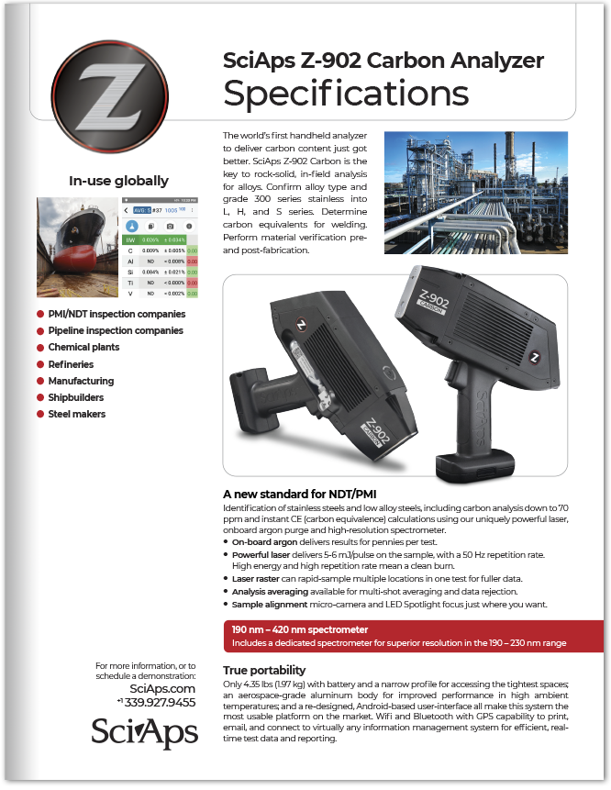

Layout Preview | English Text | Translated Text
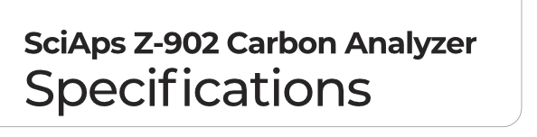 | SciAps Z-902 Carbon Analyzer
 | Specifications
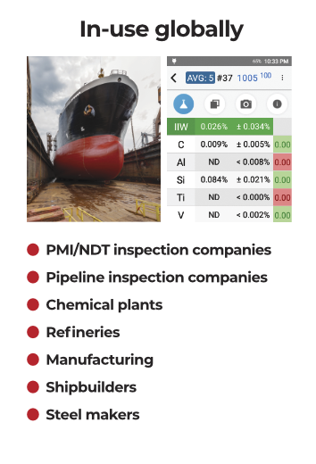 | In-use globally
 | PMI/NDT inspection companies
 | Pipeline inspection companies
 | Chemical plants
 | Refineries
 | Manufacturing
 | Shipbuilders
 | Steel makers
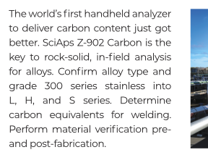 | The world’s first handheld analyzer to deliver carbon content just got better. SciAps Z-902 Carbon is the key to rock-solid, in-field analysis for alloys. Confirm alloy type and grade 300 series stainless into  L, H, and S series. Determine carbon equivalents for welding. Perform material verification pre- and post-fabrication.
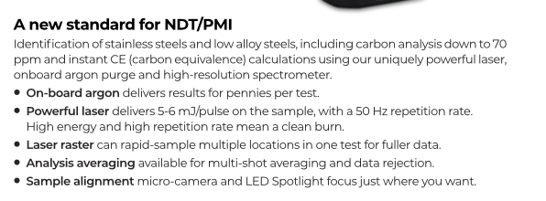 | A new standard for NDT/PMI
 | Identification of stainless steels and low alloy steels, including carbon analysis down to 70 ppm and instant CE (carbon equivalence) calculations using our uniquely powerful laser, onboard argon purge and high-resolution spectrometer.
 | • On-board argon
 | delivers results for pennies per test.
 | • Powerful laser
delivers 5-6 mJ/pulse on the sample, with a 50 Hz repetition rate.
High energy and high repetition rate mean a clean burn.
 | • Laser raster
 | can rapid-sample multiple locations in one test for fuller data.
 | • Analysis averaging
 | available for multi-shot averaging and data rejection.
 | • Sample alignment
 | micro-camera and LED Spotlight focus just where you want.
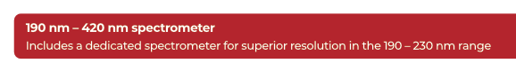 | 190 nm – 420 nm spectrometer
 | Includes a dedicated spectrometer for superior resolution in the 190 – 230 nm range
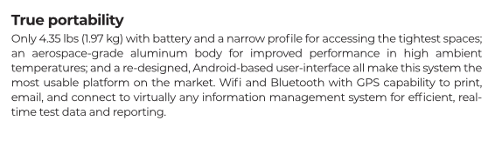 | True portability
 | Only 4.35 lbs (1.97 kg) with battery and a narrow profile for accessing the tightest spaces; an aerospace-grade aluminum body for improved performance in high ambient temperatures; and a re-designed, Android-based user-interface all make this system the most usable platform on the market. Wifi and Bluetooth with GPS capability to print, email, and connect to virtually any information management system for efficient, real-time test data and reporting.
 | For more information, or to schedule a demonstration:
SciAps.com

+1 339.927.9455
(Back)
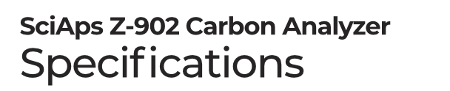 | SciAps Z-902 Carbon Analyzer
 | Specifications
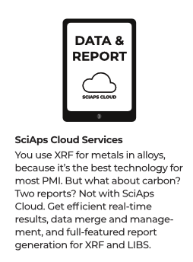 | SciAps Cloud Services
You use XRF for metals in alloys,
because it’s the best technology for most PMI. But what about carbon? Two reports? Not with SciAps Cloud. Get efficient real-time
results, data merge and management, and full-featured report
generation for XRF and LIBS.
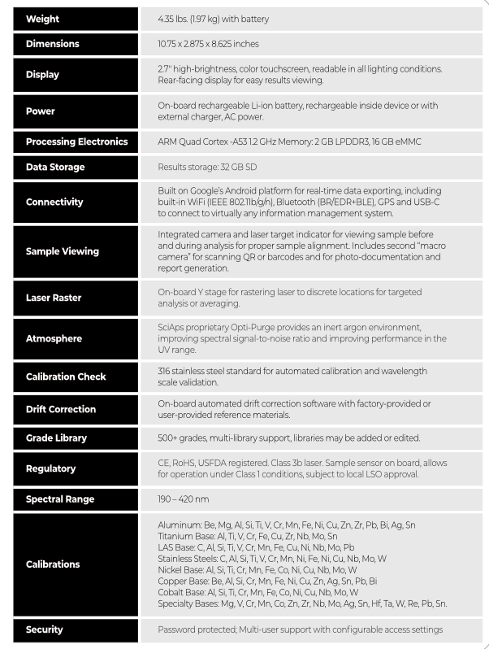 | Weight
 | 4.35 lbs. (1.97 kg) with battery
 | Dimensions
 | 10.75 x 2.875 x 8.625 inches
 | Display
 | 2.7″ high-brightness, color touchscreen, readable in all lighting conditions. Rear-facing display for easy results viewing.
 | Power
 | On-board rechargeable Li-ion battery, rechargeable inside device or with external charger, AC power.
 | Processing Electronics
 | ARM Quad Cortex -A53 1.2 GHz Memory: 2 GB LPDDR3, 16 GB eMMC
 | Data Storage
 | Results storage: 32 GB SD
 | Connectivity
 | Built on Google’s Android platform for real-time data exporting, including built-in WiFi (IEEE 802.11b/g/n), Bluetooth (BR/EDR+BLE), GPS and USB-C to connect to virtually any information management system.
 | Sample Viewing
 | Integrated camera and laser target indicator for viewing sample before and during analysis for proper sample alignment. Includes second “macro camera” for scanning QR or barcodes and for photo-documentation and report generation.
 | Laser Raster
 | On-board Y stage for rastering laser to discrete locations for targeted analysis or averaging.
 | Atmosphere
 | SciAps proprietary Opti-Purge provides an inert argon environment, improving spectral signal-to-noise ratio and improving performance in the UV range.
 | Calibration Check
316 stainless steel standard for automated calibration and wavelength
scale validation.
 | Drift Correction
 | On-board automated drift correction software with factory-provided or user-provided reference materials.
 | Grade Library
 | 500+ grades, multi-library support, libraries may be added or edited.
 | Regulatory
 | CE, RoHS, USFDA registered. Class 3b laser. Sample sensor on board, allows for operation under Class 1 conditions, subject to local LSO approval.
 | Spectral Range
 | 190 – 420 nm
 | Calibrations
Aluminum: Be, Mg, Al, Si, Ti, V, Cr, Mn, Fe, Ni, Cu, Zn, Zr, Pb, Bi, Ag, Sn
Titanium Base: Al, Ti, V, Cr, Fe, Cu, Zr, Nb, Mo, Sn
LAS Base: C, Al, Si, Ti, V, Cr, Mn, Fe, Cu, Ni, Nb, Mo, Pb
Stainless Steels: C, Al, Si, Ti, V, Cr, Mn, Ni, Fe, Ni, Cu, Nb, Mo, W
Nickel Base: Al, Si, Ti, Cr, Mn, Fe, Co, Ni, Cu, Nb, Mo, W
Copper Base: Be, Al, Si, Cr, Mn, Fe, Ni, Cu, Zn, Ag, Sn, Pb, Bi
Cobalt Base: Al, Si, Ti, Cr, Mn, Fe, Co, Ni, Cu, Nb, Mo, W
Specialty Bases: Mg, V, Cr, Mn, Co, Zn, Zr, Nb, Mo, Ag, Sn, Hf, Ta, W, Re, Pb, Sn.
 | Security
 | Password protected; Multi-user support with configurable access settings
 | JUN2021
 | YouTube.com/SciAps
If applicable, please add:
LOCAL COMPANY NAME
LOCAL WEBSITE
LOCAL PHONE

