Document Title: SciAps_Where’s the Gold?
Rev Date: rev Sept 2021
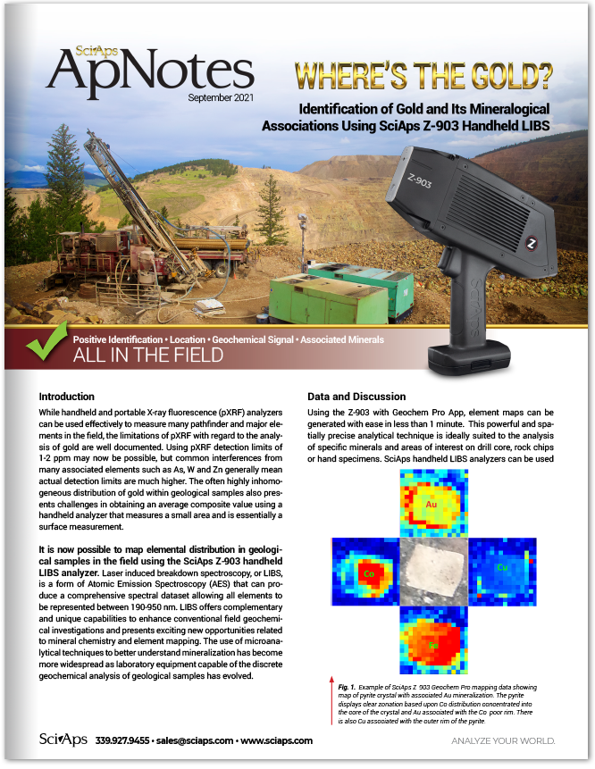
Layout Preview | English Text | Translated Text
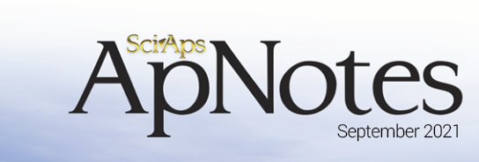 | SciAps
 | ApNotes
 | September 2021
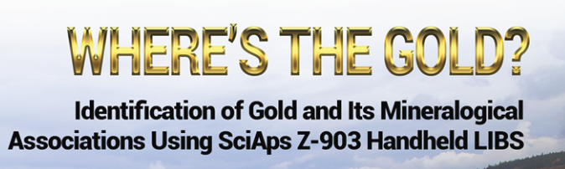 | WHERE’S THE GOLD?
 | Identification of Gold and Its Mineralogical Associations Using SciAps Z-903 Handheld LIBS
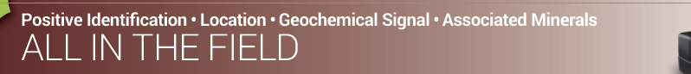 | Positive Identification • Location • Geochemical Signal • Associated Minerals
 | ALL IN THE FIELD
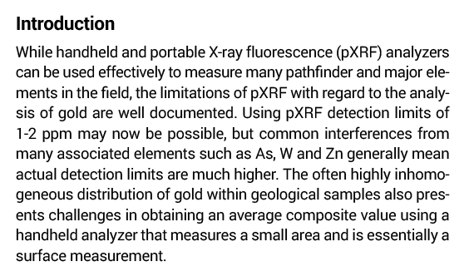 | Introduction
 | While handheld and portable X-ray fluorescence (pXRF) analyzers can be used effectively to measure many pathfinder and major elements in the field, the limitations of pXRF with regard to the analysis of gold are well documented. Using pXRF detection limits of 1-2 ppm may now be possible, but common interferences from many associated elements such as As, W and Zn generally mean actual detection limits are much higher. The often highly inhomogeneous distribution of gold within geological samples also presents challenges in obtaining an average composite value using a handheld analyzer that measures a small area and is essentially a surface measurement.
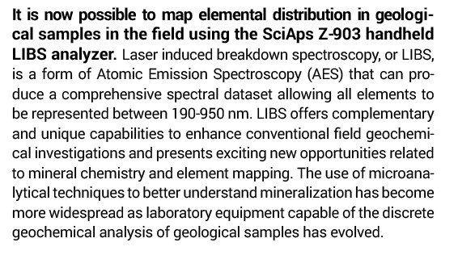 | It is now possible to map elemental distribution in geological samples in the field using the SciAps Z-903 handheld LIBS analyzer.
 | Laser induced breakdown spectroscopy, or LIBS, is a form of Atomic Emission Spectroscopy (AES) that can produce a comprehensive spectral dataset allowing all elements to be represented between 190-950 nm. LIBS offers complementary and unique capabilities to enhance conventional field geochemical investigations and presents exciting new opportunities related to mineral chemistry and element mapping. The use of microanalytical techniques to better understand mineralization has become more widespread as laboratory equipment capable of the discrete geochemical analysis of geological samples has evolved.
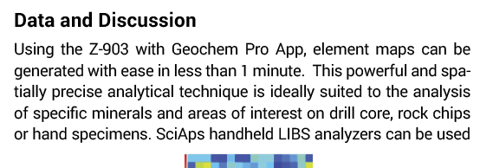 | Data and Discussion
 | Using the Z-903 with Geochem Pro App, element maps can be generated with ease in less than 1 minute. This powerful and spatially precise analytical technique is ideally suited to the analysis of specific minerals and areas of interest on drill core, rock chips or hand specimens. SciAps handheld LIBS analyzers can be used
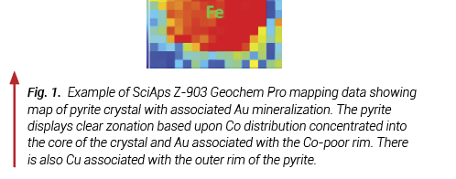 | Fig. 1.
 | Example of SciAps Z-903 Geochem Pro mapping data showing map of pyrite crystal with associated Au mineralization. The pyrite displays clear zonation based upon Co distribution concentrated into the core of the crystal and Au associated with the Co-poor rim. There is also Cu associated with the outer rim of the pyrite.
 | 339.927.9455 • sales@sciaps.com • www.sciaps.com
 | ANALYZE YOUR WORLD
(BACK)
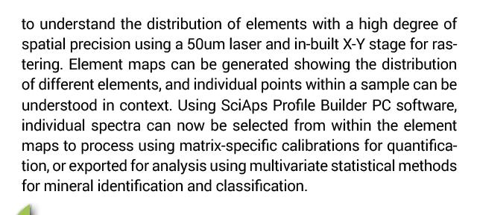 | to understand the distribution of elements with a high degree of spatial precision using a 50um laser and in-built X-Y stage for rastering. Element maps can be generated showing the distribution of different elements, and individual points within a sample can be understood in context. Using SciAps Profile Builder PC software, individual spectra can now be selected from within the element maps to process using matrix-specific calibrations for quantification, or exported for analysis using multivariate statistical methods for mineral identification and classification.
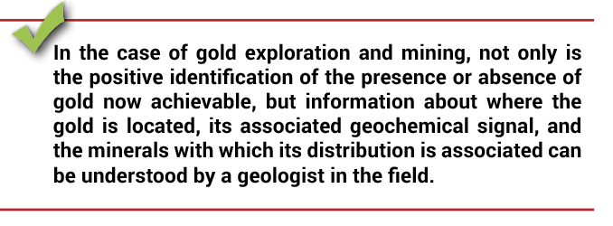 | In the case of gold exploration and mining, not only is the positive identification of the presence or absence of gold now achievable, but information about where the gold is located, its associated geochemical signal, and the minerals with which its distribution is associated can be understood by a geologist in the field.
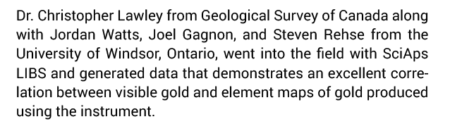 | Dr. Christopher Lawley from Geological Survey of Canada along with Jordan Watts, Joel Gagnon, and Steven Rehse from the University of Windsor, Ontario, went into the field with SciAps LIBS and generated data that demonstrates an excellent correlation between visible gold and element maps of gold produced using the instrument.
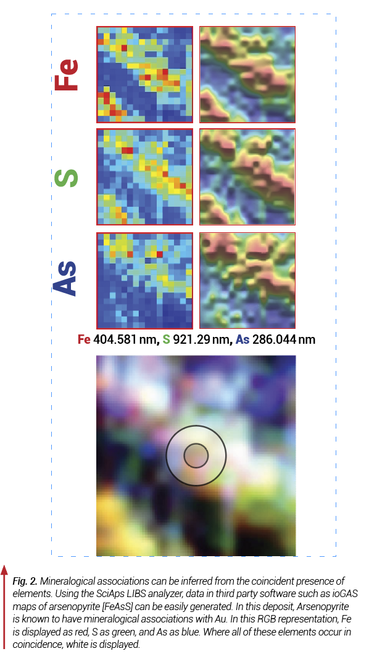 | Fe 404.581 nm, S 921.29 nm, As 286.044 nm
 | Fig. 2.
 | Mineralogical associations can be inferred from the coincident presence of elements. Using the SciAps LIBS analyzer, data in third party software such as ioGAS maps of arsenopyrite [FeAsS] can be easily generated. In this deposit, Arsenopyrite is known to have mineralogical associations with Au. In this RGB representation, Fe is displayed as red, S as green, and As as blue. Where all of these elements occur in coincidence, white is displayed.
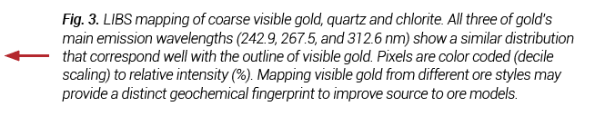 | Fig. 3.
 | LIBS mapping of coarse visible gold, quartz and chlorite. All three of gold’s main emission wavelengths (242.9, 267.5, and 312.6 nm) show a similar distribution that correspond well with the outline of visible gold. Pixels are color coded (decile scaling) to relative intensity (%). Mapping visible gold from different ore styles may provide a distinct geochemical fingerprint to improve source to ore models.
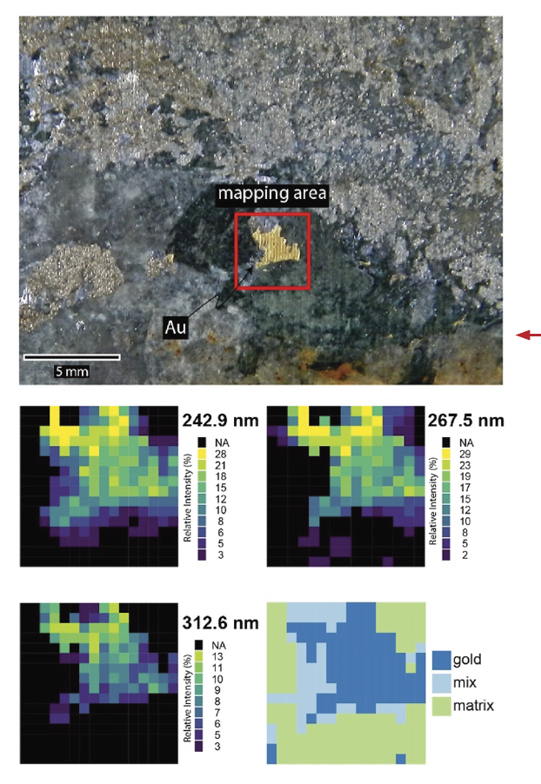 | mapping area
 | Relative Intensity
gold
mix
matrix
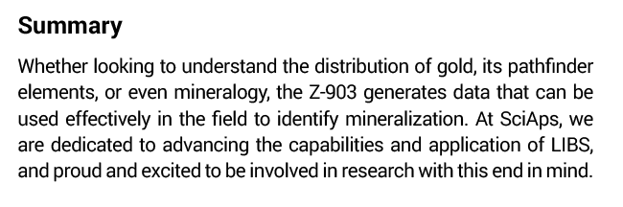 | Summary
 | Whether looking to understand the distribution of gold, its pathfinder elements, or even mineralogy, the Z-903 generates data that can be used effectively in the field to identify mineralization. At SciAps, we are dedicated to advancing the capabilities and application of LIBS, and proud and excited to be involved in research with this end in mind.
 | SciAps, Inc.  7 Constitution Way  Woburn, MA  www.sciaps.com  339.927.9455
If applicable, please add:
LOCAL COMPANY NAME
LOCAL WEBSITE
LOCAL PHONE

