Document Title: SciAps X-550 Pb Specifications
Rev Date: 0823
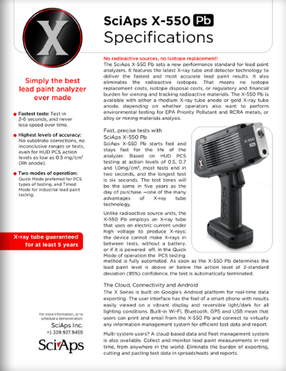
Layout Preview | English Text | Translated Text
 | SciAps X-550 Pb
 | Specifications
 | Simply the best
 | lead paint analyzer
 | ever made
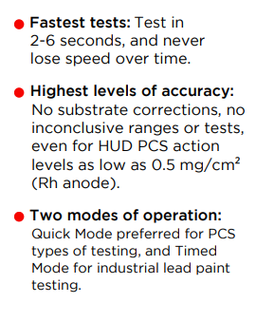 | Fastest tests:
Test in 2-6 seconds, and never
lose speed over time.
 | Highest levels of accuracy:
 | No substrate corrections, no inconclusive ranges or tests, even for HUD PCS action levels as low as 0.5 mg/cm² (Rh anode).
 | Two modes of operation:
 | Quick Mode preferred for PCS types of testing, and Timed Mode for industrial lead paint testing.
 | X-ray tube guaranteed
 | for at least 5 years
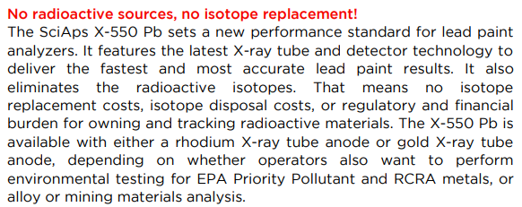 | No radioactive sources, no isotope replacement!
The SciAps X-550 Pb sets a new performance standard for lead paint analyzers. It features the latest X-ray tube and detector technology to deliver the fastest and most accurate lead paint results. It also eliminates the radioactive isotopes. That means no isotope replacement costs, isotope disposal costs, or regulatory and financial burden for owning and tracking radioactive materials. The X-550 Pb is available with either a rhodium X-ray tube anode or gold X-ray tube anode, depending on whether operators also want to perform
environmental testing for EPA Priority Pollutant and RCRA metals, or alloy or mining materials analysis.
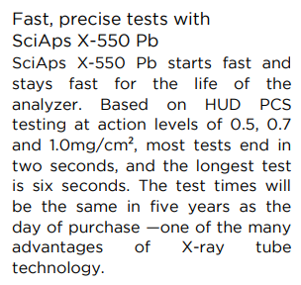 | Fast, precise tests with
 | SciAps X-550 Pb
 | SciAps X-550 Pb starts fast and stays fast for the life of the analyzer. Based on HUD PCS testing at action levels of 0.5, 0.7 and 1.0mg/cm², most tests end in two seconds, and the longest test is six seconds. The test times will be the same in five years as the day of purchase —one of the many advantages of X-ray tube technology.
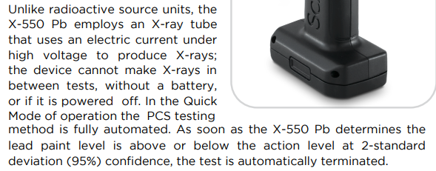 | Unlike radioactive source units, the X-550 Pb employs an X-ray tube that uses an electric current under high voltage to produce X-rays; the device cannot make X-rays in between tests, without a battery, or if it is powered off. In the Quick Mode of operation the PCS testing  method is fully automated. As soon as the X-550 Pb determines the lead paint level is above or below the action level at 2-standard deviation (95%) confidence, the test is automatically terminated.
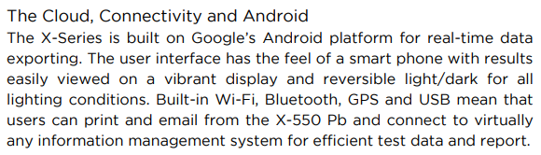 | The Cloud, Connectivity and Android
 | The X-Series is built on Google’s Android platform for real-time data exporting. The user interface has the feel of a smart phone with results easily viewed on a vibrant display and reversible light/dark for all lighting conditions. Built-in Wi-Fi, Bluetooth, GPS and USB mean that users can print and email from the X-550 Pb and connect to virtually any information management system for efficient test data and report.
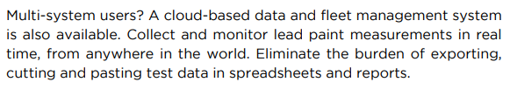 | Multi-system users? A cloud-based data and fleet management system is also available. Collect and monitor lead paint measurements in real time, from anywhere in the world. Eliminate the burden of exporting, cutting and pasting test data in spreadsheets and reports.
 | For more information, or to
 | schedule a demonstration:
If applicable, please add:
LOCAL COMPANY NAME
LOCAL WEBSITE
LOCAL PHONE
(BACK)
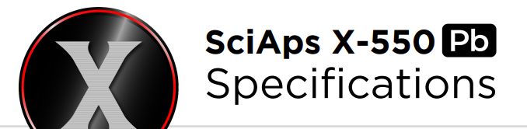 | SciAps X-550 Pb
 | Specifications
 | Simply the best
 | lead paint analyzer
 | ever made
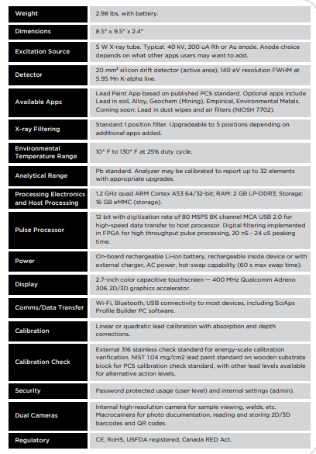
 | Weight
 | 2.98 lbs. with battery.
 | Dimensions
 | 8.5" x 9.5" x 2.4"
 | Excitation Source
 | 5 W X-ray tube. Typical: 40 kV, 200 uA Rh or Au anode. Anode choice depends on what other apps users may want to add.
 | Detector
 | 20 mm² silicon drift detector (active area), 140 eV resolution FWHM at 5.95 Mn K-alpha line.
 | Available Apps
 | Lead Paint App based on published PCS standard. Optional apps include Lead in soil, Alloy, Geochem (Mining), Empirical, Environmental Metals. Coming soon: Lead in dust wipes and air filters (NIOSH 7702).
 | X-ray Filtering
 | Standard 1 position filter. Upgradeable to 5 positions depending on additional apps added.
 | Environmental
 | Temperature Range
 | 10° F to 130° F at 25% duty cycle.
 | Analytical Range
 | Pb standard. Analyzer may be calibrated to report up to 32 elements with appropriate upgrades.
 | Processing Electronics
 | and Host Processing
 | 1.2 GHz quad ARM Cortex A53 64/32-bit; RAM: 2 GB LP-DDR3; Storage: 16 GB eMMC (storage).
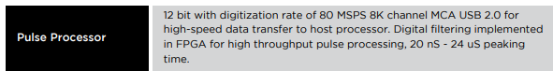 | Pulse Processor
 | 12 bit with digitization rate of 80 MSPS 8K channel MCA USB 2.0 for high-speed data transfer to host processor. Digital filtering implemented in FPGA for high throughput pulse processing, 20 nS - 24 uS peaking time.
 | Power
 | On-board rechargeable Li-ion battery, rechargeable inside device or with external charger, AC power, hot-swap capability (60 s max swap time).
 | Display
 | 2.7-inch color capacitive touchscreen — 400 MHz Qualcomm Adreno 306 2D/3D graphics accelerator.
 | Comms/Data Transfer
 | Wi-Fi, Bluetooth, USB connectivity to most devices, including SciAps Profile Builder PC software.
 | Calibration
 | Linear or quadratic lead calibration with absorption and depth corrections.
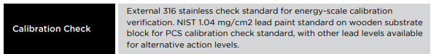 | Calibration Check
 | External 316 stainless check standard for energy-scale calibration verification. NIST 1.04 mg/cm2 lead paint standard on wooden substrate block for PCS calibration check standard, with other lead levels available for alternative action levels.
 | Security
 | Password protected usage (user level) and internal settings (admin).
 | Dual Cameras
 | Internal high-resolution camera for sample viewing, welds, etc. Macrocamera for photo documentation, reading and storing 2D/3D barcodes and QR codes.
 | Regulatory
 | CE, RoHS, USFDA registered, Canada RED Act.
 | If applicable, please add:  LOCAL COMPANY NAME  LOCAL WEBSITE  LOCAL PHONE
 | YouTube.com/SciAps

