Document Title: X-505 detectORE
Rev Date: 0823
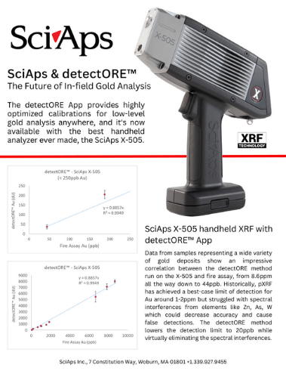
Layout Preview | English Text | Translated Text
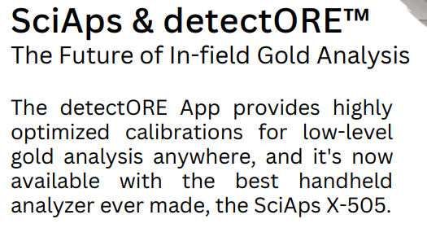 | SciAps & detectORE™
 | The Future of In-field Gold Analysis
The detectORE App provides highly optimized calibrations for low-level gold analysis anywhere, and it's now available with the best handheld
analyzer ever made, the SciAps X-505.
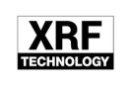 | XRF
 | Technology
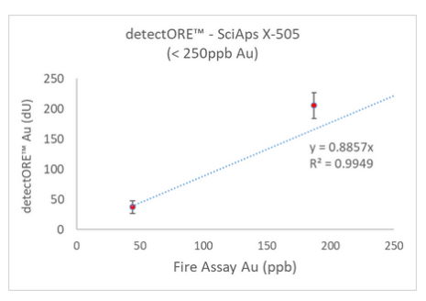
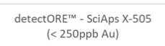 | detectORE™ - SciAps X-505
 | (<250ppb Au)
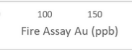 | Fire Assay Au (ppb)
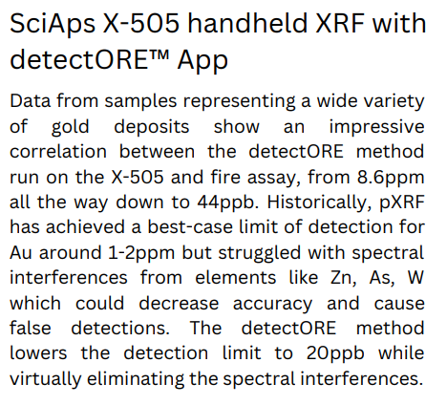 | SciAps X-505 handheld XRF with
 | detectORE™ App
Data from samples representing a wide variety of gold deposits show an impressive correlation between the detectORE method run on the X-505 and fire assay, from 8.6ppm all the way down to 44ppb. Historically, pXRF has achieved a best-case limit of detection for Au around 1-2ppm but struggled with spectral interferences from elements like Zn, As, W which could decrease accuracy and cause false detections. The detectORE method
lowers the detection limit to 20ppb while virtually eliminating the spectral interferences.
If applicable, please add:
LOCAL COMPANY NAME
LOCAL WEBSITE
LOCAL PHONE
(BACK)
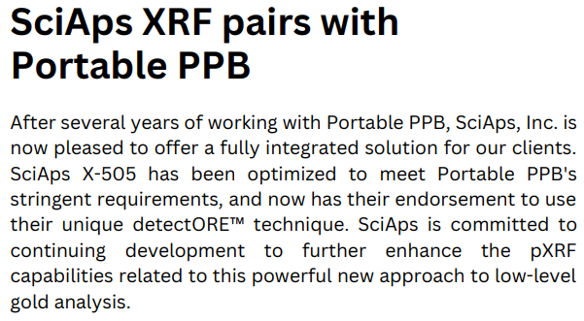 | SciAps XRF pairs with
 | Portable PPB
After several years of working with Portable PPB, SciAps, Inc. is now pleased to offer a fully integrated solution for our clients. SciAps X-505 has been optimized to meet Portable PPB's
stringent requirements, and now has their endorsement to use their unique detectORE™ technique. SciAps is committed to continuing development to further enhance the pXRF capabilities related to this powerful new approach to low-level gold analysis.
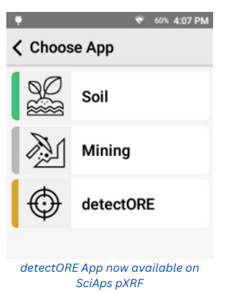 | detectORE App now available on
 | SciAps pXRF
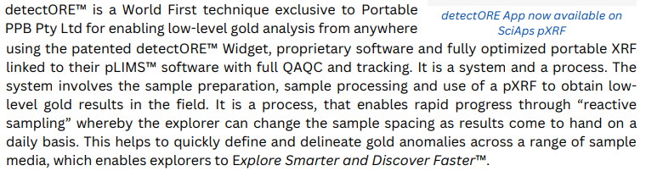 | detectORE™ is a World First technique exclusive to Portable PPB Pty Ltd for enabling low-level gold analysis from anywhere using the patented detectORE™ Widget, proprietary software and fully optimized portable XRF linked to their pLIMS™ software with full QAQC and tracking. It is a system and a process. The system involves the sample preparation, sample processing and use of a pXRF to obtain low-level gold results in the field. It is a process, that enables rapid progress through “reactive sampling” whereby the explorer can change the sample spacing as results come to hand on a  daily basis. This helps to quickly define and delineate gold anomalies across a range of sample media, which enables explorers to Explore Smarter and Discover Faster™.
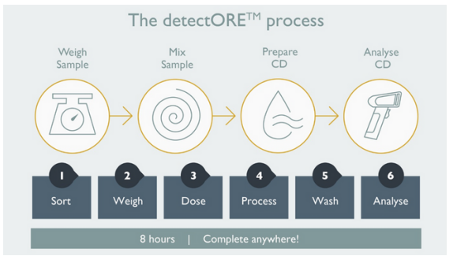 | The detectORE™ process
 | Weigh Sample
 | Mix Sample
 | Prepare CD
 | Analyse CD
 | Sort
 | Weigh
 | Dose
 | Process
 | Wash
 | Analyse
 | 8 hours
 | Complete anywhere!
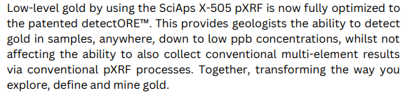 | Low-level gold by using the SciAps X-505 pXRF is now fully optimized to the patented detectORE™. This provides geologists the ability to detect gold in samples, anywhere, down to low ppb concentrations, whilst not affecting the ability to also collect conventional multi-element results via conventional pXRF processes. Together, transforming the way you explore, define and mine gold.
 | The SciAps X-505 pXRF offers the only way to find economically viable gold concentrations in the field.
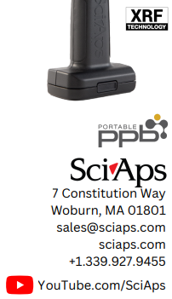 | XRF
 | Technology
 | Portable
 | ppb
If applicable, please add:
LOCAL COMPANY NAME
LOCAL WEBSITE
LOCAL PHONE
 | YouTube.com/SciAps

