Document Title: SciAps Introducing the PowerHouse
Rev Date: March 2024
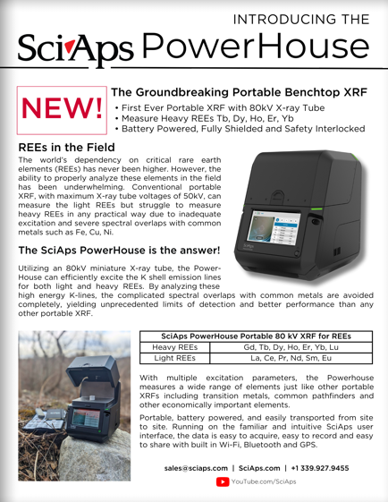
Layout Preview | English Text | Translated Text
 | Introducing the
 | SciAps PowerHouse
 | New!
 | The Groundbreaking Portable Benchtop XRF
 | First Ever Portable XRF with 80kV X-ray Tube
 | Measure Heavy REEs Tb, Dy, Ho, Er, Yb
 | Battery Powered, Fully Shielded and Safety Interlocked
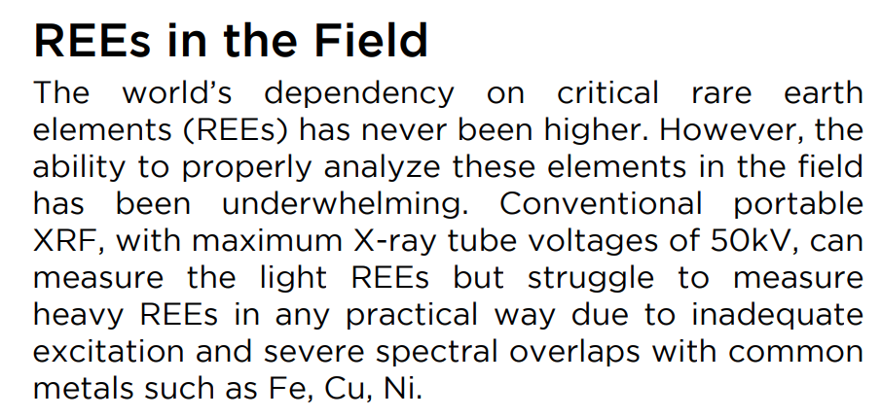 | REEs in the Field
 | The world’s dependency on critical rare earth elements (REEs) has never been higher. However, the ability to properly analyze these elements in the field has been underwhelming. Conventional portable XRF, with maximum X-ray tube voltages of 50kV, can measure the light REEs but struggle to measure heavy REEs in any practical way due to inadequate excitation and severe spectral overlaps with common metals such as Fe, Cu, Ni.
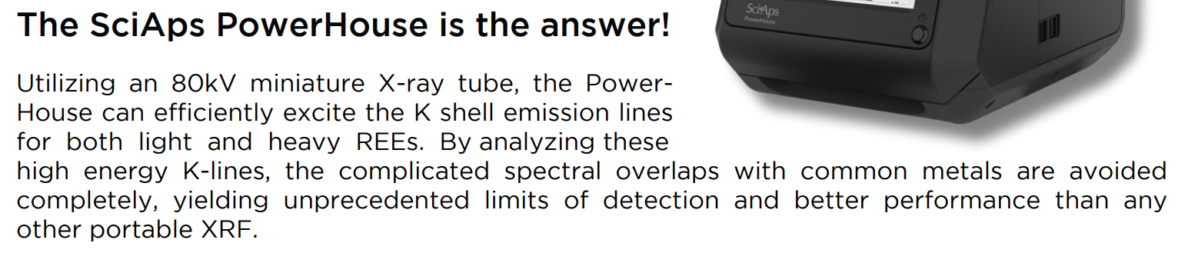 | The SciAps PowerHouse is the answer!
 | Utilizing an 80kV miniature X-ray tube, the PowerHouse can efficiently excite the K shell emission lines for both light and heavy REEs. By analyzing these high energy K-lines, the complicated spectral overlaps with common metals are avoided completely, yielding unprecedented limits of detection and better performance than any other portable XRF.
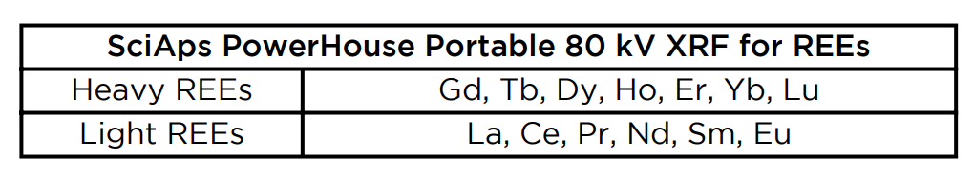 | SciAps PowerHouse Portable 80 kV XRF for REEs
 | Heavy REEs
 | Gd, Tb, Dy, Ho, Er, Yb, Lu
 | Light REEs
 | La, Ce, Pr, Nd, Sm, Eu
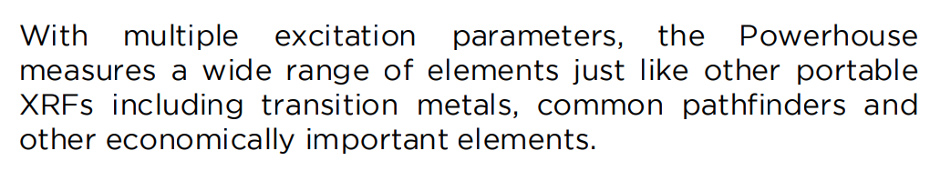 | With multiple excitation parameters, the Powerhouse measures a wide range of elements just like other portable XRFs including transition metals, common pathfinders and other economically important elements.
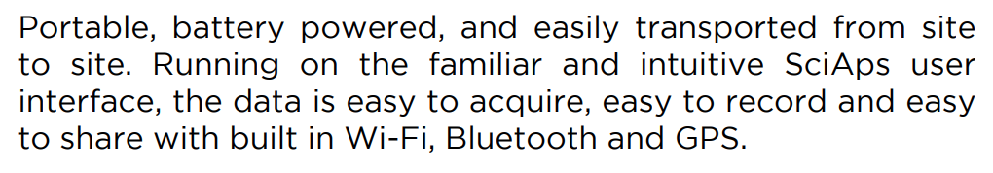 | Portable, battery powered, and easily transported from site to site. Running on the familiar and intuitive SciAps user interface, the data is easy to acquire, easy to record and easy to share with built in Wi-Fi, Bluetooth and GPS.
 | If applicable, please add:  LOCAL COMPANY NAME  LOCAL WEBSITE  LOCAL PHONE
 | YouTube.com/SciAps
(BACK)
 | SciAps PowerHouse

