Document Title: SciAps X-550 Geochem Specifications
Rev Date: March 2024
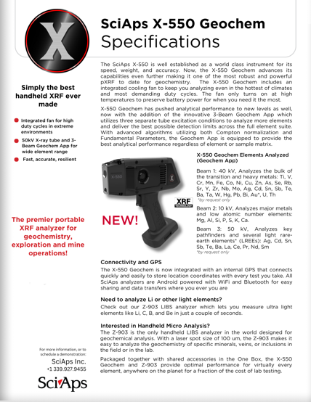
Layout Preview | English Text | Translated Text
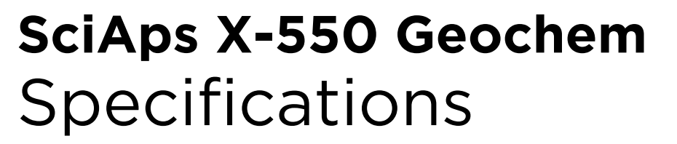 | SciAps X-550 Geochem
 | Specifications
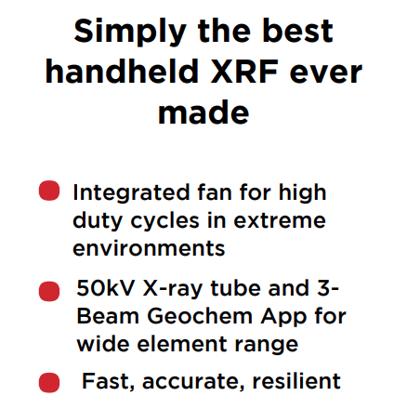 | Simply the best handheld XRF ever made
 | Integrated fan for high duty cycles in extreme environments
 | 50kV X-ray tube and 3- Beam Geochem App for wide element range
 | Fast, accurate, resilient
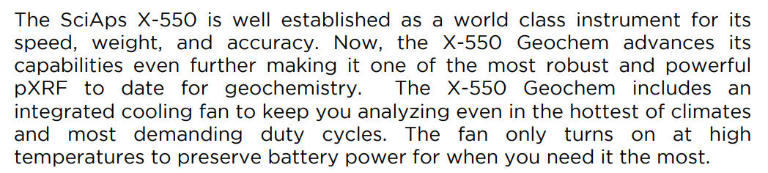 | The SciAps X-550 is well established as a world class instrument for its speed, weight, and accuracy. Now, the X-550 Geochem advances its capabilities even further making it one of the most robust and powerful pXRF to date for geochemistry. The X-550 Geochem includes an integrated cooling fan to keep you analyzing even in the hottest of climates and most demanding duty cycles. The fan only turns on at high temperatures to preserve battery power for when you need it the most.
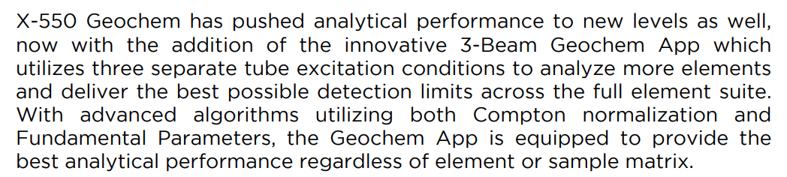 | X-550 Geochem has pushed analytical performance to new levels as well, now with the addition of the innovative 3-Beam Geochem App which utilizes three separate tube excitation conditions to analyze more elements and deliver the best possible detection limits across the full element suite. With advanced algorithms utilizing both Compton normalization and Fundamental Parameters, the Geochem App is equipped to provide the best analytical performance regardless of element or sample matrix.
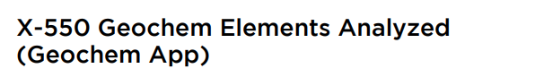 | X-550 Geochem Elements Analyzed
 | (Geochem App)
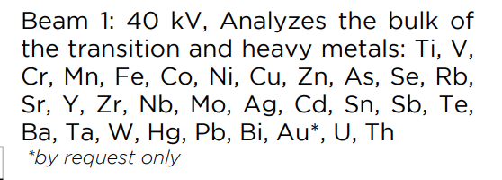 | Beam 1: 40 kV, Analyzes the bulk of the transition and heavy metals: Ti, V, Cr, Mn, Fe, Co, Ni, Cu, Zn, As, Se, Rb, Sr, Y, Zr, Nb, Mo, Ag, Cd, Sn, Sb, Te, Ba, Ta, W, Hg, Pb, Bi, Au*, U, Th
 | *by request only
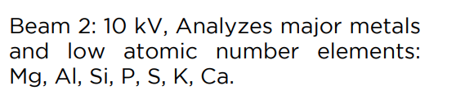 | Beam 2: 10 kV, Analyzes major metals and low atomic number elements: Mg, Al, Si, P, S, K, Ca.
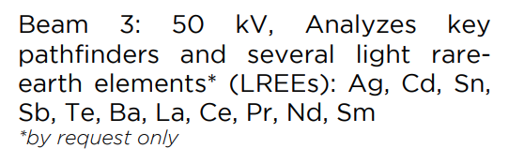 | Beam 3: 50 kV, Analyzes key pathfinders and several light rareearth elements* (LREEs): Ag, Cd, Sn, Sb, Te, Ba, La, Ce, Pr, Nd, Sm
 | *by request only
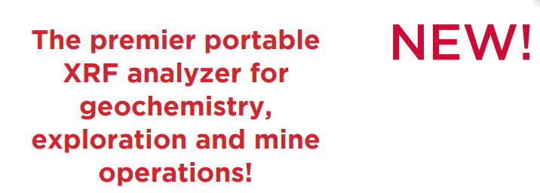 | New!
 | The premier portable XRF analyzer for geochemistry, exploration and mine operations!
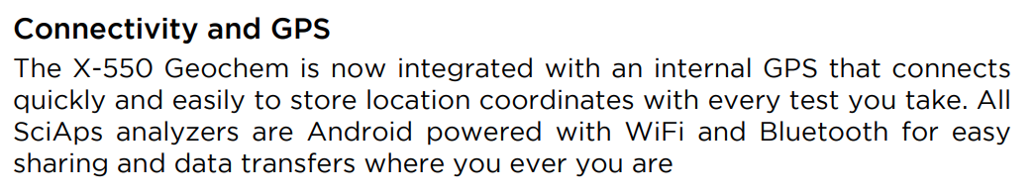 | Connectivity and GPS
 | The X-550 Geochem is now integrated with an internal GPS that connects quickly and easily to store location coordinates with every test you take. All SciAps analyzers are Android powered with WiFi and Bluetooth for easy sharing and data transfers where you ever you are.
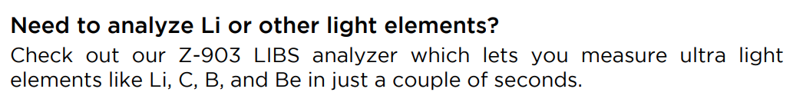 | Need to analyze Li or other light elements?
 | Check out our Z-903 LIBS analyzer which lets you measure ultra lightelements like Li, C, B, and Be in just a couple of seconds.
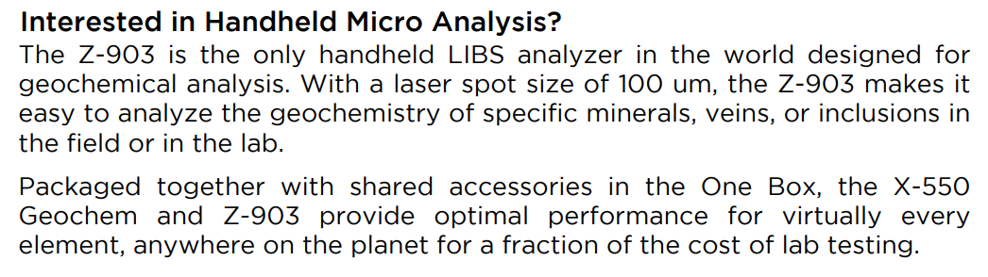 | Interested in Handheld Micro Analysis?
 | The Z-903 is the only handheld LIBS analyzer in the world designed for geochemical analysis. With a laser spot size of 100 um, the Z-903 makes it easy to analyze the geochemistry of specific minerals, veins, or inclusions in the field or in the lab.
 | Packaged together with shared accessories in the One Box, the X-550 Geochem and Z-903 provide optimal performance for virtually every element, anywhere on the planet for a fraction of the cost of lab testing.
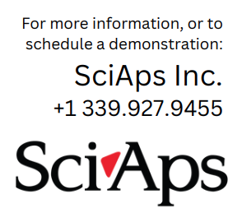 | For more information, or to schedule a demonstration:
If applicable, please add:
LOCAL COMPANY NAME
LOCAL WEBSITE
LOCAL PHONE
(BACK)
 | SciAps X-550 Geochem
 | Specifications
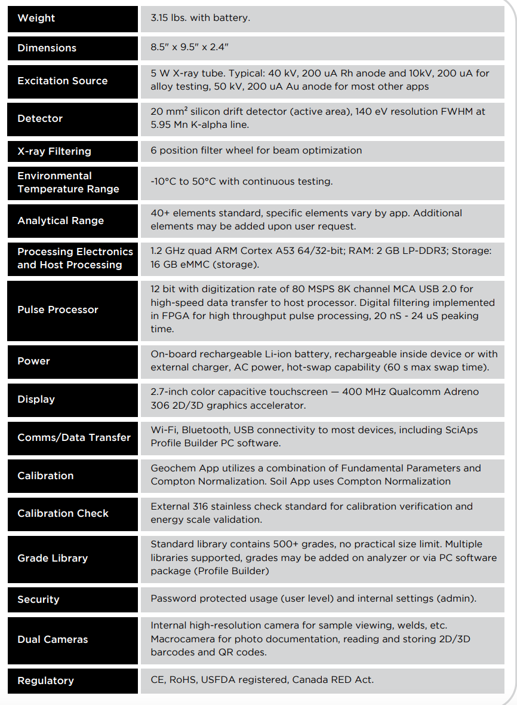 | Weight
 | 3.15 lbs. with battery.
 | Dimensions
 | 8.5" x 9.5" x 2.4"
 | Excitation Source
 | 5 W X-ray tube. Typical: 40 kV, 200 uA Rh anode and 10kV, 200 uA for alloy testing, 50 kV, 200 uA Au anode for most other apps
 | Detector
 | 20 mm² silicon drift detector (active area), 140 eV resolution FWHM at 5.95 Mn K-alpha line.
 | X-ray Filtering
 | 6 position filter wheel for beam optimization
 | Environmental Temperature Range
 | -10°C to 50°C with continuous testing.
 | Analytical Range
 | 40+ elements standard, specific elements vary by app. Additional elements may be added upon user request.
Processing Electronics and Host Processing | 1.2 GHz quad ARM Cortex A53 64/32-bit; RAM: 2 GB LP-DDR3; Storage: 16 GB eMMC (storage).
 | Pulse Processor
 | 12 bit with digitization rate of 80 MSPS 8K channel MCA USB 2.0 for high-speed data transfer to host processor. Digital filtering implemented in FPGA for high throughput pulse processing, 20 nS - 24 uS peaking time.
 | Power
 | On-board rechargeable Li-ion battery, rechargeable inside device or with external charger, AC power, hot-swap capability (60 s max swap time).
 | Display
 | 2.7-inch color capacitive touchscreen — 400 MHz Qualcomm Adreno 306 2D/3D graphics accelerator.
 | Comms/Data Transfer
 | Wi-Fi, Bluetooth, USB connectivity to most devices, including SciAps Profile Builder PC software.
 | Calibration
 | Geochem App utilizes a combination of Fundamental Parameters and Compton Normalization. Soil App uses Compton Normalization
 | Calibration Check
 | External 316 stainless check standard for calibration verification and energy scale validation.
 | Grade Library
 | Standard library contains 500+ grades, no practical size limit. Multiple libraries supported, grades may be added on analyzer or via PC software package (Profile Builder)
 | Security
 | Password protected usage (user level) and internal settings (admin).
 | Dual Cameras
 | Internal high-resolution camera for sample viewing, welds, etc. Macrocamera for photo documentation, reading and storing 2D/3D barcodes and QR codes.
 | Regulatory
 | CE, RoHS, USFDA registered, Canada RED Act.
 | YouTube.com/SciAps
If applicable, please add:
LOCAL COMPANY NAME
LOCAL WEBSITE
LOCAL PHONE

