Document Title: SciAps X-550 Enviro/HUD Specifications
Rev Date: March 2024
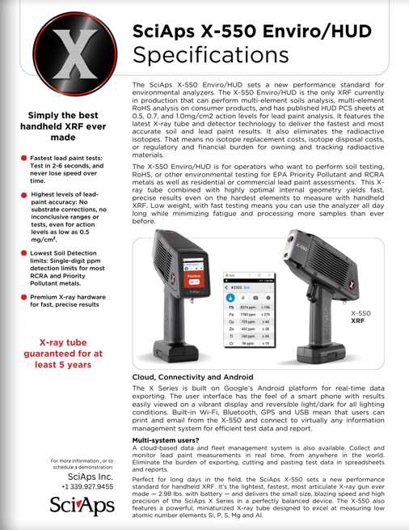
Layout Preview | English Text | Translated Text
 | SciAps X-550 Enviro/HUD
 | Specifications
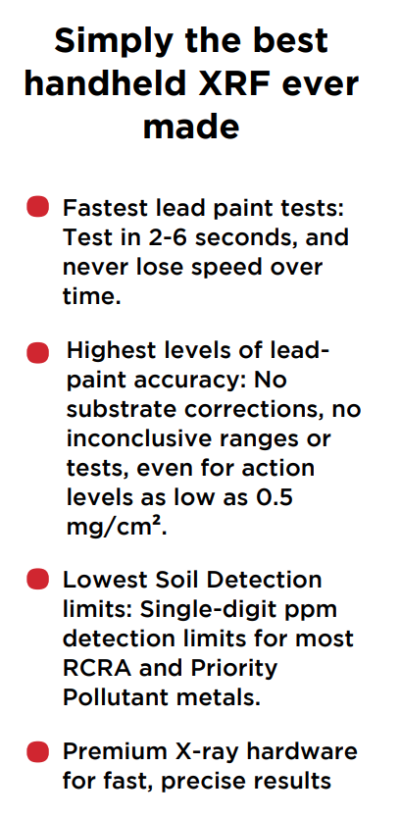 | Simply the best handheld XRF ever made
 | Fastest lead paint tests: Test in 2-6 seconds, and never lose speed over time.
 | Highest levels of leadpaint accuracy: No substrate corrections, no inconclusive ranges or tests, even for action levels as low as 0.5 mg/cm².
 | Lowest Soil Detection limits: Single-digit ppm detection limits for most RCRA and Priority Pollutant metals.
 | Premium X-ray hardware for fast, precise results
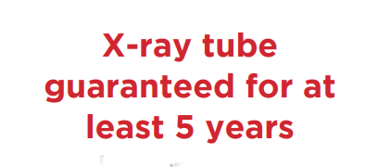 | X-ray tube guaranteed for at least 5 years
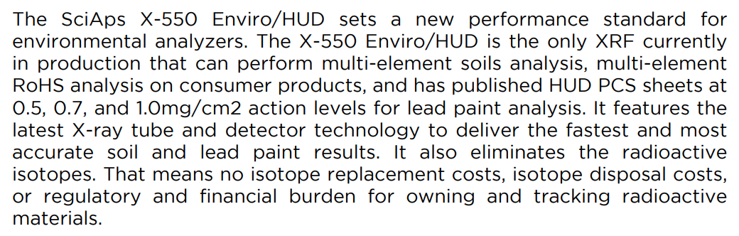 | The SciAps X-550 Enviro/HUD sets a new performance standard for environmental analyzers. The X-550 Enviro/HUD is the only XRF currently in production that can perform multi-element soils analysis, multi-element RoHS analysis on consumer products, and has published HUD PCS sheets at 0.5, 0.7, and 1.0mg/cm2 action levels for lead paint analysis. It features the latest X-ray tube and detector technology to deliver the fastest and most accurate soil and lead paint results. It also eliminates the radioactive isotopes. That means no isotope replacement costs, isotope disposal costs, or regulatory and financial burden for owning and tracking radioactive materials.
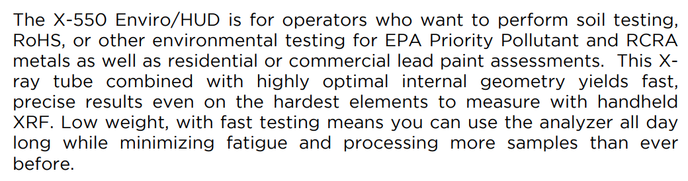 | The X-550 Enviro/HUD is for operators who want to perform soil testing, RoHS, or other environmental testing for EPA Priority Pollutant and RCRA metals as well as residential or commercial lead paint assessments. This Xray tube combined with highly optimal internal geometry yields fast, precise results even on the hardest elements to measure with handheld XRF. Low weight, with fast testing means you can use the analyzer all day long while minimizing fatigue and processing more samples than ever before.
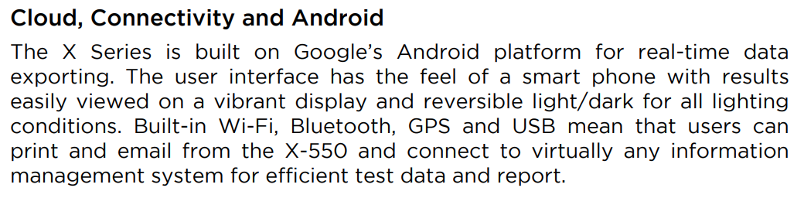 | Cloud, Connectivity and Android
 | The X Series is built on Google’s Android platform for real-time data exporting. The user interface has the feel of a smart phone with results easily viewed on a vibrant display and reversible light/dark for all lighting conditions. Built-in Wi-Fi, Bluetooth, GPS and USB mean that users can print and email from the X-550 and connect to virtually any information management system for efficient test data and report.
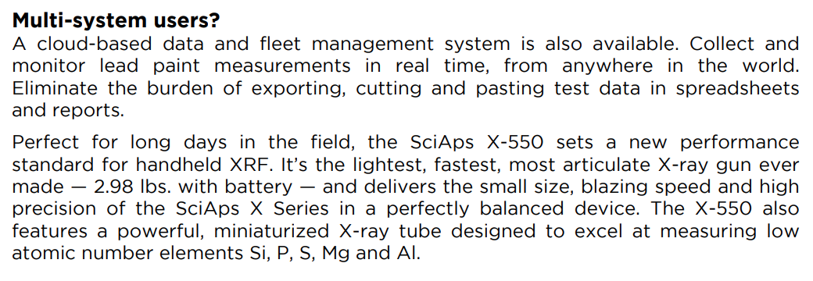 | Multi-system users?
 | A cloud-based data and fleet management system is also available. Collect and monitor lead paint measurements in real time, from anywhere in the world. Eliminate the burden of exporting, cutting and pasting test data in spreadsheets and reports.
 | Perfect for long days in the field, the SciAps X-550 sets a new performance standard for handheld XRF. It’s the lightest, fastest, most articulate X-ray gun ever made — 2.98 lbs. with battery — and delivers the small size, blazing speed and high precision of the SciAps X Series in a perfectly balanced device. The X-550 also features a powerful, miniaturized X-ray tube designed to excel at measuring low atomic number elements Si, P, S, Mg and Al.
 | For more information, or to schedule a demonstration:
If applicable, please add:
LOCAL COMPANY NAME
LOCAL WEBSITE
LOCAL PHONE
(BACK)
 | SciAps X-550 Enviro/HUD
 | Specifications
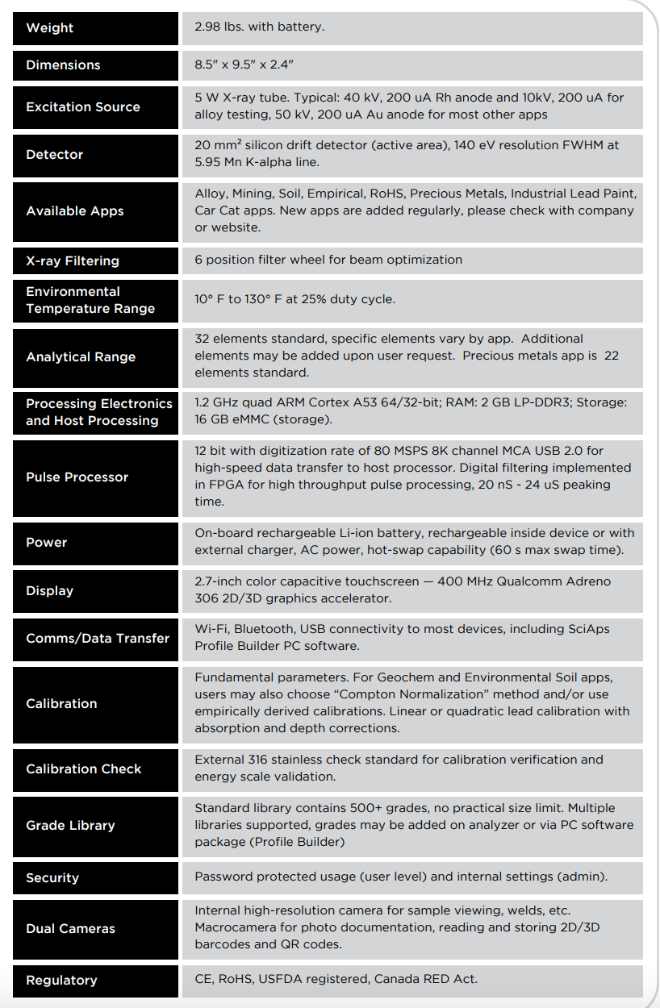 | Weight
 | 2.98 lbs. with battery.
 | Dimensions
 | 8.5" x 9.5" x 2.4"
 | Excitation Source
 | 5 W X-ray tube. Typical: 40 kV, 200 uA Rh anode and 10kV, 200 uA for alloy testing, 50 kV, 200 uA Au anode for most other apps
 | Detector
 | 20 mm² silicon drift detector (active area), 140 eV resolution FWHM at 5.95 Mn K-alpha line.
 | Available Apps
 | Alloy, Mining, Soil, Empirical, RoHS, Precious Metals, Industrial Lead Paint, Car Cat apps. New apps are added regularly, please check with company or website.
 | X-ray Filtering
 | 6 position filter wheel for beam optimization
 | Environmental Temperature Range
 | 10° F to 130° F at 25% duty cycle.
 | Analytical Range
 | 32 elements standard, specific elements vary by app. Additional elements may be added upon user request. Precious metals app is 22 elements standard.
 | Processing Electronics and Host Processing
 | 1.2 GHz quad ARM Cortex A53 64/32-bit; RAM: 2 GB LP-DDR3; Storage: 16 GB eMMC (storage).
 | Pulse Processor
 | 12 bit with digitization rate of 80 MSPS 8K channel MCA USB 2.0 for high-speed data transfer to host processor. Digital filtering implemented in FPGA for high throughput pulse processing, 20 nS - 24 uS peaking time.
 | Power
 | On-board rechargeable Li-ion battery, rechargeable inside device or with external charger, AC power, hot-swap capability (60 s max swap time).
 | Display
 | 2.7-inch color capacitive touchscreen — 400 MHz Qualcomm Adreno 306 2D/3D graphics accelerator.
 | Comms/Data Transfer
 | Wi-Fi, Bluetooth, USB connectivity to most devices, including SciAps Profile Builder PC software.
 | Calibration
 | Fundamental parameters. For Geochem and Environmental Soil apps, users may also choose “Compton Normalization” method and/or use empirically derived calibrations. Linear or quadratic lead calibration with absorption and depth corrections.
 | Calibration Check
 | External 316 stainless check standard for calibration verification and energy scale validation.
 | Grade Library
 | Standard library contains 500+ grades, no practical size limit. Multiple libraries supported, grades may be added on analyzer or via PC software package (Profile Builder)
 | Security
 | Password protected usage (user level) and internal settings (admin).
 | Dual Cameras
 | Internal high-resolution camera for sample viewing, welds, etc. Macrocamera for photo documentation, reading and storing 2D/3D barcodes and QR codes.
 | Regulatory
 | CE, RoHS, USFDA registered, Canada RED Act.
 | YouTube.com/SciAps
If applicable, please add:
LOCAL COMPANY NAME
LOCAL WEBSITE
LOCAL PHONE

