Document Title: SciAps ApNote ApNote Lithium Battery Recycling and Manufacturing
Rev Date: March 2024
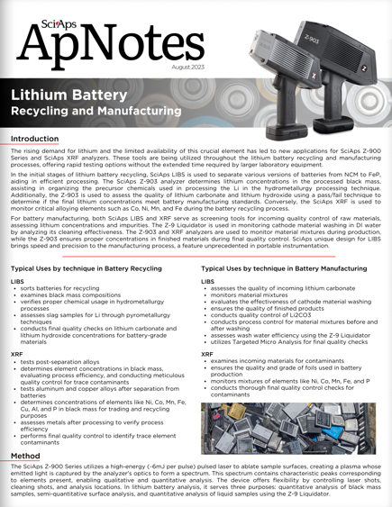
Layout Preview | English Text | Translated Text
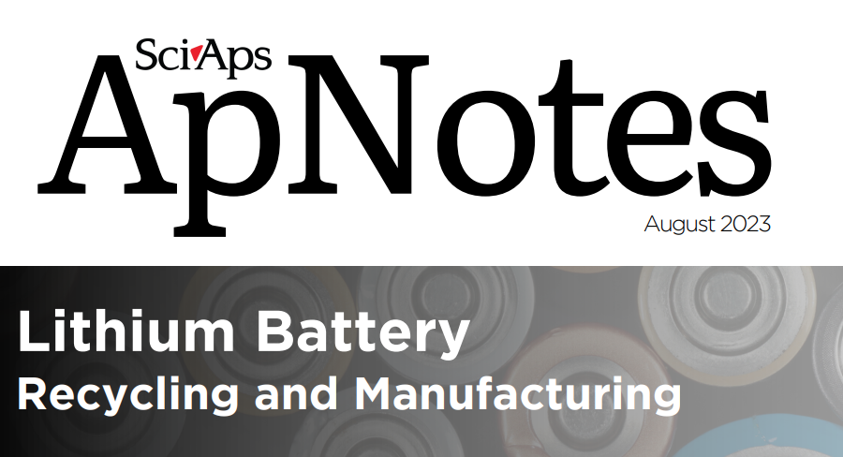 | SciAps
 | ApNotes
 | August 2023
 | Lithium Battery
 | Recycling and Manufacturing
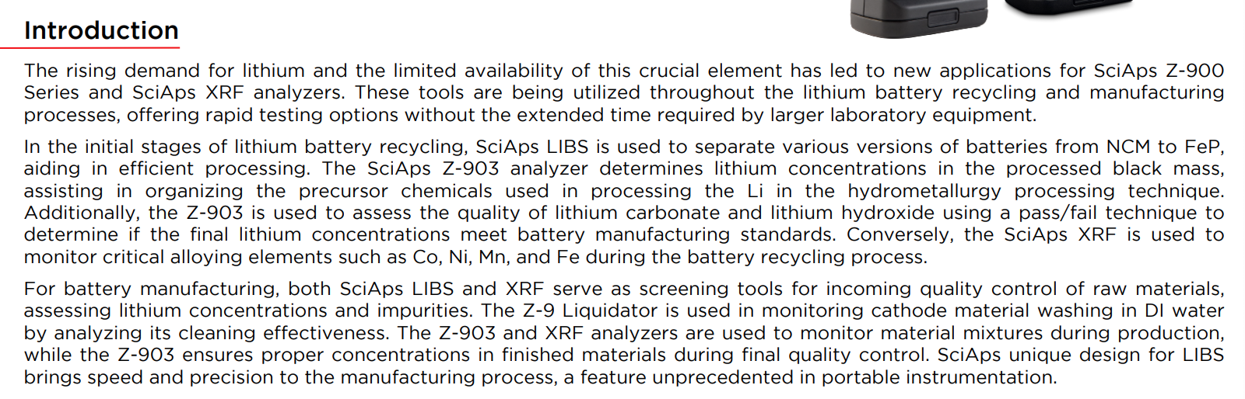 | Introduction
 | The rising demand for lithium and the limited availability of this crucial element has led to new applications for SciAps Z-900 Series and SciAps XRF analyzers. These tools are being utilized throughout the lithium battery recycling and manufacturing processes, offering rapid testing options without the extended time required by larger laboratory equipment.
 | In the initial stages of lithium battery recycling, SciAps LIBS is used to separate various versions of batteries from NCM to FeP, aiding in efficient processing. The SciAps Z-903 analyzer determines lithium concentrations in the processed black mass, assisting in organizing the precursor chemicals used in processing the Li in the hydrometallurgy processing technique. Additionally, the Z-903 is used to assess the quality of lithium carbonate and lithium hydroxide using a pass/fail technique to determine if the final lithium concentrations meet battery manufacturing standards. Conversely, the SciAps XRF is used to monitor critical alloying elements such as Co, Ni, Mn, and Fe during the battery recycling process.
 | For battery manufacturing, both SciAps LIBS and XRF serve as screening tools for incoming quality control of raw materials, assessing lithium concentrations and impurities. The Z-9 Liquidator is used in monitoring cathode material washing in DI water by analyzing its cleaning effectiveness. The Z-903 and XRF analyzers are used to monitor material mixtures during production, while the Z-903 ensures proper concentrations in finished materials during final quality control. SciAps unique design for LIBS brings speed and precision to the manufacturing process, a feature unprecedented in portable instrumentation.
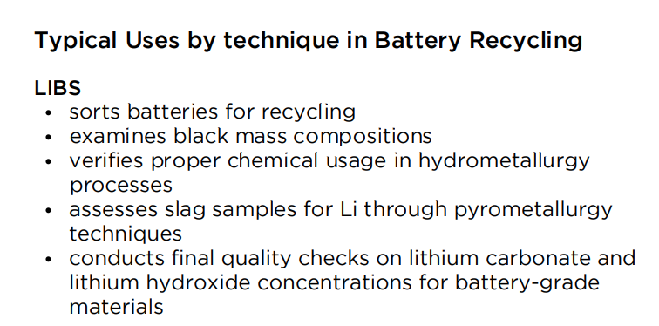 | Typical Uses by technique in Battery Recycling
 | LIBS
 | sorts batteries for recycling
 | examines black mass compositions
 | verifies proper chemical usage in hydrometallurgy processes
 | assesses slag samples for Li through pyrometallurgy techniques
 | conducts final quality checks on lithium carbonate and lithium hydroxide concentrations for battery-grade materials
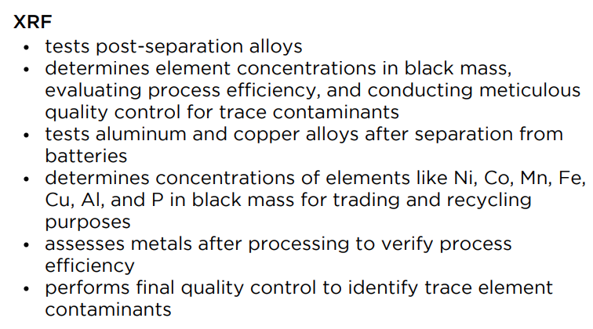 | XRF
 | tests post-separation alloys
 | determines element concentrations in black mass, evaluating process efficiency, and conducting meticulous quality control for trace contaminants
 | tests aluminum and copper alloys after separation from batteries
 | determines concentrations of elements like Ni, Co, Mn, Fe, Cu, Al, and P in black mass for trading and recycling purposes
 | assesses metals after processing to verify process efficiency
 | performs final quality control to identify trace element contaminants
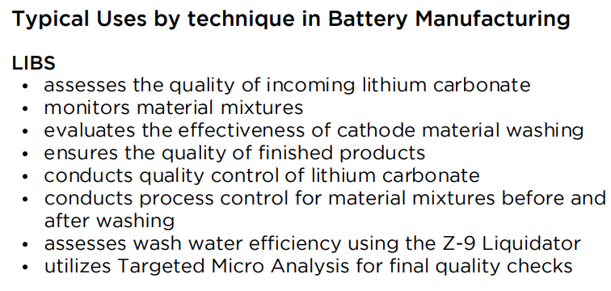 | Typical Uses by technique in Battery Manufacturing
 | LIBS
 | assesses the quality of incoming lithium carbonate
 | monitors material mixtures
 | evaluates the effectiveness of cathode material washing
 | ensures the quality of finished products
 | conducts quality control of lithium carbonate
 | conducts process control for material mixtures before and after washing
 | assesses wash water efficiency using the Z-9 Liquidator
 | utilizes Targeted Micro Analysis for final quality checks
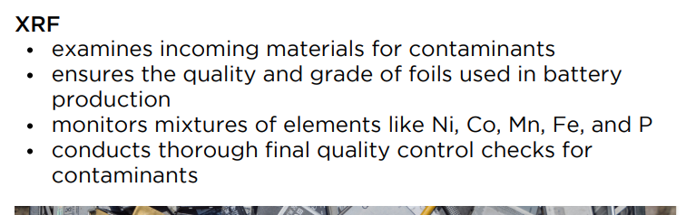 | XRF
 | examines incoming materials for contaminants
 | ensures the quality and grade of foils used in battery production
 | monitors mixtures of elements like Ni, Co, Mn, Fe, and P
 | conducts thorough final quality control checks for contaminants
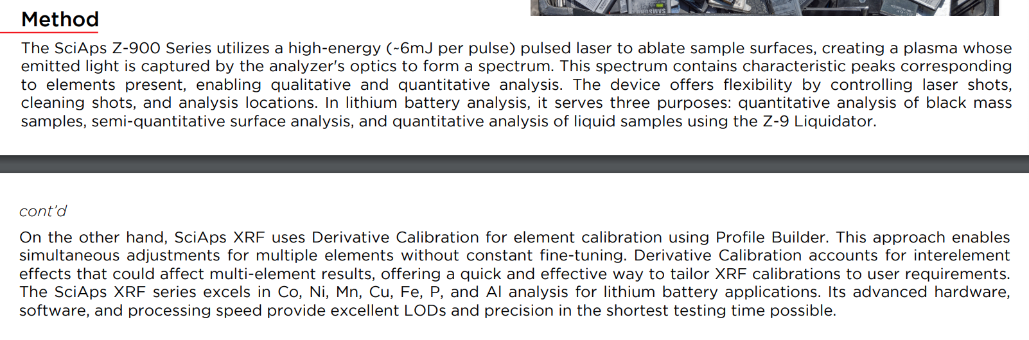  [Cont’d on back page] | Method
 | The SciAps Z-900 Series utilizes a high-energy (~6mJ per pulse) pulsed laser to ablate sample surfaces, creating a plasma whose emitted light is captured by the analyzer's optics to form a spectrum. This spectrum contains characteristic peaks corresponding to elements present, enabling qualitative and quantitative analysis. The device offers flexibility by controlling laser shots, cleaning shots, and analysis locations. In lithium battery analysis, it serves three purposes: quantitative analysis of black mass samples, semi-quantitative surface analysis, and quantitative analysis of liquid samples using the Z-9 Liquidator.
 | On the other hand, SciAps XRF uses Derivative Calibration for element calibration using Profile Builder. This approach enables simultaneous adjustments for multiple elements without constant fine-tuning. Derivative Calibration accounts for interelement effects that could affect multi-element results, offering a quick and effective way to tailor XRF calibrations to user requirements. The SciAps XRF series excels in Co, Ni, Mn, Cu, Fe, P, and Al analysis for lithium battery applications. Its advanced hardware, software, and processing speed provide excellent LODs and precision in the shortest testing time possible.
(BACK)
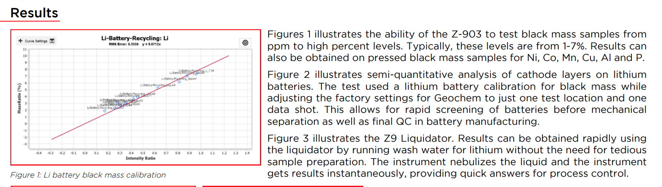 | Results
 | Figures 1 illustrates the ability of the Z-903 to test black mass samples from ppm to high percent levels. Typically, these levels are from 1-7%. Results can also be obtained on pressed black mass samples for Ni, Co, Mn, Cu, Al and P.
 | Figure 2 illustrates semi-quantitative analysis of cathode layers on lithium batteries. The test used a lithium battery calibration for black mass while adjusting the factory settings for Geochem to just one test location and one data shot. This allows for rapid screening of batteries before mechanical separation as well as final QC in battery manufacturing.
 | Figure 3 illustrates the Z9 Liquidator. Results can be obtained rapidly using the liquidator by running wash water for lithium without the need for tedious sample preparation. The instrument nebulizes the liquid and the instrument gets results instantaneously, providing quick answers for process control.
 | Figure 1: Li battery black mass calibration
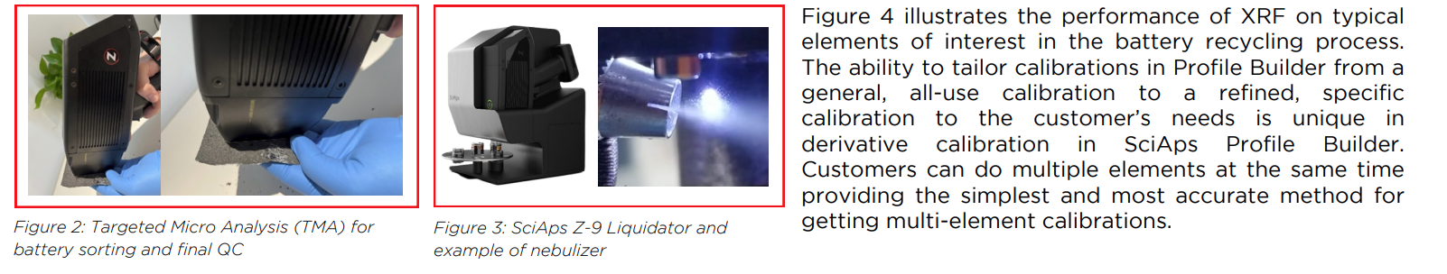 | Figure 4 illustrates the performance of XRF on typical elements of interest in the battery recycling process. The ability to tailor calibrations in Profile Builder from a general, all-use calibration to a refined, specific calibration to the customer’s needs is unique in derivative calibration in SciAps Profile Builder. Customers can do multiple elements at the same time providing the simplest and most accurate method for getting multi-element calibrations.
 | Figure 2: Targeted Micro Analysis (TMA) for battery sorting and final QC
 | Figure 3: SciAps Z-9 Liquidator and example of nebulizer
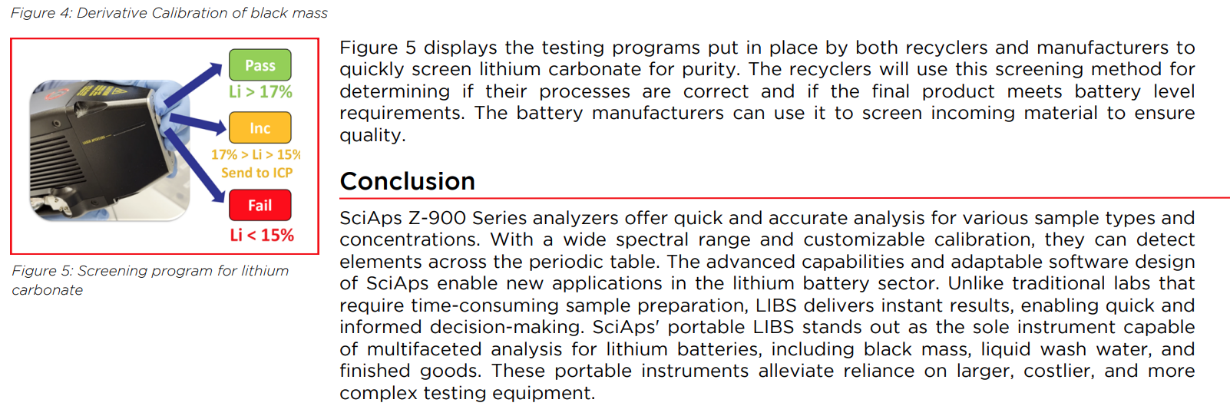 | Figure 4: Derivative Calibration of black mass
 | Figure 5 displays the testing programs put in place by both recyclers and manufacturers to quickly screen lithium carbonate for purity. The recyclers will use this screening method for determining if their processes are correct and if the final product meets battery level requirements. The battery manufacturers can use it to screen incoming material to ensure quality.
 | Figure 5: Screening program for lithium carbonate
 | Conclusion
 | SciAps Z-900 Series analyzers offer quick and accurate analysis for various sample types and concentrations. With a wide spectral range and customizable calibration, they can detect elements across the periodic table. The advanced capabilities and adaptable software design of SciAps enable new applications in the lithium battery sector. Unlike traditional labs that require time-consuming sample preparation, LIBS delivers instant results, enabling quick and informed decision-making. SciAps' portable LIBS stands out as the sole instrument capable of multifaceted analysis for lithium batteries, including black mass, liquid wash water, and finished goods. These portable instruments alleviate reliance on larger, costlier, and more complex testing equipment.
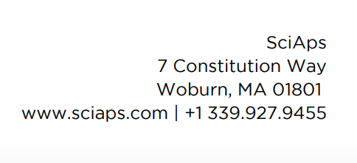 | If applicable, please add:  LOCAL COMPANY NAME  LOCAL WEBSITE  LOCAL PHONE

