Document Title: SciAps Field Guide for Residual Element Analysis
Rev Date: March 2024
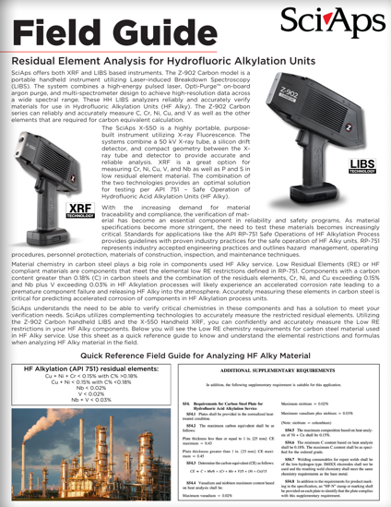
Layout Preview | English Text | Translated Text
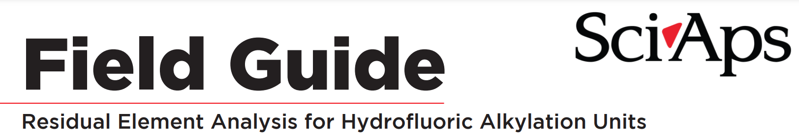 | Field Guide
 | Residual Element Analysis for Hydrofluoric Alkylation Units
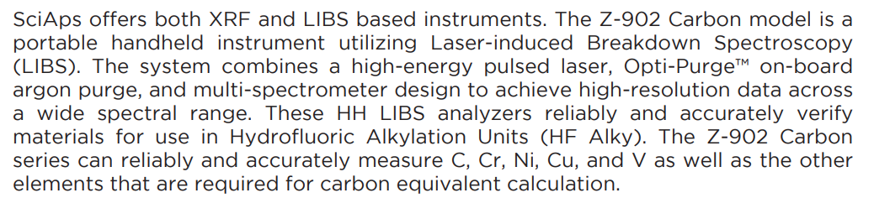 | SciAps offers both XRF and LIBS based instruments. The Z-902 Carbon model is a portable handheld instrument utilizing Laser-induced Breakdown Spectroscopy (LIBS). The system combines a high-energy pulsed laser, Opti-Purge™ on-board argon purge, and multi-spectrometer design to achieve high-resolution data across a wide spectral range. These HH LIBS analyzers reliably and accurately verify materials for use in Hydrofluoric Alkylation Units (HF Alky). The Z-902 Carbon series can reliably and accurately measure C, Cr, Ni, Cu, and V as well as the other elements that are required for carbon equivalent calculation.
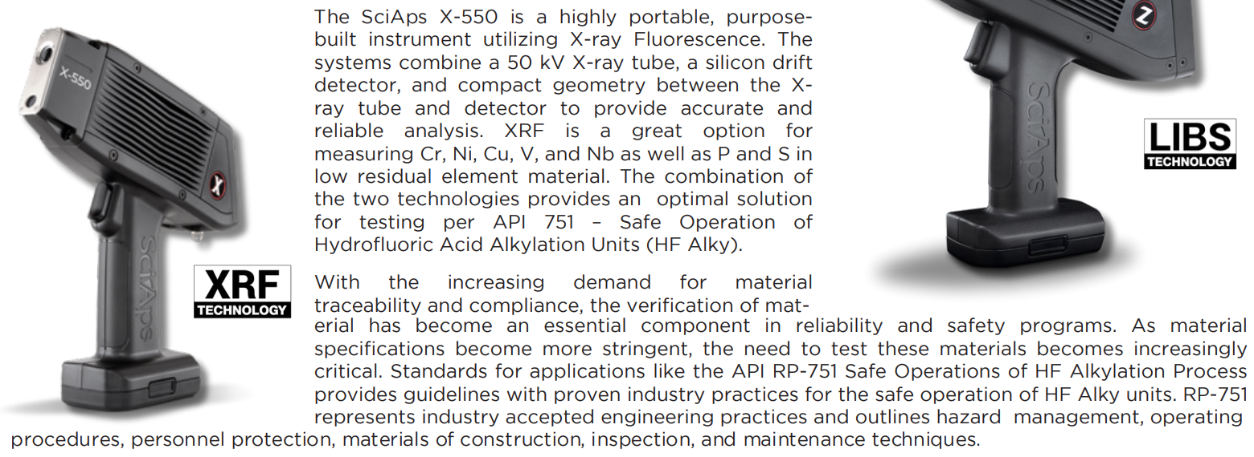 | The SciAps X-550 is a highly portable, purpose- built instrument utilizing X-ray Fluorescence. The systems combine a 50 kV X-ray tube, a silicon drift detector, and compact geometry between the Xray tube and detector to provide accurate and reliable analysis. XRF is a great option for measuring Cr, Ni, Cu, V, and Nb as well as P and S in low residual element material. The combination of the two technologies provides an optimal solution for testing per API 751 – Safe Operation of Hydrofluoric Acid Alkylation Units (HF Alky).
 | With the increasing demand for material traceability and compliance, the verification of mat- erial has become an essential component in reliability and safety programs. As material specifications become more stringent, the need to test these materials becomes increasingly critical. Standards for applications like the API RP-751 Safe Operations of HF Alkylation Process provides guidelines with proven industry practices for the safe operation of HF Alky units. RP-751 represents industry accepted engineering practices and outlines hazard management, operating procedures, personnel protection, materials of construction, inspection, and maintenance techniques.
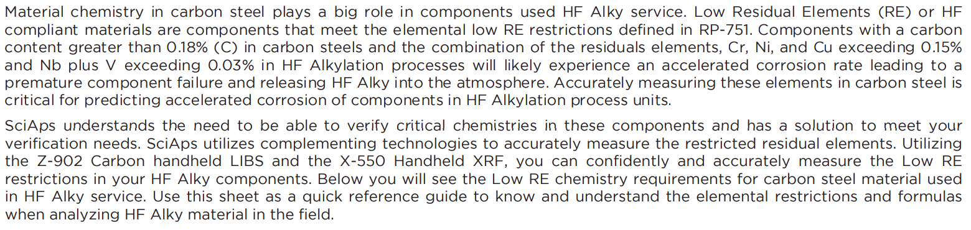 | Material chemistry in carbon steel plays a big role in components used HF Alky service. Low Residual Elements (RE) or HF compliant materials are components that meet the elemental low RE restrictions defined in RP-751. Components with a carbon content greater than 0.18% (C) in carbon steels and the combination of the residuals elements, Cr, Ni, and Cu exceeding 0.15% and Nb plus V exceeding 0.03% in HF Alkylation processes will likely experience an accelerated corrosion rate leading to a premature component failure and releasing HF Alky into the atmosphere. Accurately measuring these elements in carbon steel is critical for predicting accelerated corrosion of components in HF Alkylation process units.
 | SciAps understands the need to be able to verify critical chemistries in these components and has a solution to meet your verification needs. SciAps utilizes complementing technologies to accurately measure the restricted residual elements. Utilizing the Z-902 Carbon handheld LIBS and the X-550 Handheld XRF, you can confidently and accurately measure the Low RE restrictions in your HF Alky components. Below you will see the Low RE chemistry requirements for carbon steel material used in HF Alky service. Use this sheet as a quick reference guide to know and understand the elemental restrictions and formulas when analyzing HF Alky material in the field.
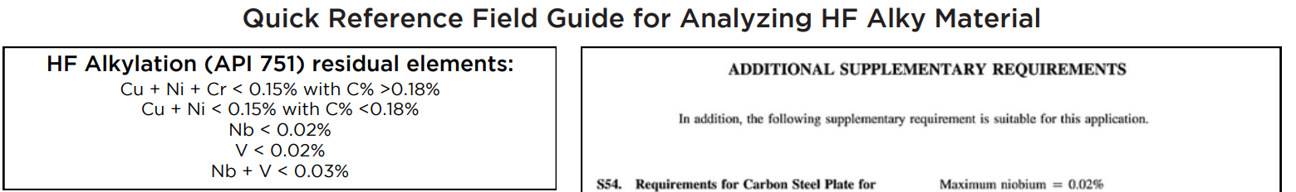 | Quick Reference Field Guide for Analyzing HF Alky Material
 | HF Alkylation (API 751) residual elements:
 | Cu + Ni + Cr < 0.15% with C% >0.18%
 | Cu + Ni < 0.15% with C% <0.18%
 | Nb < 0.02%
 | V < 0.02%
 | Nb + V < 0.03%
[Back]
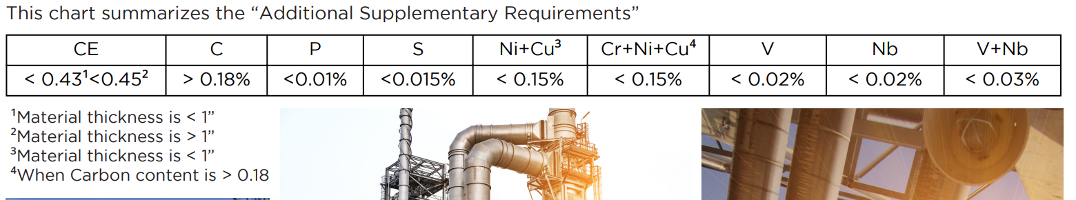 | This chart summarizes the “Additional Supplementary Requirements”
 | CE
 | < 0.43¹<0.45²
 | C
 | > 0.18%
 | P
 | <0.01%
 | S
 | <0.015%
 | Ni+Cu³
 | < 0.15%
 | Cr+Ni+Cu⁴
 | < 0.15%
 | V
 | < 0.02%
 | Nb
 | < 0.02%
 | V+Nb
 | < 0.03%
 | ¹Material thickness is < 1”
 | ²Material thickness is > 1”
 | ³Material thickness is < 1”
 | ⁴When Carbon content is > 0.18
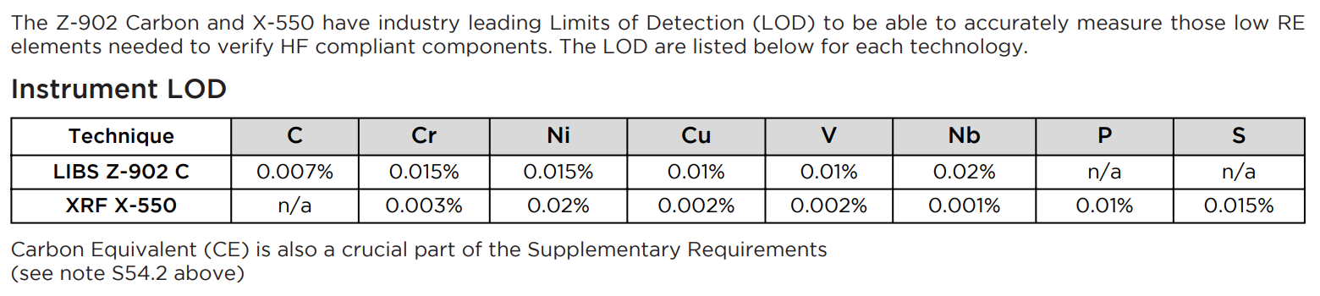 | The Z-902 Carbon and X-550 have industry leading Limits of Detection (LOD) to be able to accurately measure those low RE elements needed to verify HF compliant components. The LOD are listed below for each technology.
 | Instrument LOD
 | Technique
 | LIBS Z-902 C
 | XRF X-550
 | C
 | 0.007%
 | n/a
 | Cr
 | 0.015%
 | 0.003%
 | Ni
 | 0.015%
 | 0.02%
 | Cu
 | 0.01%
 | 0.002%
 | V
 | 0.01%
 | 0.002%
 | Nb
 | 0.02%
 | 0.001%
 | P
 | n/a
 | 0.01%
 | S
 | n/a
 | 0.015%
 | Carbon Equivalent (CE) is also a crucial part of the Supplementary Requirements
 | (see note S54.2 above)
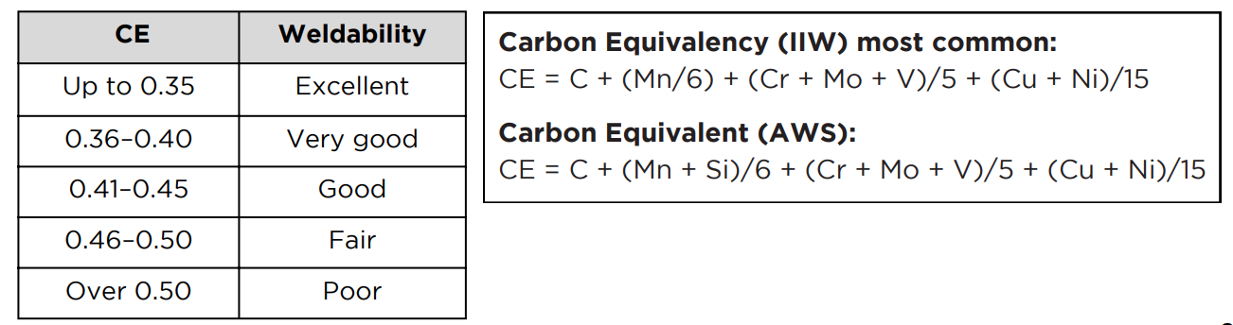 | CE
 | Weldability
 | Up to 0.35
 | 0.36–0.40
 | 0.41–0.45
 | 0.46–0.50
 | Over 0.50
 | Excellent
 | Very good
 | Good
 | Fair
 | Poor
 | Carbon Equivalency (IIW) most common:
 | CE = C + (Mn/6) + (Cr + Mo + V)/5 + (Cu + Ni)/15
 | Carbon Equivalent (AWS):
 | CE = C + (Mn + Si)/6 + (Cr + Mo + V)/5 + (Cu + Ni)/15
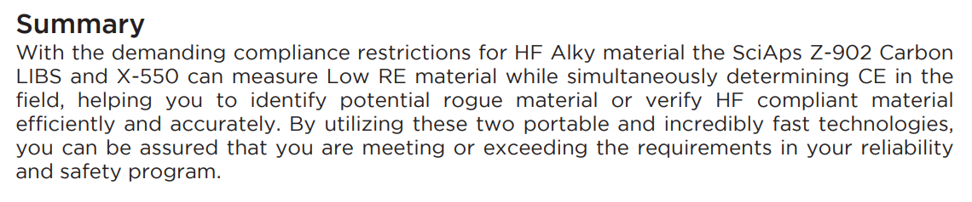 | Summary
 | With the demanding compliance restrictions for HF Alky material the SciAps Z-902 Carbon LIBS and X-550 can measure Low RE material while simultaneously determining CE in the field, helping you to identify potential rogue material or verify HF compliant material efficiently and accurately. By utilizing these two portable and incredibly fast technologies, you can be assured that you are meeting or exceeding the requirements in your reliability and safety program.
 | If applicable, please add:  LOCAL COMPANY NAME  LOCAL WEBSITE  LOCAL PHONE
 | YouTube.com/SciAps

