Document Title: SciAps RoHS Brochure
Rev Date: March 2024
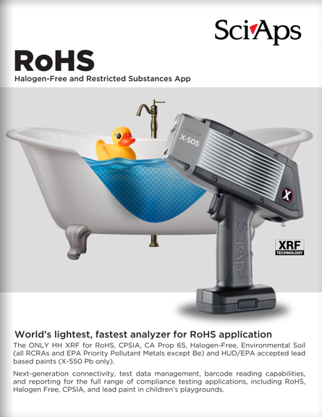
Layout Preview | English Text | Translated Text
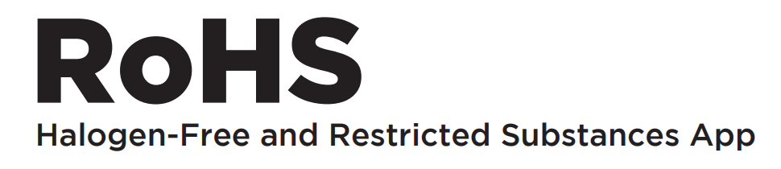 | RoHS
 | Halogen-Free and Restricted Substances App
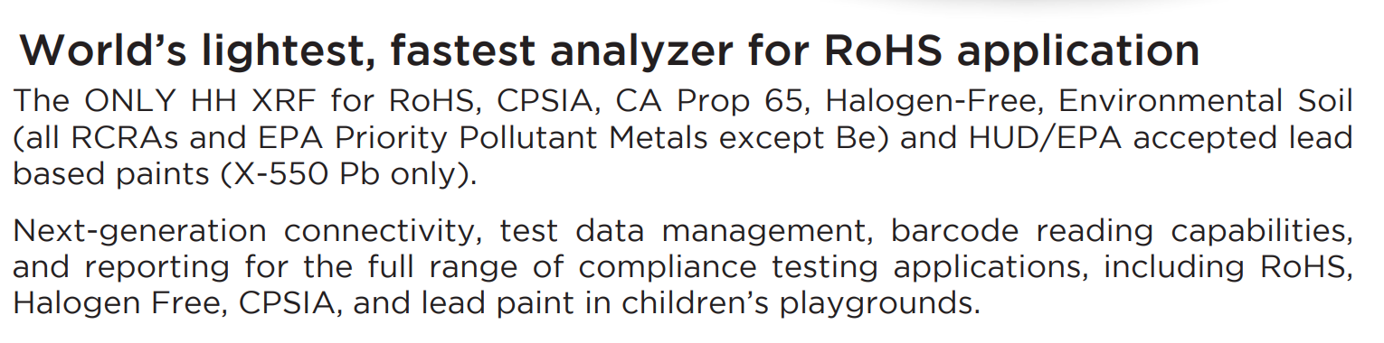 | World’s lightest, fastest analyzer for RoHS application
 | The ONLY HH XRF for RoHS, CPSIA, CA Prop 65, Halogen-Free, Environmental Soil (all RCRAs and EPA Priority Pollutant Metals except Be) and HUD/EPA accepted lead based paints (X-550 Pb only).
 | Next-generation connectivity, test data management, barcode reading capabilities, and reporting for the full range of compliance testing applications, including RoHS, Halogen Free, CPSIA, and lead paint in children’s playgrounds.
[page 2]
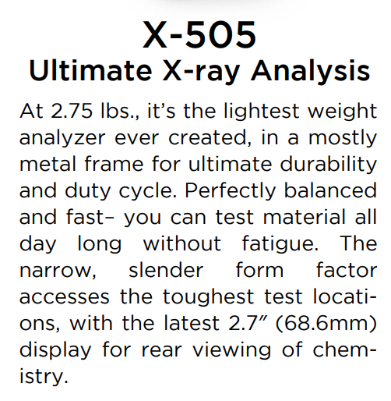 | X-505
 | Ultimate X-ray Analysis
 | At 2.75 lbs., it’s the lightest weight analyzer ever created, in a mostly metal frame for ultimate durability and duty cycle. Perfectly balanced and fast– you can test material all day long without fatigue. The narrow, slender form factor accesses the toughest test locations, with the latest 2.7″ (68.6mm) display for rear viewing of chemistry.
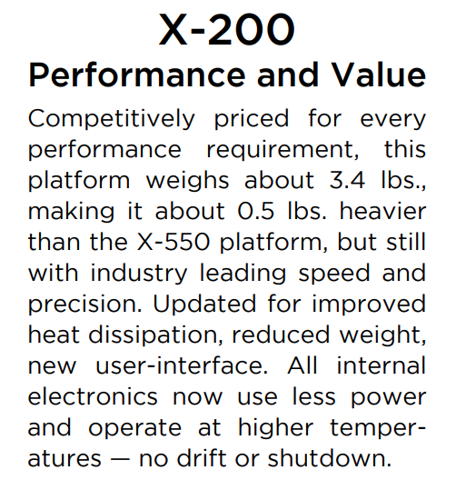 | X-200
 | Performance and Value
 | Competitively priced for every performance requirement, this platform weighs about 3.4 lbs., making it about 0.5 lbs. heavier than the X-550 platform, but still with industry leading speed and precision. Updated for improved heat dissipation, reduced weight, new user-interface. All internal electronics now use less power and operate at higher temperatures — no drift or shutdown.
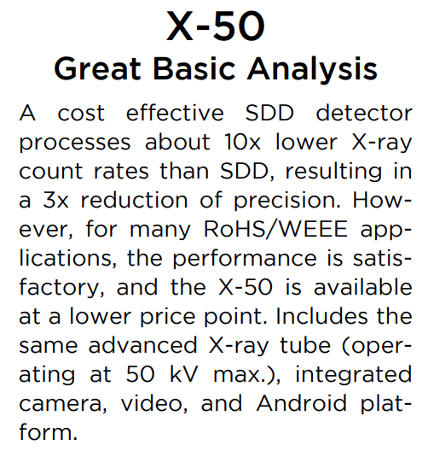 | X-50
 | Great Basic Analysis
 | A cost effective SDD detector processes about 10x lower X-ray count rates than SDD, resulting in a 3x reduction of precision. However, for many RoHS/WEEE applications, the performance is satisfactory, and the X-50 is available at a lower price point. Includes the same advanced X-ray tube (operating at 50 kV max.), integrated camera, video, and Android platform.
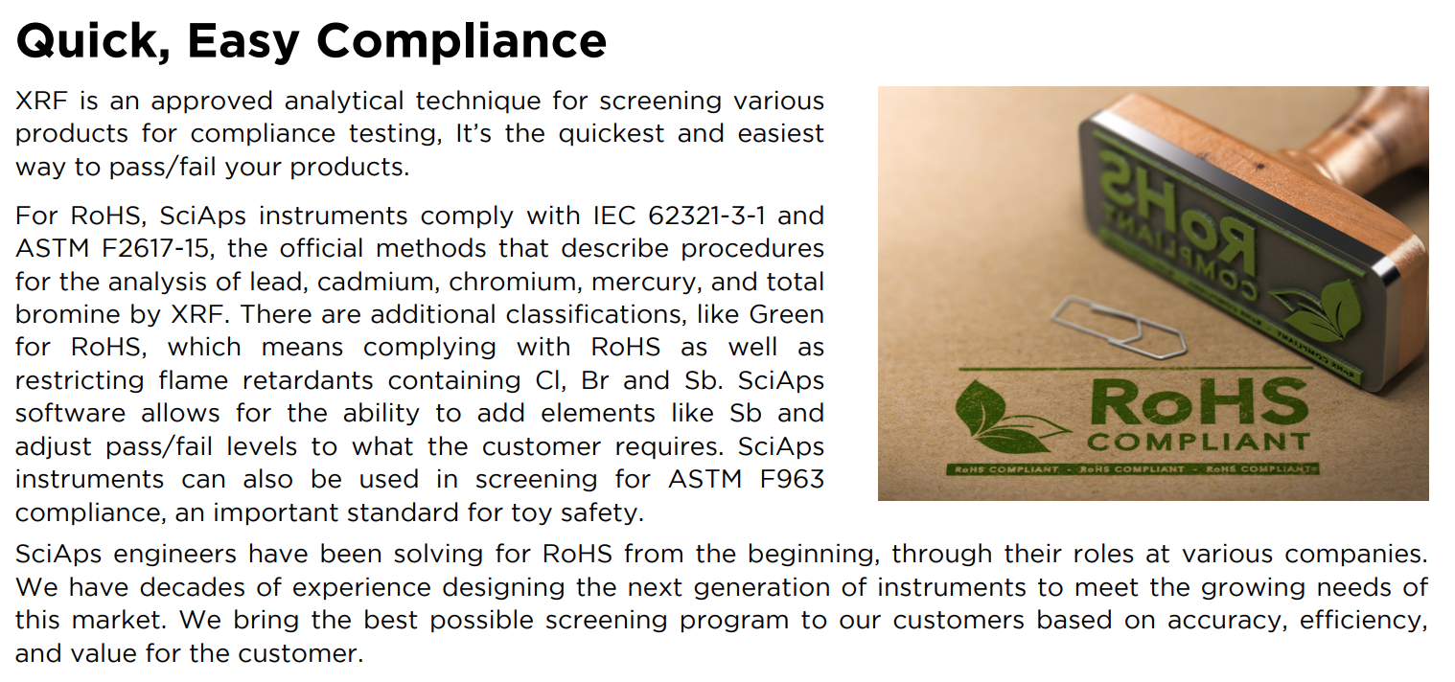 | Quick, Easy Compliance
 | XRF is an approved analytical technique for screening various products for compliance testing, It’s the quickest and easiest way to pass/fail your products.
 | For RoHS, SciAps instruments comply with IEC 62321-3-1 and ASTM F2617-15, the official methods that describe procedures for the analysis of lead, cadmium, chromium, mercury, and total bromine by XRF. There are additional classifications, like Green for RoHS, which means complying with RoHS as well as restricting flame retardants containing Cl, Br and Sb. SciAps software allows for the ability to add elements like Sb and adjust pass/fail levels to what the customer requires. SciAps instruments can also be used in screening for ASTM F963 compliance, an important standard for toy safety.
 | SciAps engineers have been solving for RoHS from the beginning, through their roles at various companies. We have decades of experience designing the next generation of instruments to meet the growing needs of this market. We bring the best possible screening program to our customers based on accuracy, efficiency, and value for the customer.
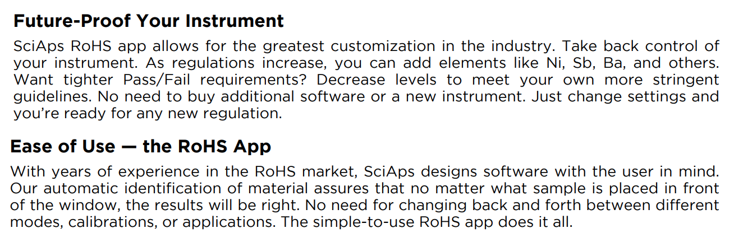 | Future-Proof Your Instrument
 | SciAps RoHS app allows for the greatest customization in the industry. Take back control of your instrument. As regulations increase, you can add elements like Ni, Sb, Ba, and others. Want tighter Pass/Fail requirements? Decrease levels to meet your own more stringent guidelines. No need to buy additional software or a new instrument. Just change settings and you’re ready for any new regulation.
 | Ease of Use — the RoHS App
 | With years of experience in the RoHS market, SciAps designs software with the user in mind. Our automatic identification of material assures that no matter what sample is placed in front of the window, the results will be right. No need for changing back and forth between different modes, calibrations, or applications. The simple-to-use RoHS app does it all.
[page 3]
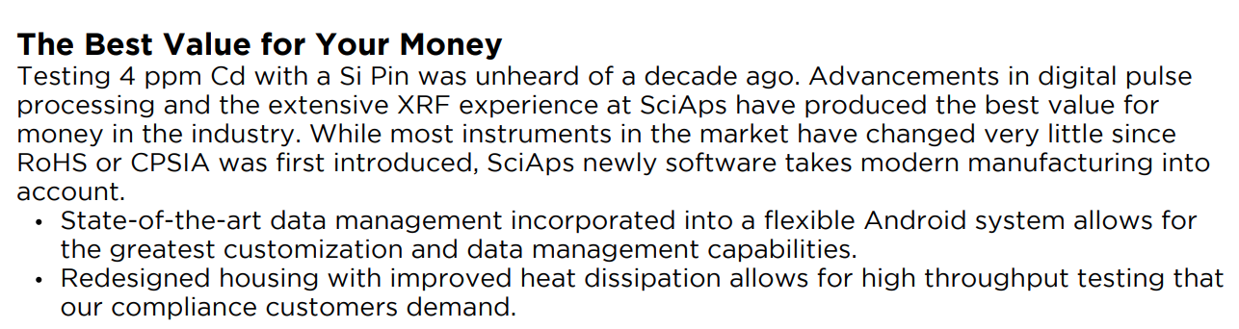 | The Best Value for Your Money
 | Testing 4 ppm Cd with a Si Pin was unheard of a decade ago. Advancements in digital pulse processing and the extensive XRF experience at SciAps have produced the best value for money in the industry. While most instruments in the market have changed very little since RoHS or CPSIA was first introduced, SciAps newly software takes modern manufacturing into account.
 | State-of-the-art data management incorporated into a flexible Android system allows for the greatest customization and data management capabilities
 | Redesigned housing with improved heat dissipation allows for high throughput testing that our compliance customers demand.
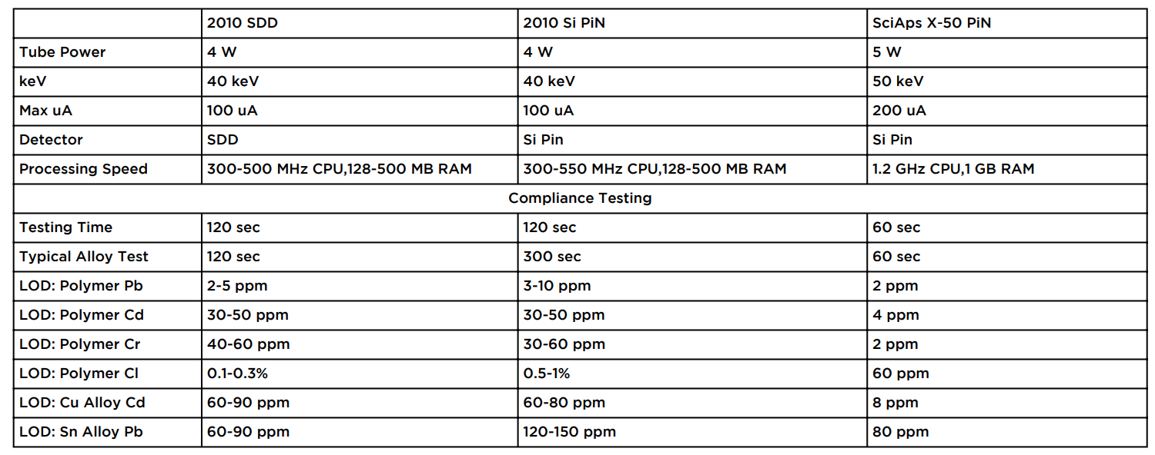 | 2010 SDD
 | 2010 Si PiN
 | SciAps X-50 PiN
 | Tube Power
 | 4 W
 | 4 W
 | 5 W
 | keV
 | 40 keV
 | 40 keV
 | 50 keV
 | Max uA
 | 100 uA
 | 100 uA
 | 200 uA
 | Detector
 | SDD
 | Si Pin
 | Si Pin
 | Processing Speed
 | 300-500 MHz CPU,128-500 MB RAM
 | 300-550 MHz CPU,128-500 MB RAM
 | 1.2 GHz CPU,1 GB RAM
 | Compliance Testing
 | Testing Time
 | 120 sec
 | 120 sec
 | 60 sec
 | Typical Alloy Test
 | 120 sec
 | 300 sec
 | 60 sec
 | LOD: Polymer Pb
 | 2-5 ppm
 | 3-10 ppm
 | 2 ppm
 | LOD: Polymer Cd
 | 30-50 ppm
 | 30-50 ppm
 | 4 ppm
 | LOD: Polymer Cr
 | 40-60 ppm
 | 30-60 ppm
 | 2 ppm
 | LOD: Polymer Cl
 | 0.1-0.3%
 | 0.5-1%
 | 60 ppm
 | LOD: Cu Alloy Cd
 | 60-90 ppm
 | 60-80 ppm
 | 8 ppm
 | LOD: Sn Alloy Pb
 | 60-90 ppm
 | 120-150 ppm
 | 80 ppm
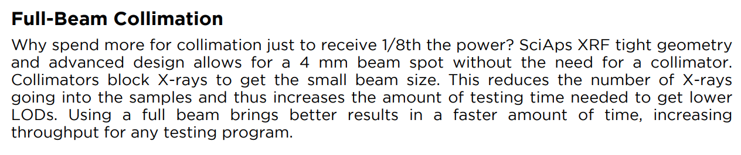 | Full-Beam Collimation
 | Why spend more for collimation just to receive 1/8th the power? SciAps XRF tight geometry and advanced design allows for a 4 mm beam spot without the need for a collimator. Collimators block X-rays to get the small beam size. This reduces the number of X-rays going into the samples and thus increases the amount of testing time needed to get lower LODs. Using a full beam brings better results in a faster amount of time, increasing throughput for any testing program.
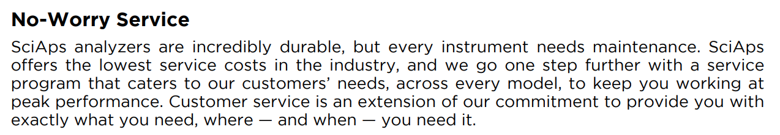 | No-Worry Service
 | SciAps analyzers are incredibly durable, but every instrument needs maintenance. SciAps offers the lowest service costs in the industry, and we go one step further with a service program that caters to our customers’ needs, across every model, to keep you working at peak performance. Customer service is an extension of our commitment to provide you with exactly what you need, where — and when — you need it.
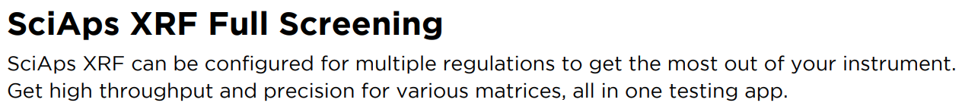 | SciAps XRF Full Screening
 | SciAps XRF can be configured for multiple regulations to get the most out of your instrument. Get high throughput and precision for various matrices, all in one testing app.
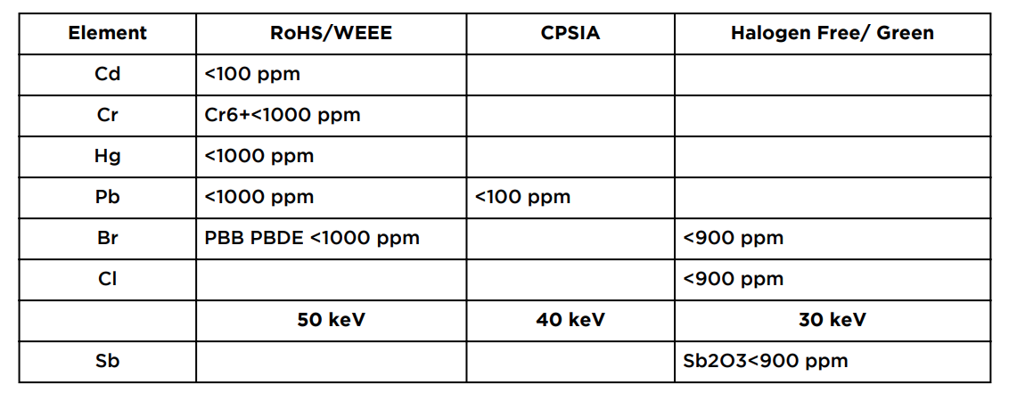 | Element
 | RoHS/WEEE
 | CPSIA
 | Halogen Free/ Green
 | Cd
 | <100 ppm
 | Cr
 | Cr6+<1000 ppm
 | Hg
 | <1000 ppm
 | Pb
 | <1000 ppm
 | <100 ppm
 | Br
 | PBB PBDE <1000 ppm
 | <900 ppm
 | Cl
 | <900 ppm
 | 50 keV
 | 40 keV
 | 30 keV
 | Sb
 | Sb2O3 <900 ppm
[page 4]
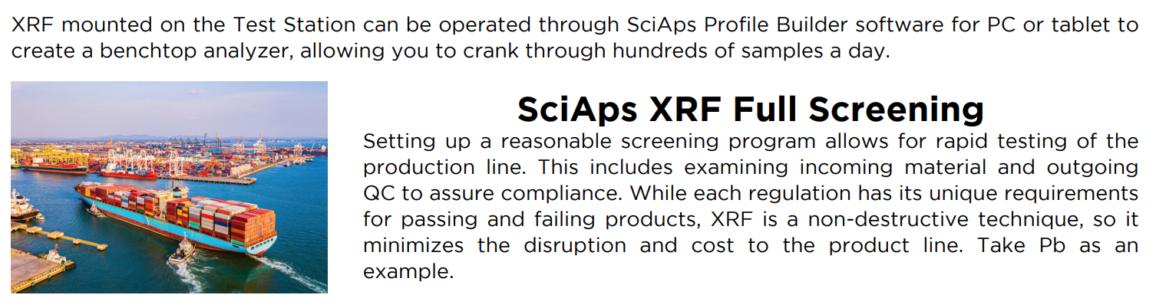 | XRF mounted on the Test Station can be operated through SciAps Profile Builder software for PC or tablet to create a benchtop analyzer, allowing you to crank through hundreds of samples a day.
 | SciAps XRF Full Screening
 | Setting up a reasonable screening program allows for rapid testing of the production line. This includes examining incoming material and outgoing QC to assure compliance. While each regulation has its unique requirements for passing and failing products, XRF is a non-destructive technique, so it minimizes the disruption and cost to the product line. Take Pb as an example.
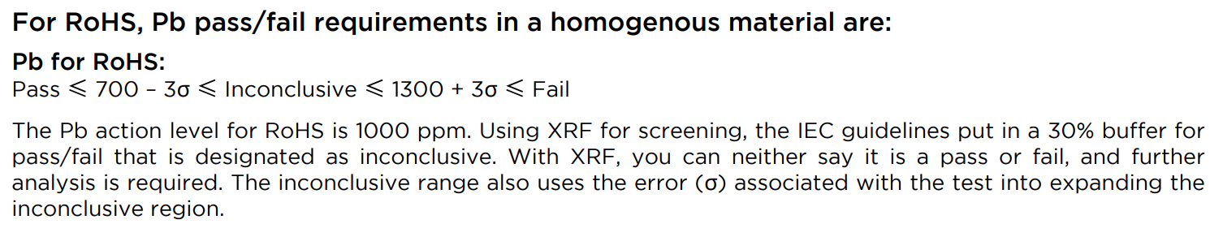 | For RoHS, Pb pass/fail requirements in a homogenous material are:
 | Pb for RoHS:
 | Pass ≤ 700 – 3σ ≤ Inconclusive ≤ 1300 + 3σ ≤ Fail
 | The Pb action level for RoHS is 1000 ppm. Using XRF for screening, the IEC guidelines put in a 30% buffer for pass/fail that is designated as inconclusive. With XRF, you can neither say it is a pass or fail, and further analysis is required. The inconclusive range also uses the error (σ) associated with the test into expanding the inconclusive region.
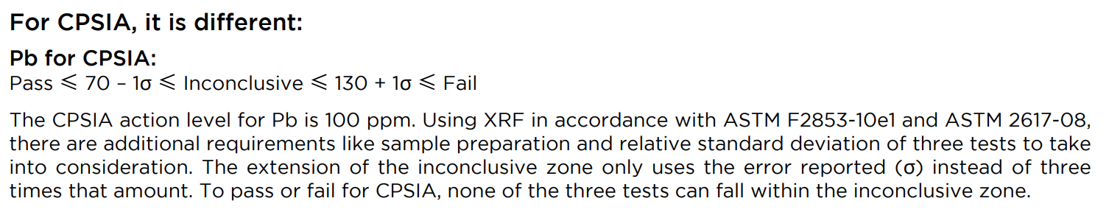 | For CPSIA, it is different:
 | Pb for CPSIA:
 | Pass ≤ 70 – 1σ ≤ Inconclusive ≤ 130 + 1σ ≤ Fail
 | The CPSIA action level for Pb is 100 ppm. Using XRF in accordance with ASTM F2853-10e1 and ASTM 2617-08, there are additional requirements like sample preparation and relative standard deviation of three tests to take into consideration. The extension of the inconclusive zone only uses the error reported (σ) instead of three times that amount. To pass or fail for CPSIA, none of the three tests can fall within the inconclusive zone.
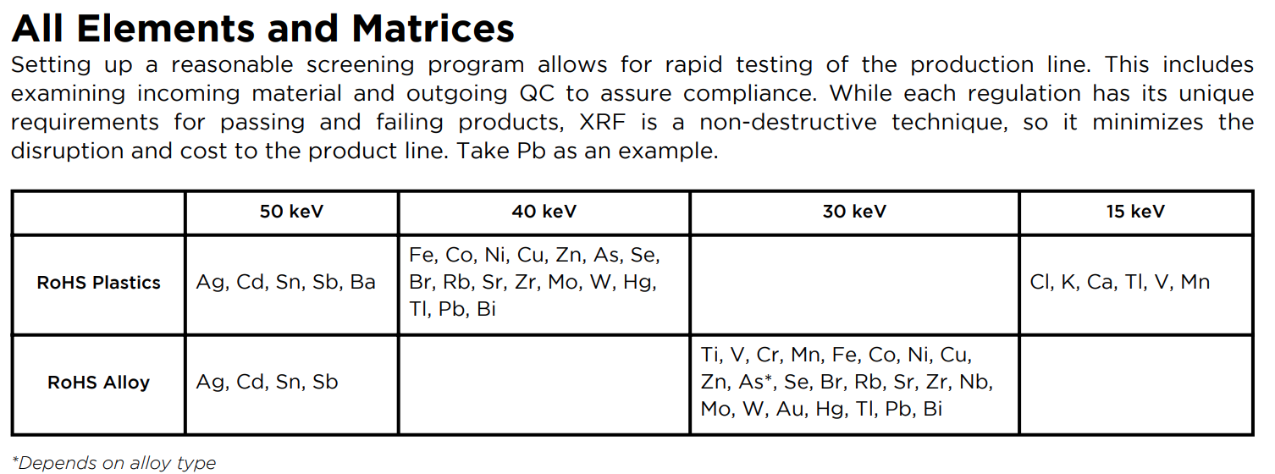 | All Elements and Matrices
 | Setting up a reasonable screening program allows for rapid testing of the production line. This includes examining incoming material and outgoing QC to assure compliance. While each regulation has its unique requirements for passing and failing products, XRF is a non-destructive technique, so it minimizes the disruption and cost to the product line. Take Pb as an example.
 | 50 keV
 | 40 keV
 | 30 keV
 | 15 keV
 | RoHS Plastics
 | Ag, Cd, Sn, Sb, Ba
 | Fe, Co, Ni, Cu, Zn, As, Se, Br, Rb, Sr, Zr, Mo, W, Hg, Tl, Pb, Bi
 | Cl, K, Ca, Tl, V, Mn
 | RoHS Alloy
 | Ag, Cd, Sn, Sb
 | Ti, V, Cr, Mn, Fe, Co, Ni, Cu, Zn, As*, Se, Br, Rb, Sr, Zr, Nb, Mo, W, Au, Hg, Tl, Pb, Bi
 | *Depends on alloy type
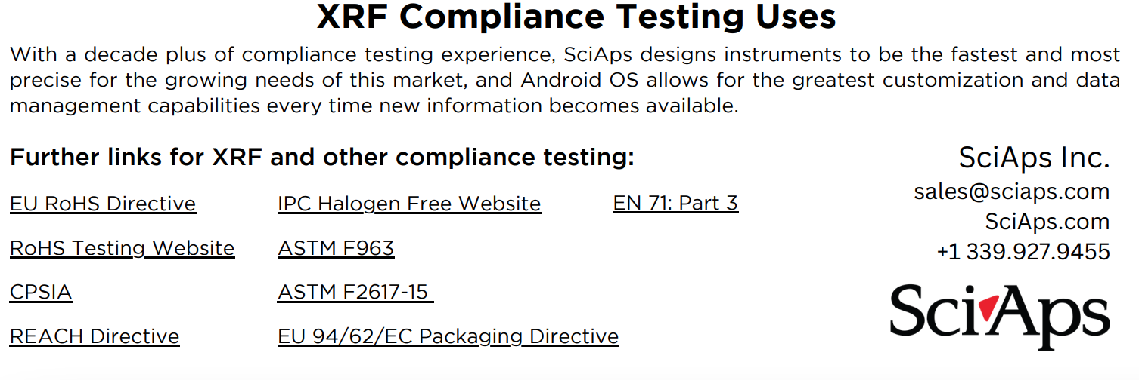 | XRF Compliance Testing Uses
 | With a decade plus of compliance testing experience, SciAps designs instruments to be the fastest and most precise for the growing needs of this market, and Android OS allows for the greatest customization and data management capabilities every time new information becomes available.
 | Further links for XRF and other compliance testing:
 | EU RoHS Directive
 | IPC Halogen Free Website
 | EN 71: Part 3
 | RoHS Testing Website
 | ASTM F963
 | CPSIA
 | ASTM F2617-15
 | REACH Directive
 | EU 94/62/EC Packaging Directive
If applicable, please add:
LOCAL COMPANY NAME
LOCAL WEBSITE
LOCAL PHONE

