Document Title: SciAps Groundbreaking X-555
Rev Date:
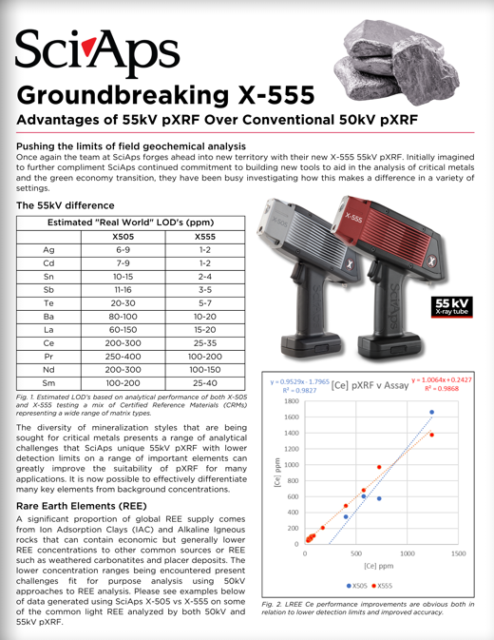
Layout Preview | English Text | Translated Text
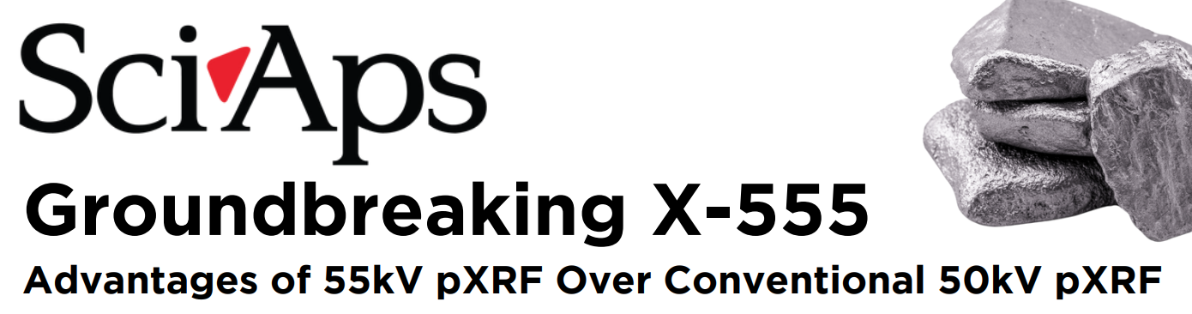 | SciAps
 | Groundbreaking X-555
 | Advantages of 55kV pXRF Over Conventional 50kV pXRF
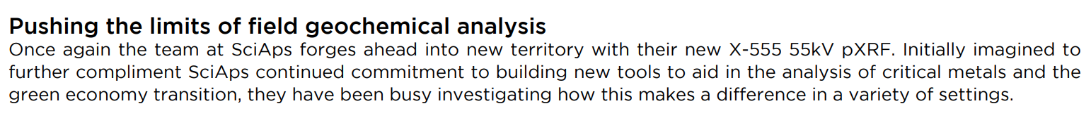 | Pushing the limits of field geochemical analysis
 | Once again the team at SciAps forges ahead into new territory with their new X-555 55kV pXRF. Initially imagined to further compliment SciAps continued commitment to building new tools to aid in the analysis of critical metals and the green economy transition, they have been busy investigating how this makes a difference in a variety of settings.
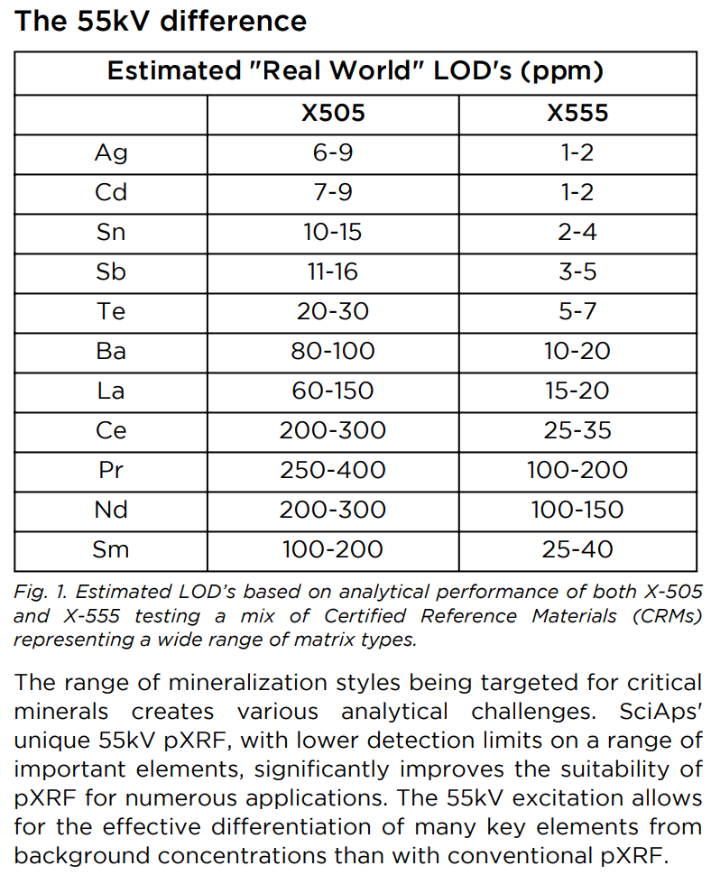 | The 55kV difference
 | Estimated "Real World" LOD's (ppm)
 | X505
 | X555
 | Ag
 | 6-9
 | 1-2
 | Cd
 | 7-9
 | 1-2
 | Sn
 | 10-15
 | 2-4
 | Sb
 | 11-16
 | 3-5
 | Te
 | 20-30
 | 5-7
 | Ba
 | 80-100
 | 10-20
 | La
 | 60-150
 | 15-20
 | Ce
 | 200-300
 | 25-35
 | Pr
 | 250-400
 | 100-200
 | Nd
 | 200-300
 | 100-150
 | Sm
 | 100-200
 | 25-40
 | Fig. 1. Estimated LOD’s based on analytical performance of both X-505 and X-555 testing a mix of Certified Reference Materials (CRMs) representing a wide range of matrix types.
 | The range of mineralization styles being targeted for critical minerals creates various analytical challenges. SciAps unique 55kV pXRF, with lower detection limits on a range of important elements, significantly improves the suitability of pXRF for numerous applications. The 55kV excitation allows for the effective differentiation of many key elements from background concentrations than with conventional pXRF.
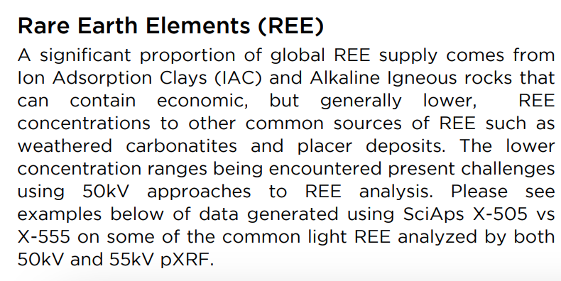 | Rare Earth Elements (REE)
 | A significant proportion of global REE supply comes from Ion Adsorption Clays (IAC) and Alkaline Igneous rocks that can contain economic, but generally lower, REE concentrations to other common sources of REE such as weathered carbonatites and placer deposits. The lower concentration ranges being encountered present challenges using 50kV approaches to REE analysis. Please see examples below of data generated using SciAps X-505 vs X-555 on some of the common light REE analyzed by both 50kV and 55kV pXRF.
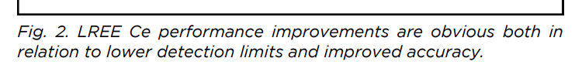 | Fig. 2. LREE Ce performance improvements are obvious both in relation to lower detection limits and improved accuracy.
(BACK)
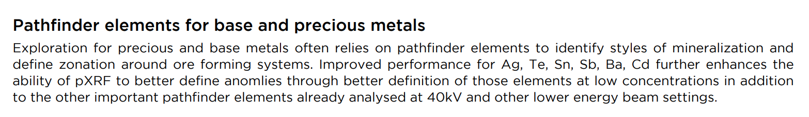 | Pathfinder elements for base and precious metals
 | Exploration for precious and base metals often relies on pathfinder elements to identify styles of mineralization and define zonation around ore forming systems. Improved performance for Ag, Te, Sn, Sb, Ba, Cd further enhances the ability of pXRF to better define anomalies through better definition of those elements at low concentrations in addition to the other important pathfinder elements already analysed at 40kV and other lower energy beam settings.
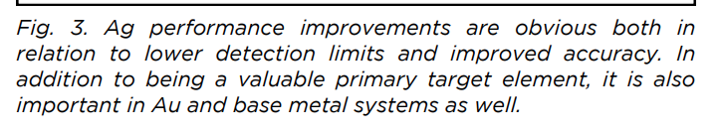 | Fig. 3. Ag performance improvements are obvious both in relation to lower detection limits and improved accuracy. In addition to being a valuable primary target element, it is also important in Au and base metal systems as well.
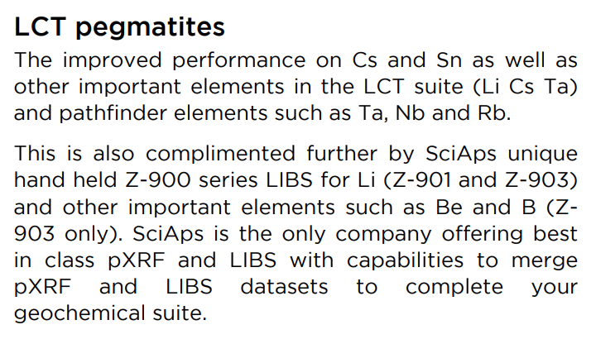 | LCT pegmatites
 | The improved performance on Cs and Sn as well as other important elements in the LCT suite (Li Cs Ta) and pathfinder elements such as Ta, Nb and Rb.
 | This is also complimented further by SciAps unique handheld Z-900 series LIBS for Li (Z-901 and Z-903) and other important elements such as Be and B (Z903 only). SciAps is the only company offering best in class pXRF and LIBS with capabilities to merge pXRF and LIBS datasets to complete your geochemical suite.
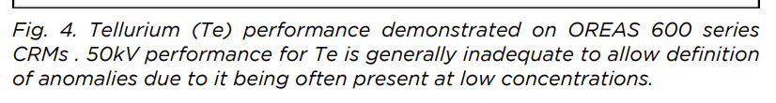 | Fig. 4. Tellurium (Te) performance demonstrated on OREAS 600 series CRMs. 50kV performance for Te is generally inadequate to allow definition of anomalies due to it being often present at low concentrations.
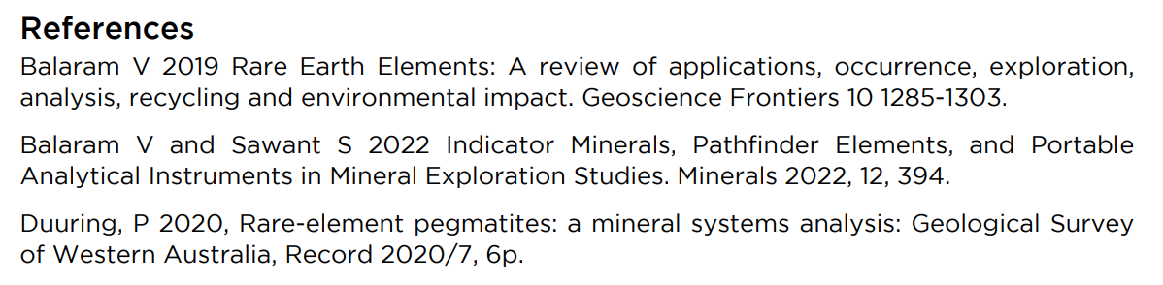 | References
 | Balaram V 2019 Rare Earth Elements: A review of applications, occurrence, exploration, analysis, recycling and environmental impact. Geoscience Frontiers 10 1285-1303.
 | Balaram V and Sawant S 2022 Indicator Minerals, Pathfinder Elements, and Portable Analytical Instruments in Mineral Exploration Studies. Minerals 2022, 12, 394.
 | Duuring, P 2020, Rare-element pegmatites: a mineral systems analysis: Geological Survey of Western Australia, Record 2020/7, 6p.
 | YouTube.com/SciAps
 | If applicable, please add:  LOCAL COMPANY NAME  LOCAL WEBSITE  LOCAL PHONE

