Document Title: SciAps ApNote In-field, Handheld XRF for Lead Exposure from Underground and Underwater Communications Cables
Rev Date: March 2024
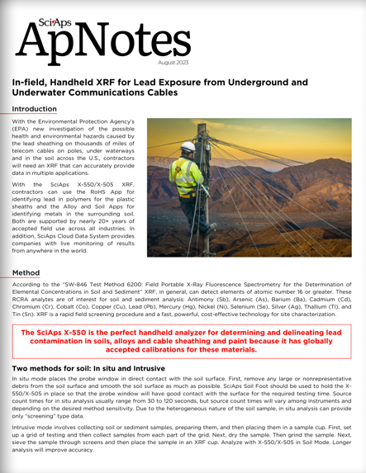
Layout Preview | English Text | Translated Text
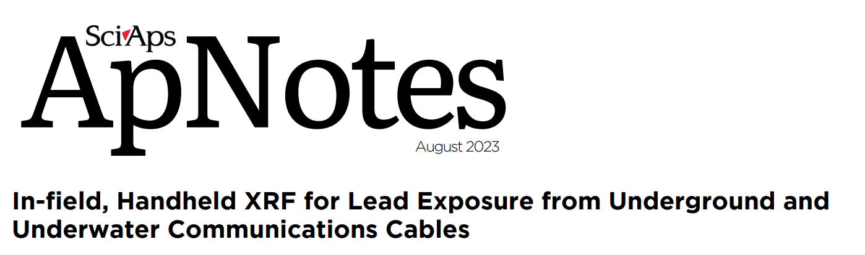 | SciAps
 | ApNotes
 | August 2023
 | In-field, Handheld XRF for Lead Exposure from Underground and Underwater Communications Cables
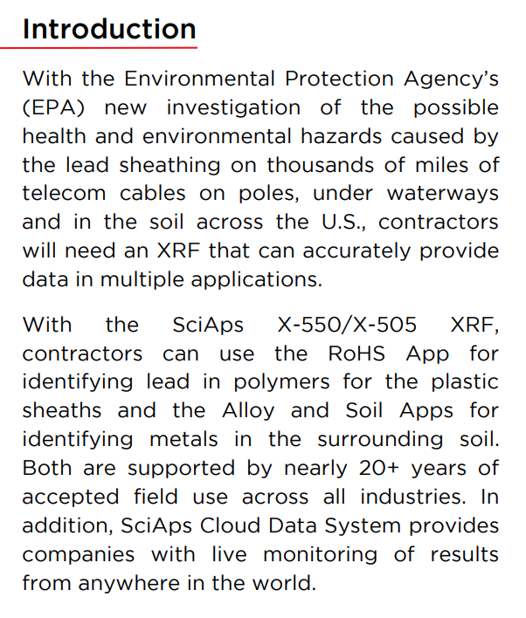 | Introduction
 | With the Environmental Protection Agency’s (EPA) new investigation of the possible health and environmental hazards caused by the lead sheathing on thousands of miles of telecom cables on poles, under waterways and in the soil across the U.S., contractors will need an XRF that can accurately provide data in multiple applications.
 | With the SciAps X-550/X-505 XRF, contractors can use the RoHS App for identifying lead in polymers for the plastic sheaths and the Alloy and Soil Apps for identifying metals in the surrounding soil. Both are supported by nearly 20+ years of accepted field use across all industries. In addition, SciAps Cloud Data System provides companies with live monitoring of results from anywhere in the world.
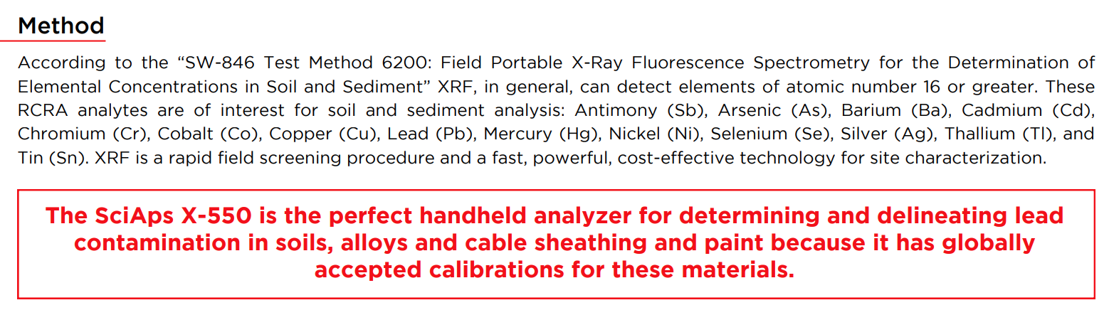 | Method
 | According to the “SW-846 Test Method 6200: Field Portable X-Ray Fluorescence Spectrometry for the Determination of Elemental Concentrations in Soil and Sediment” XRF, in general, can detect elements of atomic number 16 or greater. These RCRA analytes are of interest for soil and sediment analysis: Antimony (Sb), Arsenic (As), Barium (Ba), Cadmium (Cd), Chromium (Cr), Cobalt (Co), Copper (Cu), Lead (Pb), Mercury (Hg), Nickel (Ni), Selenium (Se), Silver (Ag), Thallium (Tl), and Tin (Sn). XRF is a rapid field screening procedure and a fast, powerful, cost-effective technology for site characterization.
 | The SciAps X-550 is the perfect handheld analyzer for determining and delineating lead contamination in soils, alloys and cable sheathing and paint because it has globally accepted calibrations for these materials.
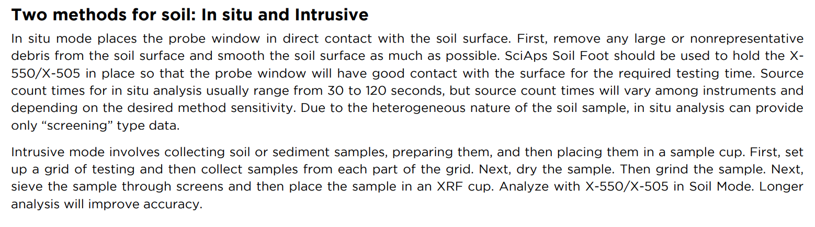 | Two methods for soil: In situ and Intrusive
 | In situ mode places the probe window in direct contact with the soil surface. First, remove any large or nonrepresentative debris from the soil surface and smooth the soil surface as much as possible. SciAps Soil Foot should be used to hold the X550/X-505 in place so that the probe window will have good contact with the surface for the required testing time. Source count times for in situ analysis usually range from 30 to 120 seconds, but source count times will vary among instruments and depending on the desired method sensitivity. Due to the heterogeneous nature of the soil sample, in situ analysis can provide only “screening” type data.
 | Intrusive mode involves collecting soil or sediment samples, preparing them, and then placing them in a sample cup. First, set up a grid of testing and then collect samples from each part of the grid. Next, dry the sample. Then grind the sample. Next, sieve the sample through screens and then place the sample in an XRF cup. Analyze with X-550/X-505 in Soil Mode. Longer analysis will improve accuracy.
(BACK)
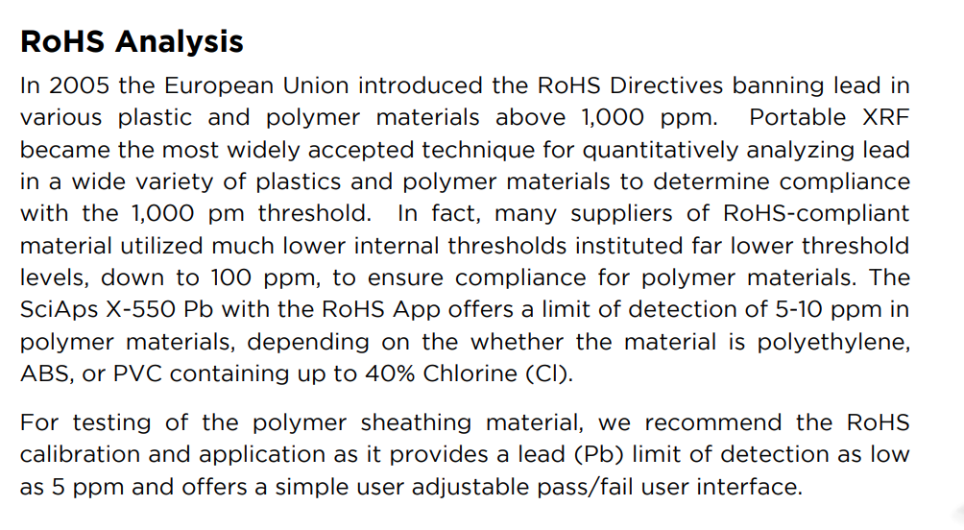 | RoHS Analysis
 | In 2005 the European Union introduced the RoHS Directives banning lead in various plastic and polymer materials above 1,000 ppm. Portable XRF became the most widely accepted technique for quantitatively analyzing lead in a wide variety of plastics and polymer materials to determine compliance with the 1,000 pm threshold. In fact, many suppliers of RoHS-compliant material utilized much lower internal thresholds instituted far lower threshold levels, down to 100 ppm, to ensure compliance for polymer materials. The SciAps X-550 Pb with the RoHS App offers a limit of detection of 5-10 ppm in polymer materials, depending on the whether the material is polyethylene, ABS, or PVC containing up to 40% Chlorine (Cl).
 | For testing of the polymer sheathing material, we recommend the RoHS calibration and application as it provides a lead (Pb) limit of detection as low as 5 ppm and offers a simple user adjustable pass/fail user interface.
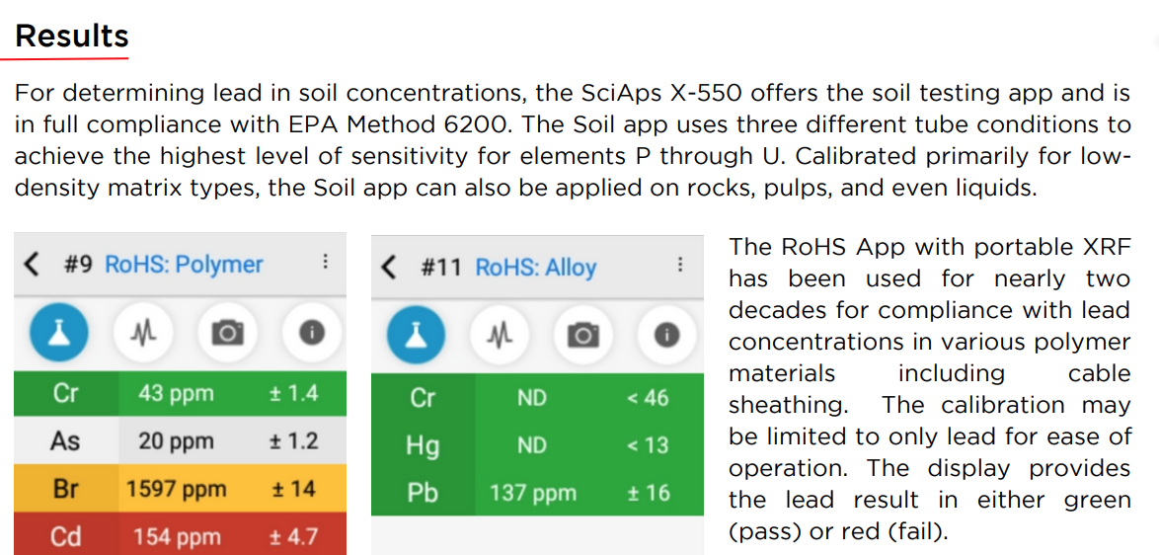 | Results
 | For determining lead in soil concentrations, the SciAps X-550 offers the soil testing app and is in full compliance with EPA Method 6200. The Soil app uses three different tube conditions to achieve the highest level of sensitivity for elements P through U. Calibrated primarily for lowdensity matrix types, the Soil app can also be applied on rocks, pulps, and even liquids.
 | The RoHS App with portable XRF has been used for nearly two decades for compliance with lead concentrations in various polymer materials including cable sheathing. The calibration may be limited to only lead for ease of operation. The display provides the lead result in either green (pass) or red (fail).
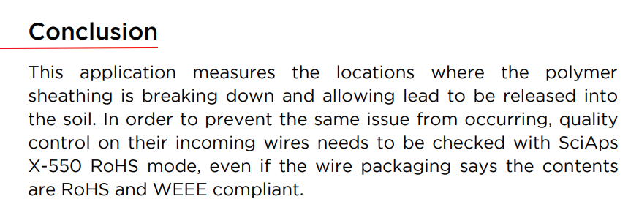 | Conclusion
 | This application measures the locations where the polymer sheathing is breaking down and allowing lead to be released into the soil. In order to prevent the same issue from occurring, quality control on their incoming wires needs to be checked with SciAps X-550 RoHS mode, even if the wire packaging says the contents are RoHS and WEEE compliant.
If applicable, please add:
LOCAL COMPANY NAME
LOCAL WEBSITE
LOCAL PHONE

