Document Title: SciAps X-50 Precious Metals Specifications
Rev Date: April 2024
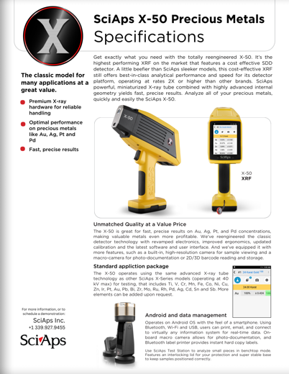
Layout Preview | English Text | Translated Text
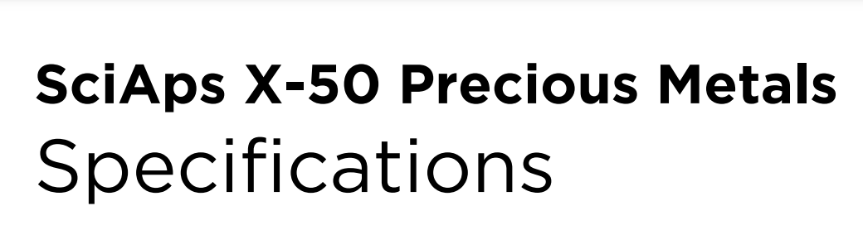 | SciAps X-50 Precious Metals
 | Specifications
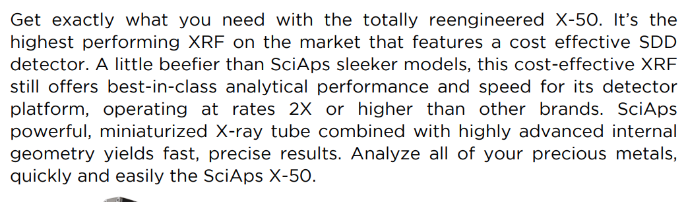 | Get exactly what you need with the totally reengineered X-50. It’s the highest performing XRF on the market that features a cost effective SDD detector. A little beefier than SciAps sleeker models, this cost-effective XRF still offers best-in-class analytical performance and speed for its detector platform, operating at rates 2X or higher than other brands. SciAps powerful, miniaturized X-ray tube combined with highly advanced internal geometry yields fast, precise results. Analyze all of your precious metals, quickly and easily the SciAps X-50.
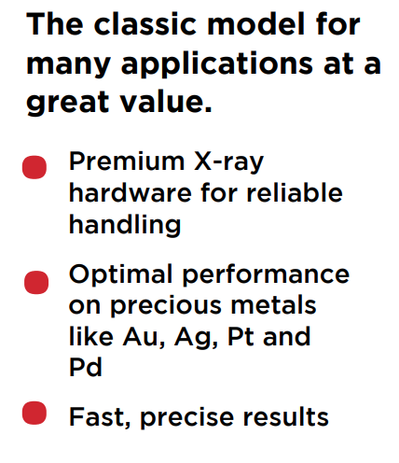 | The classic model for many applications at a great value.
 | Premium X-ray hardware for reliable handling
 | Optimal performance on precious metals like Au, Ag, Pt and Pd
 | Fast, precise results
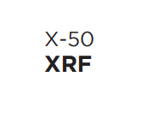 | X-50
 | XRF
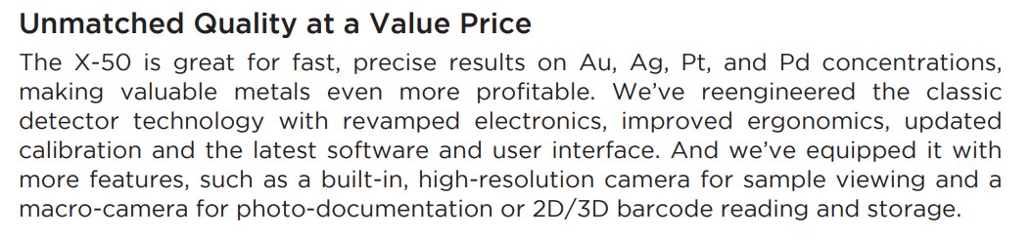 | Unmatched Quality at a Value Price
 | The X-50 is great for fast, precise results on Au, Ag, Pt, and Pd concentrations, making valuable metals even more profitable. We’ve reengineered the classic detector technology with revamped electronics, improved ergonomics, updated calibration and the latest software and user interface. And we’ve equipped it with more features, such as a built-in, high-resolution camera for sample viewing and a macro-camera for photo-documentation or 2D/3D barcode reading and storage.
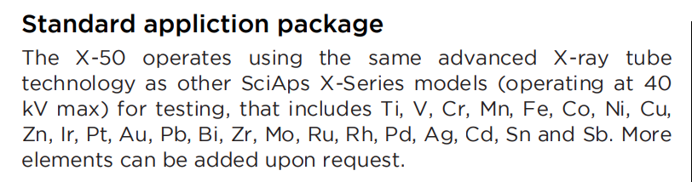 | Standard appliction package
 | The X-50 operates using the same advanced X-ray tube technology as other SciAps X-Series models (operating at 40 kV max) for testing, that includes Ti, V, Cr, Mn, Fe, Co, Ni, Cu, Zn, Ir, Pt, Au, Pb, Bi, Zr, Mo, Ru, Rh, Pd, Ag, Cd, Sn and Sb. More elements can be added upon request.
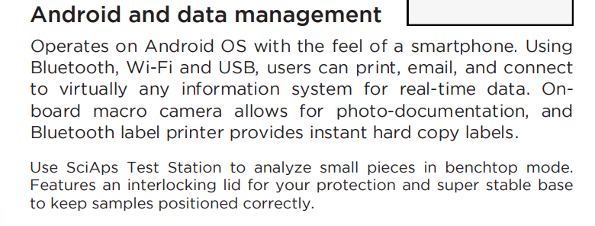 | Android and data management
 | Operates on Android OS with the feel of a smartphone. Using Bluetooth, Wi-Fi and USB, users can print, email, and connect to virtually any information system for real-time data. Onboard macro camera allows for photo-documentation, and Bluetooth label printer provides instant hard copy labels.
 | Use SciAps Test Station to analyze small pieces in benchtop mode. Features an interlocking lid for your protection and super stable base to keep samples positioned correctly.
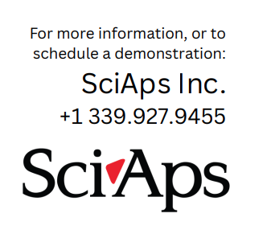 | For more information, or to schedule a demonstration:
If applicable, please add:
LOCAL COMPANY NAME
LOCAL WEBSITE
LOCAL PHONE
(BACK)
 | SciAps X-50 Precious Metals
 | Specifications
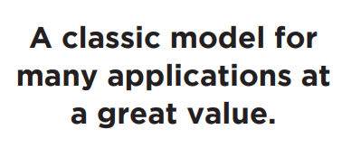 | A classic model for many applications at a great value.
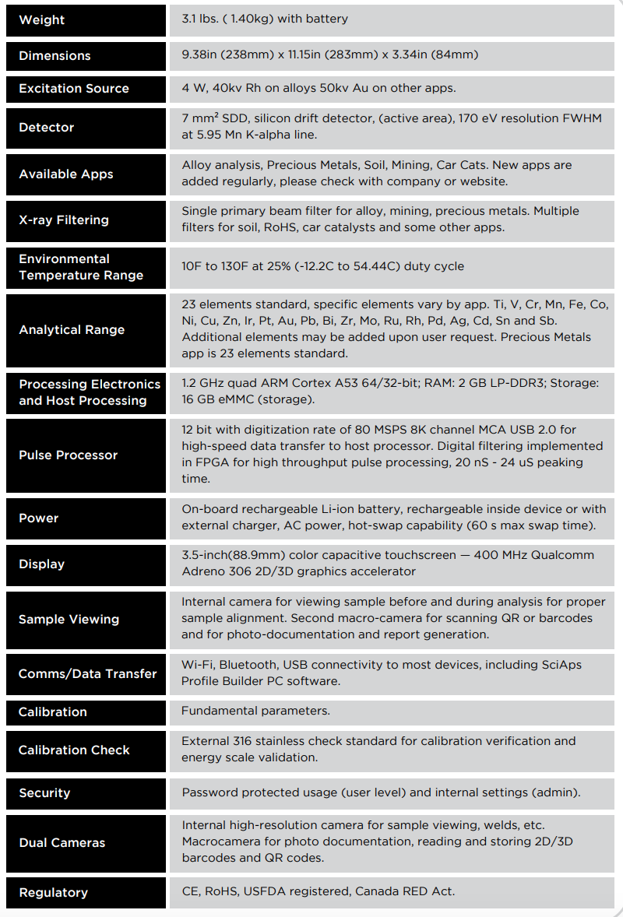 | Weight
 | 3.1 lbs. ( 1.40kg) with battery
 | Dimensions
 | 9.38in (238mm) x 11.15in (283mm) x 3.34in (84mm)
 | Excitation Source
 | 4 W, 40kv Rh on alloys 50kv Au on other apps.
 | Detector
 | 7 mm² SDD, silicon drift detector, (active area), 170 eV resolution FWHM at 5.95 Mn K-alpha line.
 | Available Apps
 | Alloy analysis, Precious Metals, Soil, Mining, Car Cats. New apps are added regularly, please check with company or website.
 | X-ray Filtering
 | Single primary beam filter for alloy, mining, precious metals. Multiple filters for soil, RoHS, car catalysts and some other apps.
 | Environmental Temperature Range
 | 10F to 130F at 25% (-12.2C to 54.44C) duty cycle
 | Analytical Range
 | 23 elements standard, specific elements vary by app. Ti, V, Cr, Mn, Fe, Co, Ni, Cu, Zn, Ir, Pt, Au, Pb, Bi, Zr, Mo, Ru, Rh, Pd, Ag, Cd, Sn and Sb. Additional elements may be added upon user request. Precious Metals app is 23 elements standard.
 | Processing Electronics and Host Processing
 | 1.2 GHz quad ARM Cortex A53 64/32-bit; RAM: 2 GB LP-DDR3; Storage: 16 GB eMMC (storage).
 | Pulse Processor
 | 12 bit with digitization rate of 80 MSPS 8K channel MCA USB 2.0 for high-speed data transfer to host processor. Digital filtering implemented in FPGA for high throughput pulse processing, 20 nS - 24 uS peaking time.
 | Power
 | On-board rechargeable Li-ion battery, rechargeable inside device or with external charger, AC power, hot-swap capability (60 s max swap time).
 | Display
 | 3.5-inch(88.9mm) color capacitive touchscreen — 400 MHz Qualcomm Adreno 306 2D/3D graphics accelerator
 | Sample Viewing
 | Internal camera for viewing sample before and during analysis for proper sample alignment. Second macro-camera for scanning QR or barcodes and for photo-documentation and report generation.
 | Comms/Data Transfer
 | Wi-Fi, Bluetooth, USB connectivity to most devices, including SciAps Profile Builder PC software.
 | Calibration
 | Fundamental parameters.
 | Calibration Check
 | External 316 stainless check standard for calibration verification and energy scale validation.
 | Security
 | Password protected usage (user level) and internal settings (admin).
 | Dual Cameras
 | Internal high-resolution camera for sample viewing, welds, etc. Macrocamera for photo documentation, reading and storing 2D/3D barcodes and QR codes.
 | Regulatory
 | CE, RoHS, USFDA registered, Canada RED Act.
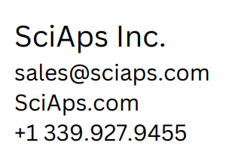 | If applicable, please add:  LOCAL COMPANY NAME  LOCAL WEBSITE  LOCAL PHONE
 | YouTube.com/SciAps

