Document Title: SciAps ApNote for Pb Analysis in Residential and Commercial Properties
Rev Date: April 2024
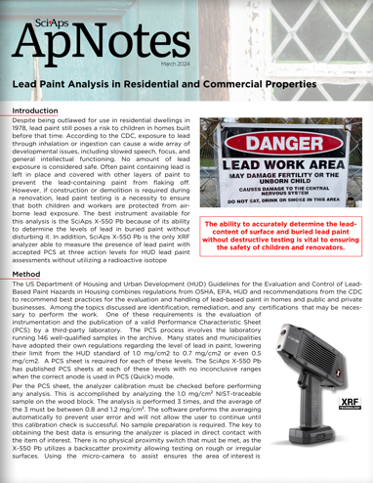
Layout Preview | English Text | Translated Text
 | SciAps
 | ApNotes
 | March 2024
 | Lead Paint Analysis in Residential and Commercial Properties
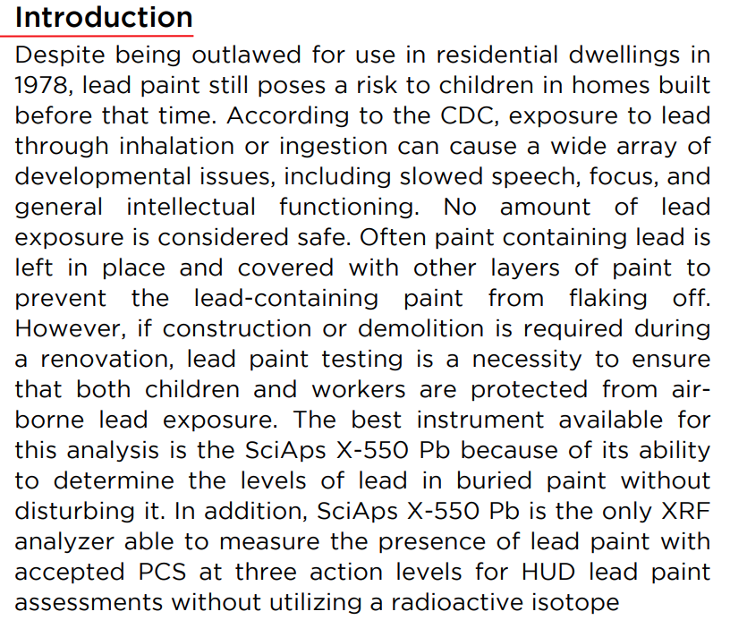 | Introduction
 | Despite being outlawed for use in residential dwellings in 1978, lead paint still poses a risk to children in homes built before that time. According to the CDC, exposure to lead through inhalation or ingestion can cause a wide array of developmental issues, including slowed speech, focus, and general intellectual functioning. No amount of lead exposure is considered safe. Often paint containing lead is left in place and covered with other layers of paint to prevent the lead-containing paint from flaking off. However, if construction or demolition is required during a renovation, lead paint testing is a necessity to ensure that both children and workers are protected from airborne lead exposure. The best instrument available for this analysis is the SciAps X-550 Pb because of its ability to determine the levels of lead in buried paint without disturbing it. In addition, SciAps X-550 Pb is the only XRF analyzer able to measure the presence of lead paint with accepted PCS at three action levels for HUD lead paint assessments without utilizing a radioactive isotope
 | The ability to accurately determine the lead content of surface and buried lead paint without destructive testing is vital to ensuring the safety of children and renovators.
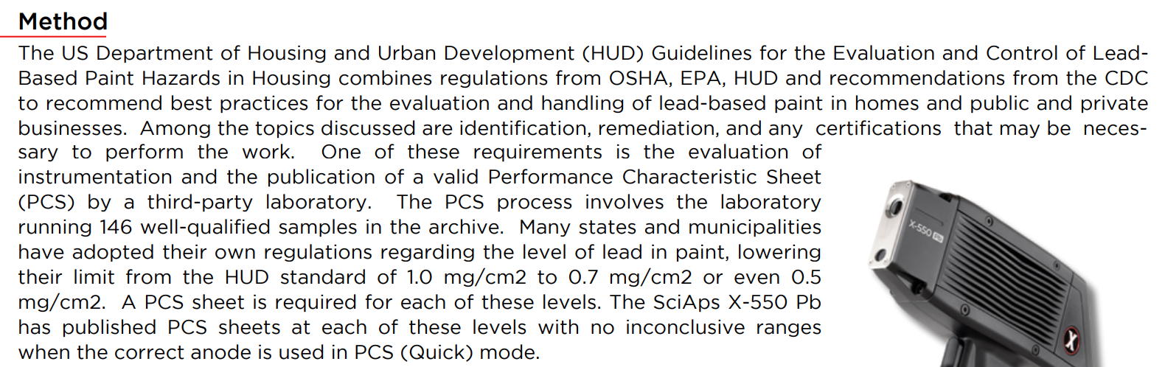 | Method
 | The US Department of Housing and Urban Development (HUD) Guidelines for the Evaluation and Control of Lead Based Paint Hazards in Housing combines regulations from OSHA, EPA, HUD and recommendations from the CDC to recommend best practices for the evaluation and handling of lead-based paint in homes and public and private businesses. Among the topics discussed are identification, remediation, and any certifications that may be necessary to perform the work. One of these requirements is the evaluation of instrumentation and the publication of a valid Performance Characteristic Sheet (PCS) by a third-party laboratory. The PCS process involves the laboratory running 146 well-qualified samples in the archive. Many states and municipalities have adopted their own regulations regarding the level of lead in paint, lowering their limit from the HUD standard of 1.0 mg/cm2 to 0.7 mg/cm2 or even 0.5 mg/cm2. A PCS sheet is required for each of these levels. The SciAps X-550 Pb has published PCS sheets at each of these levels with no inconclusive ranges when the correct anode is used in PCS (Quick) mode.
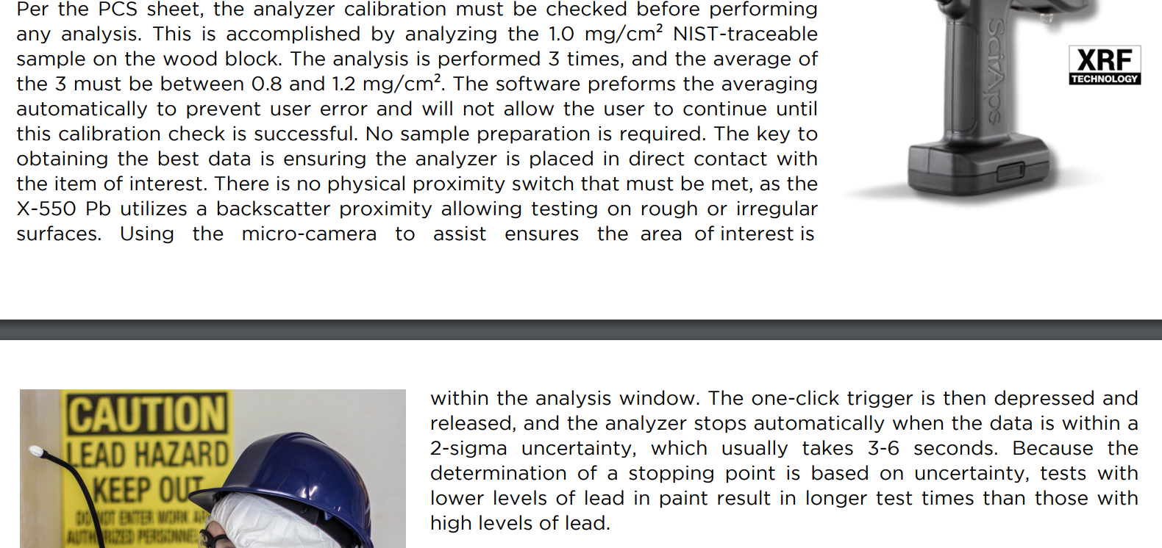 | Per the PCS sheet, the analyzer calibration must be checked before performing any analysis. This is accomplished by analyzing the 1.0 mg/cm² NIST-traceable sample on the wood block. The analysis is performed 3 times, and the average of the 3 must be between 0.8 and 1.2 mg/cm². The software preforms the averaging automatically to prevent user error and will not allow the user to continue until this calibration check is successful. No sample preparation is required. The key to obtaining the best data is ensuring the analyzer is placed in direct contact with the item of interest. There is no physical proximity switch that must be met, as the X-550 Pb utilizes a backscatter proximity allowing testing on rough or irregular surfaces. Using the micro-camera to assist ensures the area of interest is within the analysis window. The one-click trigger is then depressed and released, and the analyzer stops automatically when the data is within a 2-sigma uncertainty, which usually takes 3-6 seconds. Because the determination of a stopping point is based on uncertainty, tests with lower levels of lead in paint result in longer test times than those with high levels of lead.
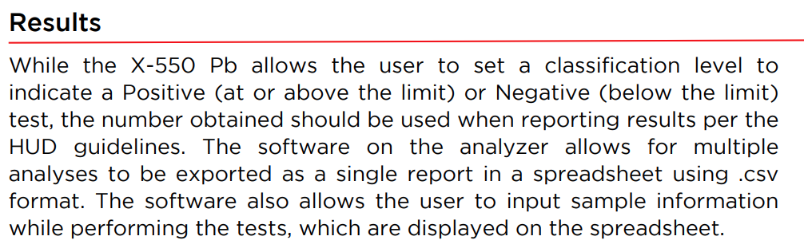 | Results
 | While the X-550 Pb allows the user to set a classification level to indicate a Positive (at or above the limit) or Negative (below the limit) test, the number obtained should be used when reporting results per the HUD guidelines. The software on the analyzer allows for multiple analyses to be exported as a single report in a spreadsheet using .csv format. The software also allows the user to input sample information while performing the tests, which are displayed on the spreadsheet.
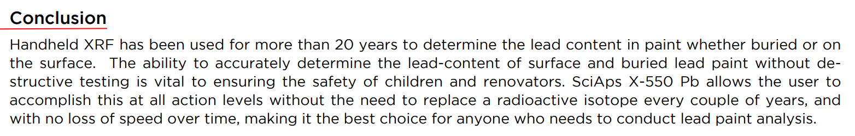 | Conclusion
 | Handheld XRF has been used for more than 20 years to determine the lead content in paint whether buried or on the surface. The ability to accurately determine the lead-content of surface and buried lead paint without destructive testing is vital to ensuring the safety of children and renovators. SciAps X-550 Pb allows the user to accomplish this at all action levels without the need to replace a radioactive isotope every couple of years, and with no loss of speed over time, making it the best choice for anyone who needs to conduct lead paint analysis.
 | If applicable, please add:  LOCAL COMPANY NAME  LOCAL WEBSITE  LOCAL PHONE

