Document Title: SciAps ApNote Targeted Micro Analysis (TMA) using Handheld LIBS
Rev Date: April 2024
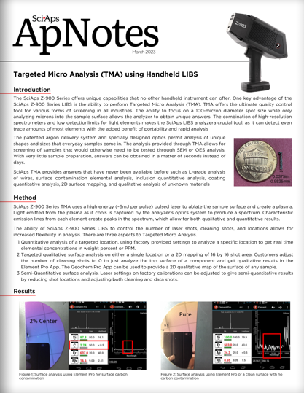
Layout Preview | English Text | Translated Text
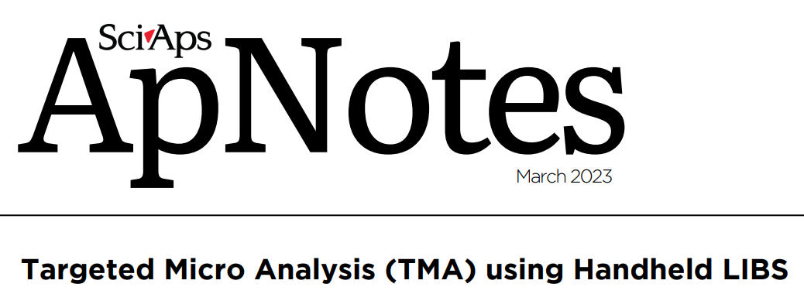 | SciAps
 | ApNotes
 | March 2023
 | Targeted Micro Analysis (TMA) using Handheld LIBS
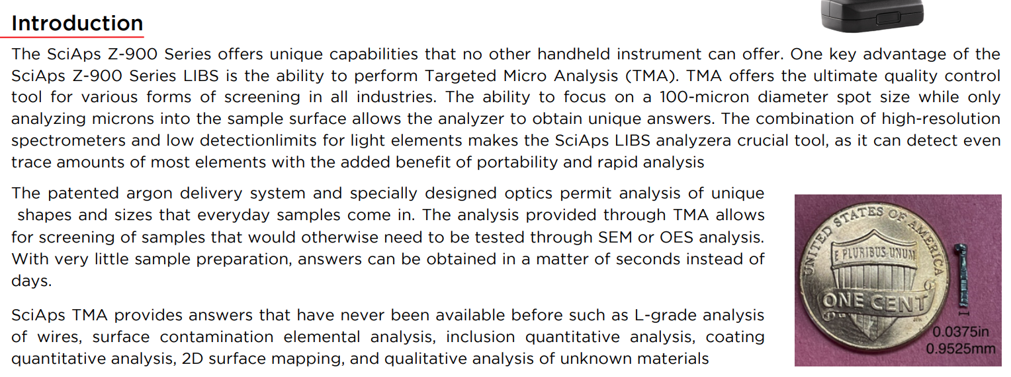 | Introduction
 | The SciAps Z-900 Series offers unique capabilities that no other handheld instrument can offer. One key advantage of the SciAps Z-900 Series LIBS is the ability to perform Targeted Micro Analysis (TMA). TMA offers the ultimate quality control tool for various forms of screening in all industries. The ability to focus on a 100-micron diameter spot size while only analyzing microns into the sample surface allows the analyzer to obtain unique answers. The combination of high-resolution spectrometers and low detection limits for light elements makes the SciAps LIBS analyzer a crucial tool, as it can detect even trace amounts of most elements with the added benefit of portability and rapid analysis.
 | The patented argon delivery system and specially designed optics permit analysis of unique shapes and sizes that everyday samples come in. The analysis provided through TMA allows for screening of samples that would otherwise need to be tested through SEM or OES analysis. With very little sample preparation, answers can be obtained in a matter of seconds instead of days.
 | SciAps TMA provides answers that have never been available before such as L-grade analysis of wires, surface contamination elemental analysis, inclusion quantitative analysis, coating quantitative analysis, 2D surface mapping, and qualitative analysis of unknown materials.
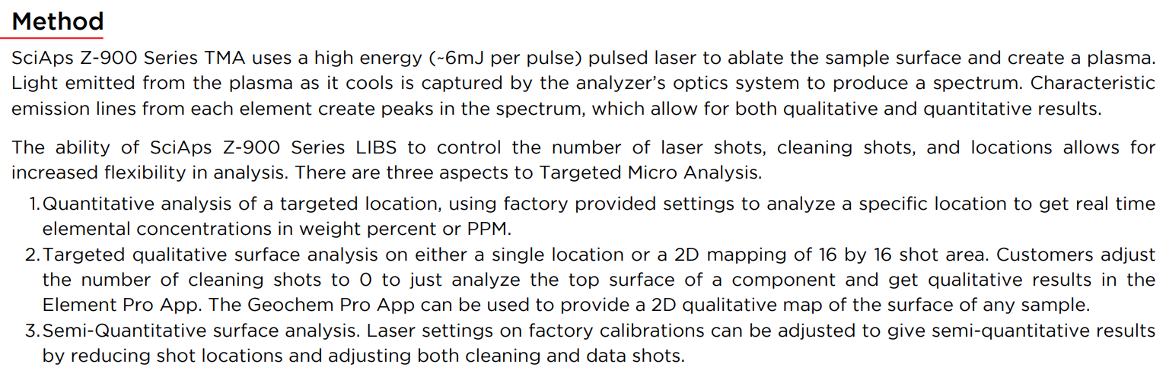 | Method
 | SciAps Z-900 Series TMA uses a high energy (~6mJ per pulse) pulsed laser to ablate the sample surface and create a plasma. Light emitted from the plasma as it cools is captured by the analyzer’s optics system to produce a spectrum. Characteristic emission lines from each element create peaks in the spectrum, which allow for both qualitative and quantitative results.
 | The ability of SciAps Z-900 Series LIBS to control the number of laser shots, cleaning shots, and locations allows for increased flexibility in analysis. There are three aspects to Targeted Micro Analysis.
 | 1. Quantitative analysis of a targeted location, using factory provided settings to analyze a specific location to get real time elemental concentrations in weight percent or PPM.
 | 2. Targeted qualitative surface analysis on either a single location or a 2D mapping of 16 by 16 shot area. Customers adjust the number of cleaning shots to 0 to just analyze the top surface of a component and get qualitative results in the Element Pro App. The Geochem Pro App can be used to provide a 2D qualitative map of the surface of any sample.
 | 3. Semi-Quantitative surface analysis. Laser settings on factory calibrations can be adjusted to give semi-quantitative results by reducing shot locations and adjusting both cleaning and data shots.
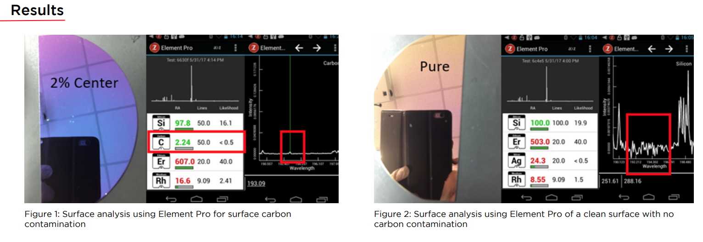 | Results
 | Figure 1: Surface analysis using Element Pro for surface carbon contamination
 | Figure 2: Surface analysis using Element Pro of a clean surface with no carbon contamination
(BACK)
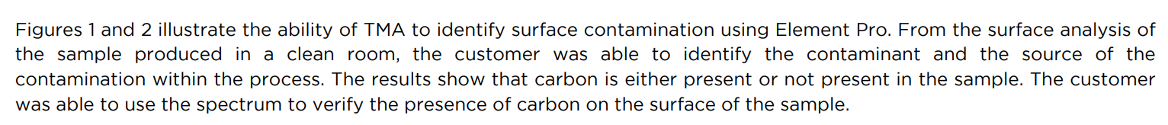 | Figures 1 and 2 illustrate the ability of TMA to identify surface contamination using Element Pro. From the surface analysis of the sample produced in a clean room, the customer was able to identify the contaminant and the source of the contamination within the process. The results show that carbon is either present or not present in the sample. The customer was able to use the spectrum to verify the presence of carbon on the surface of the sample.
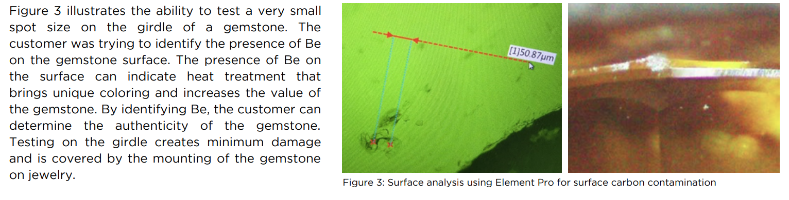 | Figure 3 illustrates the ability to test a very small spot size on the girdle of a gemstone. The customer was trying to identify the presence of Be on the gemstone surface. The presence of Be on the surface can indicate heat treatment that brings unique coloring and increases the value of the gemstone. By identifying Be, the customer can determine the authenticity of the gemstone. Testing on the girdle creates minimum damage and is covered by the mounting of the gemstone on jewelry.
 | Figure 3: Surface analysis using Element Pro for surface carbon contamination
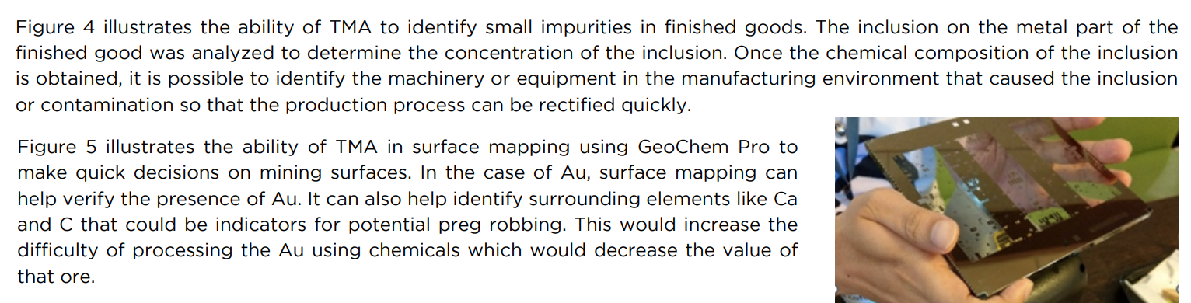 | Figure 4 illustrates the ability of TMA to identify small impurities in finished goods. The inclusion on the metal part of the finished good was analyzed to determine the concentration of the inclusion. Once the chemical composition of the inclusion is obtained, it is possible to identify the machinery or equipment in the manufacturing environment that caused the inclusion or contamination so that the production process can be rectified quickly.
 | Figure 5 illustrates the ability of TMA in surface mapping using GeoChem Pro to make quick decisions on mining surfaces. In the case of Au, surface mapping can help verify the presence of Au. It can also help identify surrounding elements like Ca and C that could be indicators for potential preg robbing. This would increase the difficulty of processing the Au using chemicals which would decrease the value of that ore.
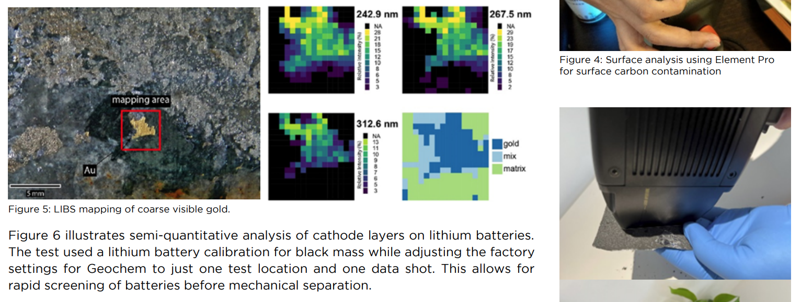 | Figure 4: Surface analysis using Element Pro for surface carbon contamination
 | Figure 5: LIBS mapping of coarse visible gold.
 | Figure 6 illustrates semi-quantitative analysis of cathode layers on lithium batteries. The test used a lithium battery calibration for black mass while adjusting the factory settings for Geochem to just one test location and one data shot. This allows for rapid screening of batteries before mechanical separation.
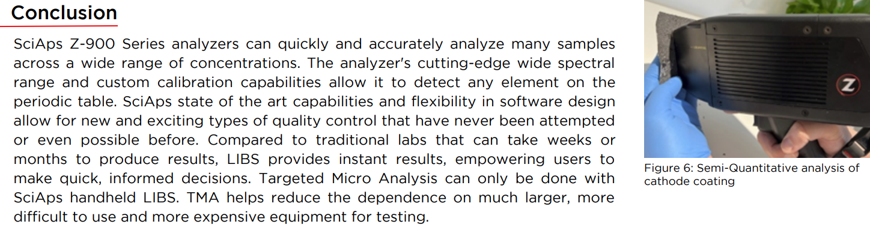 | Conclusion
 | SciAps Z-900 Series analyzers can quickly and accurately analyze many samples across a wide range of concentrations. The analyzer's cutting-edge wide spectral range and custom calibration capabilities allow it to detect any element on the periodic table. SciAps state of the art capabilities and flexibility in software design allow for new and exciting types of quality control that have never been attempted or even possible before. Compared to traditional labs that can take weeks or months to produce results, LIBS provides instant results, empowering users to make quick, informed decisions. Targeted Micro Analysis can only be done with SciAps handheld LIBS. TMA helps reduce the dependence on much larger, more difficult to use and more expensive equipment for testing.
 | Figure 6: Semi-Quantitative analysis of cathode coating
If applicable, please add:
LOCAL COMPANY NAME
LOCAL WEBSITE
LOCAL PHONE

