Document Title: SciAps ApNote Z-9 Liquidator for Rapid Multi-Element Analysis of Lithium Brines
Rev Date: April 2024
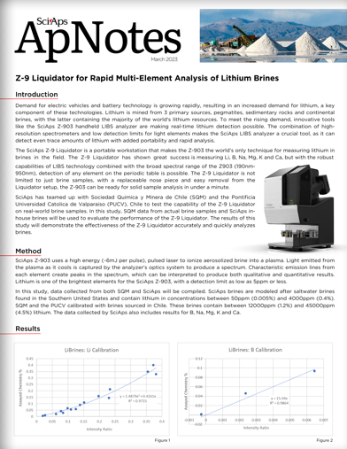
Layout Preview | English Text | Translated Text
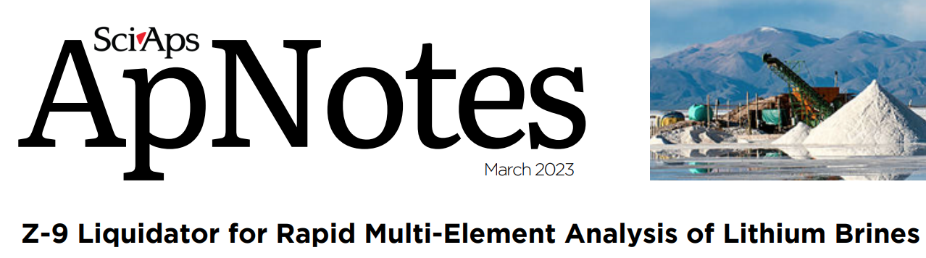 | SciAps
 | ApNotes
 | March 2023
 | Z-9 Liquidator for Rapid Multi-Element Analysis of Lithium Brines
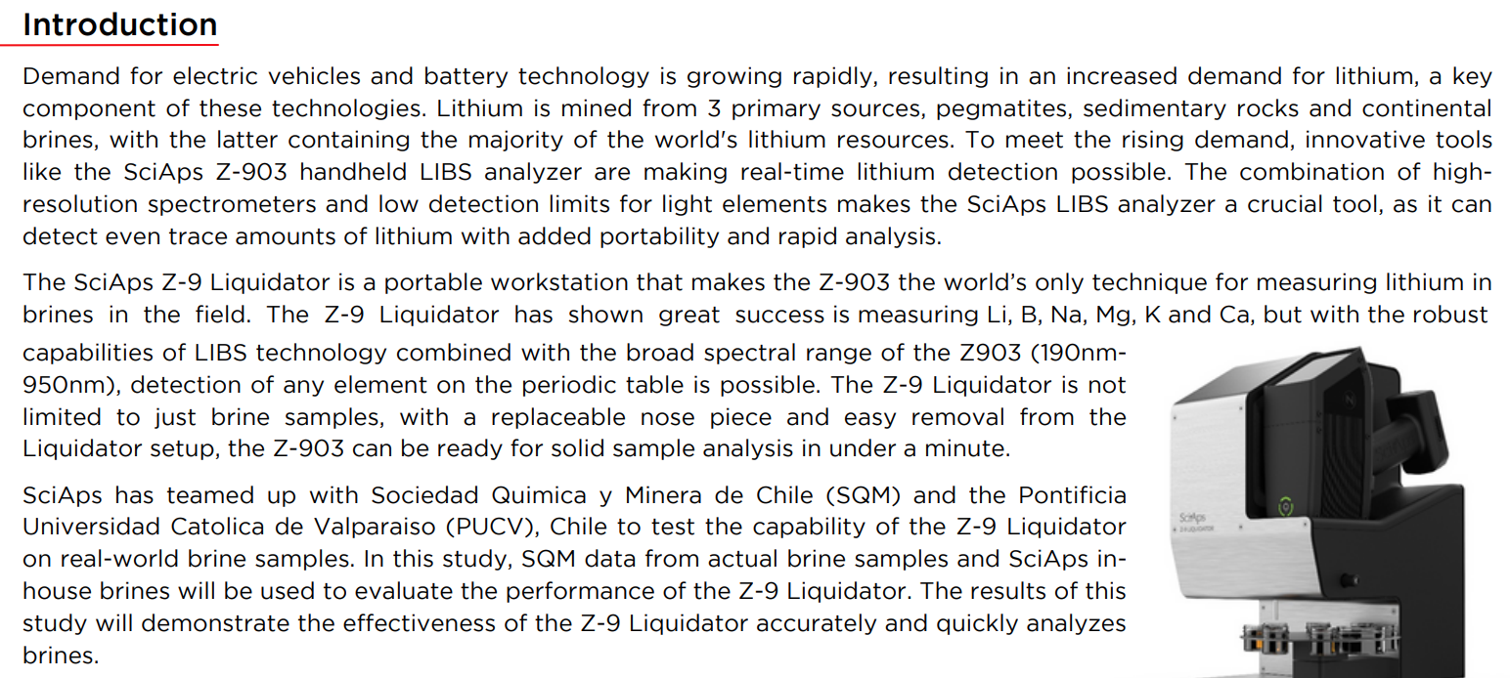 | Introduction
 | Demand for electric vehicles and battery technology is growing rapidly, resulting in an increased demand for lithium, a key component of these technologies. Lithium is mined from 3 primary sources, pegmatites, sedimentary rocks and continental brines, with the latter containing the majority of the world's lithium resources. To meet the rising demand, innovative tools like the SciAps Z-903 handheld LIBS analyzer are making real-time lithium detection possible. The combination of high resolution spectrometers and low detection limits for light elements makes the SciAps LIBS analyzer a crucial tool, as it can detect even trace amounts of lithium with added portability and rapid analysis.
 | The SciAps Z-9 Liquidator is a portable workstation that makes the Z-903 the world’s only technique for measuring lithium in brines in the field. The Z-9 Liquidator has shown great success is measuring Li, B, Na, Mg, K and Ca, but with the robust capabilities of LIBS technology combined with the broad spectral range of the Z903 (190nm- 950nm), detection of any element on the periodic table is possible. The Z-9 Liquidator is not limited to just brine samples, with a replaceable nose piece and easy removal from the Liquidator setup, the Z-903 can be ready for solid sample analysis in under a minute.
 | SciAps has teamed up with Sociedad Quimica y Minera de Chile (SQM) and the Pontificia Universidad Catolica de Valparaiso (PUCV), Chile to test the capability of the Z-9 Liquidator on real-world brine samples. In this study, SQM data from actual brine samples and SciAps in- house brines will be used to evaluate the performance of the Z-9 Liquidator. The results of this study will demonstrate the effectiveness of the Z-9 Liquidator accurately and quickly analyzes brines.
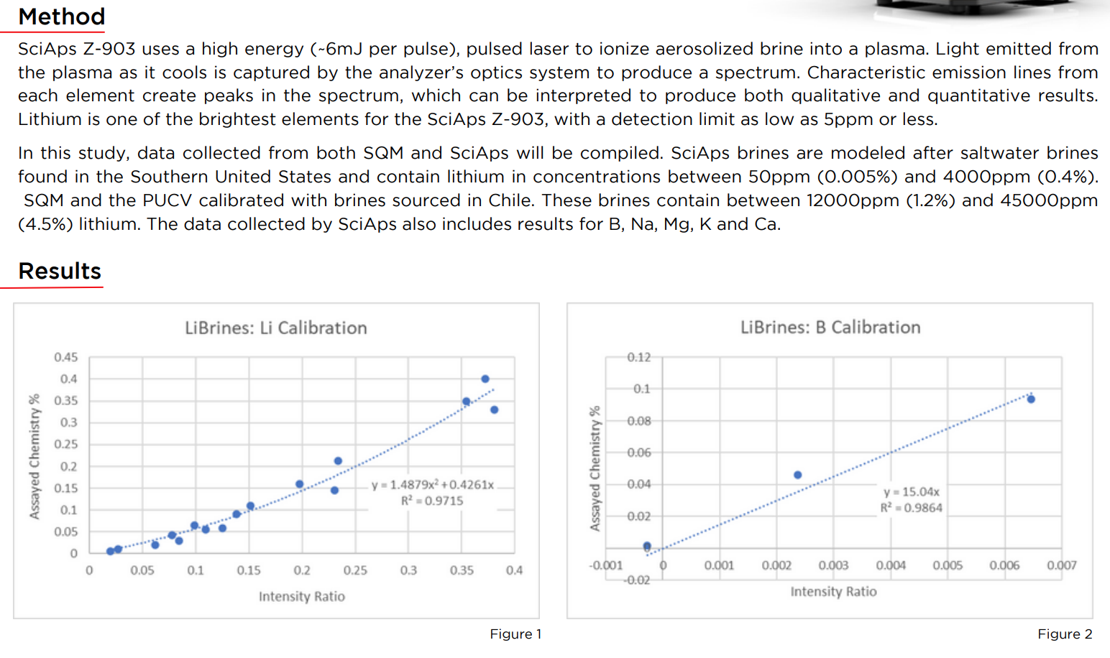 | Method
 | SciAps Z-903 uses a high energy (~6mJ per pulse), pulsed laser to ionize aerosolized brine into a plasma. Light emitted from the plasma as it cools is captured by the analyzer's optics system to produce a spectrum. Characteristic emission lines from each element create peaks in the spectrum, which can be interpreted to produce both qualitative and quantitative results. Lithium is one of the brightest elements for the SciAps Z-903, with a detection limit as low as 5ppm or less.
In this study, data collected from both SQM and SciAps will be compiled. SciAps brines are modeled after saltwater brines found in the Southern United States and contain lithium in concentrations between 50ppm (0.005%) and 4000ppm (0.4%).
SQM and the PUCV calibrated with brines sourced in Chile. These brines contain between 12000ppm (1.2%) and 45000ppm (4.5%) lithium. The data collected by SciAps also includes results for B, Na, Mg. K and Ca.
 | Results
 | Figure 1
 | Figure 2
(BACK)
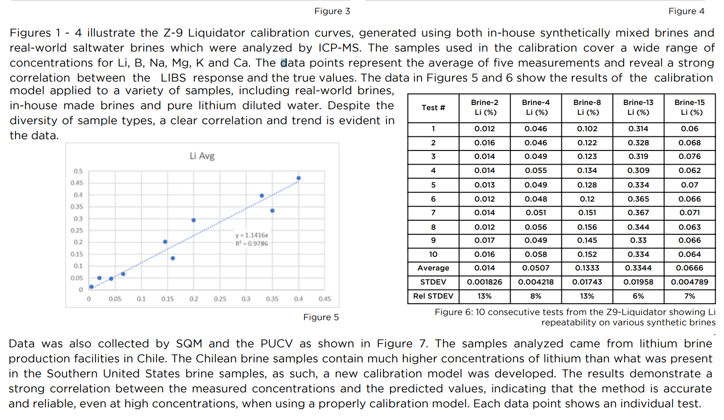 | Figure 3
 | Figure 4
 | Figures 1 - 4 illustrate the Z-9 Liquidator calibration curves, generated using both in-house synthetically mixed brines and real-world saltwater brines which were analyzed by ICP-MS. The samples used in the calibration cover a wide range of concentrations for Li, B, Na, Mg, K and Ca. The data points represent the average of five measurements and reveal a strong correlation between the LIBS response and the true values. The data in Figures 5 and 6 show the results of the calibration model applied to a variety of samples, including real-world brines, in-house made brines and pure lithium diluted water. Despite the diversity of sample types, a clear correlation and trend is evident in the data.
 | Figure 5
 | Test #
 | Brine-2 Li (%)
 | Brine-4 Li (%)
 | Brine-8 Li (%)
 | Brine-13 Li (%)
 | Brine-15 Li (%)
 | Average
 | STDEV
 | Rel STDEV
 | Figure 6: 10 consecutive tests from the Z9-Liquidator showing Li repeatability on various synthetic brines
 | Data was also collected by SQM and the PUCV as shown in Figure 7. The samples analyzed came from lithium brine production facilities in Chile. The Chilean brine samples contain much higher concentrations of lithium than what was present in the Southern United States brine samples, as such, a new calibration model was developed. The results demonstrate a strong correlation between the measured concentrations and the predicted values, indicating that the method is accurate and reliable, even at high concentrations, when using a properly calibration model. Each data point shows an individual test.
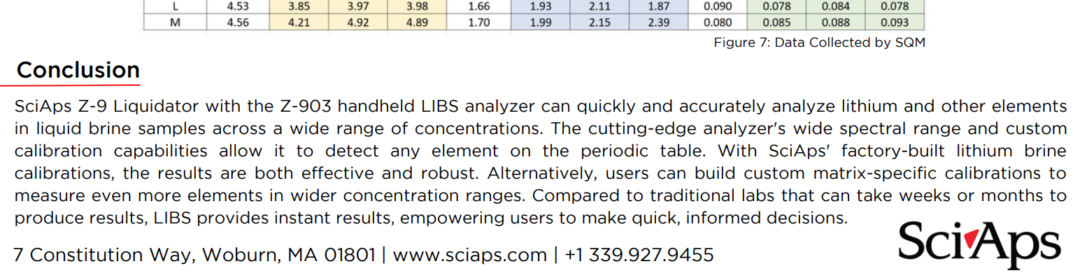 | Figure 7: Data Collected by SQM
 | Conclusion
 | SciAps Z-9 Liquidator with the Z-903 handheld LIBS analyzer can quickly and accurately analyze lithium and other elements in liquid brine samples across a wide range of concentrations. The cutting-edge analyzer's wide spectral range and custom calibration capabilities allow it to detect any element on the periodic table. With SciAps' factory-built lithium brine calibrations, the results are both effective and robust. Alternatively, users can build custom matrix-specific calibrations to measure even more elements in wider concentration ranges. Compared to traditional labs that can take weeks or months to produce results, LIBS provides instant results, empowering users to make quick, informed decisions.
If applicable, please add:
LOCAL COMPANY NAME
LOCAL WEBSITE
LOCAL PHONE

