Document Title: SciAps X-555 REE ApNote
Rev Date: April 2024
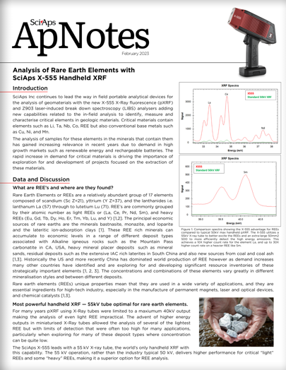
Layout Preview | English Text | Translated Text
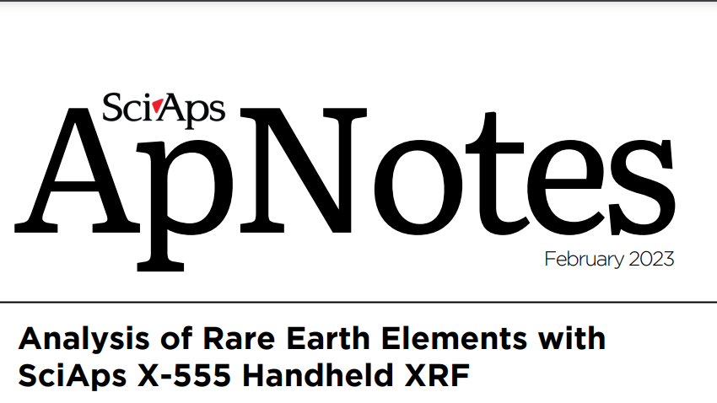 | SciAps
 | ApNotes
 | February 2023
 | Analysis of Rare Earth Elements with SciAps X-555 Handheld XRF
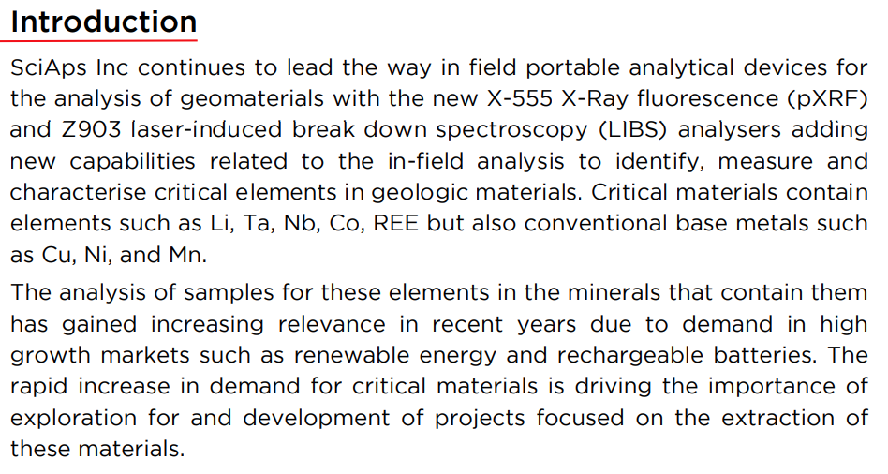 | Introduction
 | SciAps Inc continues to lead the way in field portable analytical devices for the analysis of geomaterials with the new X-555 X-Ray fluorescence (pXRF) and Z903 laser-induced break down spectroscopy (LIBS) analysers adding new capabilities related to the in-field analysis to identify, measure and characterise critical elements in geologic materials. Critical materials contain elements such as Li, Ta, Nb, Co, REE but also conventional base metals such as Cu, Ni, and Mn.
 | The analysis of samples for these elements in the minerals that contain them has gained increasing relevance in recent years due to demand in high growth markets such as renewable energy and rechargeable batteries. The rapid increase in demand for critical materials is driving the importance of exploration for and development of projects focused on the extraction of these materials.
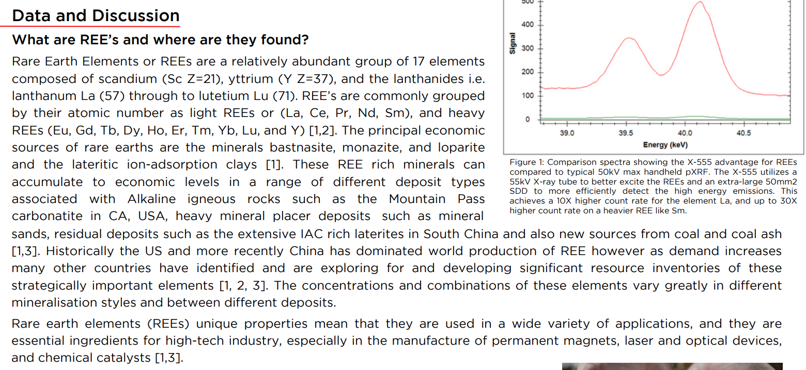 | Data and Discussion
 | What are REE’s and where are they found?
 | Rare Earth Elements or REEs are a relatively abundant group of 17 elements composed of scandium (Sc Z=21), yttrium (Y Z=37), and the lanthanides i.e. lanthanum La (57) through to lutetium Lu (71). REE’s are commonly grouped by their atomic number as light REEs or (La, Ce, Pr, Nd, Sm), and heavy REEs (Eu, Gd, Tb, Dy, Ho, Er, Tm, Yb, Lu, and Y) [1,2]. The principal economic sources of rare earths are the minerals bastnasite, monazite, and loparite and the lateritic ion-adsorption clays [1]. These REE rich minerals can accumulate to economic levels in a range of different deposit types associated with Alkaline igneous rocks such as the Mountain Pass carbonatite in CA, USA, heavy mineral placer deposits such as mineral sands, residual deposits such as the extensive IAC rich laterites in South China and also new sources from coal and coal ash [1,3]. Historically the US and more recently China has dominated world production of REE however as demand increases many other countries have identified and are exploring for and developing significant resource inventories of these strategically important elements [1, 2, 3]. The concentrations and combinations of these elements vary greatly in different mineralisation styles and between different deposits.
 | Rare earth elements (REEs) unique properties mean that they are used in a wide variety of applications, and they are essential ingredients for high-tech industry, especially in the manufacture of permanent magnets, laser and optical devices, and chemical catalysts [1,3].
 | Figure 1: Comparison spectra showing the X-555 advantage for REEs compared to typical 50kV max handheld pXRF. The X-555 utilizes a 55kV X-ray tube to better excite the REEs and an extra-large 50mm2 SDD to more efficiently detect the high energy emissions. This achieves a 10X higher count rate for the element La, and up to 30X higher count rate on a heavier REE like Sm.
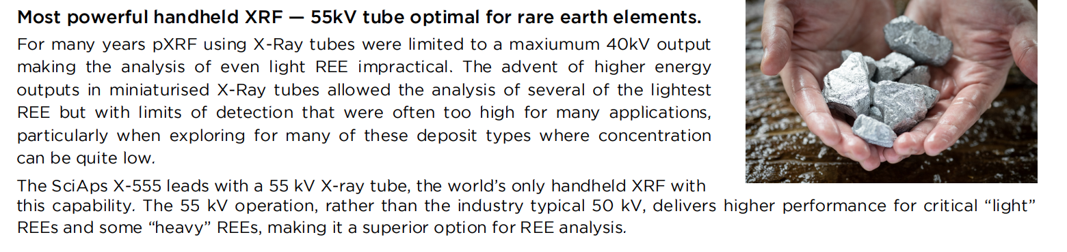 | Most powerful handheld XRF — 55kV tube optimal for rare earth elements.
 | For many years pXRF using X-Ray tubes were limited to a maxiumum 40kV output making the analysis of even light REE impractical. The advent of higher energy outputs in miniaturised X-Ray tubes allowed the analysis of several of the lightest REE but with limits of detection that were often too high for many applications, particularly when exploring for many of these deposit types where concentration can be quite low.
 | The SciAps X-555 leads with a 55 kV X-ray tube, the world’s only handheld XRF with this capability. The 55 kV operation, rather than the industry typical 50 kV, delivers higher performance for critical “light” REEs and some “heavy” REEs, making it a superior option for REE analysis.
(BACK)
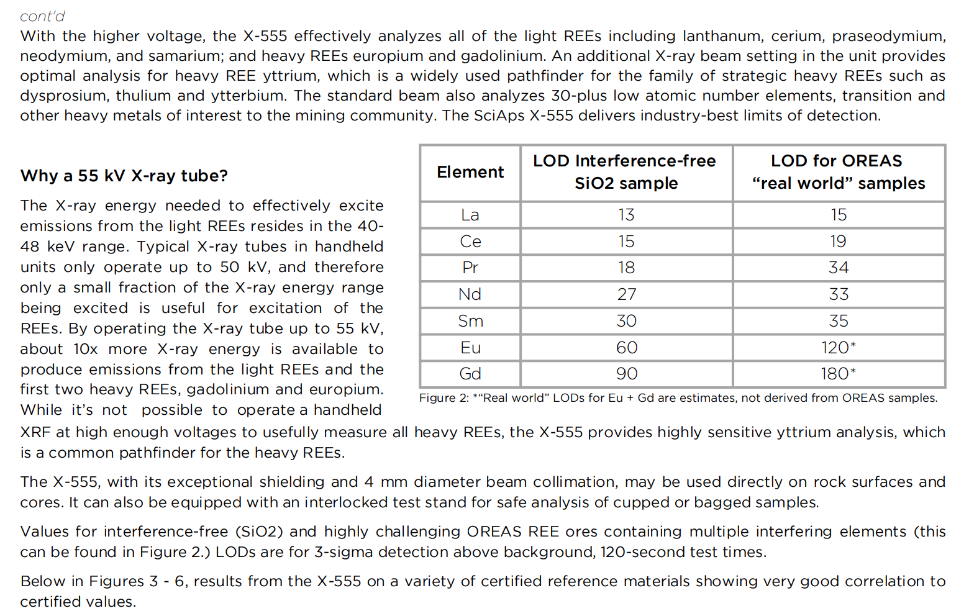 | cont'd
 | With the higher voltage, the X-555 effectively analyzes all of the light REEs including lanthanum, cerium, praseodymium, neodymium, and samarium; and heavy REEs europium and gadolinium. An additional X-ray beam setting in the unit provides optimal analysis for heavy REE yttrium, which is a widely used pathfinder for the family of strategic heavy REEs such as dysprosium, thulium and ytterbium. The standard beam also analyzes 30-plus low atomic number elements, transition and other heavy metals of interest to the mining community. The SciAps X-555 delivers industry-best limits of detection.
 | Why a 55 kV X-ray tube?
 | The X-ray energy needed to effectively excite emissions from the light REEs resides in the 40- 48 keV range. Typical X-ray tubes in handheld units only operate up to 50 kV, and therefore only a small fraction of the X-ray energy range being excited is useful for excitation of the REEs. By operating the X-ray tube up to 55 kV, about 10x more X-ray energy is available to produce emissions from the light REEs and the first two heavy REEs, gadolinium and europium. While it’s not possible to operate a handheld XRF at high enough voltages to usefully measure all heavy REEs, the X-555 provides highly sensitive yttrium analysis, which is a common pathfinder for the heavy REEs.
 | The X-555, with its exceptional shielding and 4 mm diameter beam collimation, may be used directly on rock surfaces and cores. It can also be equipped with an interlocked test stand for safe analysis of cupped or bagged samples.
 | Values for interference-free (SiO2) and highly challenging OREAS REE ores containing multiple interfering elements (this can be found in Figure 2.) LODs are for 3-sigma detection above background, 120-second test times.
 | Below in Figures 3 - 6, results from the X-555 on a variety of certified reference materials showing very good correlation to certified values.
 | Element
 | LOD Interference-free SiO2 sample
 | LOD for OREAS “real world” samples
 | La
 | Ce
 | Pr
 | Nd
 | Sm
 | Eu
 | Gd
 | Figure 2: *“Real world” LODs for Eu + Gd are estimates, not derived from OREAS samples.
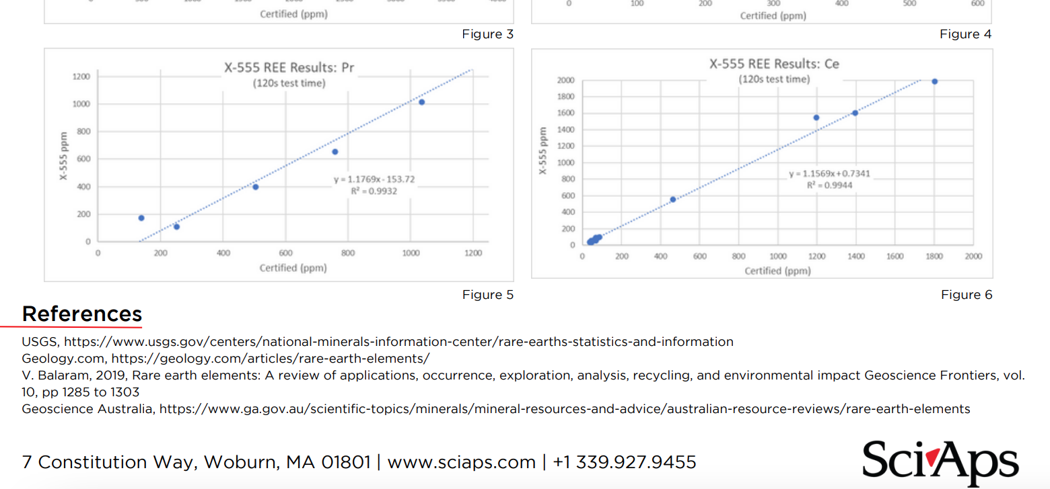 | Figure 3
 | Figure 4
 | Figure 5
 | Figure 6
 | References
 | USGS, https://www.usgs.gov/centers/national-minerals-information-center/rare-earths-statistics-and-information
 | Geology.com, https://geology.com/articles/rare-earth-elements/
 | V. Balaram, 2019, Rare earth elements: A review of applications, occurrence, exploration, analysis, recycling, and environmental impact Geoscience Frontiers, vol. 10, pp 1285 to 1303
 | Geoscience Australia, https://www.ga.gov.au/scientific-topics/minerals/mineral-resources-and-advice/australian-resource-reviews/rare-earth-elements
If applicable, please add:
LOCAL COMPANY NAME
LOCAL WEBSITE
LOCAL PHONE

