Document Title: SciAps Carbon Analysis in Stainless and Carbon Steels with Handheld LIBS
Rev Date: April 2024
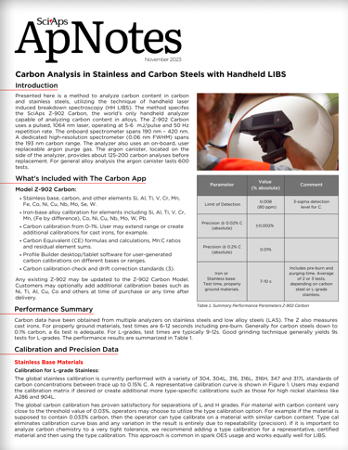
Layout Preview | English Text | Translated Text
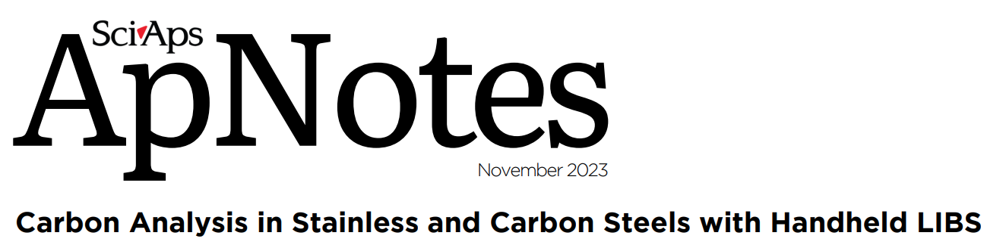 | SciAps
 | ApNotes
 | November 2023
 | Carbon Analysis in Stainless and Carbon Steels with Handheld LIBS
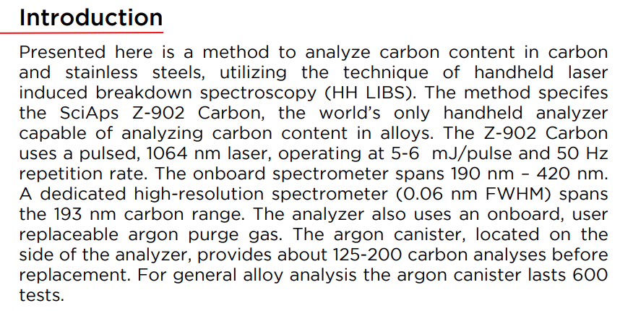 | Introduction
 | Presented here is a method to analyze carbon content in carbon and stainless steels, utilizing the technique of handheld laser induced breakdown spectroscopy (HH LIBS). The method specifies the SciAps Z-902 Carbon, the world’s only handheld analyzer capable of analyzing carbon content in alloys. The Z-902 Carbon uses a pulsed, 1064 nm laser, operating at 5-6 mJ/pulse and 50 Hz repetition rate. The onboard spectrometer spans 190 nm – 420 nm. A dedicated high-resolution spectrometer (0.06 nm FWHM) spans the 193 nm carbon range. The analyzer also uses an onboard, user replaceable argon purge gas. The argon canister, located on the side of the analyzer, provides about 125-200 carbon analyses before replacement. For general alloy analysis the argon canister lasts 600 tests.
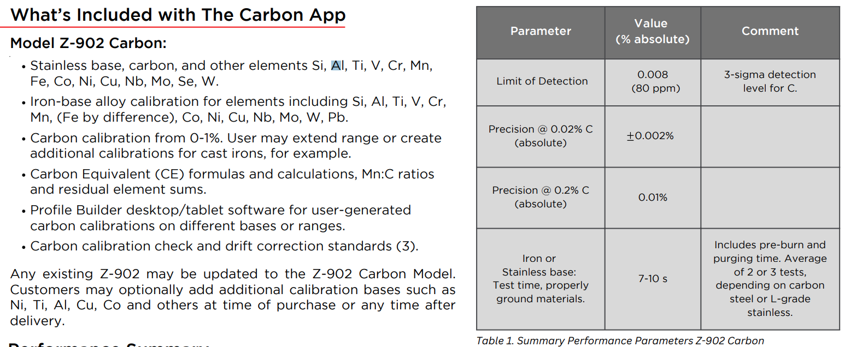 | What’s Included with The Carbon App
 | Model Z-902 Carbon:
 | Stainless base, carbon, and other elements Si, Al, Ti, V, Cr, Mn, Fe, Co, Ni, Cu, Nb, Mo, Se, W.
 | Iron-base alloy calibration for elements including Si, Al, Ti, V, Cr, Mn, (Fe by difference), Co, Ni, Cu, Nb, Mo, W, Pb.
 | Carbon calibration from 0-1%. User may extend range or create additional calibrations for cast irons, for example.
 | Carbon Equivalent (CE) formulas and calculations, Mn:C ratios and residual element sums.
 | Profile Builder desktop/tablet software for user-generated carbon calibrations on different bases or ranges.
 | Carbon calibration check and drift correction standards (3).
 | Any existing Z-902 may be updated to the Z-902 Carbon Model. Customers may optionally add additional calibration bases such as Ni, Ti, Al, Cu, Co and others at time of purchase or any time after delivery.
 | Parameter
 | Value (% absolute)
 | Comment
 | Limit of Detection
 | 0.008 (80 ppm)
 | 3-sigma detection level for C.
 | Precision @ 0.02% C (absolute)
 | 0.002%
 | Precision @ 0.2% C (absolute)
 | 0.01%
 | Iron or Stainless base: Test time, properly ground materials.
 | 7-10 s
 | Includes pre-burn and purging time. Average of 2 or 3 tests, depending on carbon steel or L-grade stainless.
 | Table 1. Summary Performance Parameters Z-902 Carbon
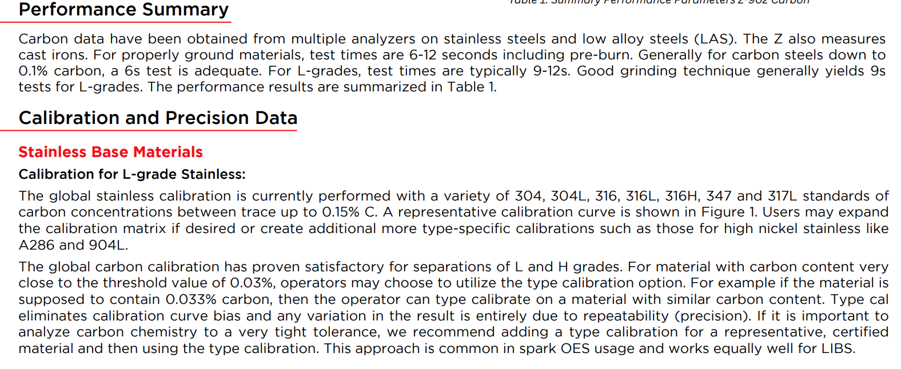 | Performance Summary
 | Carbon data have been obtained from multiple analyzers on stainless steels and low alloy steels (LAS). The Z also measures cast irons. For properly ground materials, test times are 6-12 seconds including pre-burn. Generally for carbon steels down to 0.1% carbon, a 6s test is adequate. For L-grades, test times are typically 9-12s. Good grinding technique generally yields 9s tests for L-grades. The performance results are summarized in Table 1.
 | Calibration and Precision Data
 | Stainless Base Materials
 | Calibration for L-grade Stainless:
 | The global stainless calibration is currently performed with a variety of 304, 304L, 316, 316L, 316H, 347 and 317L standards of carbon concentrations between trace up to 0.15% C. A representative calibration curve is shown in Figure 1. Users may expand the calibration matrix if desired or create additional more type-specific calibrations such as those for high nickel stainless likeA286 and 904L.
 | The global carbon calibration has proven satisfactory for separations of L and H grades. For material with carbon content very close to the threshold value of 0.03%, operators may choose to utilize the type calibration option. For example if the material is supposed to contain 0.033% carbon, then the operator can type calibrate on a material with similar carbon content. Type cal eliminates calibration curve bias and any variation in the result is entirely due to repeatability (precision). If it is important to analyze carbon chemistry to a very tight tolerance, we recommend adding a type calibration for a representative, certified material and then using the type calibration. This approach is common in spark OES usage and works equally well for LIBS.
(Page 2)
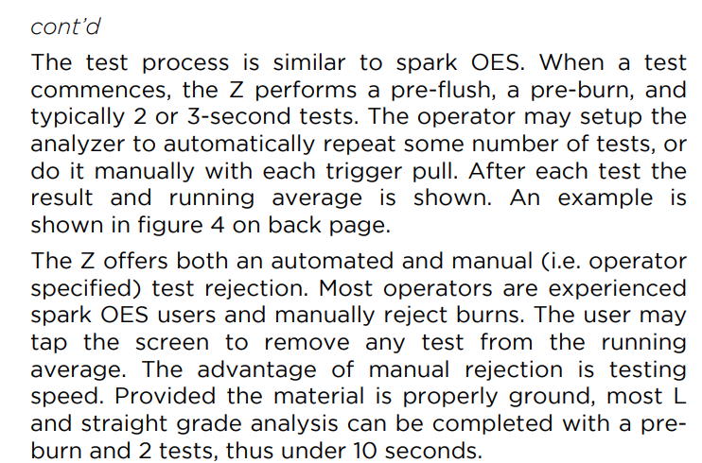 | cont’d
 | The test process is similar to spark OES. When a test commences, the Z performs a pre-flush, a pre-burn, and typically 2 or 3-second tests. The operator may setup the analyzer to automatically repeat some number of tests, or do it manually with each trigger pull. After each test the result and running average is shown. An example is shown in figure 4 on back page.
 | The Z offers both an automated and manual (i.e. operator specified) test rejection. Most operators are experienced spark OES users and manually reject burns. The user may tap the screen to remove any test from the running average. The advantage of manual rejection is testing speed. Provided the material is properly ground, most L and straight grade analysis can be completed with a pre- burn and 2 tests, thus under 10 seconds.
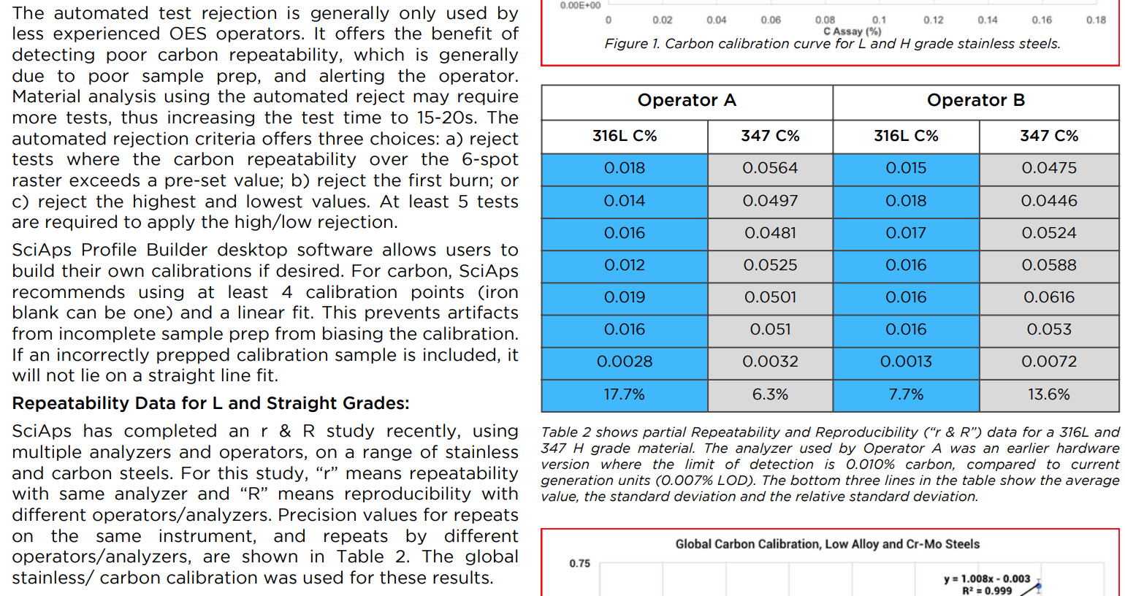 | The automated test rejection is generally only used by less experienced OES operators. It offers the benefit of detecting poor carbon repeatability, which is generally due to poor sample prep, and alerting the operator. Material analysis using the automated reject may require more tests, thus increasing the test time to 15-20s. The automated rejection criteria offers three choices: a) reject tests where the carbon repeatability over the 6-spot raster exceeds a pre-set value; b) reject the first burn; or c) reject the highest and lowest values. At least 5 tests are required to apply the high/low rejection.
 | SciAps Profile Builder desktop software allows users to build their own calibrations if desired. For carbon, SciAps recommends using at least 4 calibration points (iron blank can be one) and a linear fit. This prevents artifacts from incomplete sample prep from biasing the calibration. If an incorrectly prepped calibration sample is included, it will not lie on a straight line fit.
 | Repeatability Data for L and Straight Grades:
 | SciAps has completed an r & R study recently, using multiple analyzers and operators, on a range of stainless and carbon steels. For this study, “r” means repeatability with same analyzer and “R” means reproducibility with different operators/analyzers. Precision values for repeats on the same instrument, and repeats by different operators/analyzers, are shown in Table 2. The global stainless/ carbon calibration was used for these results.
 | Figure 1. Carbon calibration curve for L and H grade stainless steels.
 | Operator A
 | Operator B
 | 316L C%
 | 347 C%
 | 316L C%
 | 347 C%
 | 0.018
 | 0.0564
 | 0.015
 | 0.0475
 | 0.014
 | 0.0497
 | 0.018
 | 0.0446
 | 0.016
 | 0.0481
 | 0.017
 | 0.0524
 | 0.012
 | 0.0525
 | 0.016
 | 0.0588
 | 0.019
 | 0.0501
 | 0.016
 | 0.0616
 | 0.016
 | 0.051
 | 0.016
 | 0.053
 | 0.0028
 | 0.0032
 | 0.0013
 | 0.0072
 | 17.7%
 | 6.3%
 | 7.7%
 | 13.6%
 | Table 2 shows partial Repeatability and Reproducibility (“r & R”) data for a 316L and 347 H grade material. The analyzer used by Operator A was an earlier hardware version where the limit of detection is 0.010% carbon, compared to current generation units (0.007% LOD). The bottom three lines in the table show the average value, the standard deviation and the relative standard deviation.
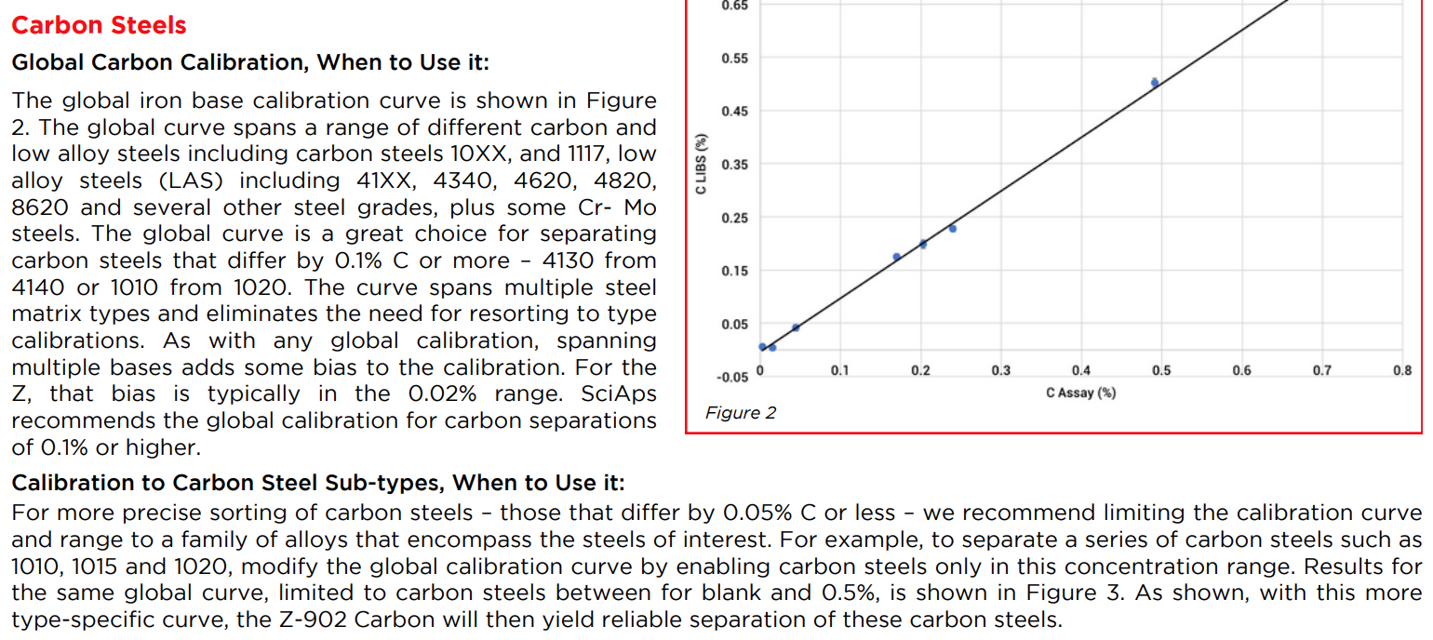 | Carbon Steels
 | Global Carbon Calibration, When to Use it:
 | The global iron base calibration curve is shown in Figure 2. The global curve spans a range of different carbon and low alloy steels including carbon steels 10XX, and 1117, low alloy steels (LAS) including 41XX, 4340, 4620, 4820, 8620 and several other steel grades, plus some Cr- Mo steels. The global curve is a great choice for separating carbon steels that differ by 0.1% C or more – 4130 from 4140 or 1010 from 1020. The curve spans multiple steel matrix types and eliminates the need for resorting to type calibrations. As with any global calibration, spanning multiple bases adds some bias to the calibration. For the Z, that bias is typically in the 0.02% range. SciAps recommends the global calibration for carbon separations of 0.1% or higher.
 | Calibration to Carbon Steel Sub-types, When to Use it:
 | For more precise sorting of carbon steels – those that differ by 0.05% C or less – we recommend limiting the calibration curve and range to a family of alloys that encompass the steels of interest. For example, to separate a series of carbon steels such as 1010, 1015 and 1020, modify the global calibration curve by enabling carbon steels only in this concentration range. Results for the same global curve, limited to carbon steels between for blank and 0.5%, is shown in Figure 3. As shown, with this more type-specific curve, the Z-902 Carbon will then yield reliable separation of these carbon steels.
 | Figure 2
(Page 3)
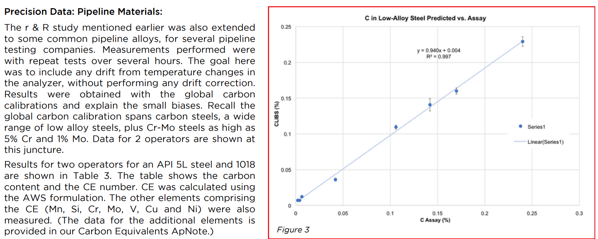 | Precision Data: Pipeline Materials:
 | The r & R study mentioned earlier was also extended to some common pipeline alloys, for several pipeline testing companies. Measurements performed were with repeat tests over several hours. The goal here was to include any drift from temperature changes in the analyzer, without performing any drift correction. Results were obtained with the global carbon calibrations and explain the small biases. Recall the global carbon calibration spans carbon steels, a wide range of low alloy steels, plus Cr-Mo steels as high as 5% Cr and 1% Mo. Data for 2 operators are shown at this juncture.
 | Results for two operators for an API 5L steel and 1018 are shown in Table 3. The table shows the carbon content and the CE number. CE was calculated using the AWS formulation. The other elements comprising the CE (Mn, Si, Cr, Mo, V, Cu and Ni) were also measured. (The data for the additional elements is provided in our Carbon Equivalents ApNote.)
 | Figure 3
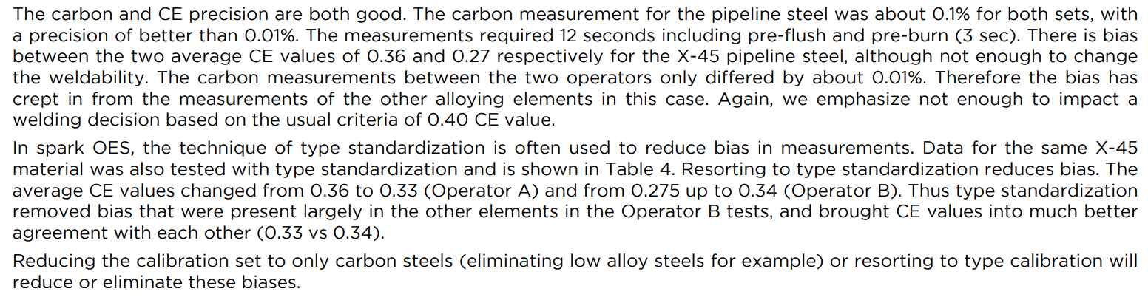 | The carbon and CE precision are both good. The carbon measurement for the pipeline steel was about 0.1% for both sets, with a precision of better than 0.01%. The measurements required 12 seconds including pre-flush and pre-burn (3 sec). There is bias between the two average CE values of 0.36 and 0.27 respectively for the X-45 pipeline steel, although not enough to change the weldability. The carbon measurements between the two operators only differed by about 0.01%. Therefore the bias has crept in from the measurements of the other alloying elements in this case. Again, we emphasize not enough to impact a welding decision based on the usual criteria of 0.40 CE value.
 | In spark OES, the technique of type standardization is often used to reduce bias in measurements. Data for the same X-45material was also tested with type standardization and is shown in Table 4. Resorting to type standardization reduces bias. The average CE values changed from 0.36 to 0.33 (Operator A) and from 0.275 up to 0.34 (Operator B). Thus type standardization removed bias that were present largely in the other elements in the Operator B tests, and brought CE values into much better agreement with each other (0.33 vs 0.34).
 | Reducing the calibration set to only carbon steels (eliminating low alloy steels for example) or resorting to type calibration will reduce or eliminate these biases.
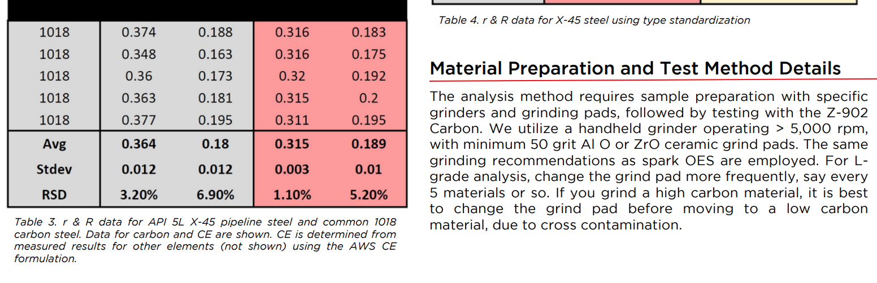 | Table 3. r & R data for API 5L X-45 pipeline steel and common 1018 carbon steel. Data for carbon and CE are shown. CE is determined from measured results for other elements (not shown) using the AWS CE formulation.
 | Table 4. r & R data for X-45 steel using type standardization
 | Material Preparation and Test Method Details
 | The analysis method requires sample preparation with specific grinders and grinding pads, followed by testing with the Z-902 Carbon. We utilize a handheld grinder operating > 5,000 rpm, with minimum 50 grit Al O or ZrO ceramic grind pads. The same grinding recommendations as spark OES are employed. For L- grade analysis, change the grind pad more frequently, say every 5 materials or so. If you grind a high carbon material, it is best to change the grind pad before moving to a low carbon material, due to cross contamination.
(Page 4)
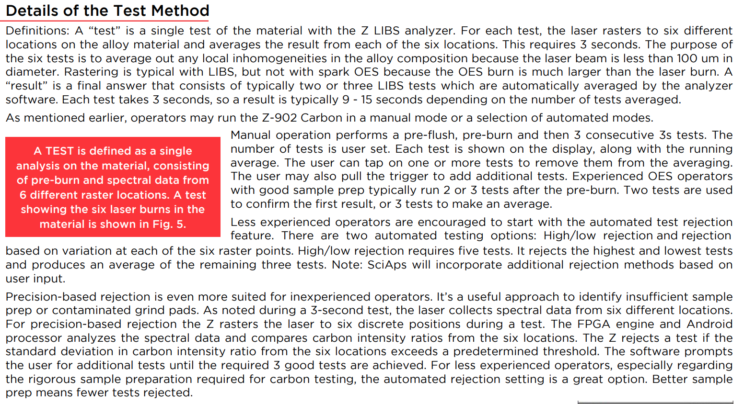 | Details of the Test Method
 | Definitions: A “test” is a single test of the material with the Z LIBS analyzer. For each test, the laser rasters to six different locations on the alloy material and averages the result from each of the six locations. This requires 3 seconds. The purpose of the six tests is to average out any local inhomogeneities in the alloy composition because the laser beam is less than 100 umindiameter. Rastering is typical with LIBS, but not with spark OES because the OES burn is much larger than the laser burn. A“result” is a final answer that consists of typically two or three LIBS tests which are automatically averaged by the analyzer software. Each test takes 3 seconds, so a result is typically 9 - 15 seconds depending on the number of tests averaged.
 | As mentioned earlier, operators may run the Z-902 Carbon in a manual mode or a selection of automated modes. Manual operation performs a pre-flush, pre-burn and then 3 consecutive 3s tests. The number of tests is user set. Each test is shown on the display, along with the running average. The user can tap on one or more tests to remove them from the averaging. The user may also pull the trigger to add additional tests. Experienced OES operators with good sample prep typically run 2 or 3 tests after the pre-burn. Two tests are used to confirm the first result, or 3 tests to make an average.
 | Less experienced operators are encouraged to start with the automated test rejection feature. There are two automated testing options: High/low rejection and rejection based on variation at each of the six raster points. High/low rejection requires five tests. It rejects the highest and lowest tests and produces an average of the remaining three tests. Note: SciAps will incorporate additional rejection methods based on user input.
 | Precision-based rejection is even more suited for inexperienced operators. It’s a useful approach to identify insufficient sample prep or contaminated grind pads. As noted during a 3-second test, the laser collects spectral data from six different locations. For precision-based rejection the Z rasters the laser to six discrete positions during a test. The FPGA engine and Android processor analyzes the spectral data and compares carbon intensity ratios from the six locations. The Z rejects a test if the standard deviation in carbon intensity ratio from the six locations exceeds a predetermined threshold. The software prompts the user for additional tests until the required 3 good tests are achieved. For less experienced operators, especially regarding the rigorous sample preparation required for carbon testing, the automated rejection setting is a great option. Better sample prep means fewer tests rejected.
 | A TEST is defined as a single analysis on the material, consisting of pre-burn and spectral data from 6 different raster locations. A test showing the six laser burns in the material is shown in Fig. 5.
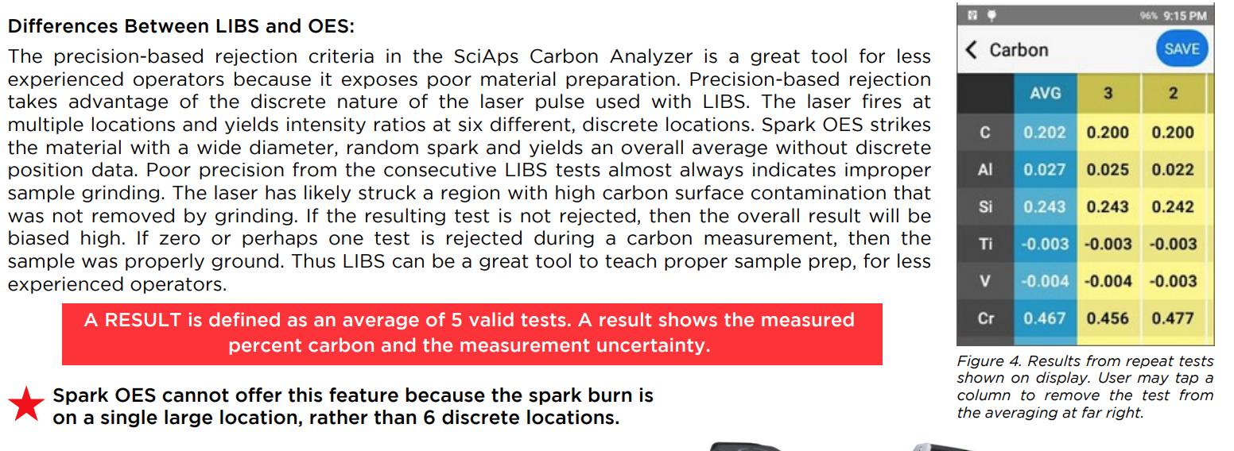 | Differences Between LIBS and OES:
 | The precision-based rejection criteria in the SciAps Carbon Analyzer is a great tool for less experienced operators because it exposes poor material preparation. Precision-based rejection takes advantage of the discrete nature of the laser pulse used with LIBS. The laser fires at multiple locations and yields intensity ratios at six different, discrete locations. Spark OES strikes the material with a wide diameter, random spark and yields an overall average without discrete position data. Poor precision from the consecutive LIBS tests almost always indicates improper sample grinding. The laser has likely struck a region with high carbon surface contamination that was not removed by grinding. If the resulting test is not rejected, then the overall result will be biased high. If zero or perhaps one test is rejected during a carbon measurement, then the sample was properly ground. Thus LIBS can be a great tool to teach proper sample prep, for less experienced operators.
 | A RESULT is defined as an average of 5 valid tests. A result shows the measured percent carbon and the measurement uncertainty.
 | Spark OES cannot offer this feature because the spark burn is on a single large location, rather than 6 discrete locations.
 | Figure 4. Results from repeat tests shown on display. User may tap a column to remove the test from the averaging at far right.
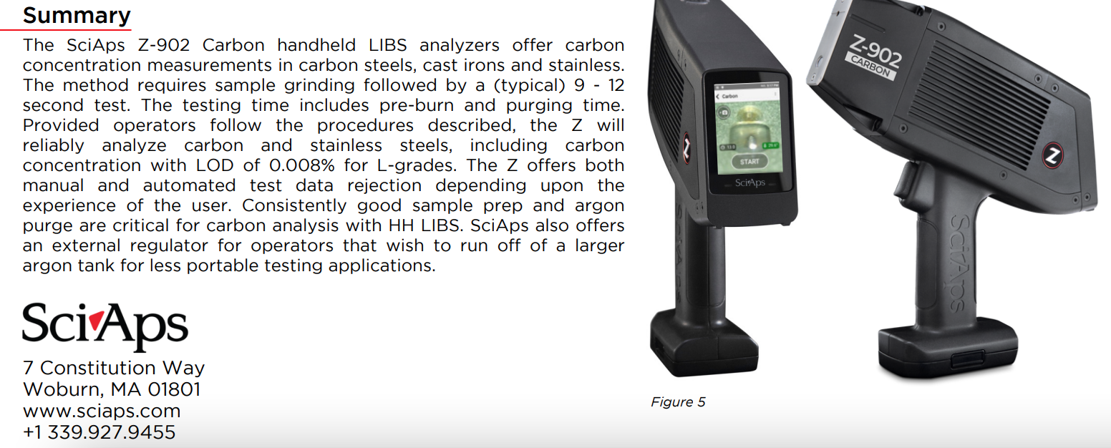 | Summary
 | The SciAps Z-902 Carbon handheld LIBS analyzers offer carbon concentration measurements in carbon steels, cast irons and stainless. The method requires sample grinding followed by a (typical) 9 - 12 second test. The testing time includes pre-burn and purging time. Provided operators follow the procedures described, the Z will reliably analyze carbon and stainless steels, including carbon concentration with LOD of 0.008% for L-grades. The Z offers both manual and automated test data rejection depending upon the experience of the user. Consistently good sample prep and argon purge are critical for carbon analysis with HH LIBS. SciAps also offers an external regulator for operators that wish to run off of a larger argon tank for less portable testing applications.
 | Figure 5
If applicable, please add:
LOCAL COMPANY NAME
LOCAL WEBSITE
LOCAL PHONE

