Document Title: SciAps Carbon Equivalents Measurement with Handheld LIBS
Rev Date: April 2024
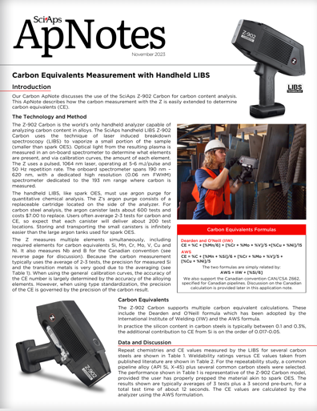
Layout Preview | English Text | Translated Text
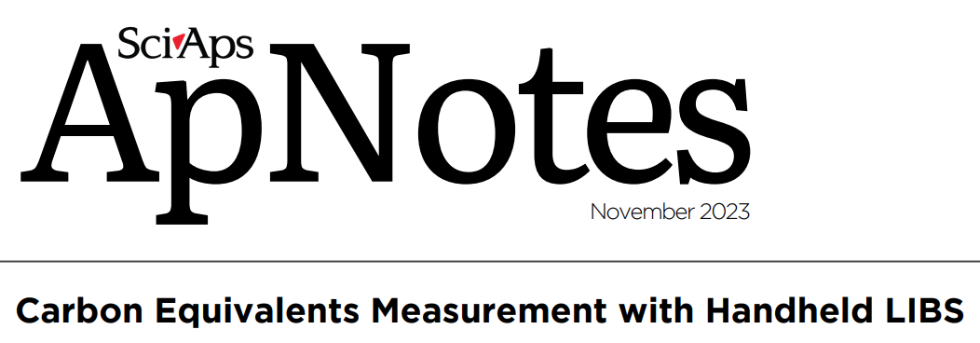 | SciAps
 | ApNotes
 | November 2023
 | Carbon Equivalents Measurement with Handheld LIBS
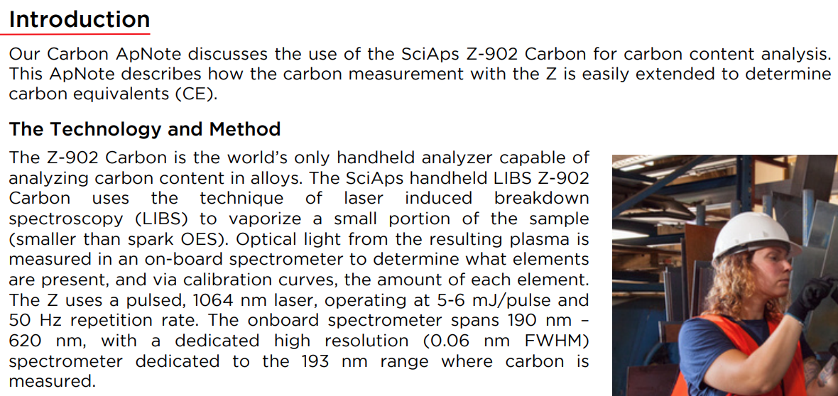 | Introduction
 | Our Carbon ApNote discusses the use of the SciAps Z-902 Carbon for carbon content analysis. This ApNote describes how the carbon measurement with the Z is easily extended to determine carbon equivalents (CE).
 | The Technology and Method
 | The Z-902 Carbon is the world’s only handheld analyzer capable of analyzing carbon content in alloys. The SciAps handheld LIBS Z-902 Carbon uses the technique of laser induced breakdown spectroscopy (LIBS) to vaporize a small portion of the sample (smaller than spark OES). Optical light from the resulting plasma is measured in an on-board spectrometer to determine what elements are present, and via calibration curves, the amount of each element. The Z uses a pulsed, 1064 nm laser, operating at 5-6 mJ/pulse and 50 Hz repetition rate. The onboard spectrometer spans 190 nm – 620 nm, with a dedicated high resolution (0.06 nm FWHM) spectrometer dedicated to the 193 nm range where carbon is measured.
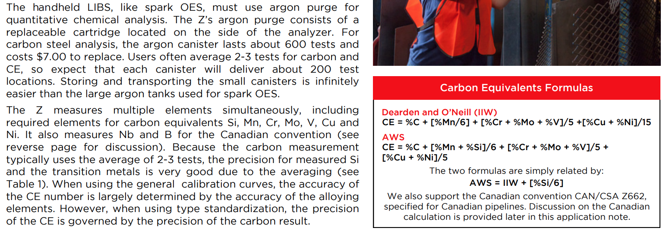 | The handheld LIBS, like spark OES, must use argon purge for quantitative chemical analysis. The Z’s argon purge consists of a replaceable cartridge located on the side of the analyzer. For carbon steel analysis, the argon canister lasts about 600 tests and costs $7.00 to replace. Users often average 2-3 tests for carbon and CE, so expect that each canister will deliver about 200 test locations. Storing and transporting the small canisters is infinitely easier than the large argon tanks used for spark OES.
 | The Z measures multiple elements simultaneously, including required elements for carbon equivalents Si, Mn, Cr, Mo, V, Cu and Ni. It also measures Nb and B for the Canadian convention (see reverse page for discussion). Because the carbon measurement typically uses the average of 2-3 tests, the precision for measured Si and the transition metals is very good due to the averaging (see Table 1). When using the general calibration curves, the accuracy of the CE number is largely determined by the accuracy of the alloying elements. However, when using type standardization, the precision of the CE is governed by the precision of the carbon result.
 | Carbon Equivalents Formulas
 | Dearden and O’Neill (IIW)
 | CE = %C + [%Mn/6] + [%Cr + %Mo + %V]/5 +[%Cu + %Ni]/15
 | AWS
 | CE = %C + [%Mn + %Si]/6 + [%Cr + %Mo + %V]/5 + [%Cu + %Ni]/5
 | The two formulas are simply related by:
 | AWS = IIW + [%Si/6]
 | We also support the Canadian convention CAN/CSA Z662, specified for Canadian pipelines. Discussion on the Canadian calculation is provided later in this application note.
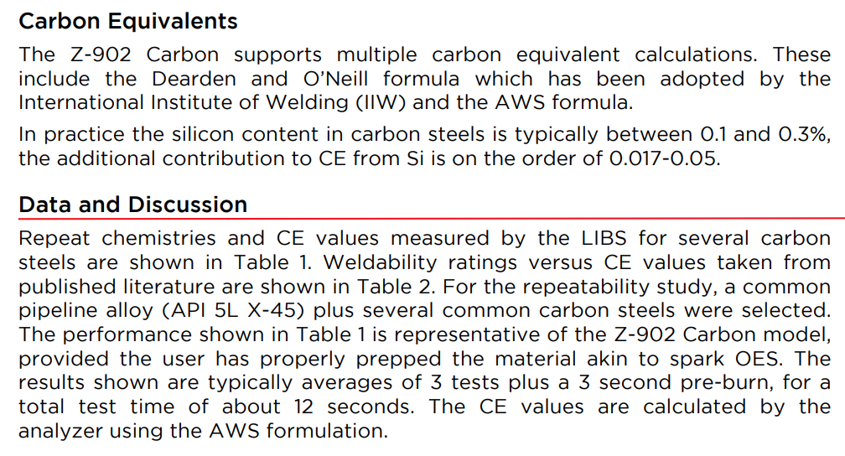 | Carbon Equivalents
 | The Z-902 Carbon supports multiple carbon equivalent calculations. These include the Dearden and O’Neill formula which has been adopted by the International Institute of Welding (IIW) and the AWS formula.
 | In practice the silicon content in carbon steels is typically between 0.1 and 0.3%, the additional contribution to CE from Si is on the order of 0.017-0.05.
 | Data and Discussion
 | Repeat chemistries and CE values measured by the LIBS for several carbon steels are shown in Table 1. Weldability ratings versus CE values taken frompublished literature are shown in Table 2. For the repeatability study, a common pipeline alloy (API 5L X-45) plus several common carbon steels were selected. The performance shown in Table 1 is representative of the Z-902 Carbon model, provided the user has properly prepped the material akin to spark OES. The results shown are typically averages of 3 tests plus a 3 second pre-burn, for a total test time of about 12 seconds. The CE values are calculated by the analyzer using the AWS formulation.
(BACK)
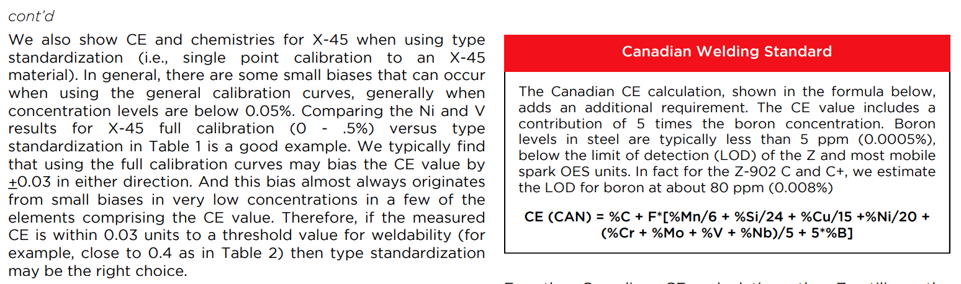 | cont’d
 | We also show CE and chemistries for X-45 when using type standardization (i.e., single point calibration to an X-45 material). In general, there are some small biases that can occur when using the general calibration curves, generally when concentration levels are below 0.05%. Comparing the Ni and V results for X-45 full calibration (0 - .5%) versus type standardization in Table 1 is a good example. We typically find that using the full calibration curves may bias the CE value by _0.03 in either direction. And this bias almost always originates from small biases in very low concentrations in a few of the elements comprising the CE value. Therefore, if the measured CE is within 0.03 units to a threshold value for weldability (for example, close to 0.4 as in Table 2) then type standardization may be the right choice.
 | Canadian Welding Standard
 | The Canadian CE calculation, shown in the formula below, adds an additional requirement. The CE value includes a contribution of 5 times the boron concentration. Boron levels in steel are typically less than 5 ppm (0.0005%), below the limit of detection (LOD) of the Z and most mobile spark OES units. In fact for the Z-902 C and C+, we estimate the LOD for boron at about 80 ppm (0.008%)
 | CE (CAN) = %C + F*[%Mn/6 + %Si/24 + %Cu/15 +%Ni/20 + (%Cr + %Mo + %V + %Nb)/5 + 5*%B]
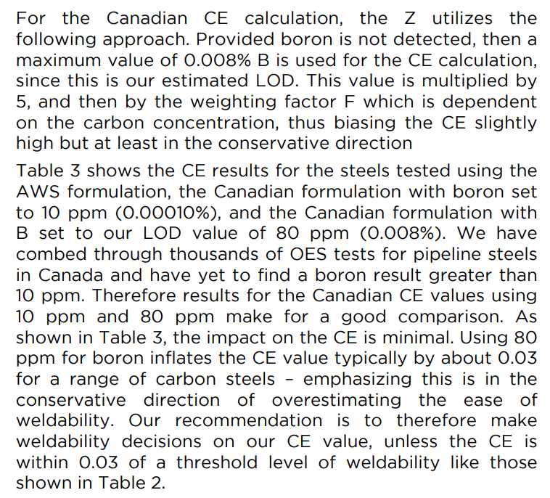 | For the Canadian CE calculation, the Z utilizes the following approach. Provided boron is not detected, then a maximum value of 0.008% B is used for the CE calculation, since this is our estimated LOD. This value is multiplied by 5, and then by the weighting factor F which is dependent on the carbon concentration, thus biasing the CE slightly high but at least in the conservative direction.
 | Table 3 shows the CE results for the steels tested using the AWS formulation, the Canadian formulation with boron set to 10 ppm (0.00010%), and the Canadian formulation with B set to our LOD value of 80 ppm (0.008%). We have combed through thousands of OES tests for pipeline steels in Canada and have yet to find a boron result greater than 10 ppm. Therefore results for the Canadian CE values using 10 ppm and 80 ppm make for a good comparison. As shown in Table 3, the impact on the CE is minimal. Using 80 ppm for boron inflates the CE value typically by about 0.03 for a range of carbon steels – emphasizing this is in the conservative direction of overestimating the ease of weldability. Our recommendation is to therefore make weldability decisions on our CE value, unless the CE is within 0.03 of a threshold level of weldability like those shown in Table 2.
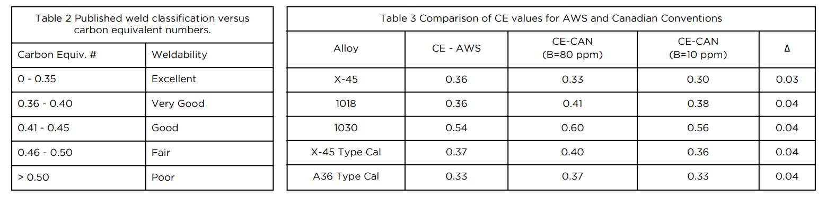 | Table 2 Published weld classification versus carbon equivalent numbers.
 | Carbon Equiv. #
 | Weldability
 | 0 - 0.35
 | Excellent
 | 0.36 - 0.40
 | Very Good
 | 0.41 - 0.45
 | Good
 | 0.46 - 0.50
 | Fair
 | > 0.50
 | Poor
 | Table 3 Comparison of CE values for AWS and Canadian Conventions
 | Alloy
 | CE - AWS
 | CE-CAN (B=80 ppm)
 | CE-CAN (B=10 ppm)
 | Δ
 | X-45
 | 0.36
 | 0.33
 | 0.30
 | 0.03
 | 1018
 | 0.36
 | 0.41
 | 0.38
 | 0.04
 | 1030
 | 0.54
 | 0.60
 | 0.56
 | 0.04
 | X-45 Type Cal
 | 0.37
 | 0.40
 | 0.36
 | 0.04
 | A36 Type Cal
 | 0.33
 | 0.37
 | 0.33
 | 0.04
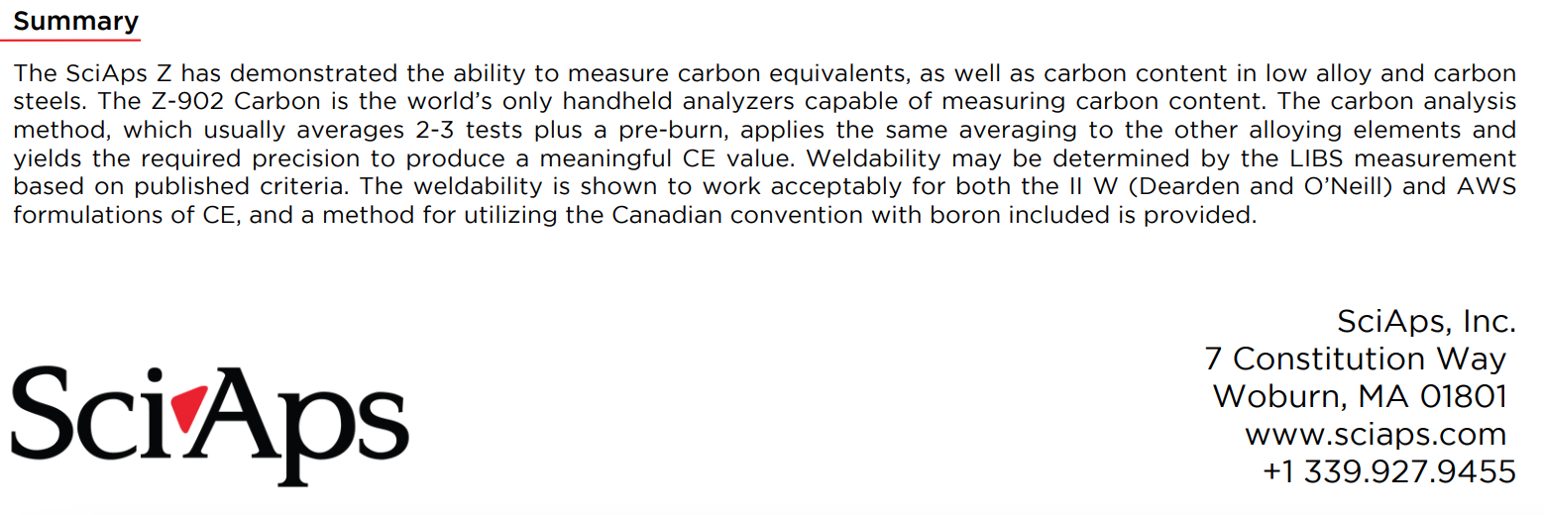 | Summary
 | The SciAps Z has demonstrated the ability to measure carbon equivalents, as well as carbon content in low alloy and carbon steels. The Z-902 Carbon is the world’s only handheld analyzers capable of measuring carbon content. The carbon analysis method, which usually averages 2-3 tests plus a pre-burn, applies the same averaging to the other alloying elements and yields the required precision to produce a meaningful CE value. Weldability may be determined by the LIBS measurement based on published criteria. The weldability is shown to work acceptably for both the II W (Dearden and O’Neill) and AWS formulations of CE, and a method for utilizing the Canadian convention with boron included is provided.
If applicable, please add:
LOCAL COMPANY NAME
LOCAL WEBSITE
LOCAL PHONE

