Document Title: SciAps ApNote -Detection of trace elements in steel piping and components susceptible to FAC using handheld XRF
Rev Date: April 2024
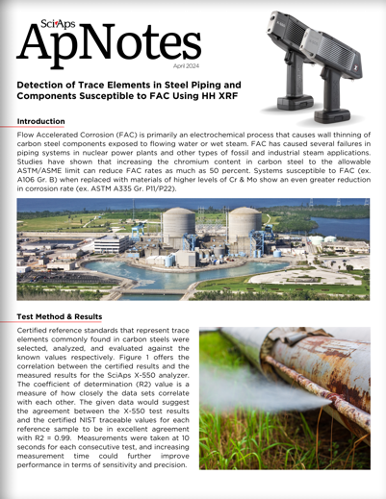
Layout Preview | English Text | Translated Text
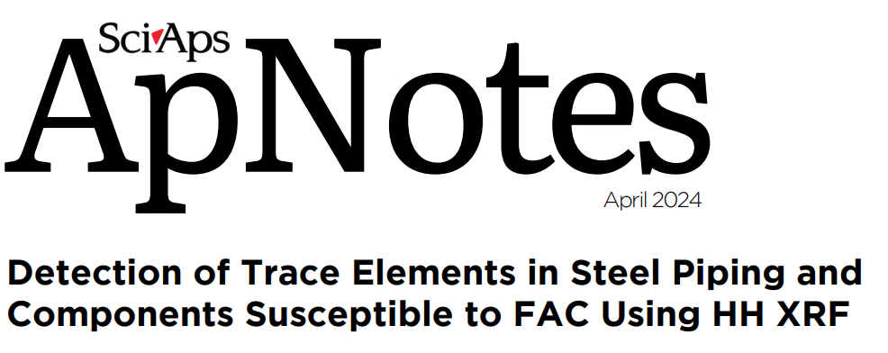 | SciAps
 | ApNotes
 | April 2024
 | Detection of Trace Elements in Steel Piping and Components Susceptible to FAC Using HH XRF
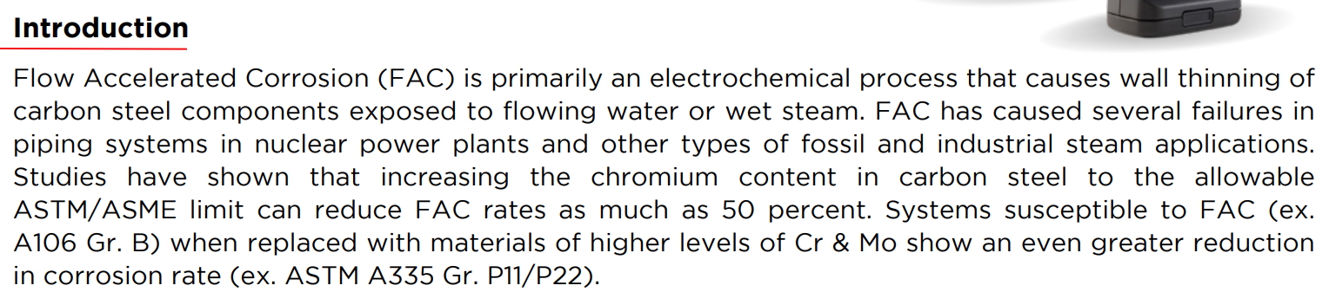 | Introduction
 | Flow Accelerated Corrosion (FAC) is primarily an electrochemical process that causes wall thinning of carbon steel components exposed to flowing water or wet steam. FAC has caused several failures in piping systems in nuclear power plants and other types of fossil and industrial steam applications. Studies have shown that increasing the chromium content in carbon steel to the allowable ASTM/ASME limit can reduce FAC rates as much as 50 percent. Systems susceptible to FAC (ex. A106 Gr. B) when replaced with materials of higher levels of Cr & Mo show an even greater reduction in corrosion rate (ex. ASTM A335 Gr. P11/P22).
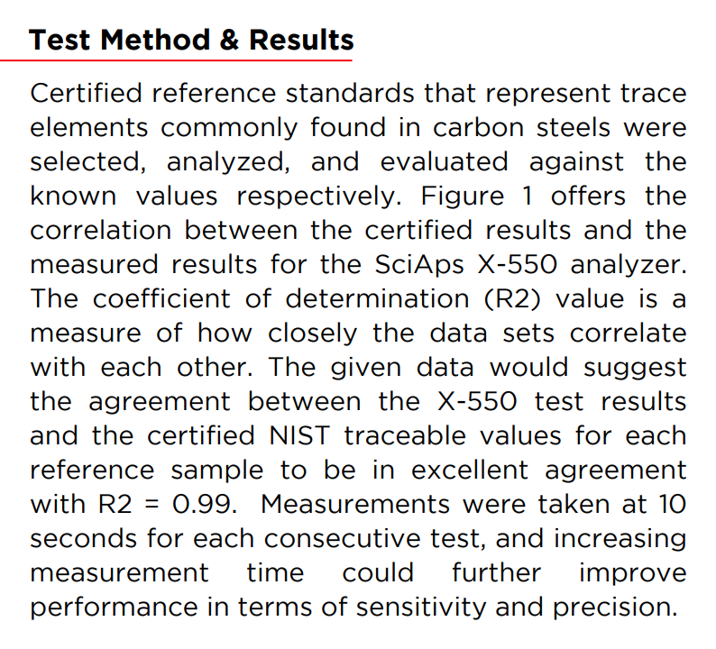 | Test Method & Results
 | Certified reference standards that represent trace elements commonly found in carbon steels were selected, analyzed, and evaluated against the known values respectively. Figure 1 offers the correlation between the certified results and the measured results for the SciAps X-550 analyzer. The coefficient of determination (R2) value is a measure of how closely the data sets correlate with each other. The given data would suggest the agreement between the X-550 test results and the certified NIST traceable values for each reference sample to be in excellent agreement with R2 = 0.99. Measurements were taken at 10 seconds for each consecutive test, and increasing measurement time could further improve performance in terms of sensitivity and precision.
(BACK)
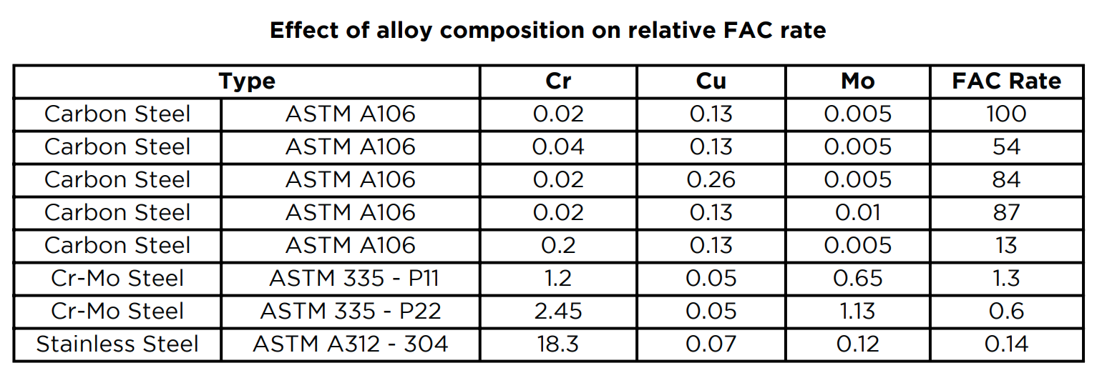 | Effect of alloy composition on relative FAC rate
 | Type
 | Cr
 | Cu
 | Mo
 | FAC Rate
 | Carbon Steel
 | Carbon Steel
 | Carbon Steel
 | Carbon Steel
 | Carbon Steel
 | Cr-Mo Steel
 | Cr-Mo Steel
 | Stainless Steel
 | ASTM A106
 | ASTM A106
 | ASTM A106
 | ASTM A106
 | ASTM A106
 | ASTM 335 - P11
 | ASTM 335 - P22
 | ASTM A312 - 304
 | 0.02
 | 0.04
 | 0.02
 | 0.02
 | 0.2
 | 1.2
 | 2.45
 | 18.3
 | 0.13
 | 0.13
 | 0.26
 | 0.13
 | 0.13
 | 0.05
 | 0.05
 | 0.07
 | 0.005
 | 0.005
 | 0.005
 | 0.01
 | 0.005
 | 0.65
 | 1.13
 | 0.12
 | 100
 | 54
 | 84
 | 87
 | 13
 | 1.3
 | 0.6
 | 0.14
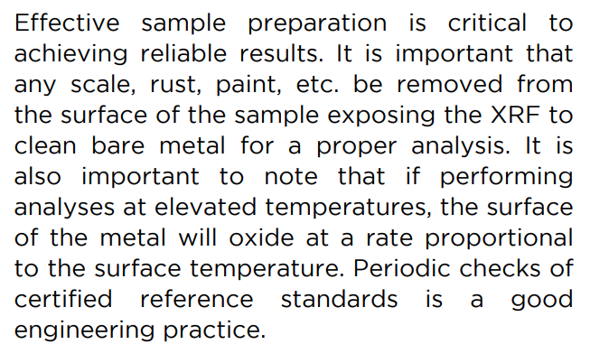 | Effective sample preparation is critical to achieving reliable results. It is important that any scale, rust, paint, etc. be removed from the surface of the sample exposing the XRF to clean bare metal for a proper analysis. It is also important to note that if performing analyses at elevated temperatures, the surface of the metal will oxide at a rate proportional to the surface temperature. Periodic checks of certified reference standards is a good engineering practice.
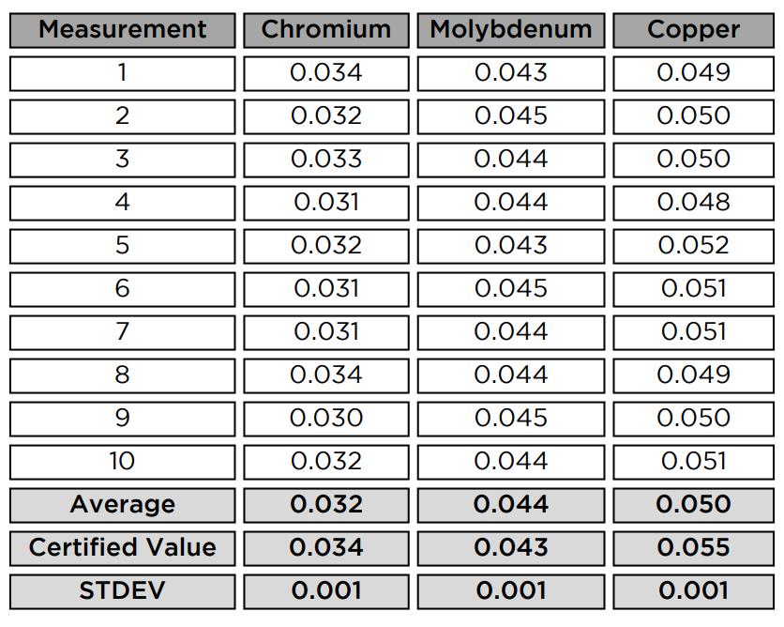 | Measurement
 | 1
 | 2
 | 3
 | 4
 | 5
 | 6
 | 7
 | 8
 | 9
 | 10
 | Average
 | Certified Value
 | STDEV
 | Chromium
 | 0.034
 | 0.032
 | 0.033
 | 0.031
 | 0.032
 | 0.031
 | 0.031
 | 0.034
 | 0.030
 | 0.032
 | 0.032
 | 0.034
 | 0.001
 | Molybdenum
 | 0.043
 | 0.045
 | 0.044
 | 0.044
 | 0.043
 | 0.045
 | 0.044
 | 0.044
 | 0.045
 | 0.044
 | 0.044
 | 0.043
 | 0.001
 | Copper
 | 0.049
 | 0.050
 | 0.050
 | 0.048
 | 0.052
 | 0.051
 | 0.051
 | 0.049
 | 0.050
 | 0.051
 | 0.050
 | 0.055
 | 0.001
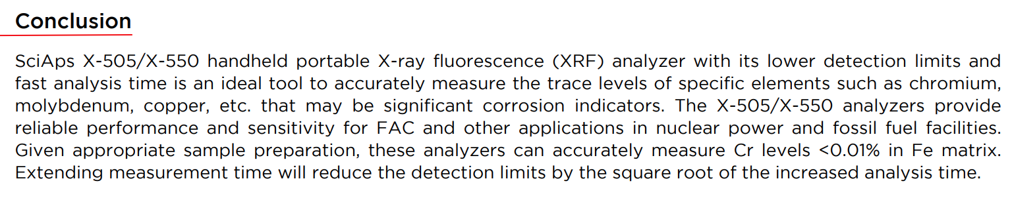 | Conclusion
 | SciAps X-505/X-550 handheld portable X-ray fluorescence (XRF) analyzer with its lower detection limits and fast analysis time is an ideal tool to accurately measure the trace levels of specific elements such as chromium, molybdenum, copper, etc. that may be significant corrosion indicators. The X-505/X-550 analyzers provide reliable performance and sensitivity for FAC and other applications in nuclear power and fossil fuel facilities. Given appropriate sample preparation, these analyzers can accurately measure Cr levels.
 | If applicable, please add:  LOCAL COMPANY NAME  LOCAL WEBSITE  LOCAL PHONE

