SciAps TranslationTable X-5 Precious Metals Specifications
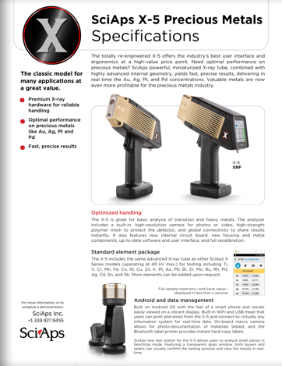Rev Date: Jan 2024
Layout Preview | English Text | Translated Text
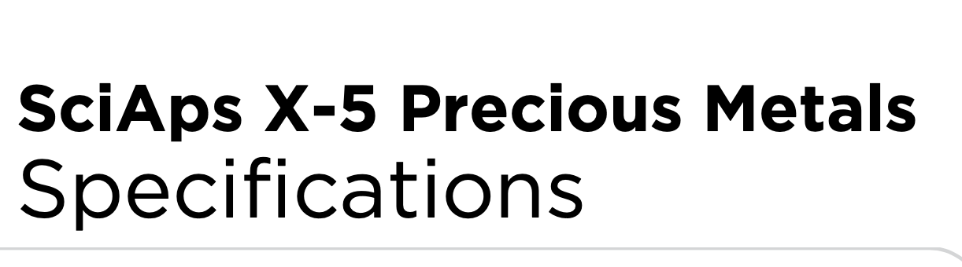 | SciAps X-5
 | Precious Metals
 | Specifications
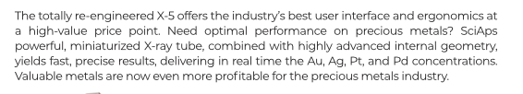 | The totally re-engineered X-5 offers the industry’s best user interface and ergonomics at a high-value price point. Need optimal performance on precious metals? SciAps powerful, miniaturized X-ray tube, combined with highly advanced internal geometry, yields fast, precise results, delivering in real time the Au, Ag, Pt, and Pd concentrations. Valuable metals are now even more profitable for the precious metals industry.
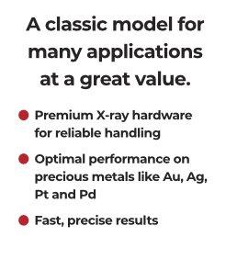 | A classic model for many applications at a great value.
 | Premium X-ray hardware for reliable handling
 | Optimal performance on precious metals like Au, Ag, Pt and Pd
 | Fast, precise results
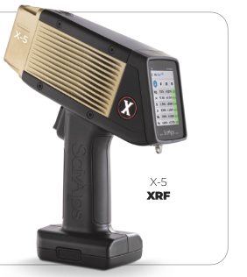 | X-5
 | XRF
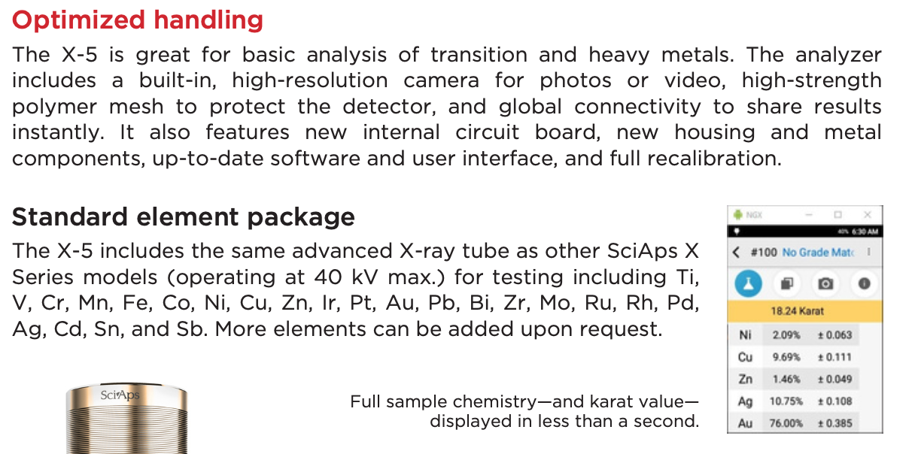 | Optimized handling
 | The X-5 is great for basic analysis of transition and heavy metals. The analyzer includes a built-in, high-resolution camera for photos or video, high-strength polymer mesh to protect the detector, and global connectivity to share results instantly. It also features new internal circuit board, new housing and metal components, up-to-date software and user interface, and full recalibration.
 | Standard element package
 | The X-5 includes the same advanced X-ray tube as other SciAps X Series models (operating at 40 kV max.) for testing including Ti, V, Cr, Mn, Fe, Co, Ni, Cu, Zn, Ir, Pt, Au, Pb, Bi, Zr, Mo, Ru, Rh, Pd, Ag, Cd, Sn, and Sb. More elements can be added upon request.
Full sample chemistry—and karat value—
displayed in less than a second.
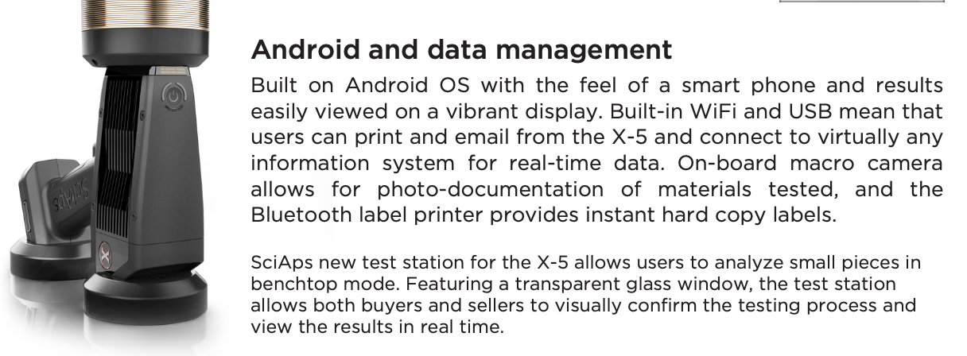 | Android and data management
 | Built on Android OS with the feel of a smart phone and results easily viewed on a vibrant display. Built-in WiFi and USB mean that users can print and email from the X-5 and connect to virtually any information system for real-time data. On-board macro camera allows for photo-documentation of materials tested, and the Bluetooth label printer provides instant hard copy labels.
 | SciAps new test station for the X-5 allows users to analyze small pieces in benchtop mode. Featuring a transparent glass window, the test station allows both buyers and sellers to visually confirm the testing process and view the results in real time.
 | For more information, or to schedule a demonstration:
If applicable, please add:
LOCAL COMPANY NAME
LOCAL WEBSITE
LOCAL PHONE

(BACK)
 | SciAps X-5
 | Precious Metals
 | Specifications
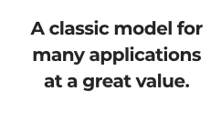 | A classic model for many applications at a great value.
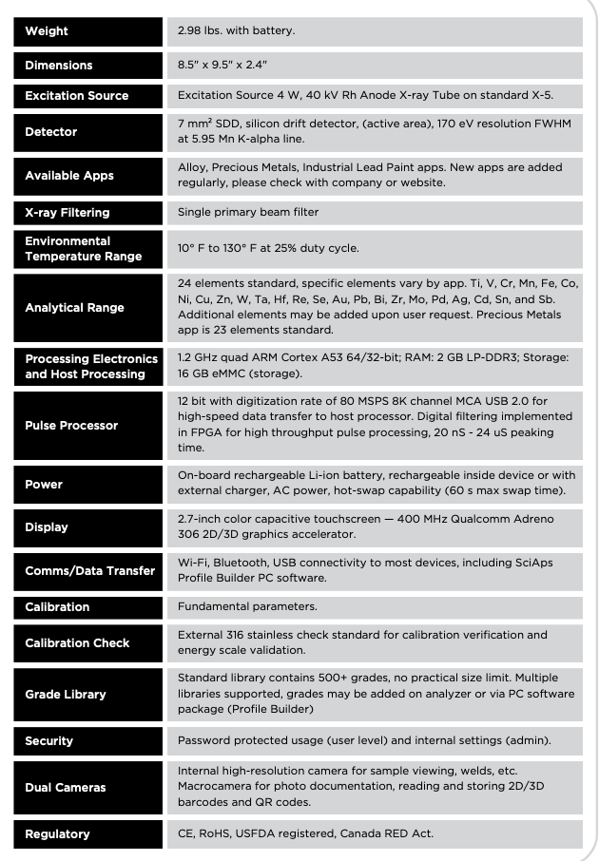 | Weight
 | 2.98 lbs. with battery.
 | Dimensions
 | 8.5" x 9.5" x 2.4"
 | Excitation Source
 | 4 W, 40 kV Rh Anode X-ray Tube on standard X-5.
 | Detector
 | 7 mm2 SDD, silicon drift detector, (active area), 170 eV resolution FWHM at 5.95 Mn K-alpha line.
 | Available Apps
 | Alloy, Precious Metals, Industrial Lead Paint apps. New apps are added regularly, please check with company or website.
 | X-ray Filtering
 | Single primary beam filter
Environmental
Temperature Range
 | 10F to 130F at 25% duty cycle.
 | Analytical Range
 | 24 elements standard, specific elements vary by app. Ti, V, Cr, Mn, Fe, Co, Ni, Cu, Zn, W, Ta, Hf, Re, Se, Au, Pb, Bi, Zr, Mo, Pd, Ag, Cd, Sn, and Sb. Additional elements may be added upon user request. Precious Metals app is 23 elements standard.
Processing Electronics
and Host Processing
 | 1.2 GHz quad ARM Cortex A53 64/32-bit; RAM: 2 GB LP-DDR3; Storage: 16 GB eMMC (storage).
 | Pulse Processor
 | 12 bit with digitization rate of 80 MSPS 8K channel MCA USB 2.0 for high-speed data transfer to host processor. Digital filtering implemented in FPGA for high throughput pulse processing, 20 nS - 24 uS peaking time.
 | Power
 | On-board rechargeable Li-ion battery, rechargeable inside device or with external charger, AC power, hot-swap capability (60 s max swap time).
 | Display
 | 2.7-inch color capacitive touchscreen — 400 MHz Qualcomm Adreno 306 2D/3D graphics accelerator.
 | Comms/Data Transfer
 | Wi-Fi, Bluetooth, USB connectivity to most devices, including SciAps Profile Builder PC software.
 | Calibration
 | Fundamental parameters.
 | Calibration Check
 | External 316 stainless check standard for calibration verification and energy scale validation.
 | Grade Library
 | Standard library contains 500+ grades, no practical size limit. Multiple libraries supported, grades may be added on analyzer or via PC software package (Profile Builder)
 | Security
 | Password protected usage (user level) and internal settings (admin).
 | Dual Cameras
 | Internal high-resolution camera for sample viewing, welds, etc. Macrocamera for photo documentation, reading and storing 2D/3D barcodes and QR codes.
 | Regulatory
 | CE, RoHS, USFDA registered, Canada RED Act.
 | YouTube.com/SciAps
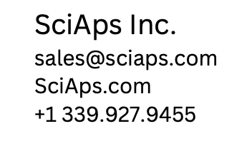 | If applicable, please add:  LOCAL COMPANY NAME  LOCAL WEBSITE  LOCAL PHONE

