Document Title: SciAps NDT-PMI Brochure
Rev Date: Feb 2024
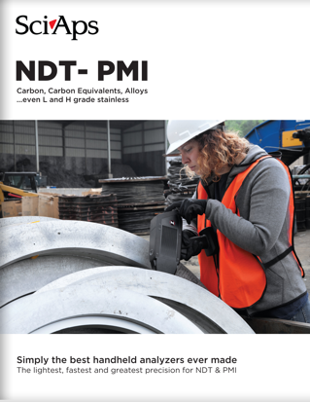
Layout Preview | English Text | Translated Text
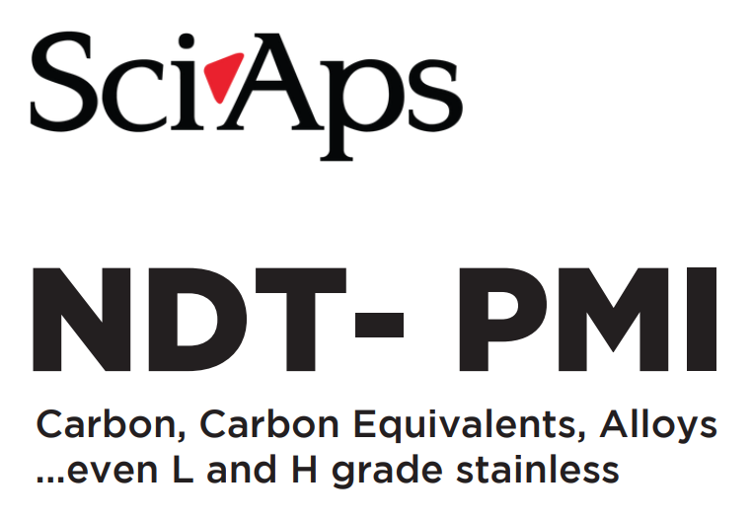 | SciAps
 | NDT-PMI
 | Carbon, Carbon Equivalents, Alloys
 | ...even L and H grade stainless
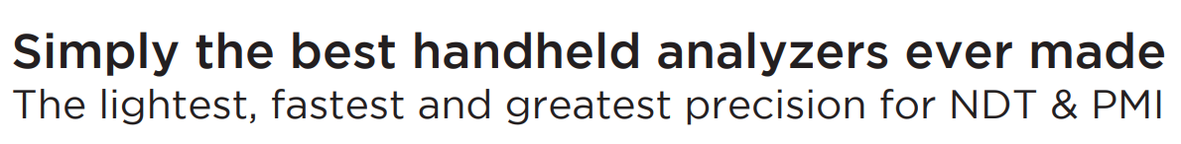 | Simply the best handheld analyzers ever made
 | The lightest, fastest and greatest precision for NDT & PMI
[Page 2]
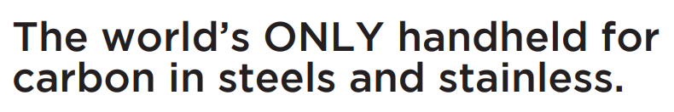 | The world’s ONLY handheld for carbon in steels and stainless.
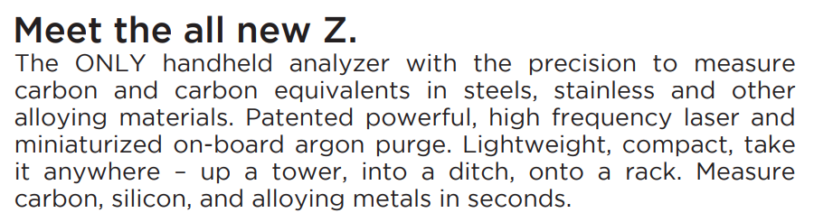 | Meet the all new Z.
 | The ONLY handheld analyzer with the precision to measure carbon and carbon equivalents in steels, stainless and other alloying materials. Patented powerful, high frequency laser and miniaturized on-board argon purge. Lightweight, compact, take it anywhere – up a tower, into a ditch, onto a rack. Measure carbon, silicon, and alloying metals in seconds.
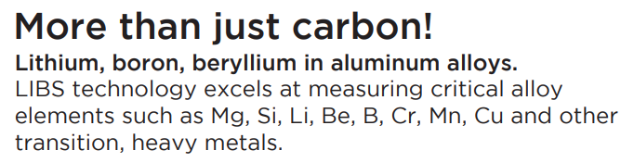 | More than just carbon!
 | Lithium, boron, beryllium in aluminum alloys.
 | LIBS technology excels at measuring critical alloy elements such as Mg, Si, Li, Be, B, Cr, Mn, Cu and other transition, heavy metals.
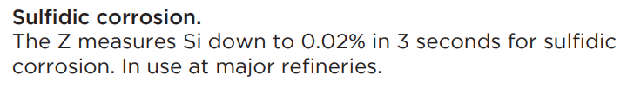 | Sulfidic corrosion.
 | The Z measures Si down to 0.02% in 3 seconds for sulfidic corrosion. In use at major refineries.
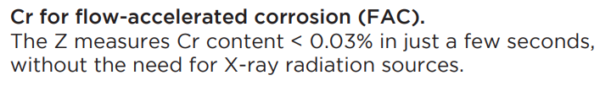 | Cr for flow-accelerated corrosion (FAC).
 | The Z measures Cr content < 0.03% in just a few seconds, without the need for X-ray radiation sources.
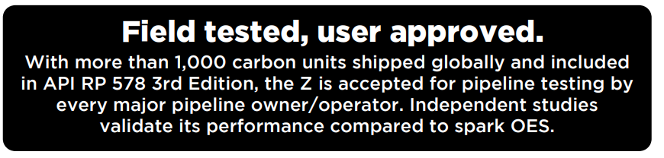 | Field tested, user approved.
 | With more than 1,000 carbon units shipped globally and included in API RP 578 3rd Edition, the Z is accepted for pipeline testing by every major pipeline owner/operator. Independent studies validate its performance compared to spark OES.
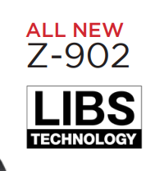 | All New
 | Z-902
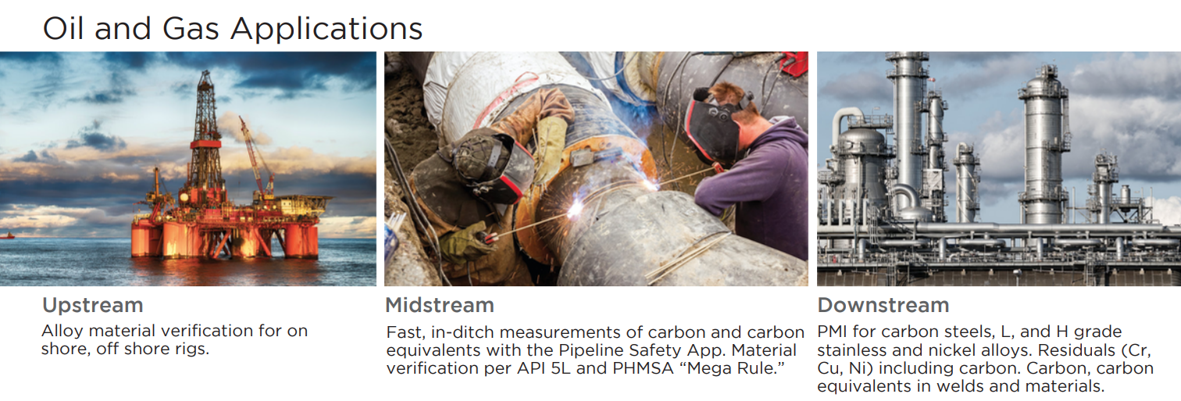 | Oil and Gas Applications
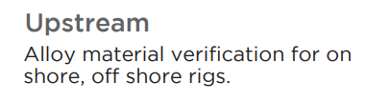 | Upstream
 | Alloy material verification for on shore, off shore rigs.
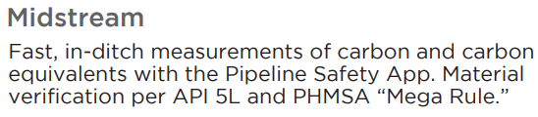 | Midstream
 | Fast, in-ditch measurements of carbon and carbon equivalents with the Pipeline Safety App. Material verification per API 5L and PHMSA “Mega Rule.”
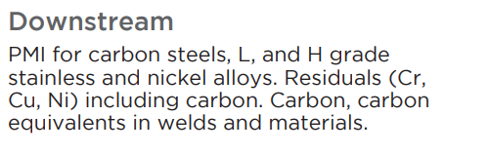 | Downstream
 | PMI for carbon steels, L, and H grade stainless and nickel alloys. Residuals (Cr, Cu, Ni) including carbon. Carbon, carbon equivalents in welds and materials.
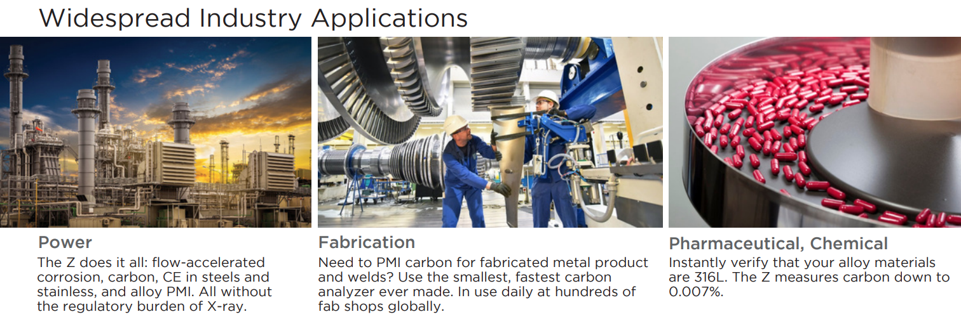 | Widespread Industry Applications
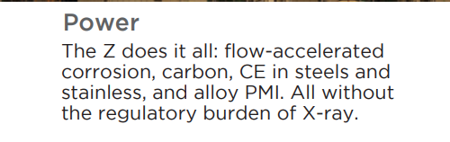 | Power
 | The Z does it all: flow-accelerated corrosion, carbon, CE in steels and stainless, and alloy PMI. All without the regulatory burden of X-ray.
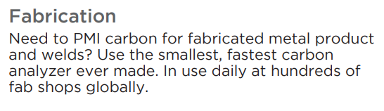 | Fabrication
 | Need to PMI carbon for fabricated metal product and welds? Use the smallest, fastest carbon analyzer ever made. In use daily at hundreds of fab shops globally.
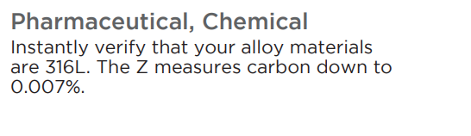 | Pharmaceutical, Chemical
 | Instantly verify that your alloy materials are 316L. The Z measures carbon down to 0.007%.
[Page 3]
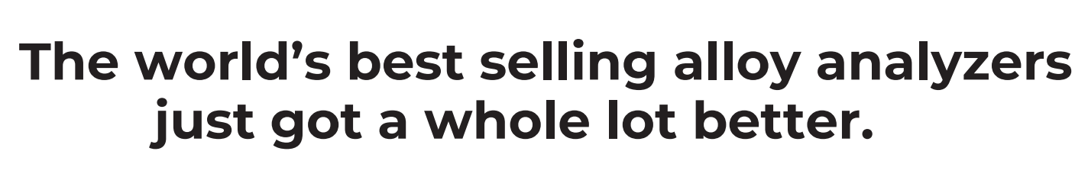 | The world’s best selling alloy analyzers just got a whole lot better.
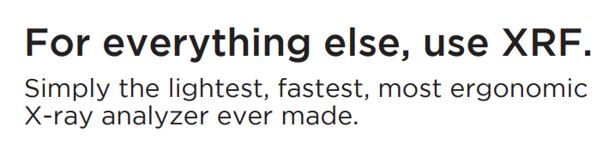 | For everything else, use XRF
 | Simply the lightest, fastest, most ergonomic X-ray analyzer ever made.
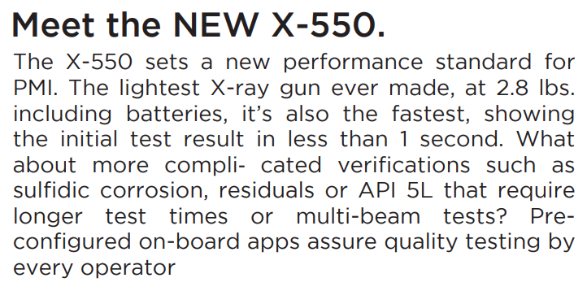 | Meet the New X-550
 | The X-550 sets a new performance standard for PMI. The lightest X-ray gun ever made, at 2.8 lbs. including batteries, it’s also the fastest, showing the initial test result in less than 1 second. What about more complicated verifications such as sulfidic corrosion, residuals or API 5L that require longer test times or multi-beam tests? Preconfigured on-board apps assure quality testing by every operator.
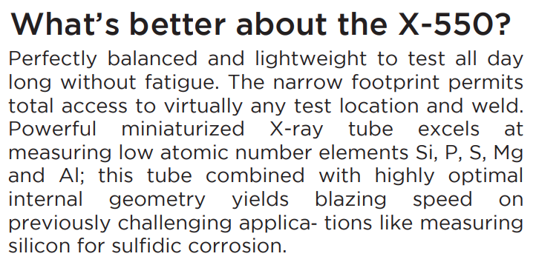 | What’s better about the X-550?
 | Perfectly balanced and lightweight to test all day long without fatigue. The narrow footprint permits total access to virtually any test location and weld. Powerful miniaturized X-ray tube excels at measuring low atomic number elements Si, P, S, Mg and Al; this tube combined with highly optimal internal geometry yields blazing speed on previously challenging applications like measuring silicon for sulfidic corrosion.
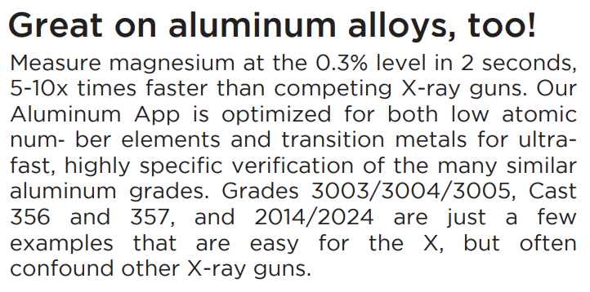 | Great on aluminum alloys, too!
 | Measure magnesium at the 0.3% level in 2 seconds, 5-10x times faster than competing X-ray guns. Our Aluminum App is optimized for both low atomic number elements and transition metals for ultrafast, highly specific verification of the many similar aluminum grades. Grades 3003/3004/3005, Cast 356 and 357, and 2014/2024 are just a few examples that are easy for the X, but often confound other X-ray guns.
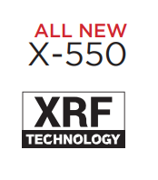 | All New
 | X-550
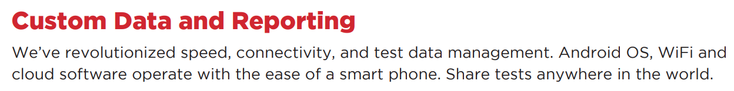 | Custom Data and Reporting
 | We’ve revolutionized speed, connectivity, and test data management. Android OS, WiFi and cloud software operates with the ease of a smart phone. Share tests anywhere in the world.
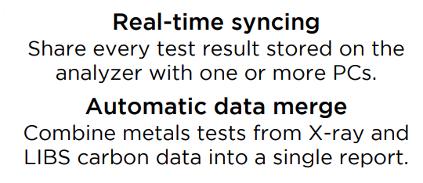 | Real-time syncing
 | Share every test result stored on the analyzer with one or more PCs.
 | Automatic data merge
 | Combine metals tests from X-ray and LIBS carbon data into a single report.
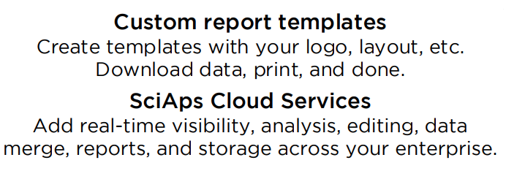 | Custom report templates
 | Create templates with your logo, layout, etc. Download data, print, and done.
 | SciAps Cloud Services
 | Add real-time visibility, analysis, editing, data merge, reports, and storage across your enterprise.
[Page 4]
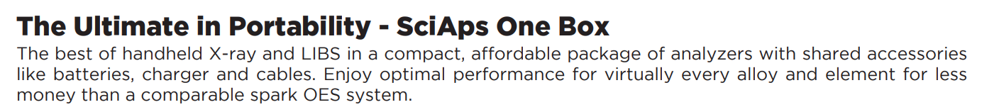 | The Ultimate in Portability - SciAps One Box
 | The best of handheld X-ray and LIBS in a compact, affordable package of analyzers with shared accessories like batteries, charger and cables. Enjoy optimal performance for virtually every alloy and element for less money than a comparable spark OES system.
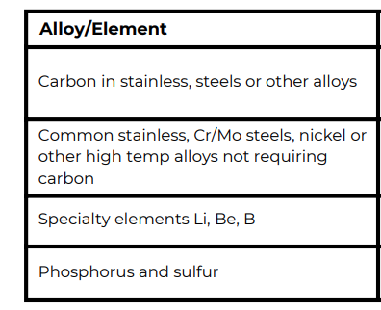 | Alloy/Element
 | Carbon in stainless, steels or other alloys
 | Common stainless, Cr/Mo steels, nickel or other high temp alloys not requiring carbon
 | Specialty elements Li, Be, B
 | Phosphorus and sulfur
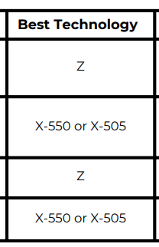 | Best Technology
 | Z
 | X-550 or X-505
 | Z
 | X-550 or X-505
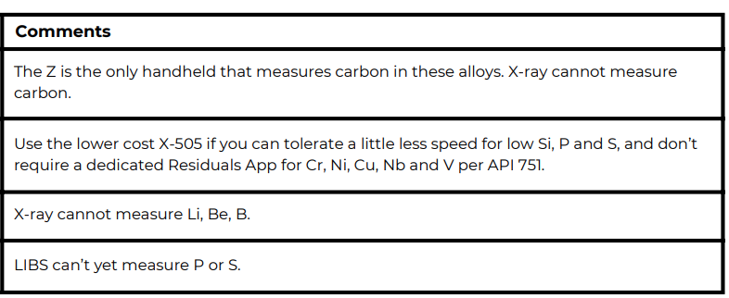 | Comments
 | The Z is the only handheld that measures carbon in these alloys. X-ray cannot measure carbon.
 | Use the lower cost X-505 if you can tolerate a little less speed for low Si, P and S, and don’t require a dedicated Residuals App for Cr, Ni, Cu, Nb and V per API 751.
 | X-ray cannot measure Li, Be, B.
 | LIBS can’t yet measure P or S.
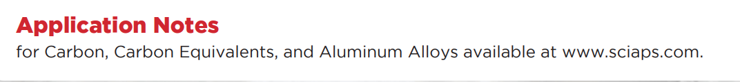 | Application Notes
 | for Carbon, Carbon Equivalents, and Aluminum Alloys available at www.sciaps.com.
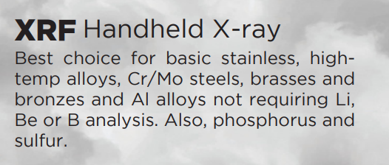 | XRF Handheld X-ray
 | Best choice for basic stainless, high temp alloys, Cr/Mo steels, brasses and bronzes and Al alloys not requiring Li, Be or B analysis. Also, phosphorus and sulfur.
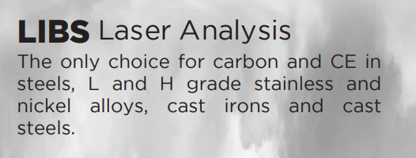 | LIBS Laser Analysis
 | The only choice for carbon and CE in steels, L and H grade stainless and nickel alloys, cast irons and cast steels.
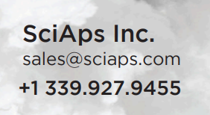 | If applicable, please add:  LOCAL COMPANY NAME  LOCAL WEBSITE  LOCAL PHONE
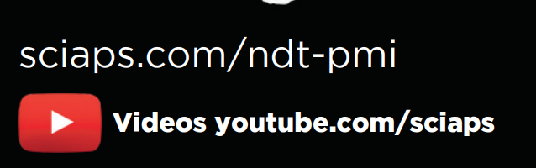 | sciaps.com/ndt-pmi
 | Videos youtube.com/sciaps

