Document Title: SciAps Z-9 Liquidator Specifications
Rev Date: 0823
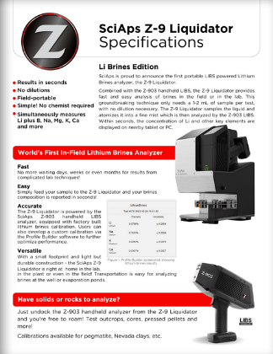
Layout Preview | English Text | Translated Text
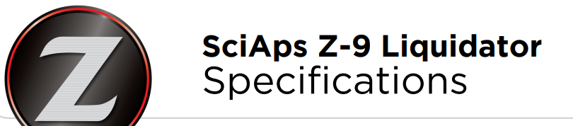 | SciAps Z-9 Liquidator
 | Specifications
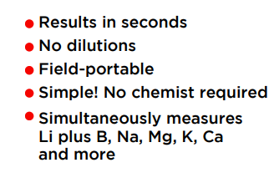 | Results in seconds
 | No dilutions
 | Field-portable
 | Simple! No chemist required
 | Simultaneously measures Li plus B, Na, Mg, K, Ca and more
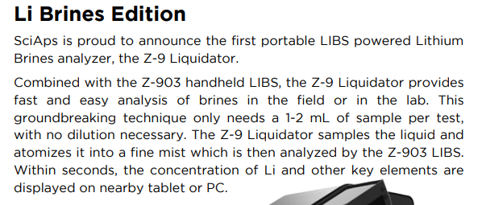 | Li Brines Edition
 | SciAps is proud to announce the first portable LIBS powered Lithium Brines analyzer, the Z-9 Liquidator.
 | Combined with the Z-903 handheld LIBS, the Z-9 Liquidator provides fast and easy analysis of brines in the field or in the lab. This groundbreaking technique only needs a 1-2 mL of sample per test, with no dilution necessary. The Z-9 Liquidator samples the liquid and atomizes it into a fine mist which is then analyzed by the Z-903 LIBS. Within seconds, the concentration of Li and other key elements are displayed on nearby tablet or PC.
 | World's First In-Field Lithium Brines Analyzer
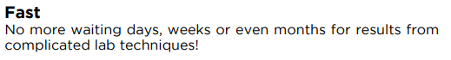 | Fast
 | No more waiting days, weeks or even months for results from complicated lab techniques!
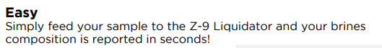 | Easy
 | Simply feed your sample to the Z-9 Liquidator and your brines composition is reported in seconds!
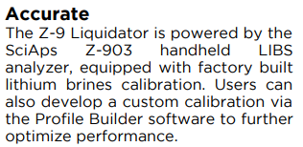 | Accurate
The Z-9 Liquidator is powered by the
SciAps Z-903 handheld LIBS analyzer, equipped with factory built lithium brines calibration. Users can also develop a custom calibration via the Profile Builder software to further optimize performance.
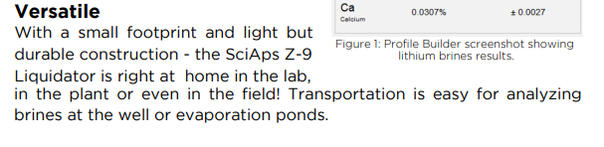 | Versatile
With a small footprint and light but durable construction - the SciAps Z-9
Liquidator is right at home in the lab, in the plant or even in the field! Transportation is easy for analyzing
brines at the well or evaporation ponds.
 | Figure 1: Profile Builder screenshot showing lithium brines results.
 | Have solids or rocks to analyze?
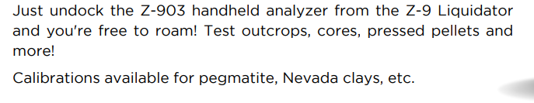 | Just undock the Z-903 handheld analyzer from the Z-9 Liquidator and you're free to roam! Test outcrops, cores, pressed pellets and more!
 | Calibrations available for pegmatite, Nevada clays, etc.
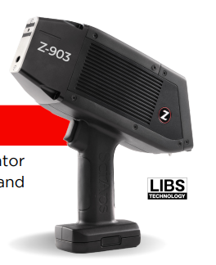 | LIBS  Technology
(BACK)
 | SciAps Z-9 Liquidator
 | Specifications
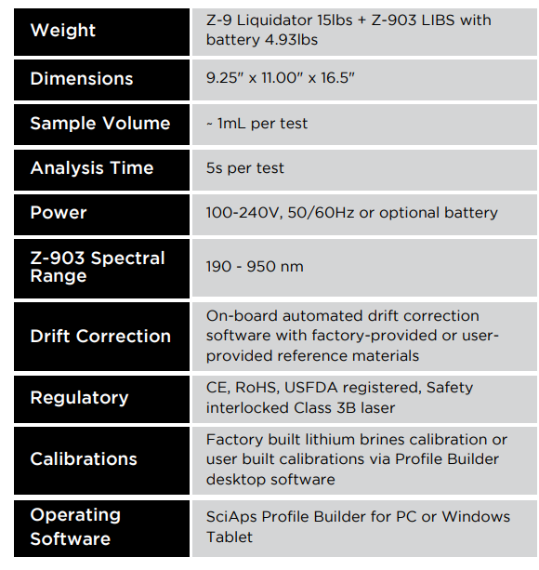
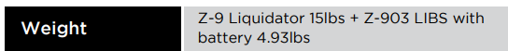 | Weight
Z-9 Liquidator 15lbs + Z-903 LIBS with
battery 4.93lbs
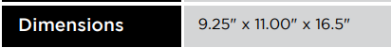 | Dimensions
 | 9.25" x 11.00" x 16.5"
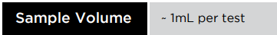 | Sample Volume
 | ~ 1mL per test
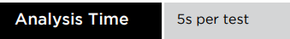 | Analysis Time
 | 5s per test
 | Power
 | 100-240V, 50/60Hz or optional battery
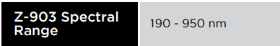 | Z-903 Spectral  Range
 | 190 - 950 nm
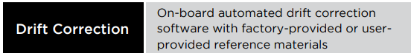 | Drift Correction
 | On-board automated drift correction software with factory-provided or user-provided reference materials
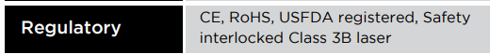 | Regulatory
 | CE, RoHS, USFDA registered, Safety interlocked Class 3B laser
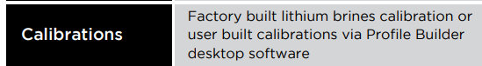 | Calibrations
 | Factory built lithium brines calibration or user built calibrations via Profile Builder desktop software
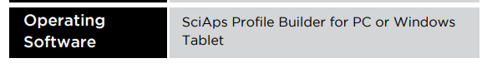 | Operating  Software
 | SciAps Profile Builder for PC or Windows Tablet
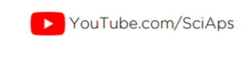 | YouTube.com/SciAps
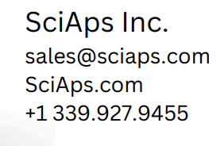 | If applicable, please add:  LOCAL COMPANY NAME  LOCAL WEBSITE  LOCAL PHONE

