Document Title: SciAps ApNote X-50 - The Best Economical XRF for Market Volatility in Scrap Sorting
Rev Date: April 2024
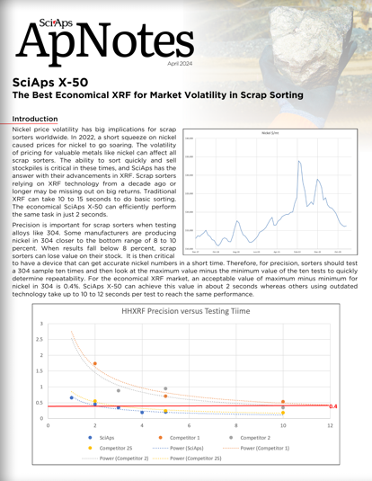
Layout Preview | English Text | Translated Text
 | SciAps
 | ApNotes
 | April 2024
 | SciAps X-50
 | The Best Economical XRF for Market Volatility in Scrap Sorting
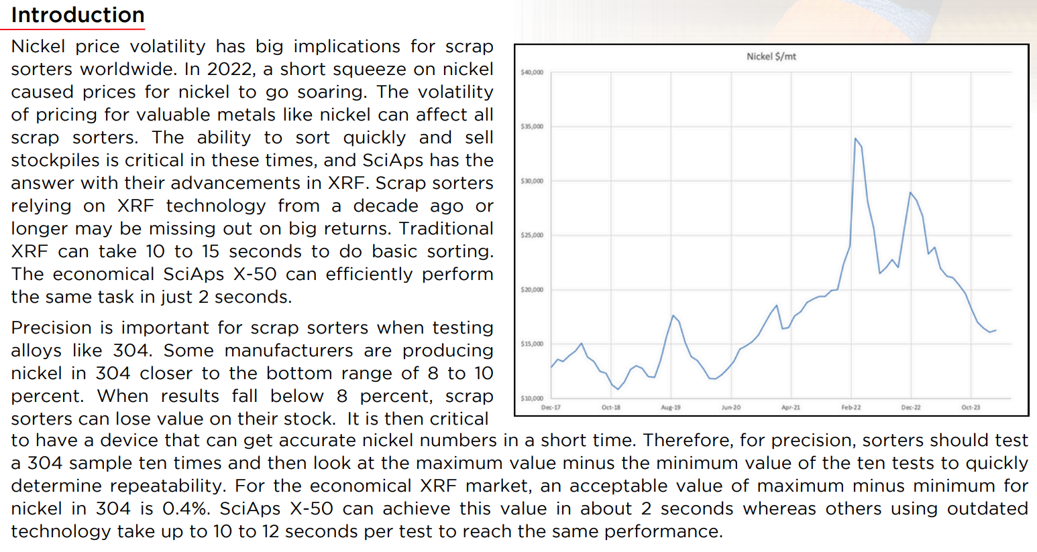 | Introduction
 | Nickel price volatility has big implications for scrap sorters worldwide. In 2022, a short squeeze on nickel caused prices for nickel to go soaring. The volatility of pricing for valuable metals like nickel can affect all scrap sorters. The ability to sort quickly and sell stockpiles is critical in these times, and SciAps has the answer with their advancements in XRF. Scrap sorters relying on XRF technology from a decade ago or longer may be missing out on big returns. Traditional XRF can take 10 to 15 seconds to do basic sorting. The economical SciAps X-50 can efficiently perform the same task in just 2 seconds.
 | Precision is important for scrap sorters when testing alloys like 304. Some manufacturers are producing nickel in 304 closer to the bottom range of 8 to 10 percent. When results fall below 8 percent, scrap sorters can lose value on their stock. It is then critical to have a device that can get accurate nickel numbers in a short time. Therefore, for precision, sorters should test a 304 sample ten times and then look at the maximum value minus the minimum value of the ten tests to quickly determine repeatability. For the economical XRF market, an acceptable value of maximum minus minimum for nickel in 304 is 0.4%. SciAps X-50 can achieve this value in about 2 seconds whereas others using outdated technology take up to 10 to 12 seconds per test to reach the same performance.
(Back)
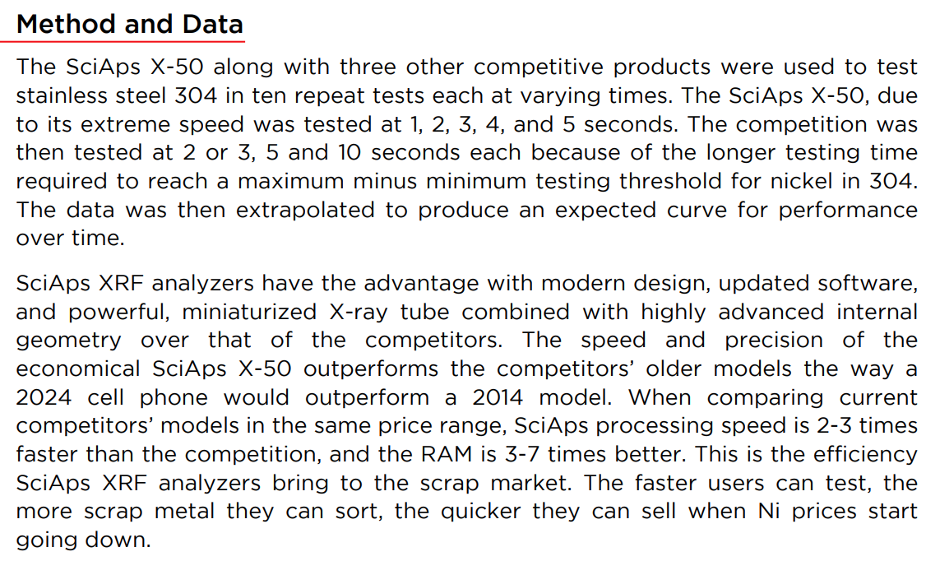 | Method and Data
 | The SciAps X-50 along with three other competitive products were used to test stainless steel 304 in ten repeat tests each at varying times. The SciAps X-50, due to its extreme speed was tested at 1, 2, 3, 4, and 5 seconds. The competition was then tested at 2 or 3, 5 and 10 seconds each because of the longer testing time required to reach a maximum minus minimum testing threshold for nickel in 304. The data was then extrapolated to produce an expected curve for performance over time.
 | SciAps XRF analyzers have the advantage with modern design, updated software, and powerful, miniaturized X-ray tube combined with highly advanced internal geometry over that of the competitors. The speed and precision of the economical SciAps X-50 outperforms the competitors’ older models the way a 2024 cell phone would outperform a 2014 model. When comparing current competitors’ models in the same price range, SciAps processing speed is 2-3 times faster than the competition, and the RAM is 3-7 times better. This is the efficiency SciAps XRF analyzers bring to the scrap market. The faster users can test, the more scrap metal they can sort, the quicker they can sell when Ni prices start going down.
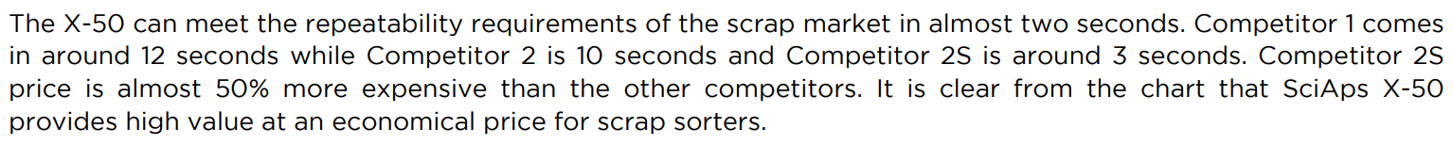 | The X-50 can meet the repeatability requirements of the scrap market in almost two seconds. Competitor 1 comes in around 12 seconds while Competitor 2 is 10 seconds and Competitor 2S is around 3 seconds. Competitor 2S price is almost 50% more expensive than the other competitors. It is clear from the chart that SciAps X-50 provides high value at an economical price for scrap sorters.
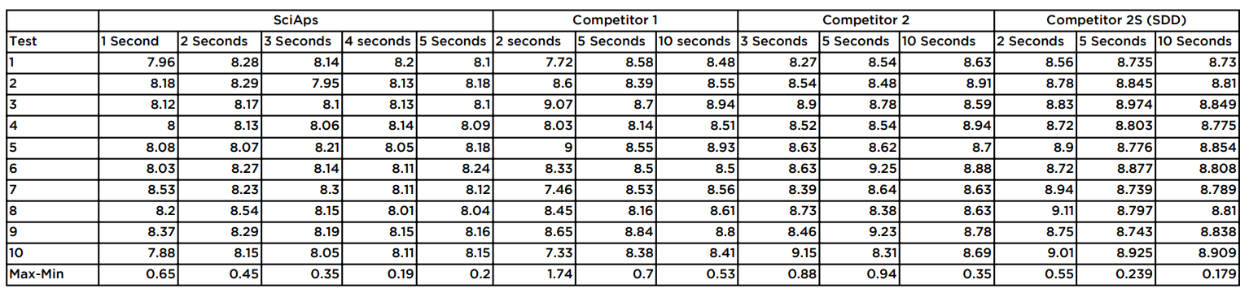 | SciAps
 | Competitor 1
 | Competitor 2
 | Competitor 2S (SDD)
 | Test
 | 1
 | 2
 | 3
 | 4
 | 5
 | 6
 | 7
 | 8
 | 9
 | 10
 | Max-Min
 | 1 Second
 | 7.96
 | 8.18
 | 8.12
 | 8
 | 8.08
 | 8,03
 | 8.53
 | 8,2
 | 8.37
 | 7.88
 | 0.65
 | 2 Seconds
 | 8.28
 | 8.29
 | 8.17
 | 8.13
 | 8.07
 | 8.27
 | 8.23
 | 8.54
 | 8.29
 | 8.15
 | 0.45
 | 3 Seconds
 | 8.14
 | 7.95
 | 8.1
 | 8.06
 | 8.21
 | 8.14
 | 8.3
 | 8.15
 | 8.19
 | 8.05
 | 0.35
 | 4 seconds
 | 8.2
 | 8.13
 | 8.13
 | 8.14
 | 8.05
 | 8.11
 | 8.11
 | 8.01
 | 8.15
 | 8.11
 | 0.19
 | 5 Seconds
 | 8.1
 | 8.18
 | 8.1
 | 8.09
 | 8.18
 | 8.24
 | 8.12
 | 8.04
 | 8.16
 | 8.15
 | 0.2
 | 2 Seconds
 | 7.72
 | 8.6
 | 9.07
 | 8.03
 | 9
 | 8.33
 | 7.46
 | 8.45
 | 8.65
 | 7.33
 | 1.74
 | 5 Seconds
 | 8.58
 | 8.39
 | 8.7
 | 8.14
 | 8.55
 | 8.5
 | 8.53
 | 8.16
 | 8.84
 | 8.38
 | 07
 | 10 Seconds
 | 8.48
 | 8.55
 | 8.94
 | 8.51
 | 8.93
 | 8.5
 | 8.56
 | 8.61
 | 8.8
 | 8.41
 | 0.53
 | 3 Seconds
 | 8.27
 | 8.54
 | 8.9
 | 8.52
 | 8.63
 | 8.63
 | 8.39
 | 8.73
 | 8.46
 | 9.15
 | 0.88
 | 5 Seconds
 | 8.54
 | 8.48
 | 8.78
 | 8.54
 | 8.62
 | 9.25
 | 8.64
 | 8.38
 | 9.23
 | 8.31
 | 0.94
 | 10 Seconds
 | 8.63
 | 8.91
 | 8.59
 | 8.94
 | 8.7
 | 8.88
 | 8.63
 | 8.63
 | 8.78
 | 8.69
 | 0.35
 | 2 Seconds
 | 8.56
 | 8.78
 | 8.83
 | 8.72
 | 8.9
 | 8.72
 | 8.94
 | 9.11
 | 8.75
 | 9.01
 | 0.55
 | 5 Seconds
 | 8.735
 | 8.845
 | 8.974
 | 8.803
 | 8.776
 | 8.877
 | 8.739
 | 8.797
 | 8.743
 | 8.925
 | 0.239
 | 10 Seconds
 | 8.73
 | 8.81
 | 8.849
 | 8.775
 | 8.854
 | 8.808
 | 8.789
 | 8.81
 | 8.838
 | 8.909
 | 0.179
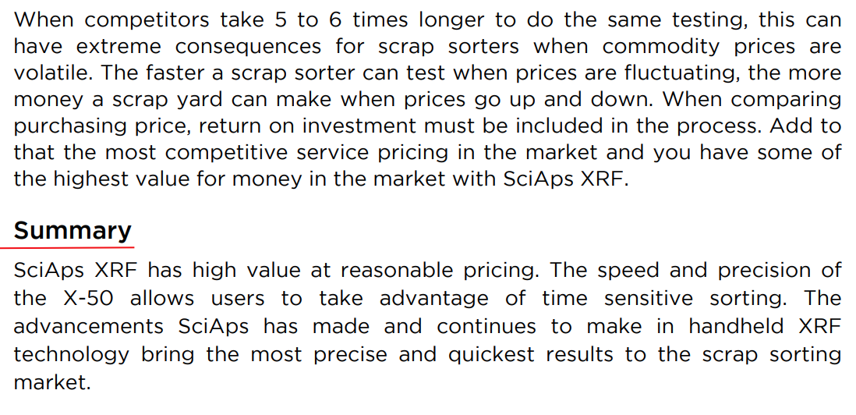 | When competitors take 5 to 6 times longer to do the same testing, this can have extreme consequences for scrap sorters when commodity prices are volatile. The faster a scrap sorter can test when prices are fluctuating, the more money a scrap yard can make when prices go up and down. When comparing purchasing price, return on investment must be included in the process. Add to that the most competitive service pricing in the market and you have some of the highest value for money in the market with SciAps XRF.
 | SciAps XRF has high value at reasonable pricing. The speed and precision of the X-50 allows users to take advantage of time sensitive sorting. The advancements SciAps has made and continues to make in handheld XRF technology bring the most precise and quickest results to the scrap sorting market.
 | If applicable, please add:  LOCAL COMPANY NAME  LOCAL WEBSITE  LOCAL PHONE

