Document Title: SciAps ApNote Z-70 A Material ID LIBS
Rev Date:
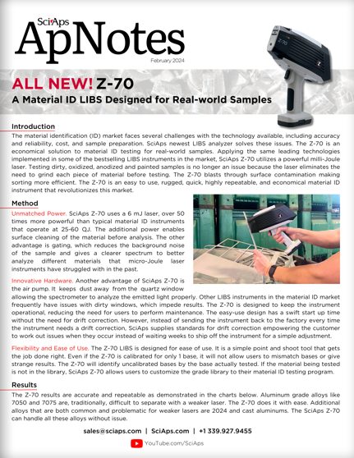
Layout Preview | English Text | Translated Text
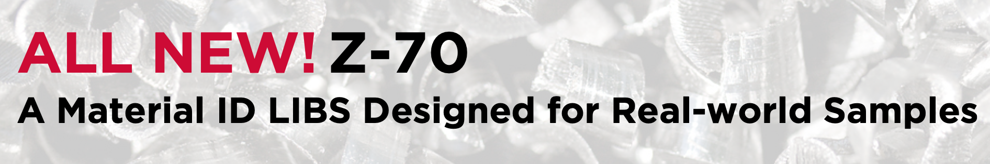 | ALL NEW! Z-70
 | A Material ID LIBS Designed for Real-world Samples
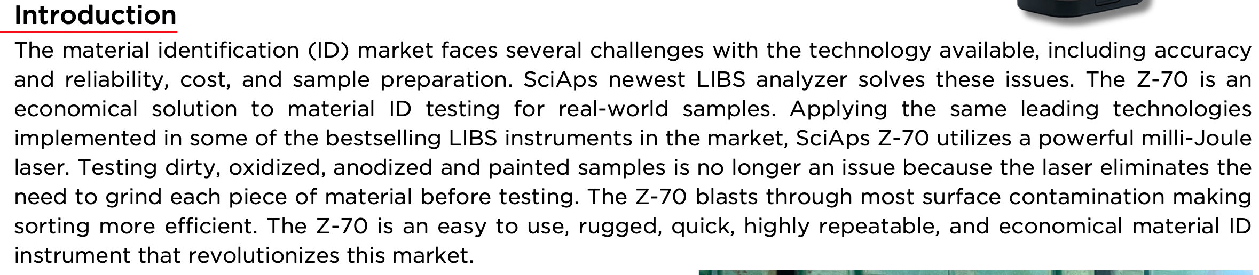 | Introduction
 | The material identification (ID) market faces several challenges with the technology available, including accuracy and reliability, cost, and sample preparation. SciAps newest LIBS analyzer solves these issues. The Z-70 is an economical solution to material ID testing for real-world samples. Applying the same leading technologies implemented in some of the bestselling LIBS instruments in the market, SciAps Z-70 utilizes a powerful milli-Joule laser. Testing dirty, oxidized, anodized and painted samples is no longer an issue because the laser eliminates the need to grind each piece of material before testing. The Z-70 blasts through most surface contamination making sorting more efficient. The Z-70 is an easy to use, rugged, quick, highly repeatable, and economical material ID instrument that revolutionizes this market.
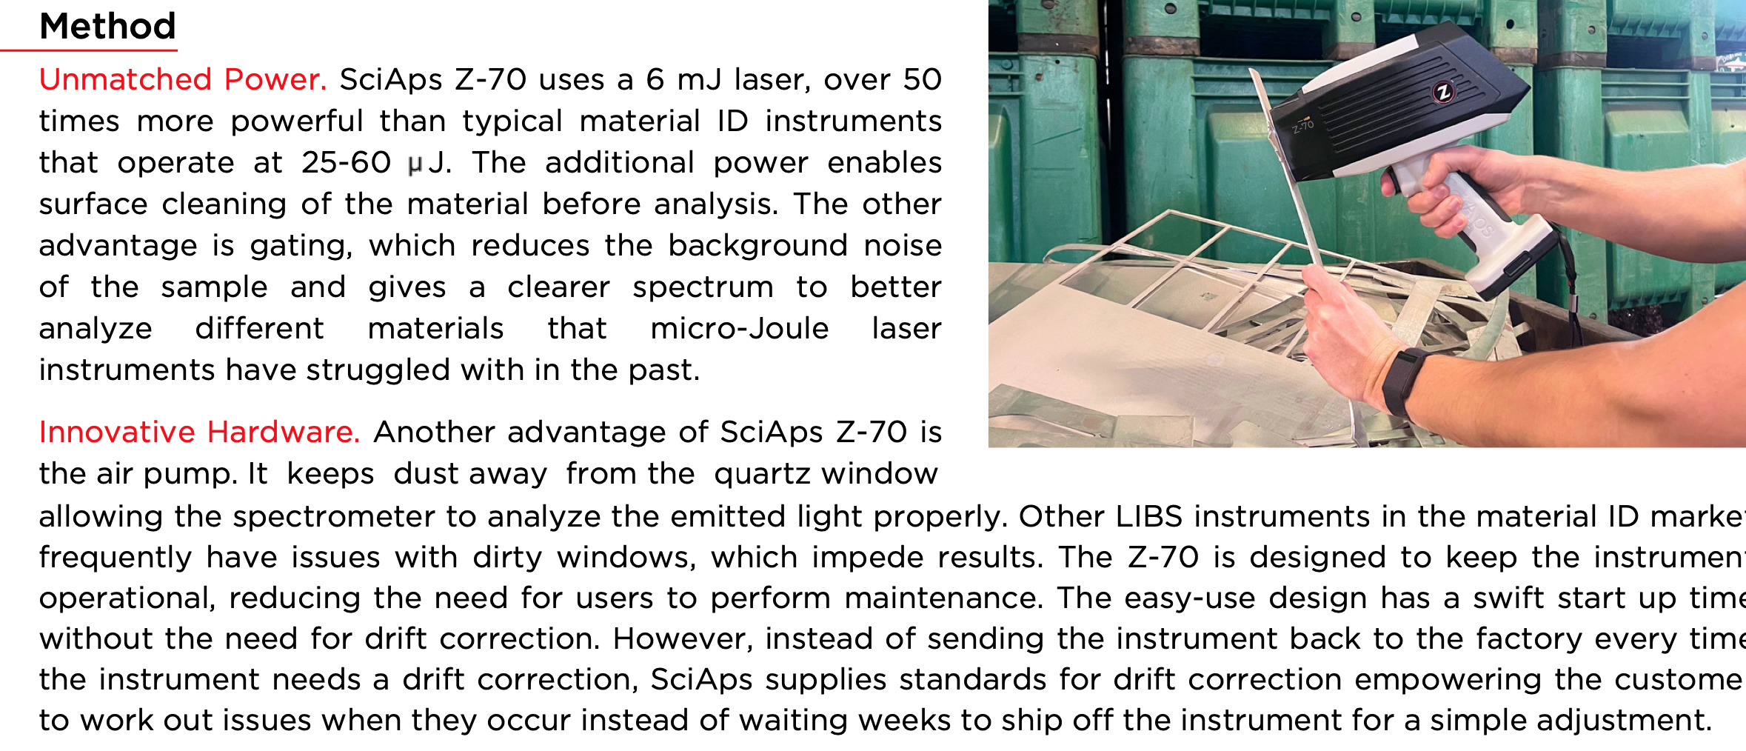 | Method
 | Unmatched Power. SciAps Z-70 uses a 6 mJ laser, over 50 times more powerful than typical material ID instruments that operate at 25-60 J. The additional power enables surface cleaning of the material before analysis. The other advantage is gating, which reduces the background noise of the sample and gives a clearer spectrum to better analyze different materials that micro-Joule laser instruments have struggled with in the past.
 | Innovative Hardware. Another advantage of SciAps Z-70 is the air pump. It keeps dust away from the quartz window allowing the spectrometer to analyze the emitted light properly. Other LIBS instruments in the material ID market frequently have issues with dirty windows, which impede results. The Z-70 is designed to keep the instrument operational, reducing the need for users to perform maintenance. The easy-use design has a swift start up time without the need for drift correction. However, instead of sending the instrument back to the factory every time the instrument needs a drift correction, SciAps supplies standards for drift correction empowering the customer to work out issues when they occur instead of waiting weeks to ship off the instrument for a simple adjustment.
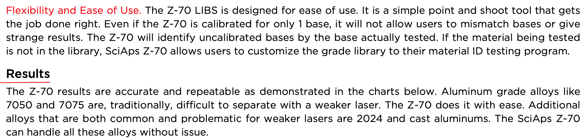 | Flexibility and Ease of Use. The Z-70 LIBS is designed for ease of use. It is a simple point and shoot tool that gets the job done right. Even if the Z-70 is calibrated for only 1 base, it will not allow users to mismatch bases or give strange results. The Z-70 will identify uncalibrated bases by the base actually tested. If the material being tested is not in the library, SciAps Z-70 allows users to customize the grade library to their material ID testing program.
 | Results
 | The Z-70 results are accurate and repeatable as demonstrated in the charts below. Aluminum grade alloys like 7050 and 7075 are, traditionally, difficult to separate with a weaker laser. The Z-70 does it with ease. Additional alloys that are both common and problematic for weaker lasers are 2024 and cast aluminums. The SciAps Z-70 can handle all these alloys without issue.
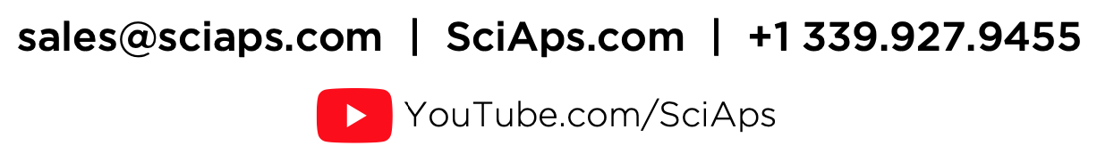 | YouTube.com/SciAps
If applicable, please add:
LOCAL COMPANY NAME
LOCAL WEBSITE
LOCAL PHONE
(BACK)
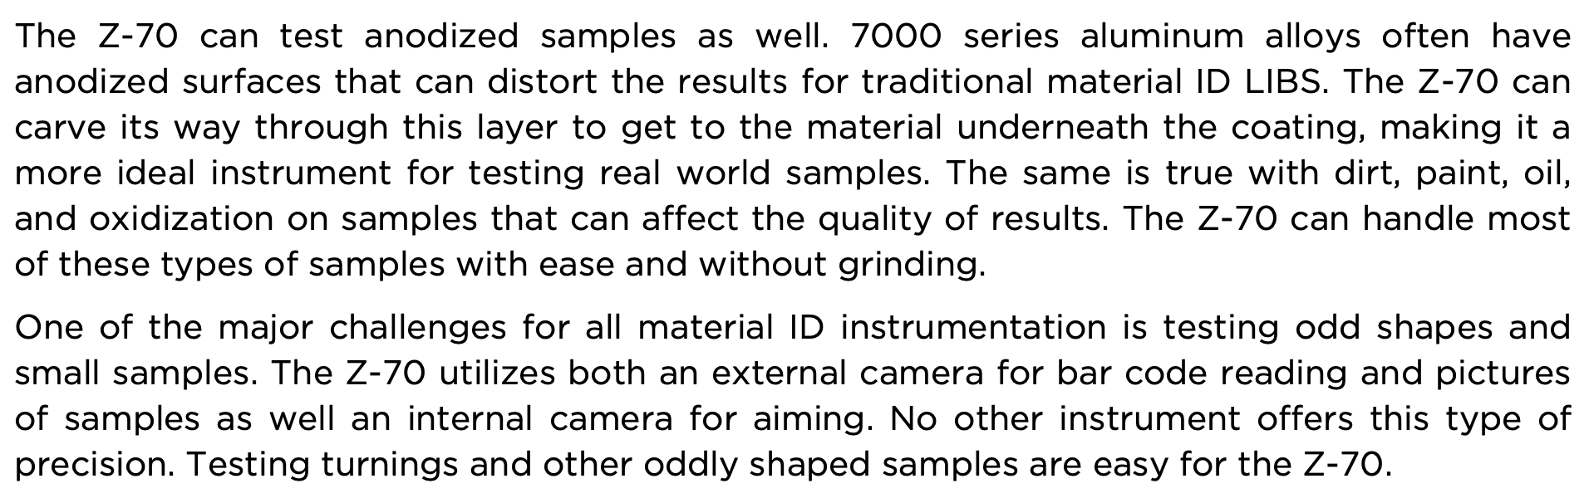 | The Z-70 can test anodized samples as well. 7000 series aluminum alloys often have anodized surfaces that can distort the results for traditional material ID LIBS. The Z-70 can carve its way through this layer to get to the material underneath the coating, making it a more ideal instrument for testing real world samples. The same is true with dirt, paint, oil, and oxidization on samples that can affect the quality of results. The Z-70 can handle most of these types of samples with ease and without grinding.
 | One of the major challenges for all material ID instrumentation is testing odd shapes and small samples. The Z-70 utilizes both an external camera for bar code reading and pictures of samples as well an internal camera for aiming. No other instrument offers this type of precision. Testing turnings and other oddly shaped samples are easy for the Z-70.
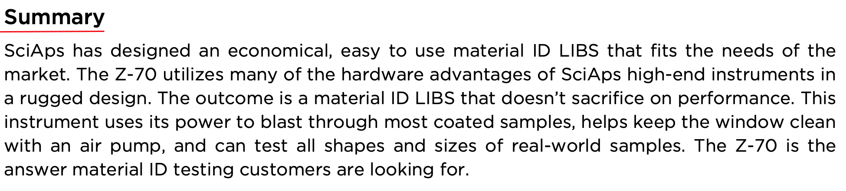 | Summary
 | SciAps has designed an economical, easy to use material ID LIBS that fits the needs of the market. The Z-70 utilizes many of the hardware advantages of SciAps high-end instruments in a rugged design. The outcome is a material ID LIBS that doesn’t sacrifice on performance. This instrument uses its power to blast through most coated samples, helps keep the window clean with an air pump, and can test all shapes and sizes of real-world samples. The Z-70 is the answer material ID testing customers are looking for.
If applicable, please add:
LOCAL COMPANY NAME
LOCAL WEBSITE
LOCAL PHONE

