Document Title: SciAps ApNote SciAps X-555 & Portable PPB detectORE™ App The Future of In-field Gold and Silver Analysis
Rev Date: March 2024
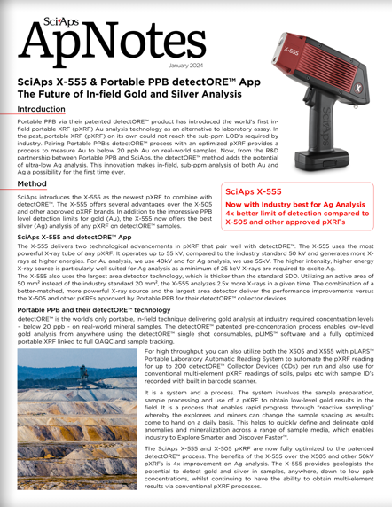
Layout Preview | English Text | Translated Text
 | SciAps
 | ApNotes
 | January 2024
 | SciAps X-555 & Portable PPB detectORE™ App
 | The Future of In-field Gold and Silver Analysis
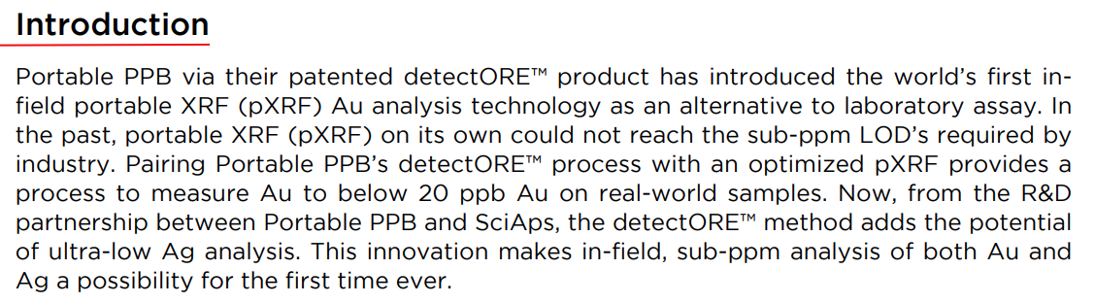 | Introduction
 | Portable PPB via their patented detectORE™ product has introduced the world’s first infield portable XRF (pXRF) Au analysis technology as an alternative to laboratory assay. In the past, portable XRF (pXRF) on its own could not reach the sub-ppm LOD’s required by industry. Pairing Portable PPB’s detectORE™ process with an optimized pXRF provides a process to measure Au to below 20 ppb Au on real-world samples. Now, from the R&D partnership between Portable PPB and SciAps, the detectORE™ method adds the potential of ultra-low Ag analysis. This innovation makes in-field, sub-ppm analysis of both Au and Ag a possibility for the first time ever.
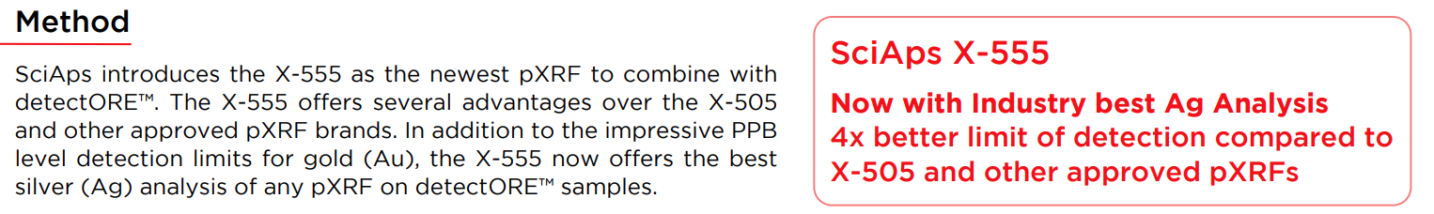 | Method
 | SciAps introduces the X-555 as the newest pXRF to combine with detectORE™. The X-555 offers several advantages over the X-505 and other approved pXRF brands. In addition to the impressive PPB level detection limits for gold (Au), the X-555 now offers the best silver (Ag) analysis of any pXRF on detectORE™ samples.
 | SciAps X-555
 | Now with Industry best Ag Analysis
 | 4x better limit of detection compared to X-505 and other approved pXRFs
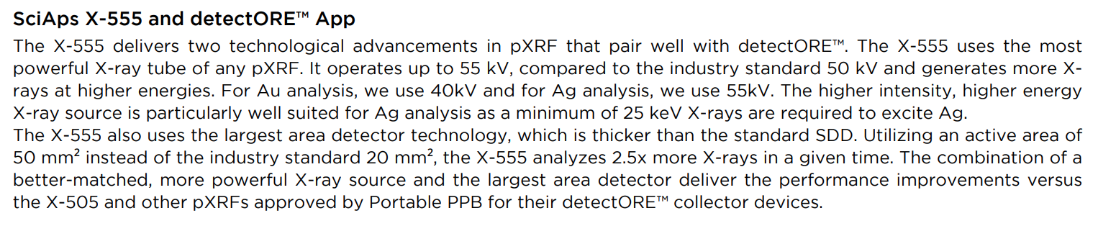 | SciAps X-555 and detectORE™ App
 | The X-555 delivers two technological advancements in pXRF that pair well with detectORE™. The X-555 uses the most powerful X-ray tube of any pXRF. It operates up to 55 kV, compared to the industry standard 50 kV and generates more Xrays at higher energies. For Au analysis, we use 40kV and for Ag analysis, we use 55kV. The higher intensity, higher energy X-ray source is particularly well suited for Ag analysis as a minimum of 25 keV X-rays are required to excite Ag. The X-555 also uses the largest area detector technology, which is thicker than the standard SDD. Utilizing an active area of 50 mm² instead of the industry standard 20 mm², the X-555 analyzes 2.5x more X-rays in a given time. The combination of a better-matched, more powerful X-ray source and the largest area detector deliver the performance improvements versus the X-505 and other pXRFs approved by Portable PPB for their detectORE™ collector devices.
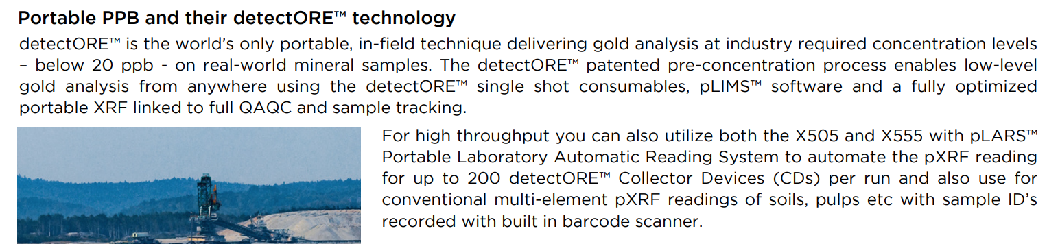 | Portable PPB and their detectORE™ technology
 | detectORE™ is the world’s only portable, in-field technique delivering gold analysis at industry required concentration levels – below 20 ppb - on real-world mineral samples. The detectORE™ patented pre-concentration process enables low-level gold analysis from anywhere using the detectORE™ single shot consumables, pLIMS™ software and a fully optimized portable XRF linked to full QAQC and sample tracking.
 | For high throughput you can also utilize both the X505 and X555 with pLARS™ Portable Laboratory Automatic Reading System to automate the pXRF reading for up to 200 detectORE™ Collector Devices (CDs) per run and also use for conventional multi-element pXRF readings of soils, pulps etc with sample ID’s recorded with built in barcode scanner.
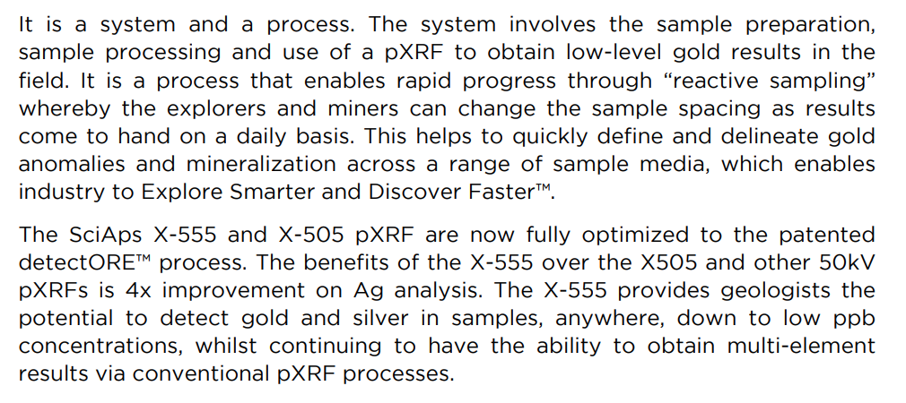 | It is a system and a process. The system involves the sample preparation, sample processing and use of a pXRF to obtain low-level gold results in the field. It is a process that enables rapid progress through “reactive sampling” whereby the explorers and miners can change the sample spacing as results come to hand on a daily basis. This helps to quickly define and delineate gold anomalies and mineralization across a range of sample media, which enables industry to Explore Smarter and Discover Faster™.
 | The SciAps X-555 and X-505 pXRF are now fully optimized to the patented detectORE™ process. The benefits of the X-555 over the X505 and other 50kV pXRFs is 4x improvement on Ag analysis. The X-555 provides geologists the potential to detect gold and silver in samples, anywhere, down to low ppb concentrations, whilst continuing to have the ability to obtain multi-element results via conventional pXRF processes.
[Back]
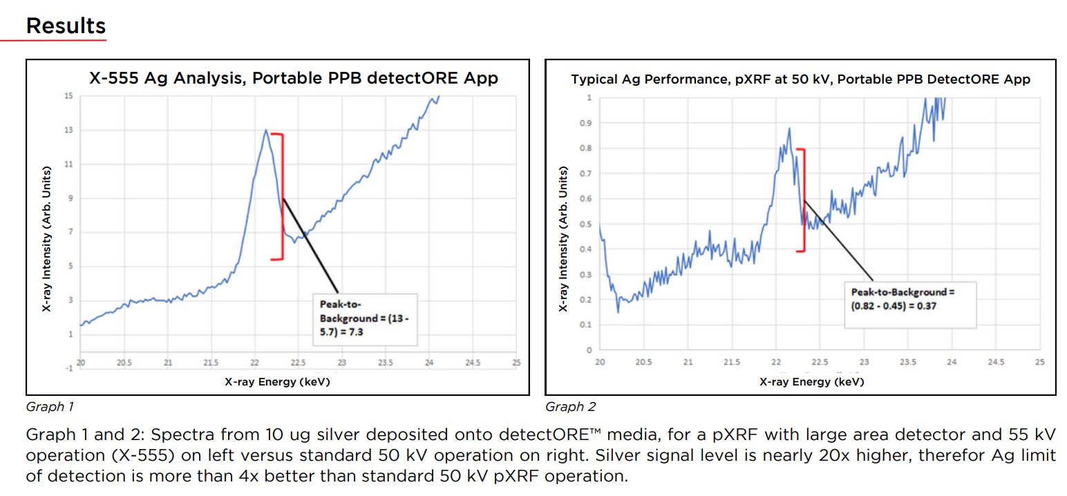 | Results
 | X-555 Ag Analysis, Portable PPB detectORE App
 | X-ray Intensity (Arb. Units)
 | X-ray Energy (keV)
 | Typical Ag Performance, pXRF at 50 kV, Portable PPB DetectORE App
 | X-ray Intensity (Arb. Units)
 | X-ray Energy (keV)
 | Graph 1
 | Graph 2
 | Graph 1 and 2: Spectra from 10 ug silver deposited onto detectORE™ media, for a pXRF with large area detector and 55 kV operation (X-555) on left versus standard 50 kV operation on right. Silver signal level is nearly 20x higher, therefor Ag limit of detection is more than 4x better than standard 50 kV pXRF operation.
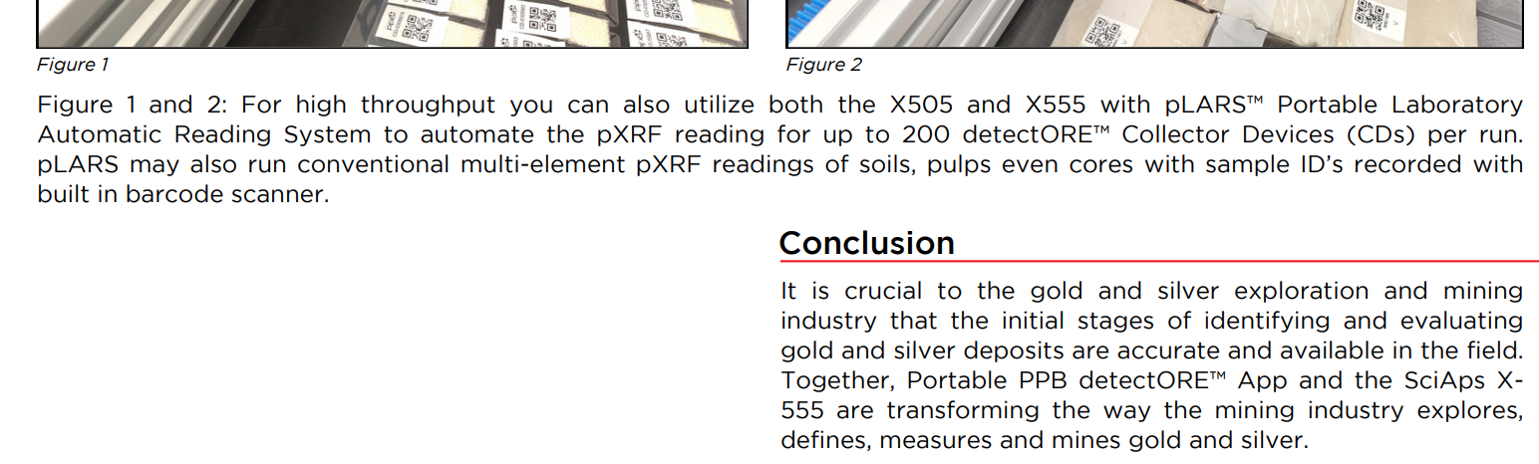 | Figure 1
 | Figure 2
 | Figure 1 and 2: For high throughput you can also utilize both the X505 and X555 with pLARS™ Portable Laboratory Automatic Reading System to automate the pXRF reading for up to 200 detectORE™ Collector Devices (CDs) per run. pLARS may also run conventional multi-element pXRF readings of soils, pulps even cores with sample ID’s recorded with built in barcode scanner.
 | Conclusion
 | It is crucial to the gold and silver exploration and mining industry that the initial stages of identifying and evaluating gold and silver deposits are accurate and available in the field. Together, Portable PPB detectORE™ App and the SciAps X555 are transforming the way the mining industry explores, defines, measures and mines gold and silver.
 | If applicable, please add:  LOCAL COMPANY NAME  LOCAL WEBSITE  LOCAL PHONE

