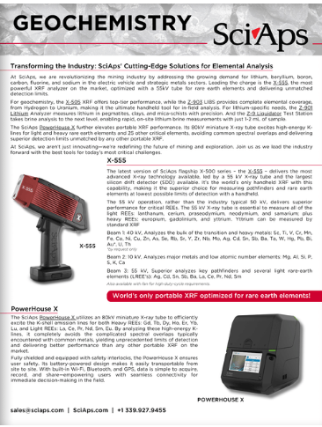
Document Title: Geochemistry | Transforming the Industry: SciAps' Cutting-Edge Solutions for Elemental Analysis
Rev. Date: September 2022

Layout Preview | English Text | Translated Text
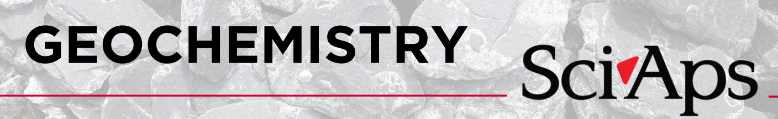 | Geochemistry
 | SciAps
 | Transforming the Industry: SciAps' Cutting-Edge Solutions for Elemental Analysis
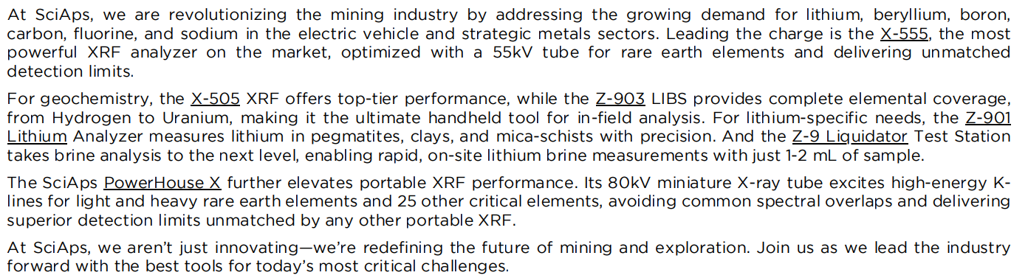 | At SciAps, we are revolutionizing the mining industry by addressing the growing demand for lithium, beryllium, boron, carbon, fluorine, and sodium in the electric vehicle and strategic metals sectors. Leading the charge is the X-555, the most powerful XRF analyzer on the market, optimized with a 55kV tube for rare earth elements and delivering unmatched detection limits.
 | For geochemistry, the X-505 XRF offers top-tier performance, while the Z-903 LIBS provides complete elemental coverage, from Hydrogen to Uranium, making it the ultimate handheld tool for in-field analysis. For lithium-specific needs, the Z-901 Lithium Analyzer measures lithium in pegmatites, clays, and mica-schists with precision. And the Z-9 Liquidator Test Station takes brine analysis to the next level, enabling rapid, on-site lithium brine measurements with just 1-2 mL of sample.
 | The SciAps PowerHouse X further elevates portable XRF performance. Its 80kV miniature X-ray tube excites high-energy Klines for light and heavy rare earth elements and 25 other critical elements, avoiding common spectral overlaps and delivering superior detection limits unmatched by any other portable XRF.
 | At SciAps, we aren’t just innovating—we’re redefining the future of mining and exploration. Join us as we lead the industry forward with the best tools for today’s most critical challenges.
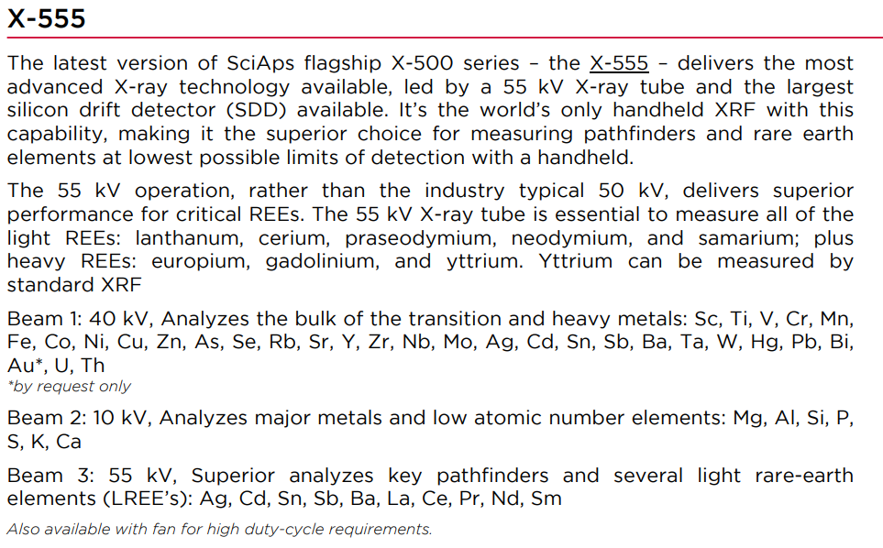 | X-555
 | The latest version of SciAps flagship X-500 series – the X-555 – delivers the most advanced X-ray technology available, led by a 55 kV X-ray tube and the largest silicon drift detector (SDD) available. It’s the world’s only handheld XRF with this capability, making it the superior choice for measuring pathfinders and rare earth elements at lowest possible limits of detection with a handheld.
 | The 55 kV operation, rather than the industry typical 50 kV, delivers superior performance for critical REEs. The 55 kV X-ray tube is essential to measure all of the light REEs: lanthanum, cerium, praseodymium, neodymium, and samarium; plus heavy REEs: europium, gadolinium, and yttrium. Yttrium can be measured by standard XRF.
 | Beam 1: 40 kV, Analyzes the bulk of the transition and heavy metals: Sc, Ti, V, Cr, Mn, Fe, Co, Ni, Cu, Zn, As, Se, Rb, Sr, Y, Zr, Nb, Mo, Ag, Cd, Sn, Sb, Ba, Ta, W, Hg, Pb, Bi, Au*, U, Th
 | *by request only
 | Beam 2: 10 kV, Analyzes major metals and low atomic number elements: Mg, Al, Si, P, S, K, Ca
 | Beam 3: 55 kV, Superior analyzes key pathfinders and several light rare-earth elements (LREE’s): Ag, Cd, Sn, Sb, Ba, La, Ce, Pr, Nd, Sm
 | Also available with fan for high duty-cycle requirements.
 | World’s only portable XRF optimized for rare earth elements!
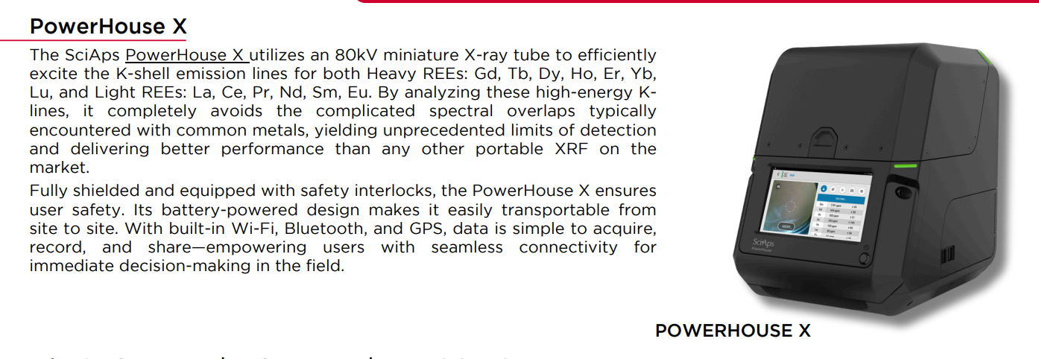 | PowerHouse X
 | The SciAps PowerHouse X utilizes an 80kV miniature X-ray tube to efficiently excite the K-shell emission lines for both Heavy REEs: Gd, Tb, Dy, Ho, Er, Yb, Lu, and Light REEs: La, Ce, Pr, Nd, Sm, Eu. By analyzing these high-energy Klines, it completely avoids the complicated spectral overlaps typically encountered with common metals, yielding unprecedented limits of detection and delivering better performance than any other portable XRF on the market.
 | Fully shielded and equipped with safety interlocks, the PowerHouse X ensures user safety. Its battery-powered design makes it easily transportable from site to site. With built-in Wi-Fi, Bluetooth, and GPS, data is simple to acquire, record, and share—empowering users with seamless connectivity for immediate decision-making in the field.
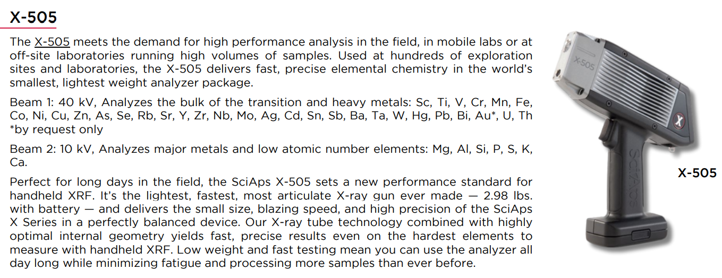 | The X-505 meets the demand for high performance analysis in the field, in mobile labs or at off-site laboratories running high volumes of samples. Used at hundreds of exploration sites and laboratories, the X-505 delivers fast, precise elemental chemistry in the world’s smallest, lightest weight analyzer package.
 | Beam 1: 40 kV, Analyzes the bulk of the transition and heavy metals: Sc, Ti, V, Cr, Mn, Fe, Co, Ni, Cu, Zn, As, Se, Rb, Sr, Y, Zr, Nb, Mo, Ag, Cd, Sn, Sb, Ba, Ta, W, Hg, Pb, Bi, Au*, U, Th
 | *by request only
 | Beam 2: 10 kV, Analyzes major metals and low atomic number elements: Mg, Al, Si, P, S, K, Ca.
 | Perfect for long days in the field, the SciAps X-505 sets a new performance standard for handheld XRF. It’s the lightest, fastest, most articulate X-ray gun ever made — 2.98 lbs. with battery — and delivers the small size, blazing speed, and high precision of the SciAps X Series in a perfectly balanced device. Our X-ray tube technology combined with highly optimal internal geometry yields fast, precise results even on the hardest elements to measure with handheld XRF. Low weight and fast testing mean you can use the analyzer all day long while minimizing fatigue and processing more samples than ever before.
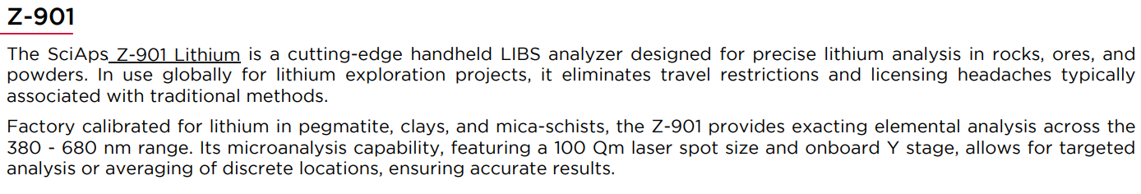 | The SciAps Z-901 Lithium is a cutting-edge handheld LIBS analyzer designed for precise lithium analysis in rocks, ores, and powders. In use globally for lithium exploration projects, it eliminates travel restrictions and licensing headaches typically associated with traditional methods.
 | Factory calibrated for lithium in pegmatite, clays, and mica-schists, the Z-901 provides exacting elemental analysis across the 380 - 680 nm range. Its microanalysis capability, featuring a 100 µm laser spot size and onboard Y stage, allows for targeted analysis or averaging of discrete locations, ensuring accurate results.
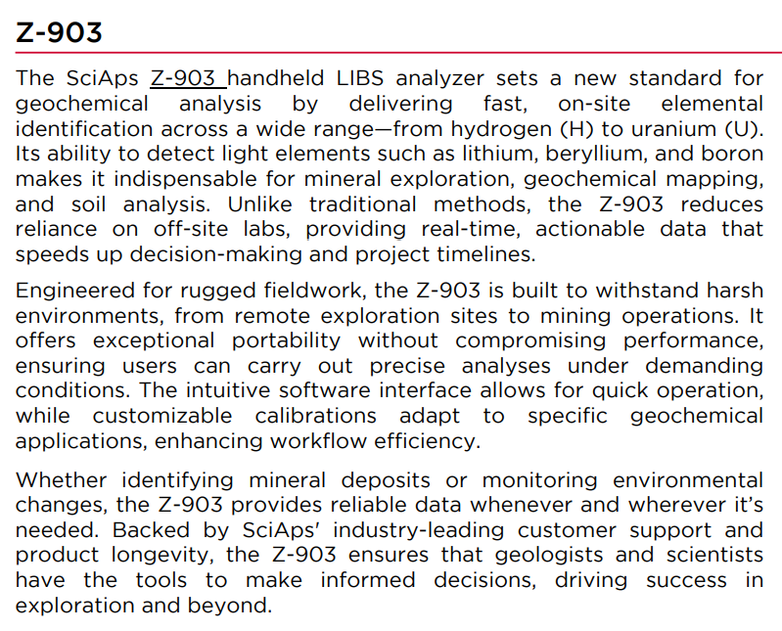 | The SciAps Z-903 handheld LIBS analyzer sets a new standard for geochemical analysis by delivering fast, on-site elemental identification across a wide range—from hydrogen (H) to uranium (U). Its ability to detect light elements such as lithium, beryllium, and boron makes it indispensable for mineral exploration, geochemical mapping, and soil analysis. Unlike traditional methods, the Z-903 reduces reliance on off-site labs, providing real-time, actionable data that speeds up decision-making and project timelines.
 | Engineered for rugged fieldwork, the Z-903 is built to withstand harsh environments, from remote exploration sites to mining operations. It offers exceptional portability without compromising performance, ensuring users can carry out precise analyses under demanding conditions. The intuitive software interface allows for quick operation, while customizable calibrations adapt to specific geochemical applications, enhancing workflow efficiency.
 | Whether identifying mineral deposits or monitoring environmental changes, the Z-903 provides reliable data whenever and wherever it’s needed. Backed by SciAps' industry-leading customer support and product longevity, the Z-903 ensures that geologists and scientists have the tools to make informed decisions, driving success in exploration and beyond.
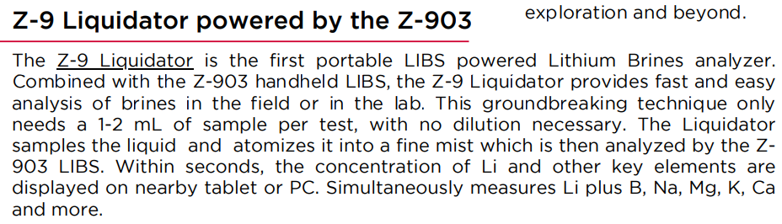 | Z-9 Liquidator powered by the Z-903
 | The Z-9 Liquidator is the first portable LIBS powered Lithium Brines analyzer. Combined with the Z-903 handheld LIBS, the Z-9 Liquidator provides fast and easy analysis of brines in the field or in the lab. This groundbreaking technique only needs a 1-2 mL of sample per test, with no dilution necessary. The Liquidator samples the liquid and atomizes it into a fine mist which is then analyzed by the Z903 LIBS. Within seconds, the concentration of Li and other key elements are displayed on nearby tablet or PC. Simultaneously measures Li plus B, Na, Mg, K, Ca and more.
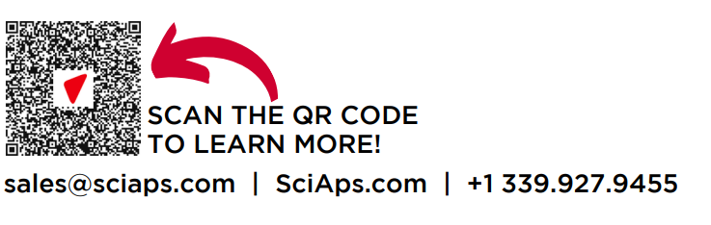 | SCAN THE QR CODE TO LEARN MORE!

