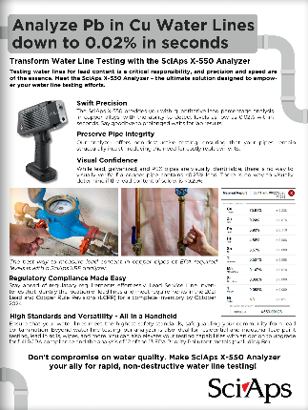
Document Title: X-550 for Lead in Copper Water Lines
Layout Preview | English Text | Translated Text
 | Analyze Pb in Cu Water Lines down to 0.02% in seconds
 | Transform Water Line Testing with the SciAps X-550 Analyzer
 | Testing water lines for lead content is a critical responsibility, and precision and speed are of the essence. Meet the SciAps X-550 Analyzer – the ultimate solution designed to empower your water line testing efforts.
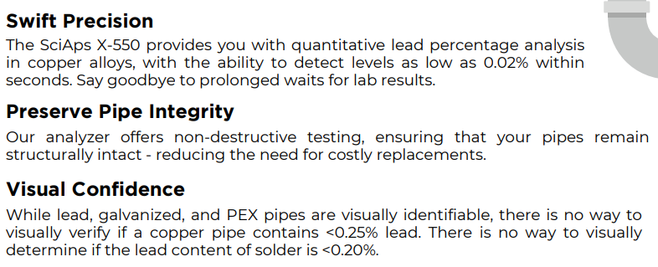 | Swift Precision
 | The SciAps X-550 provides you with quantitative lead percentage analysis in copper alloys, with the ability to detect levels as low as 0.02% within seconds. Say goodbye to prolonged waits for lab results.
 | Preserve Pipe Integrity
 | Our analyzer offers non-destructive testing, ensuring that your pipes remain structurally intact - reducing the need for costly replacements.
 | Visual Confidence
 | While lead, galvanized, and PEX pipes are visually identifiable, there is no way to visually verify if a copper pipe contains
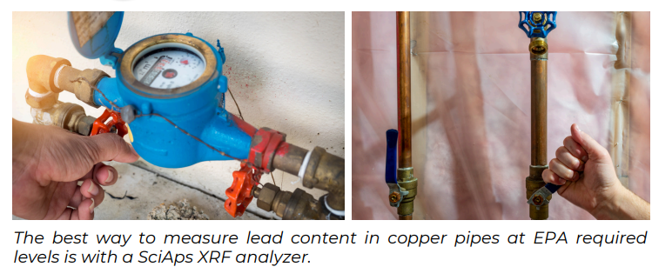 | The best way to measure lead content in copper pipes at EPA required levels is with a SciAps XRF analyzer.
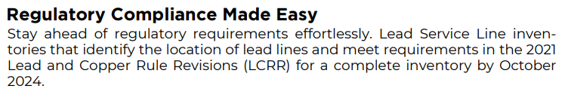 | Regulatory Compliance Made Easy
 | Stay ahead of regulatory requirements effortlessly. Lead Service Line inventories that identify the location of lead lines and meet requirements in the 2021 Lead and Copper Rule Revisions (LCRR) for a complete inventory by October 2024.
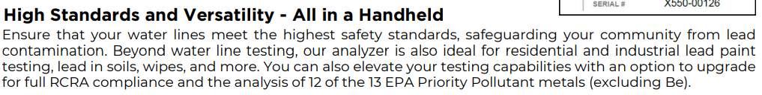 | High Standards and Versatility - All in a Handheld
 | Ensure that your water lines meet the highest safety standards, safeguarding your community from lead contamination. Beyond water line testing, our analyzer is also ideal for residential and industrial lead paint testing, lead in soils, wipes, and more. You can also elevate your testing capabilities with an option to upgrade for full RCRA compliance and the analysis of 12 of the 13 EPA Priority Pollutant metals (excluding Be).
 | Don't compromise on water quality. Make SciAps X-550 Analyzer your ally for rapid, non-destructive water line testing!

