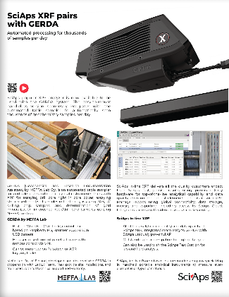
Document Title: SciAps in-line XRF
Layout Preview | English Text | Translated Text
 | SciAps XRF pairs with GERDA
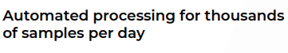 | Automated processing for thousands of samples per day
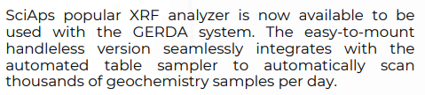 | SciAps popular XRF analyzer is now available to be used with the GERDA system. The easy-to-mount handleless version seamlessly integrates with the automated table sampler to automatically scan thousands of geochemistry samples per day.
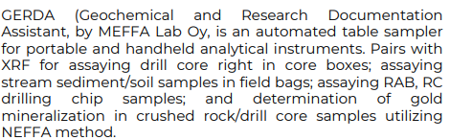 | GERDA (Geochemical and Research Documentation Assistant, by MEFFA Lab Oy, is an automated table sampler for portable and handheld analytical instruments. Pairs with XRF for assaying drill core right in core boxes; assaying stream sediment/soil samples in field bags; assaying RAB, RC drilling chip samples; and determination of gold mineralization in crushed rock/drill core samples utilizing NEFFA method.
 | GERDA by MEFFA Lab
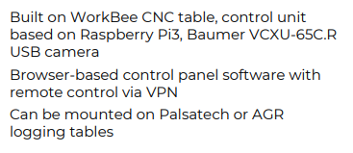 | Built on WorkBee CNC table, control unit based on Raspberry Pi3, Baumer VCXU-65C.R USB camera.
 | Browser-based control panel software with remote control via VPN
 | Can be mounted on Palsatech or AGR logging tables
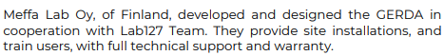 | Meffa Lab Oy, of Finland, developed and designed the GERDA in cooperation with Lab127 Team. They provide site installations, and train users, with full technical support and warranty.
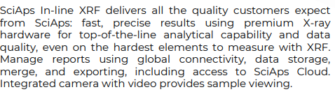 | SciAps In-line XRF delivers all the quality customers expect from SciAps: fast, precise results using premium X-ray hardware for top-of-the-line analytical capability and data quality, even on the hardest elements to measure with XRF. Manage reports using global connectivity, data storage, merge, and exporting, including access to SciAps Cloud. Integrated camera with video provides sample viewing.
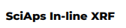 | SciAps In-line XRF
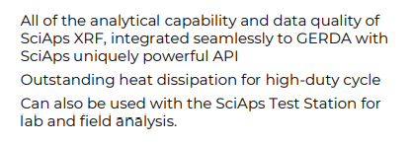 | All of the analytical capability and data quality of SciAps XRF, integrated seamlessly to GERDA with SciAps uniquely powerful API
 | Outstanding heat dissipation for high-duty cycle
 | Can also be used with the SciAps Test Station for lab and field analysis.
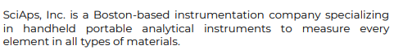 | SciAps, Inc. is a Boston-based instrumentation company specializing in handheld portable analytical instruments to measure every element in all types of materials. | SciAps Inc. es una empresa de instrumentación con base en Boston, especializada en instrumentos analíticos portátiles de mano para medir cualquier elemento en todo tipo de materiales.

