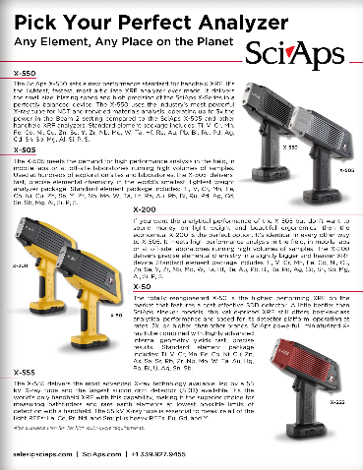
Document Title: Pick Your Favorite Analyzer
Layout Preview | English Text | Translated Text
 | Pick Your Perfect Analyzer
 | Any Element, Any Place on the Planet
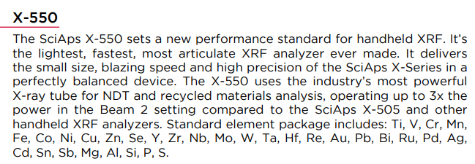 | X-550
The SciAps X-550 sets a new performance standard for handheld XRF. It’s the lightest, fastest, most articulate XRF analyzer ever made. It delivers the small size, blazing speed and high precision of the SciAps X-Series in a perfectly balanced device. The X-550 uses the industry’s most powerful X-ray tube for NDT and recycled materials analysis, operating up to 3x the
power in the Beam 2 setting compared to the SciAps X-505 and other handheld XRF analyzers. Standard element package includes: Ti, V, Cr, Mn, Fe, Co, Ni, Cu, Zn, Se, Y, Zr, Nb, Mo, W, Ta, Hf, Re, Au, Pb, Bi, Ru, Pd, Ag, Cd, Sn, Sb, Mg, Al, Si, P, S.
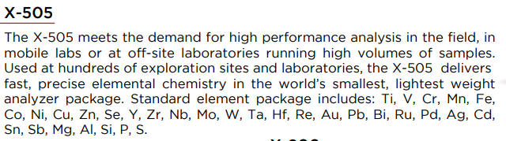 | X-505
 | The X-505 meets the demand for high performance analysis in the field, in mobile labs or at off-site laboratories running high volumes of samples. Used at hundreds of exploration sites and laboratories, the X-505 delivers precise elemental chemistry in the world’s smallest, lightest weight analyzer package. Standard element package includes: Ti, V, Cr, Mn, Fe, Co, Ni, Cu, Zn, Se, Y, Zr, Nb, Mo, W, Ta, Hf, Re, Au, Pb, Bi, Ru, Pd, Ag, Cd, Sn, Sb, Mg, Al, Si, P, S.
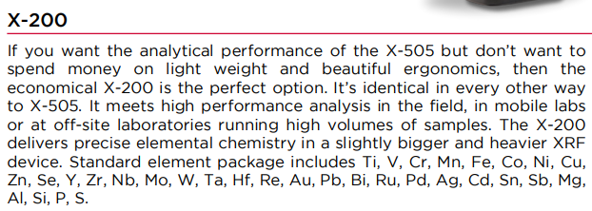 | X-200
 | If you want the analytical performance of the X-505 but don’t want to spend money on light weight and beautiful ergonomics, then the economical X-200 is the perfect option. It’s identical in every other way to X-505. It meets high performance analysis in the field, in mobile labs or at off-site laboratories running high volumes of samples. The X-200 delivers precise elemental chemistry in a slightly bigger and heavier XRF device. Standard element package includes Ti, V, Cr, Mn, Fe, Co, Ni, Cu, Zn, Se, Y, Zr, Nb, Mo, W, Ta, Hf, Re, Au, Pb, Bi, Ru, Pd, Ag, Cd, Sn, Sb, Mg, Al, Si, P, S.
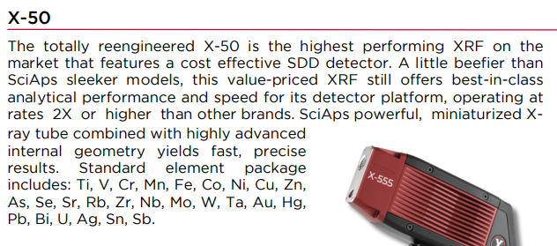 | X-50
 | The totally reengineered X-50 is the highest performing XRF on the market that features a cost effective SDD detector. A little beefier than SciAps sleeker models, this value-priced XRF still offers best-in-class analytical performance and speed for its detector platform, operating at rates 2X or higher than other brands. SciAps powerful, miniaturized X- ray tube combined with highly advanced internal geometry yields fast, precise results. Standard element package includes: Ti, V, Cr, Mn, Fe, Co, Ni, Cu, Zn, As, Se, Sr, Rb, Zr, Nb, Mo, W, Ta, Au, Hg, Pb, Bi, U, Ag, Sn, Sb.
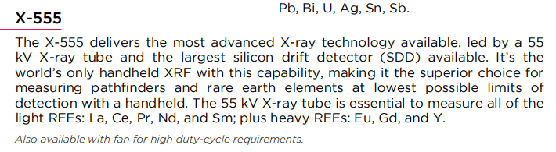 | X-555
 | The X-555 delivers the most advanced X-ray technology available, led by a 55 kV X-ray tube and the largest silicon drift detector (SDD) available. It’s the world’s only handheld XRF with this capability, making it the superior choice for measuring pathfinders and rare earth elements at lowest possible limits of detection with a handheld. The 55 kV X-ray tube is essential to measure all of the light REEs: La, Ce, Pr, Nd, and Sm; plus heavy REEs: Eu, Gd, and Y.
 | Also available with fan for high duty-cycle requirements.
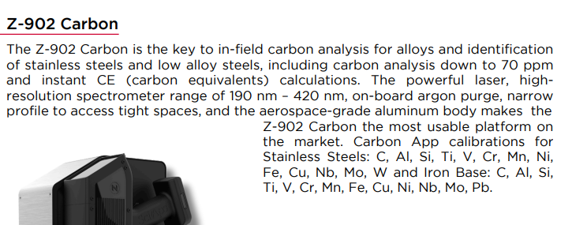 | Z-902 Carbon
 | The Z-902 Carbon is the key to in-field carbon analysis for alloys and identification of stainless steels and low alloy steels, including carbon analysis down to 70 ppm and instant CE (carbon equivalents) calculations. The powerful laser, highresolution spectrometer range of 190 nm – 420 nm, on-board argon purge, narrow profile to access tight spaces, and the aerospace-grade aluminum body makes the Z-902 Carbon the most usable platform on the market. Carbon App calibrations for Stainless Steels: C, Al, Si, Ti, V, Cr, Mn, Ni, Fe, Cu, Nb, Mo, W and Iron Base: C, Al, Si, Ti, V, Cr, Mn, Fe, Cu, Ni, Nb, Mo, Pb.
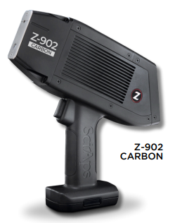 | Z-902 Carbon
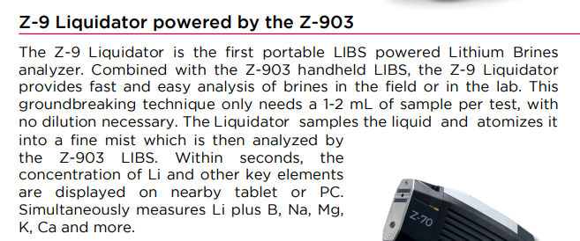 | Z-9 Liquidator powered by the Z-903
 | The Z-9 Liquidator is the first portable LIBS powered Lithium Brines analyzer. Combined with the Z-903 handheld LIBS, the Z-9 Liquidator provides fast and easy analysis of brines in the field or in the lab. This groundbreaking technique only needs a 1-2 mL of sample per test, with no dilution necessary. The Liquidator samples the liquid and atomizes it into a fine mist which is then analyzed by the Z-903 LIBS. Within seconds, the concentration of Li and other key elements are displayed on nearby tablet or PC. Simultaneously measures Li plus B, Na, Mg, K, Ca and more.
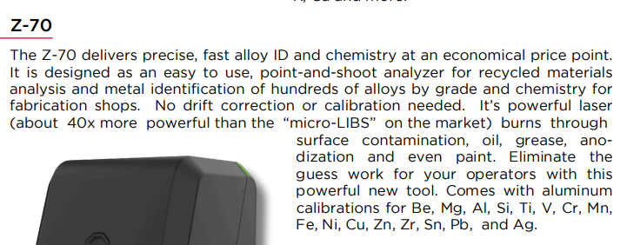 | Z-70
 | The Z-70 delivers precise, fast alloy ID and chemistry at an economical price point. It is designed as an easy to use, point-and-shoot analyzer for recycled materials analysis and metal identification of hundreds of alloys by grade and chemistry for fabrication shops. No drift correction or calibration needed. It’s powerful laser (about 40x more powerful than the “micro-LIBS” on the market) burns through surface contamination, oil, grease, ano- dization and even paint. Eliminate the guess work for your operators with this powerful new tool. Comes with aluminum calibrations for Be, Mg, Al, Si, Ti, V, Cr, Mn, Fe, Ni, Cu, Zn, Zr, Sn, Pb, and Ag.
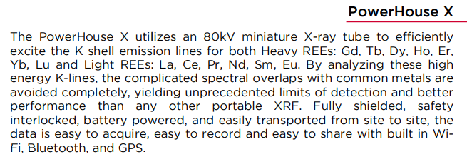 | PowerHouse X
 | The PowerHouse X utilizes an 80kV miniature X-ray tube to efficiently excite the K shell emission lines for both Heavy REEs: Gd, Tb, Dy, Ho, Er, Yb, Lu and Light REEs: La, Ce, Pr, Nd, Sm, Eu. By analyzing these high energy K-lines, the complicated spectral overlaps with common metals are avoided completely, yielding unprecedented limits of detection and better performance than any other portable XRF. Fully shielded, safety interlocked, battery powered, and easily transported from site to site, the data is easy to acquire, easy to record and easy to share with built in Wi- Fi, Bluetooth, and GPS.

