Document Title: SciAps Translation Table ApNote In-field Gold and Silver Analysis with X-555 and detectORE
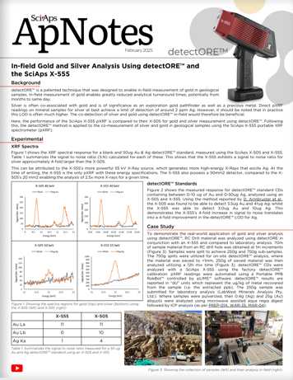
Rev Date: Feb 25

Layout Preview | English Text | Translated Text
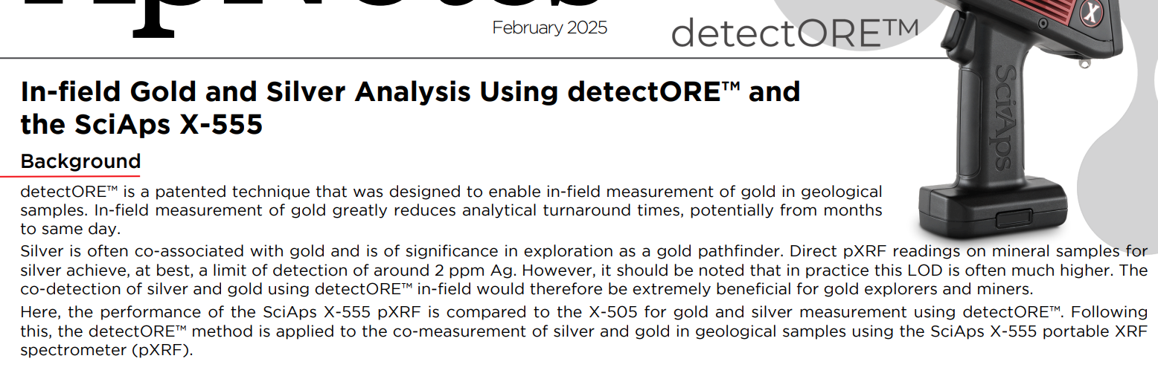 | February 2025
 | In-field Gold and Silver Analysis Using detectORE™ and the SciAps X-555
 | Background
 | detectORE™ is a patented technique that was designed to enable in-field measurement of gold in geological samples. In-field measurement of gold greatly reduces analytical turnaround times, potentially from months to same day.
 | Silver is often co-associated with gold and is of significance in exploration as a gold pathfinder. Direct pXRF readings on mineral samples for silver achieve, at best, a limit of detection of around 2 ppm Ag. However, it should be noted that in practice this LOD is often much higher. Theco-detection of silver and gold using detectORE™ in-field would therefore be extremely beneficial for gold explorers and miners. Here, the performance of the SciAps X-555 pXRF is compared to the X-505 for gold and silver measurement using detectORE™. Followingthis, the detectORE™ method is applied to the co-measurement of silver and gold in geological samples using the SciAps X-555 portable XRFspectrometer (pXRF).
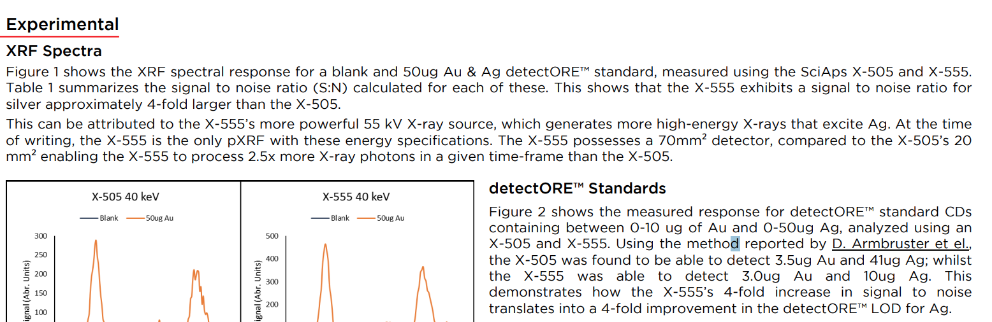 | Experimental
 | XRF Spectra
 | Figure 1 shows the XRF spectral response for a blank and 50ug Au & Ag detectORE™ standard, measured using the SciAps X-505 and X-555. Table 1 summarizes the signal to noise ratio (S:N) calculated for each of these. This shows that the X-555 exhibits a signal to noise ratio for silver approximately 4-fold larger than the X-505.
 | This can be attributed to the X-555’s more powerful 55 kV X-ray source, which generates more high-energy X-rays that excite Ag. At the timeof writing, the X-555 is the only pXRF with these energy specifications. The X-555 possesses a 70mm² detector, compared to the X-505’s 20mm² enabling the X-555 to process 2.5x more X-ray photons in a given time-frame than the X-505.
 | detectORE™ Standards
 | Figure 2 shows the measured response for detectORE™ standard CDs containing between 0-10 ug of Au and 0-50ug Ag, analyzed using an X-505 and X-555. Using the method reported by D. Armbruster et el., the X-505 was found to be able to detect 3.5ug Au and 41ug Ag; whilst the X-555 was able to detect 3.0ug Au and 10ug Ag. This demonstrates how the X-555’s 4-fold increase in signal to noise translates into a 4-fold improvement in the detectORE™ LOD for Ag.
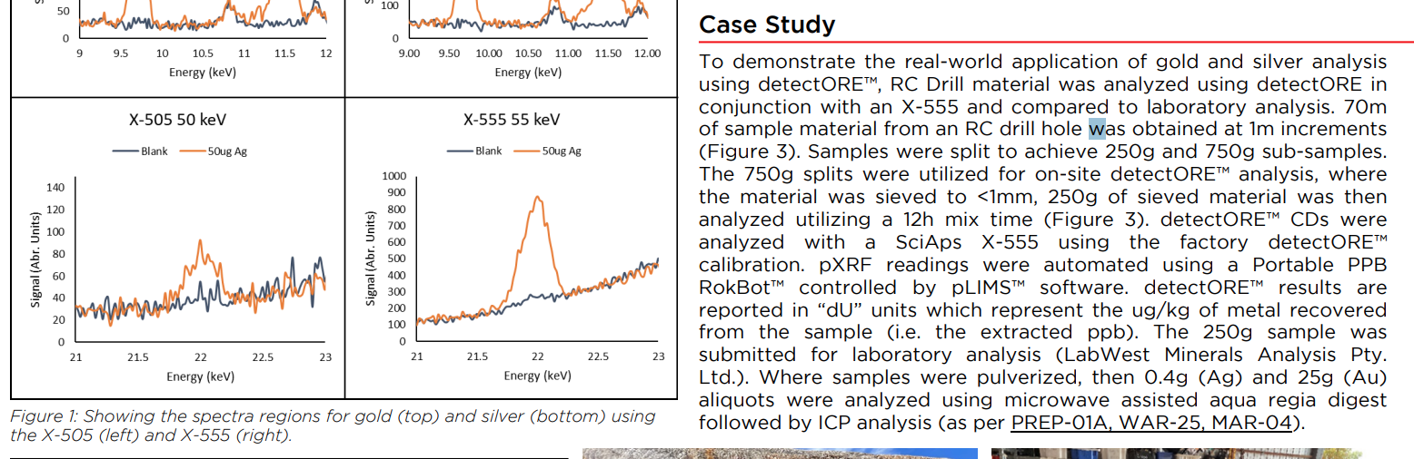 | Case Study
 | To demonstrate the real-world application of gold and silver analysis using detectORE™, RC Drill material was analyzed using detectORE in conjunction with an X-555 and compared to laboratory analysis. 70m of sample material from an RC drill hole was obtained at 1m increments (Figure 3). Samples were split to achieve 250g and 750g sub-samples. The 750g splits were utilized for on-site detectORE™ analysis, where the material was sieved to <1mm, 250g of sieved material was then analyzed utilizing a 12h mix time (Figure 3). detectORE™ CDs were analyzed with a SciAps X-555 using the factory detectORE™ calibration. pXRF readings were automated using a Portable PPB RokBot™ controlled by pLIMS™ software. detectORE™ results are reported in “dU” units which represent the ug/kg of metal recovered from the sample (i.e. the extracted ppb). The 250g sample was submitted for laboratory analysis (LabWest Minerals Analysis Pty. Ltd.). Where samples were pulverized, then 0.4g (Ag) and 25g (Au) aliquots were analyzed using microwave assisted aqua regia digest followed by ICP analysis (as per PREP-01A, WAR-25, MAR-04).
 | Figure 1: Showing the spectra regions for gold (top) and silver (bottom) using the X-505 (left) and X-555 (right).
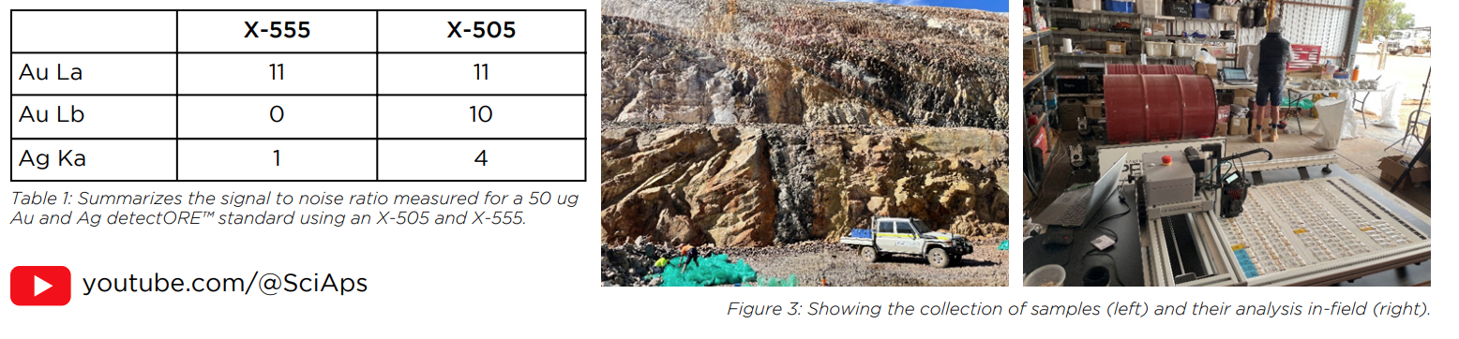 | Au La
 | Au Lb
 | Ag Ka
 | X-555
 | 11
 | 0
 | 1
 | X-505
 | 11
 | 10
 | 4
 | Table 1: Summarizes the signal to noise ratio measured for a 50 ug Au and Ag detectORE™ standard using an X-505 and X-555.
 | Figure 3: Showing the collection of samples (left) and their analysis in-field (right).
(BACK)
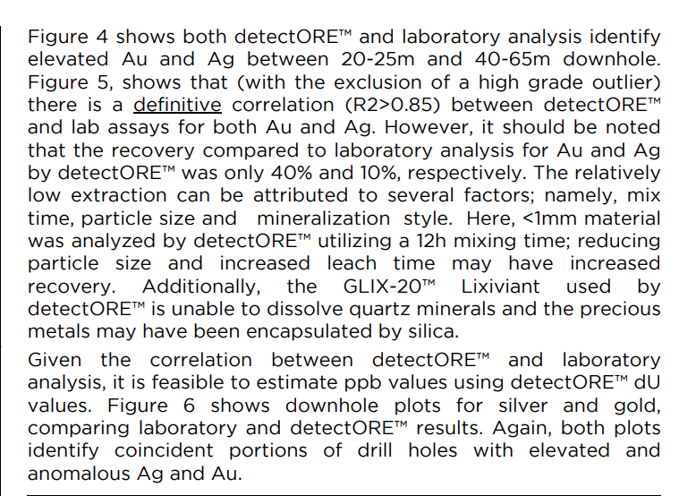 | Figure 4 shows both detectORE™ and laboratory analysis identify elevated Au and Ag between 20-25m and 40-65m downhole. Figure 5, shows that (with the exclusion of a high grade outlier)there is a definitive correlation (R2>0.85) between detectORE™and lab assays for both Au and Ag. However, it should be notedthat the recovery compared to laboratory analysis for Au and Agby detectORE™ was only 40% and 10%, respectively. The relatively low extraction can be attributed to several factors; namely, mix time, particle size and mineralization style. Here, <1mm material was analyzed by detectORE™ utilizing a 12h mixing time; reducing particle size and increased leach time may have increased recovery. Additionally, the GLIX-20™ Lixiviant used by detectORE™ is unable to dissolve quartz minerals and the precious metals may have been encapsulated by silica.
 | Given the correlation between detectORE™ and laboratoryanalysis, it is feasible to estimate ppb values using detectORE™ dUvalues. Figure 6 shows downhole plots for silver and gold, comparing laboratory and detectORE™ results. Again, both plotsidentify coincident portions of drill holes with elevated and anomalous Ag and Au.
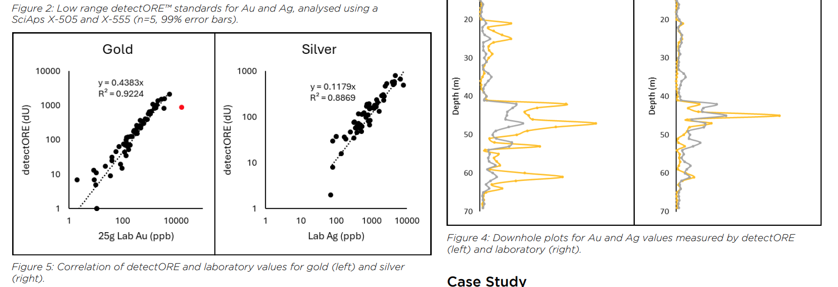 | Figure 2: Low range detectORE™ standards for Au and Ag, analysed using a SciAps X-505 and X-555 (n=5, 99% error bars).
 | Figure 4: Downhole plots for Au and Ag values measured by detectORE (left) and laboratory (right).
 | Figure 5: Correlation of detectORE and laboratory values for gold (left) and silver (right).
 | Case Study
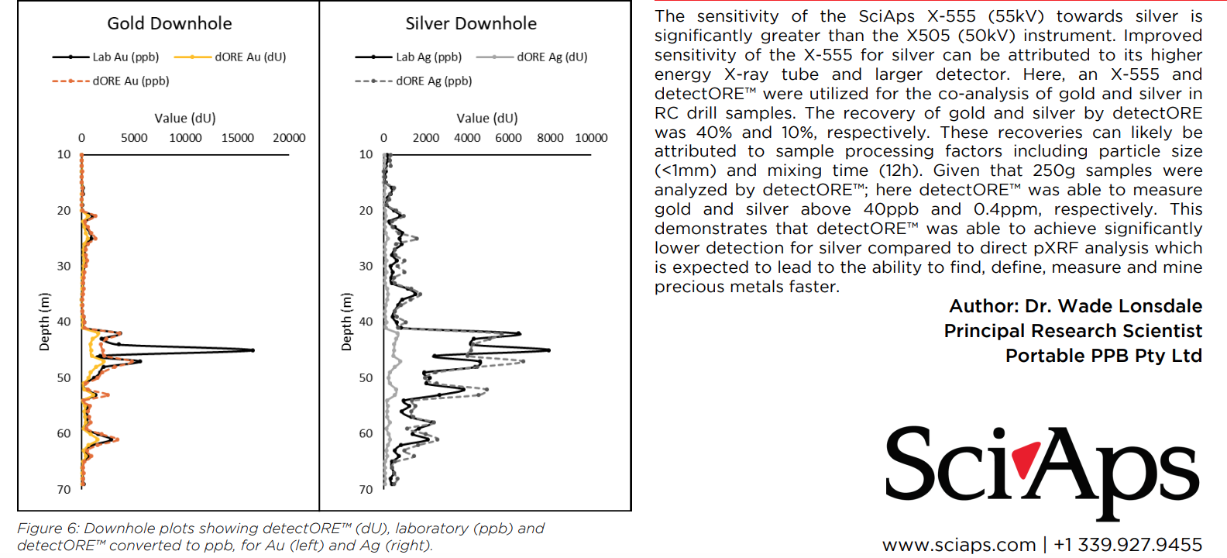 | The sensitivity of the SciAps X-555 (55kV) towards silver is significantly greater than the X505 (50kV) instrument. Improved sensitivity of the X-555 for silver can be attributed to its higher energy X-ray tube and larger detector. Here, an X-555 and detectORE™ were utilized for the co-analysis of gold and silver in RC drill samples. The recovery of gold and silver by detectORE was 40% and 10%, respectively. These recoveries can likely be attributed to sample processing factors including particle size (<1mm) and mixing time (12h). Given that 250g samples were analyzed by detectORE™; here detectORE™ was able to measure gold and silver above 40ppb and 0.4ppm, respectively. This demonstrates that detectORE™ was able to achieve significantly lower detection for silver compared to direct pXRF analysis which is expected to lead to the ability to find, define, measure and mine precious metals faster.
 | Author: Dr. Wade Lonsdale
 | Principal Research Scientist
 | Portable PPB Pty Ltd
 | Figure 6: Downhole plots showing detectORE™ (dU), laboratory (ppb) and detectORE™ converted to ppb, for Au (left) and Ag (right).

