Document Title: SciAps Handheld LIBS for Soil Nutrient Analysis
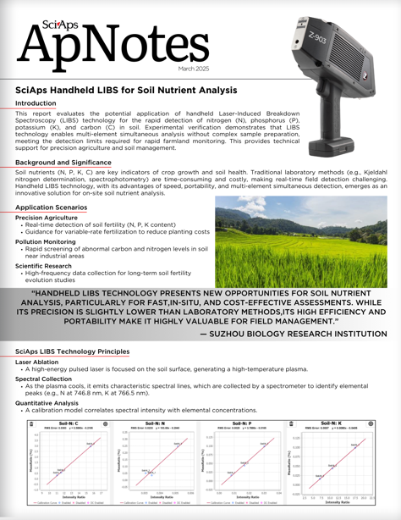
Rev Date: Mar 2025

Layout Preview | English Text | Translated Text
 | March 2025
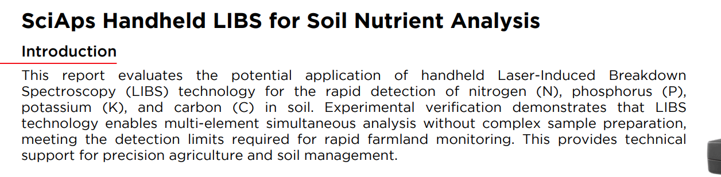 | SciAps Handheld LIBS for Soil Nutrient Analysis
 | Introduction
 | This report evaluates the potential application of handheld Laser-Induced Breakdown Spectroscopy (LIBS) technology for the rapid detection of nitrogen (N), phosphorus (P), potassium (K), and carbon (C) in soil. Experimental verification demonstrates that LIBS technology enables multi-element simultaneous analysis without complex sample preparation, meeting the detection limits required for rapid farmland monitoring. This provides technical support for precision agriculture and soil management.
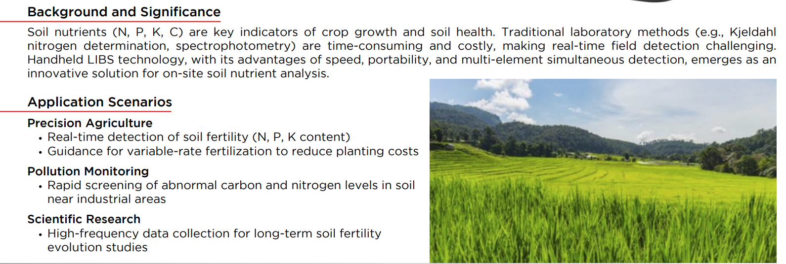 | Background and Significance
 | Soil nutrients (N, P, K, C) are key indicators of crop growth and soil health. Traditional laboratory methods (e.g., Kjeldahl nitrogen determination, spectrophotometry) are time-consuming and costly, making real-time field detection challenging. Handheld LIBS technology, with its advantages of speed, portability, and multi-element simultaneous detection, emerges as an innovative solution for on-site soil nutrient analysis.
 | Application Scenarios
 | Precision Agriculture
 | Real-time detection of soil fertility (N, P, K content)
 | Guidance for variable-rate fertilization to reduce planting costs
 | Pollution Monitoring
 | Rapid screening of abnormal carbon and nitrogen levels in soil near industrial areas
 | Scientific Research
 | High-frequency data collection for long-term soil fertility evolution studies
 | “HANDHELD LIBS TECHNOLOGY PRESENTS NEW OPPORTUNITIES FOR SOIL NUTRIENT ANALYSIS, PARTICULARLY FOR FAST,IN-SITU, AND COST-EFFECTIVE ASSESSMENTS. WHILE ITS PRECISION IS SLIGHTLY LOWER THAN LABORATORY METHODS,ITS HIGH EFFICIENCY AND PORTABILITY MAKE IT HIGHLY VALUABLE FOR FIELD MANAGEMENT.”
 | SUZHOU BIOLOGY RESEARCH INSTITUTION
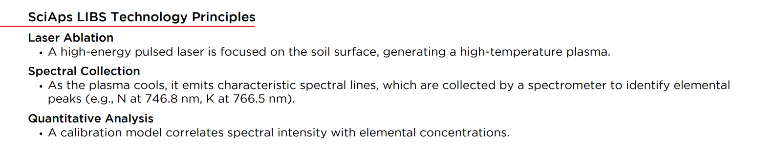 | SciAps LIBS Technology Principles
 | Laser Ablation
 | A high-energy pulsed laser is focused on the soil surface, generating a high-temperature plasma.
 | Spectral Collection
 | As the plasma cools, it emits characteristic spectral lines, which are collected by a spectrometer to identify elemental peaks (e.g., N at 746.8 nm, K at 766.5 nm).
 | Quantitative Analysis
 | A calibration model correlates spectral intensity with elemental concentrations.
(BACK)
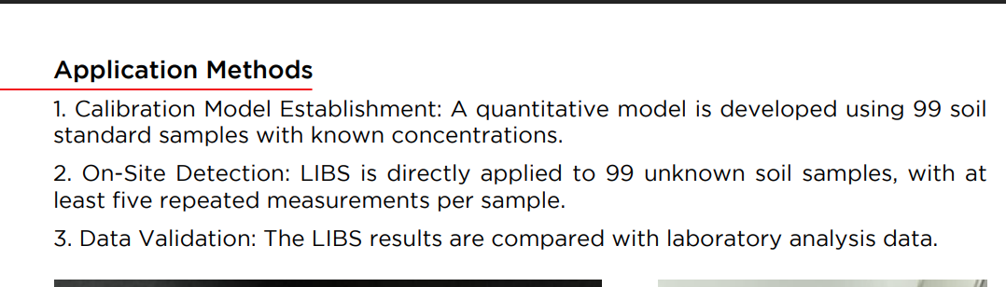 | Application Methods
 | 1. Calibration Model Establishment: A quantitative model is developed using 99 soil standard samples with known concentrations.
 | 2. On-Site Detection: LIBS is directly applied to 99 unknown soil samples, with at least five repeated measurements per sample.
 | 3. Data Validation: The LIBS results are compared with laboratory analysis data.
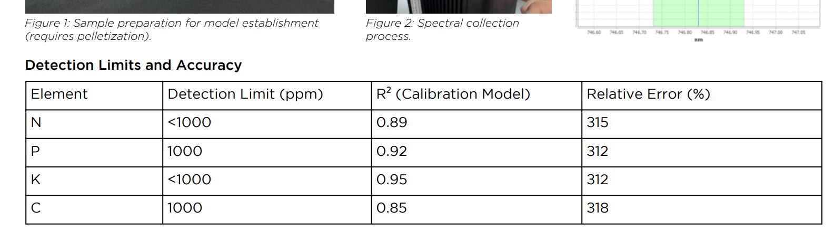 | Figure 1: Sample preparation for model establishment (requires pelletization).
 | Figure 2: Spectral collection process.
 | Detection Limits and Accuracy
 | Element
 | N
 | P
 | K
 | C
 | Detection Limit (ppm)
 | <1000
 | 1000
 | <1000
 | 1000
 | R² (Calibration Model)
 | 0.89
 | 0.92
 | 0.95
 | 0.85
 | Relative Error (%)
 | +/- 15
 | +/- 12
 | +/- 12
 | +/- 18
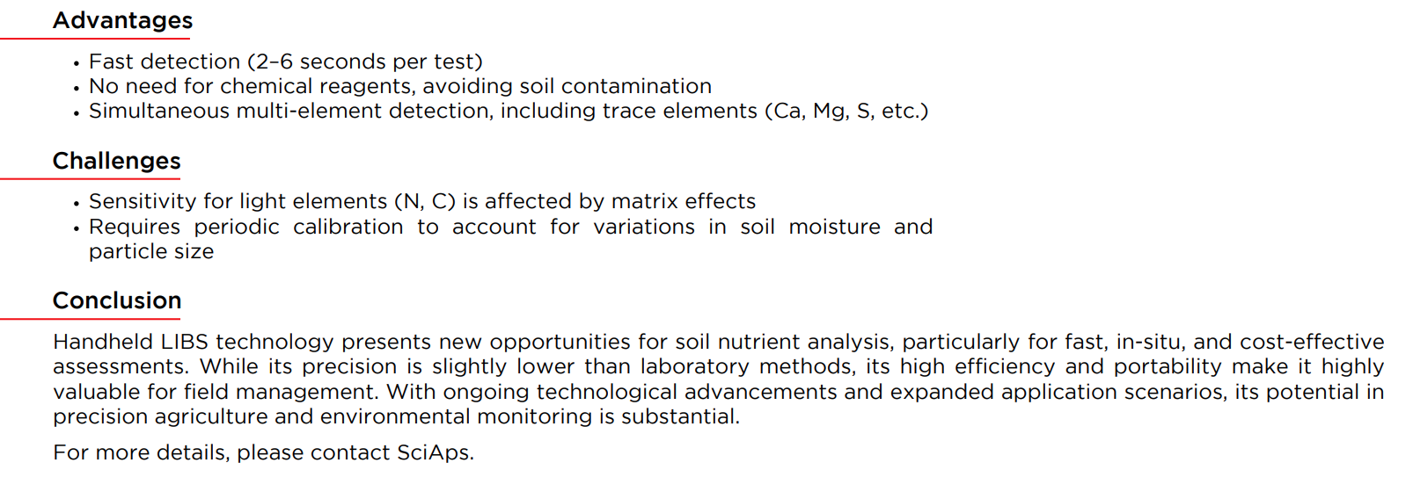 | Advantages
 | Fast detection (2–6 seconds per test)
 | No need for chemical reagents, avoiding soil contamination
 | Simultaneous multi-element detection, including trace elements (Ca, Mg, S, etc.)
 | Challenges
 | Sensitivity for light elements (N, C) is affected by matrix effects
 | Requires periodic calibration to account for variations in soil moisture and particle size
 | Conclusion
 | Handheld LIBS technology presents new opportunities for soil nutrient analysis, particularly for fast, in-situ, and cost-effective assessments. While its precision is slightly lower than laboratory methods, its high efficiency and portability make it highly valuable for field management. With ongoing technological advancements and expanded application scenarios, its potential in precision agriculture and environmental monitoring is substantial.
 | For more details, please contact SciAps.

