Document Title: SciAps Z-901 CSi Specifications
Rev Date: Apr 2025
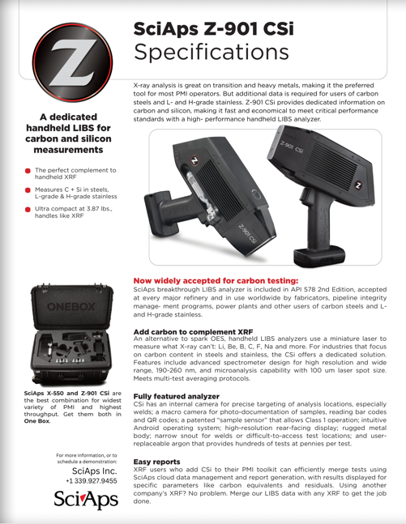

Layout Preview | English Text | Translated Text
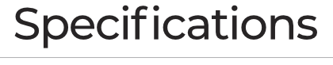 | Specifications
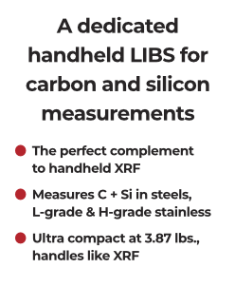 | A dedicated handheld LIBS for carbon and silicon measurements
 | The perfect complement to handheld XRF
 | Measures C + Si in steels, L-grade & H-grade stainless
 | Ultra compact at 3.87 lbs., handles like XRF
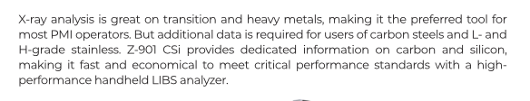 | X-ray analysis is great on transition and heavy metals, making it the preferred tool for most PMI operators. But additional data is required for users of carbon steels and L- and H-grade stainless. Z-901 CSi provides dedicated information on carbon and silicon, making it fast and economical to meet critical performance standards with a high-performance handheld LIBS analyzer.
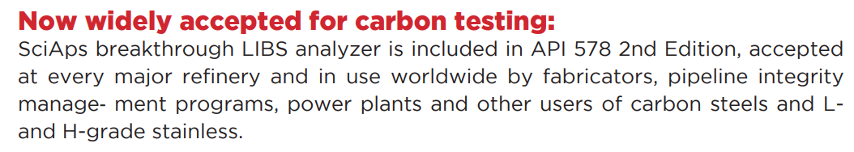 | Now widely accepted for carbon testing:
 | SciAps breakthrough LIBS analyzer is included in API 578 2nd Edition, accepted at every major refinery and in use worldwide by fabricators, pipeline integrity management programs, power plants and other users of carbon steels and L- and H-grade stainless.
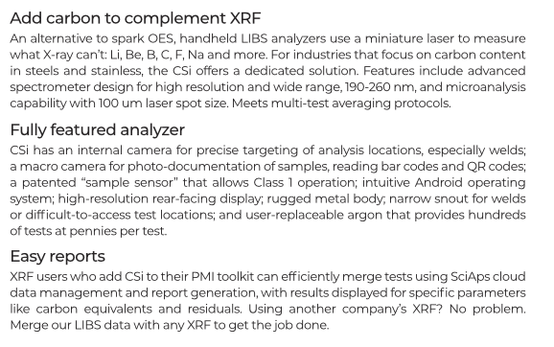 | Add carbon to complement XRF
 | An alternative to spark OES, handheld LIBS analyzers use a miniature laser to measure what X-ray can’t: Li, Be, B, C, F, Na and more. For industries that focus on carbon content in steels and stainless, the CSi offers a dedicated solution. Features include advanced spectrometer design for high resolution and wide range, 190-260 nm, and microanalysis capability with 100 um laser spot size. Meets multi-test averaging protocols.
 | Fully featured analyzer
 | CSi has an internal camera for precise targeting of analysis locations, especially welds; a macro camera for photo-documentation of samples, reading bar codes and QR codes; a patented “sample sensor” that allows Class 1 operation; intuitive Android operating system; high-resolution rear-facing display; rugged metal body; narrow snout for welds or difficult-to-access test locations; and user-replaceable argon that provides hundreds of tests at pennies per test.
 | Easy reports
 | XRF users who add CSi to their PMI toolkit can efficiently merge tests using SciAps cloud data management and report generation, with results displayed for specific parameters like carbon equivalents and residuals. Using another company’s XRF? No problem. Merge our LIBS data with any XRF to get the job done.
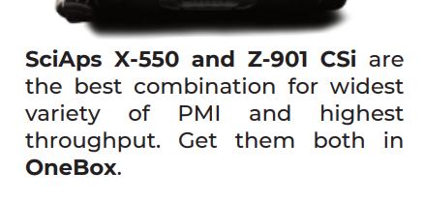 | SciAps X-550 and Z-901 CSi are the best combination for widest variety of PMI and highest throughput. Get them both in OneBox.
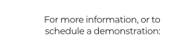 | For more information, or to schedule a demonstration:
(BACK)
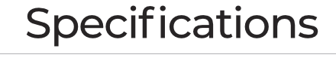 | Specifications
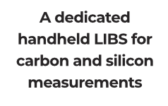 | A dedicated handheld LIBS for carbon and silicon measurements
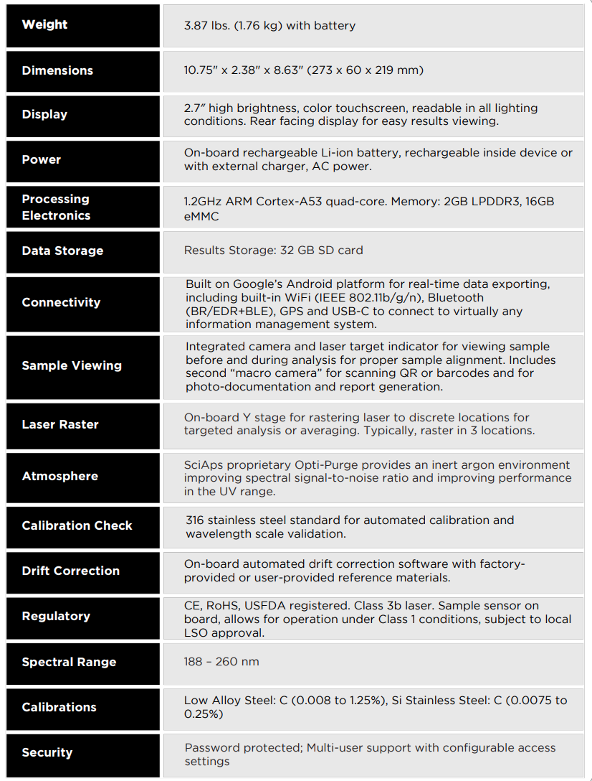 | Weight
 | 3.87 lbs. (1.76 kg) with battery
 | Dimensions
 | 10.75" x 2.38" x 8.63" (273 x 60 x 219 mm)
 | Display
 | 2.7″ high brightness, color touchscreen, readable in all lighting conditions. Rear facing display for easy results viewing.
 | Power
 | On-board rechargeable Li-ion battery, rechargeable inside device or with external charger, AC power.
 | Processing Electronics
 | 1.2GHz ARM Cortex-A53 quad-core. Memory: 2GB LPDDR3, 16GB eMMC
 | Data Storage
 | Results Storage: 32 GB SD card
 | Connectivity
 | Built on Google’s Android platform for real-time data exporting, including built-in WiFi (IEEE 802.11b/g/n), Bluetooth (BR/EDR+BLE), GPS and USB-C to connect to virtually any information management system.
 | Sample Viewing
 | Integrated camera and laser target indicator for viewing sample before and during analysis for proper sample alignment. Includes second “macro camera” for scanning QR or barcodes and for photo-documentation and report generation.
 | Laser Raster
 | On-board Y stage for rastering laser to discrete locations for targeted analysis or averaging.
 | Atmosphere
 | SciAps proprietary Opti-Purge provides an inert argon environment improving spectral signal to noise ratio and improving performance in the UV range.
 | Calibration Check
 | 316 stainless steel standard for automated calibration and wavelength scale validation.
 | Drift Correction
 | On-board automated drift correction software with factory-provided or user-provided reference materials.
 | Regulatory
 | CE, RoHS, USFDA registered. Class 3b laser. Sample sensor on board, allows for operation under Class 1 conditions, subject to local LSO approval.
 | Spectral Range
 | 188 – 260 nm
 | Calibrations
 | Low Alloy Steel: C (0.008 to 1.25%), Si Stainless Steel: C (0.0075 to 0.25%)
 | Security
 | Password protected; Multi-user support with configurable access settings

