Document Title: SciAps X-550 Alloy Specifications
Rev Date: Apr 2025
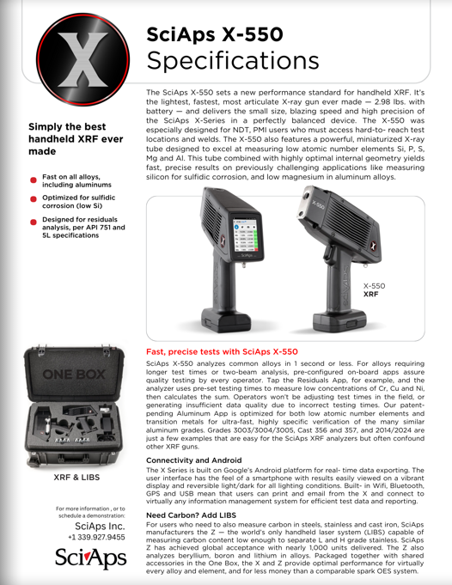
Layout Preview | English Text | Translated Text
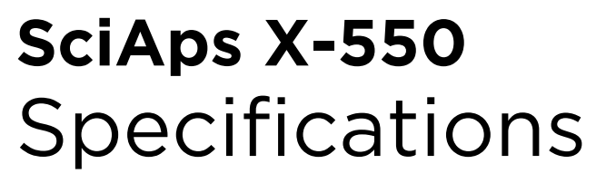 | SciAps X-550
 | Specifications
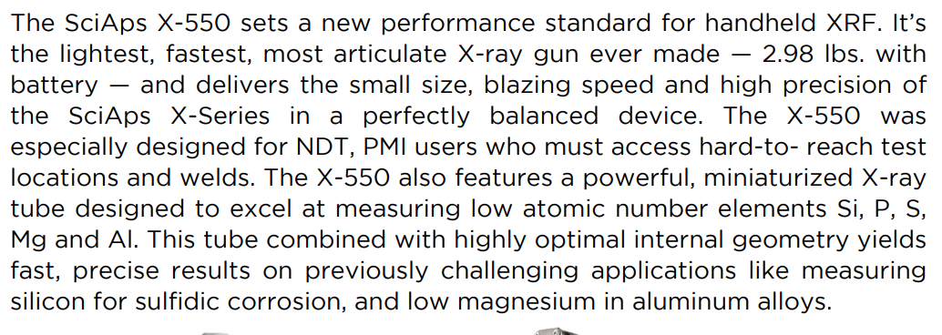 | The SciAps X-550 sets a new performance standard for handheld XRF. It’s the lightest, fastest, most articulate X-ray gun ever made — 2.98 lbs. with battery — and delivers the small size, blazing speed and high precision of the SciAps X-Series in a perfectly balanced device. The X-550 was especially designed for NDT, PMI users who must access hard-to-reach test locations and welds. The X-550 also features a powerful, miniaturized X-ray tube designed to excel at measuring low atomic number elements Si, P, S, Mg and Al. This tube combined with highly optimal internal geometry yields fast, precise results on previously challenging applications like measuring silicon for sulfidic corrosion, and low magnesium in aluminum alloys.
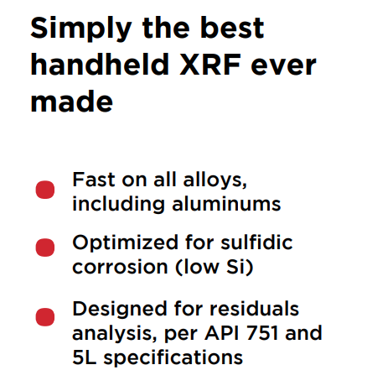 | Simply the best handheld XRF ever made
 | Fast on all alloys, including aluminums
 | Optimized for sulfidic corrosion (low Si)
 | Designed for residuals analysis, per API 751 and 5L specifications
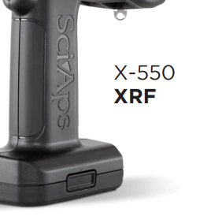 | X-550
 | XRF
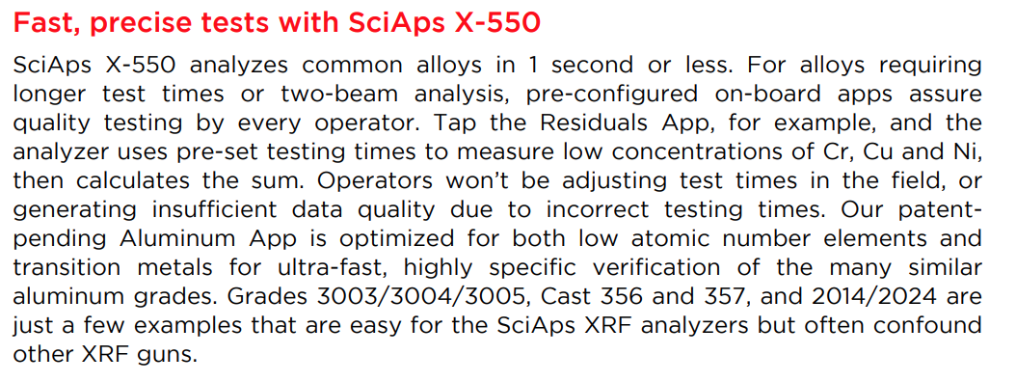 | Fast, precise tests with SciAps X-550
 | SciAps X-550 analyzes common alloys in 1 second or less. For alloys requiring longer test times or two-beam analysis, pre-configured on-board apps assure quality testing by every operator. Tap the Residuals App, for example, and the analyzer uses pre-set testing times to measure low concentrations of Cr, Cu and Ni, then calculates the sum. Operators won’t be adjusting test times in the field or generating insufficient data quality due to incorrect testing times. Our patent pending Aluminum App is optimized for both low atomic number elements and transition metals for ultra-fast, highly specific verification of the many similar aluminum grades. Grades 3003/3004/3005, Cast 356 and 357, and 2014/2024 are just a few examples that are easy for the SciAps XRF analyzers but often confound other XRF guns.
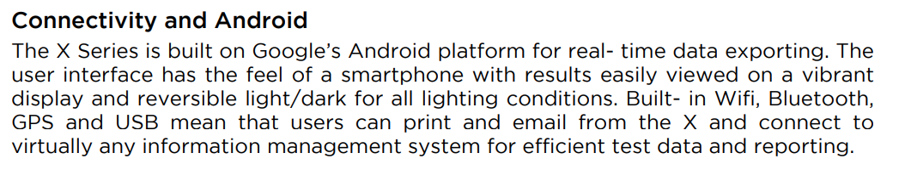 | Connectivity and Android
 | The X Series is built on Google’s Android platform for real-time data exporting. The user interface has the feel of a smartphone with results easily viewed on a vibrant display and reversible light/dark for all lighting conditions. Built-in Wifi, Bluetooth, GPS and USB mean that users can print and email from the X and connect to virtually any information management system for efficient test data and reporting.
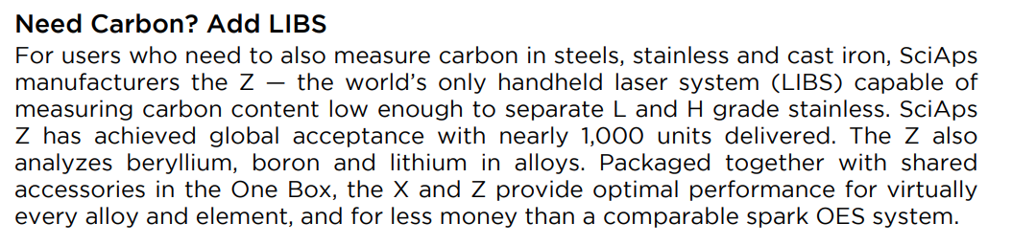 | Need Carbon? Add LIBS
 | For users who need to also measure carbon in steels, stainless and cast iron, SciAps manufacturers the Z — the world’s only handheld laser system (LIBS) capable of measuring carbon content low enough to separate L and H grade stainless. SciAps Z has achieved global acceptance with nearly 1,000 units delivered. The Z also analyzes beryllium, boron and lithium in alloys. Packaged together with shared accessories in the One Box, the X and Z provide optimal performance for virtually every alloy and element, and for less money than a comparable spark OES system.
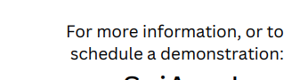 | For more information, or to schedule a demonstration:
(BACK)
 | SciAps X-550
 | Specifications
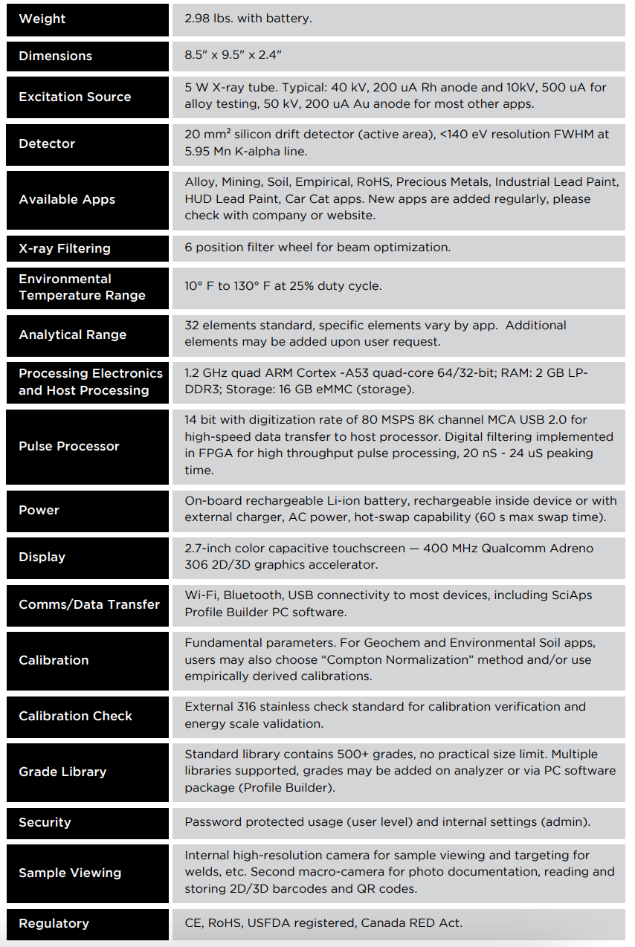 | Weight
 | 2.98 lbs. with battery.
 | Dimensions
 | 8.5" x 9.5" x 2.4"
 | Excitation Source
 | 5 W X-ray tube. Typical: 40 kV, 200 uA Rh anode and 10kV, 500 uA for alloy testing, 50 kV, 200 uA Au anode for most other apps.
 | Detector
 | 20 mm² silicon drift detector (active area), <140 eV resolution FWHM at 5.95 Mn K-alpha line.
 | Available Apps
 | Alloy, Mining, Soil, Empirical, RoHS, Precious Metals, Industrial Lead Paint, HUD Lead Paint, Car Cat apps. New apps are added regularly, please check with company or website.
 | X-ray Filtering
 | 6 position filter wheel for beam optimization.
 | Environmental Temperature Range
 | 10° F to 130° F at 25% duty cycle.
 | Analytical Range
 | 32 elements standard, specific elements vary by app. Additional elements may be added upon user request.
 | Processing Electronics and Host Processing
 | 1.2 GHz quad ARM Cortex -A53 quad-core 64/32-bit; RAM: 2 GB LP-DDR3; Storage: 16 GB eMMC (storage).
 | Pulse Processor
 | 14 bit with digitization rate of 80 MSPS 8K channel MCA USB 2.0 for high-speed data transfer to host processor. Digital filtering implemented in FPGA for high throughput pulse processing, 20 nS - 24 uS peaking time.
 | Power
 | On-board rechargeable Li-ion battery, rechargeable inside device or with external charger, AC power, hot-swap capability (60 s max swap time).
 | Display
 | 2.7-inch color capacitive touchscreen — 400 MHz Qualcomm Adreno 306 2D/3D graphics accelerator.
 | Comms/Data Transfer
 | Wi-Fi, Bluetooth, USB connectivity to most devices, including SciAps Profile Builder PC software.
 | Calibration
 | Fundamental parameters. For Geochem and Environmental Soil apps, users may also choose “Compton Normalization” method and/or use empirically derived calibrations.
 | Calibration Check
 | External 316 stainless check standard for calibration verification and energy scale validation.
 | Grade Library
 | Standard library contains 500+ grades, no practical size limit. Multiple libraries supported, grades may be added on analyzer or via PC software package (Profile Builder).
 | Security
 | Password protected usage (user level) and internal settings (admin).
 | Sample Viewing
 | Internal high-resolution camera for sample viewing and targeting for welds, etc. Second macro-camera for photo documentation, reading and storing 2D/3D barcodes and QR codes.
 | Regulatory
 | CE, RoHS, USFDA registered, Canada RED Act.

