Document Title: SciAps X-505 Alloy Specifications
Rev Date: Apr 2025
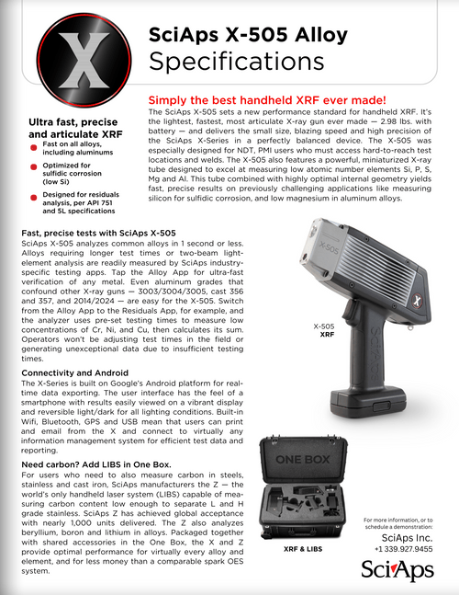
Layout Preview | English Text | Translated Text
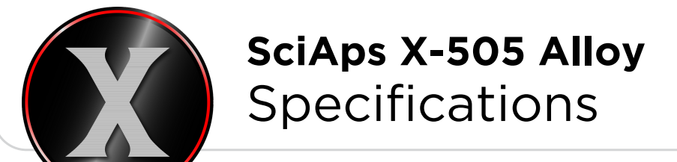 | SciAps X-505 Alloy
 | Specifications
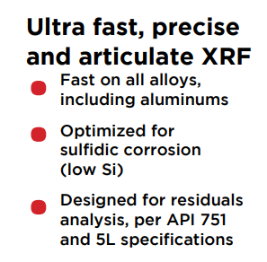 | Ultra fast, precise and articulate XRF
 | Fast on all alloys, including aluminums
 | Optimized for sulfidic corrosion (low Si)
 | Designed for residuals analysis, per API 751 and 5L specifications
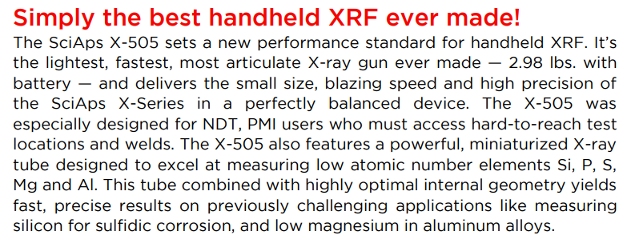 | Simply the best handheld XRF ever made!
 | The SciAps X-505 sets a new performance standard for handheld XRF. It’s the lightest, fastest, most articulate X-ray gun ever made — 2.98 lbs. with battery — and delivers the small size, blazing speed and high precision of the SciAps X-Series in a perfectly balanced device. The X-505 was especially designed for NDT, PMI users who must access hard-to-reach test locations and welds. The X-505 also features a powerful, miniaturized X-ray tube designed to excel at measuring low atomic number elements Si, P, S, Mg and Al. This tube combined with highly optimal internal geometry yields fast, precise results on previously challenging applications like measuring silicon for sulfidic corrosion, and low magnesium in aluminum alloys.
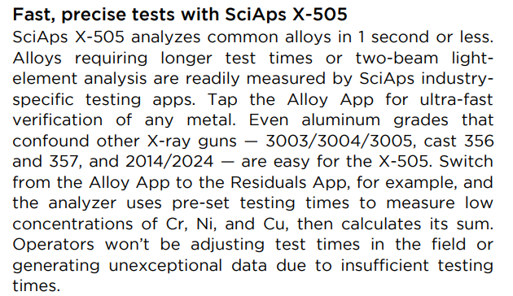 | Fast, precise tests with SciAps X-505
SciAps X-505 analyzes common alloys in 1 second or less. Alloys requiring longer test times or two-beam light-element analysis are readily measured by SciAps industry-specific testing apps. Tap the Alloy App for ultra-fast verification of any metal. Even aluminum grades that
confound other X-ray guns — 3003/3004/3005, cast 356 and 357, and 2014/2024 — are easy for the X-505. Switch from the Alloy App to the Residuals App, for example, and the analyzer uses pre-set testing times to measure low concentrations of Cr, Ni, and Cu, then calculates its sum.
Operators won’t be adjusting test times in the field or generating unexceptional data due to insufficient testing times.
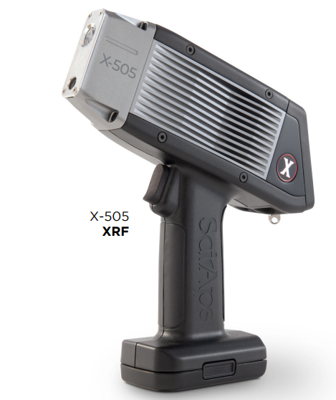 | X-505 XRF
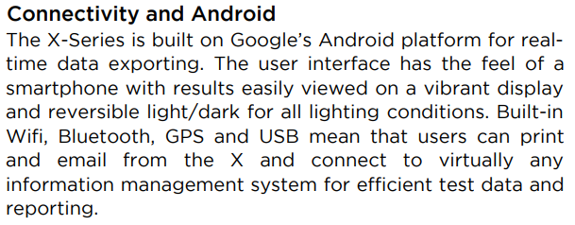 | Connectivity and Android
The X-Series is built on Google’s Android platform for real-time data exporting. The user interface has the feel of a
smartphone with results easily viewed on a vibrant display and reversible light/dark for all lighting conditions. Built-in Wifi, Bluetooth, GPS and USB mean that users can print and email from the X and connect to virtually any information management system for efficient test data and reporting.
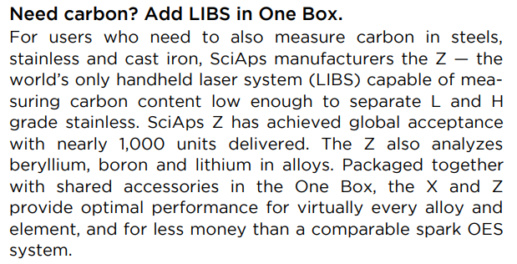 | Need carbon? Add LIBS in One Box.
For users who need to also measure carbon in steels, stainless and cast iron, SciAps manufacturers the Z — the
world’s only handheld laser system (LIBS) capable of measuring carbon content low enough to separate L and H
grade stainless. SciAps Z has achieved global acceptance with nearly 1,000 units delivered. The Z also analyzes beryllium, boron and lithium in alloys. Packaged together with shared accessories in the One Box, the X and Z
provide optimal performance for virtually every alloy and element, and for less money than a comparable spark OES system.
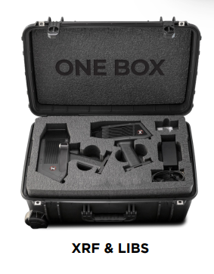 | XRF & LIBS
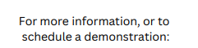 | For more information, or to schedule a demonstration:
(BACK)
 | SciAps X-505 Alloy
 | Specifications
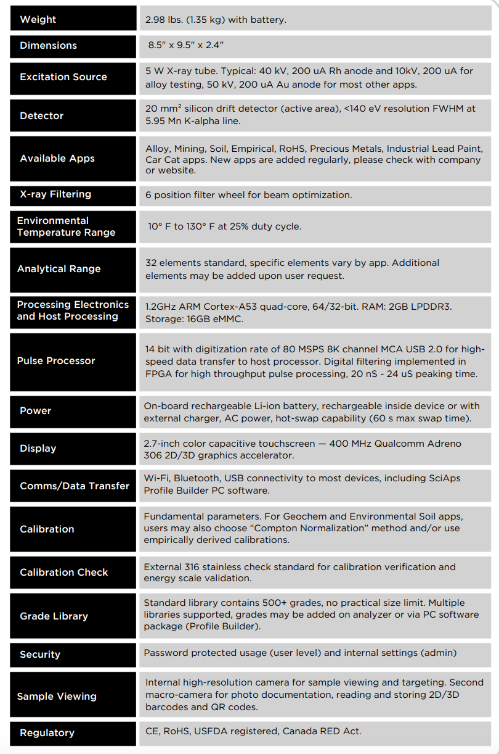 | Weight
 | 2.98 lbs. (1.35 kg) with battery.
 | Dimensions
 | 8.5" x 9.5" x 2.4"
 | Excitation Source
 | 5 W X-ray tube. Typical: 40 kV, 200 uA Rh anode and 10kV, 200 uA for alloy testing, 50 kV, 200 uA Au anode for most other apps.
 | Detector
20 mm² silicon drift detector (active area), <140 eV resolution FWHM at
5.95 Mn K-alpha line.
 | Available Apps
Alloy, Mining, Soil, Empirical, RoHS, Precious Metals, Industrial Lead Paint,
Car Cat apps. New apps are added regularly, please check with company or website.
 | X-ray Filtering
 | 6 position filter wheel for beam optimization.
 | Environmental Temperature Range
 | 10° F to 130° F at 25% duty cycle.
 | Analytical Range
 | 32 elements standard, specific elements vary by app. Additional elements may be added upon user request.
 | Processing Electronics and Host Processing
 | 1.2GHz ARM Cortex-A53 quad-core, 64/32-bit. RAM: 2GB LPDDR3. Storage: 16GB eMMC.
 | Pulse Processor
 | 14 bit with digitization rate of 80 MSPS 8K channel MCA USB 2.0 for high-speed data transfer to host processor. Digital filtering implemented in FPGA for high throughput pulse processing, 20 nS - 24 uS peaking time.
 | Power
On-board rechargeable Li-ion battery, rechargeable inside device or with
external charger, AC power, hot-swap capability (60 s max swap time).
 | Display
 | 2.7-inch color capacitive touchscreen — 400 MHz Qualcomm Adreno 306 2D/3D graphics accelerator.
 | Comms/Data Transfer
 | Wi-Fi, Bluetooth, USB connectivity to most devices, including SciAps Profile Builder PC software.
 | Calibration
 | Fundamental parameters. For Geochem and Environmental Soil apps, users may also choose “Compton Normalization” method and/or use empirically derived calibrations.
 | Calibration Check
 | External 316 stainless check standard for calibration verification and energy scale validation.
 | Grade Library
 | Standard library contains 500+ grades, no practical size limit. Multiple libraries supported, grades may be added on analyzer or via PC software package (Profile Builder).
 | Security
 | Password protected usage (user level) and internal settings (admin)
 | Sample Viewing
 | Internal high-resolution camera for sample viewing and targeting. Second macro-camera for photo documentation, reading and storing 2D/3D barcodes and QR codes.
 | Regulatory
 | CE, RoHS, USFDA registered, Canada RED Act.

