Document Title: SciAps X-200 Specifications
Rev Date: Apr 2025
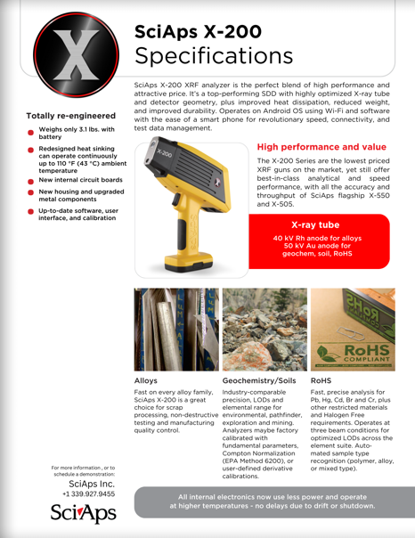
Layout Preview | English Text | Translated Text
 | SciAps X-200
 | Specifications
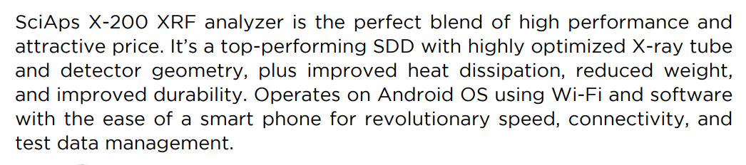 | SciAps X-200 XRF analyzer is the perfect blend of high performance and attractive price. It’s a top-performing SDD with highly optimized X-ray tube and detector geometry, plus improved heat dissipation, reduced weight, and improved durability. Operates on Android OS using Wi-Fi and software with the ease of a smart phone for revolutionary speed, connectivity, and test data management.
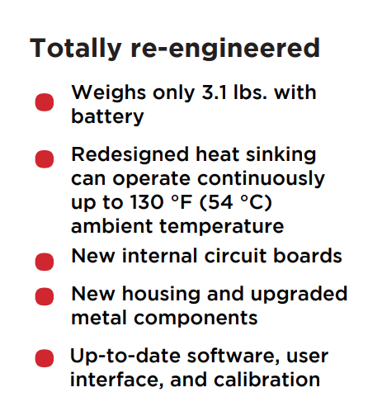 | Totally re-engineered
 | Weighs only 3.1 lbs. with battery
 | Redesigned heat sinking can operate continuously up to 130 °F (54 °C) ambient temperature
 | New internal circuit boards
 | New housing and upgraded metal components
 | Up-to-date software, user interface, and calibration
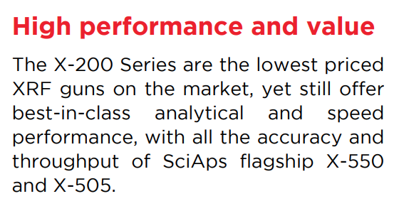 | High performance and value
 | The X-200 Series are the lowest priced XRF guns on the market, yet still offer best-in-class analytical and speed performance, with all the accuracy and throughput of SciAps flagship X-550 and X-505.
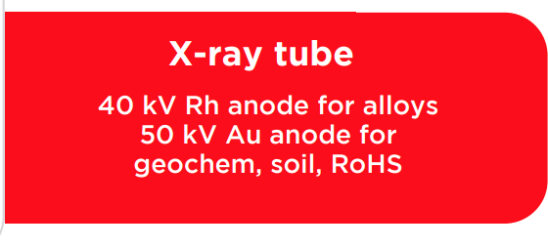 | X-ray tube
 | 40 kV Rh anode for alloys
 | 50 kV Au anode for geochem, soil, RoHS
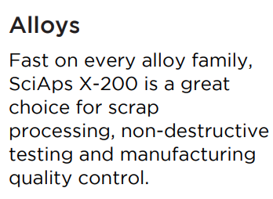 | Alloys
 | Fast on every alloy family, SciAps X-200 is a great choice for scrap processing, non-destructive testing and manufacturing quality control.
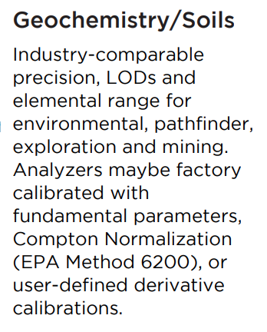 | Geochemistry/Soils
 | Industry-comparable precision, LODs and elemental range for environmental, pathfinder, exploration and mining. Analyzers may be factory calibrated with fundamental parameters, Compton Normalization (EPA Method 6200), or user-defined derivative calibrations.
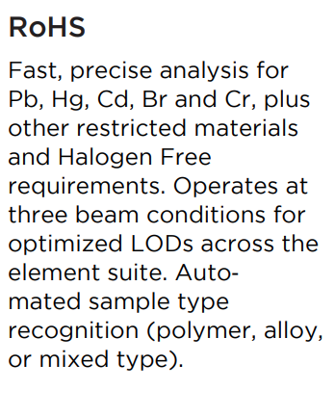 | RoHS
 | Fast, precise analysis for Pb, Hg, Cd, Br and Cr, plus other restricted materials and Halogen Free requirements. Operates at three beam conditions for optimized LODs across the element suite. Auto‐ mated sample type recognition (polymer, alloy, or mixed type).
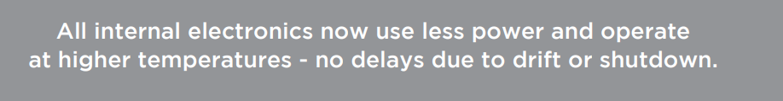 | All internal electronics now use less power and operate at higher temperatures - no delays due to drift or shutdown.
 | For more information, or to schedule a demonstration:
(BACK)
 | SciAps X-200
 | Specifications
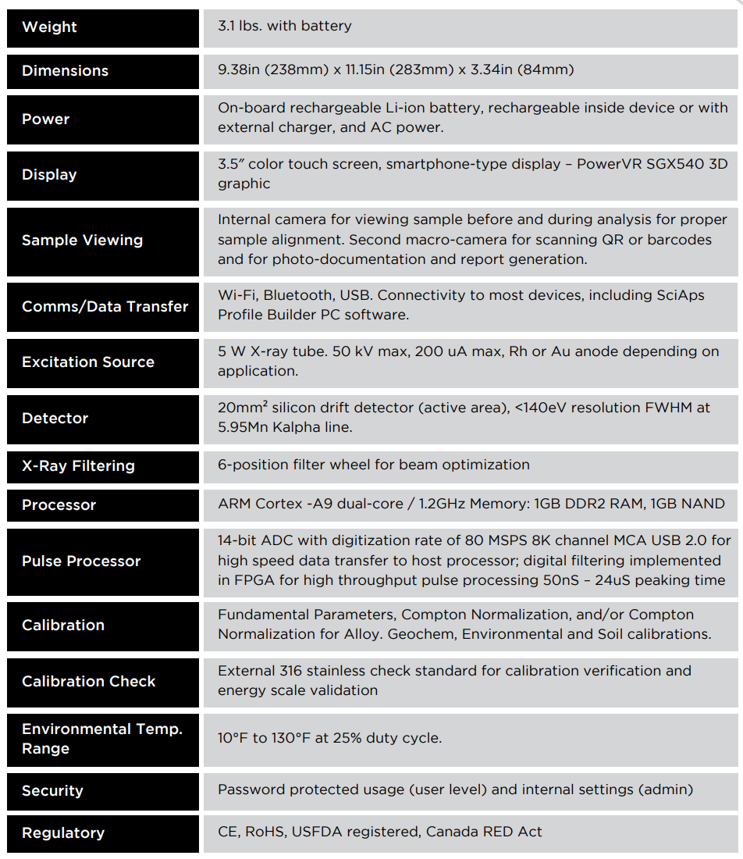 | Weight
 | 3.1 lbs. with battery
 | Dimensions
 | 9.38in (238mm) x 11.15in (283mm) x 3.34in (84mm)
 | Power
 | On-board rechargeable Li-ion battery, rechargeable inside device or with external charger, and AC power.
 | Display
 | 3.5″ color touch screen, smartphone-type display – PowerVR SGX540 3D graphic
 | Sample Viewing
 | Internal camera for viewing sample before and during analysis for proper sample alignment. Second macro-camera for scanning QR or barcodes and for photo-documentation and report generation.
 | Comms/Data Transfer
 | Wi-Fi, Bluetooth, USB. Connectivity to most devices, including SciAps Profile Builder PC software.
 | Excitation Source
 | 5 W X-ray tube. 50 kV max, 200 uA max, Rh or Au anode depending on applic
 | Detector
 | 20mm² silicon drift detector (active area), <140eV resolution FWHM at 5.95Mn Kalpha line.
 | X-Ray Filtering
 | 6-position filter wheel for beam optimization
 | Processor
 | ARM Cortex -A9 dual-core / 1.2GHz Memory: 1GB DDR2 RAM, 1GB NAND
 | Pulse Processor
 | 14-bit ADC with digitization rate of 80 MSPS 8K channel MCA USB 2.0 for high speed data transfer to host processor; digital filtering implemented in FPGA for high throughput pulse processing 50nS – 24uS peaking time
 | Calibration
 | Fundamental Parameters, Compton Normalization, and/or Compton Normalization for Alloy. Geochem, Environmental and Soil calibrations.
 | Calibration Check
 | External 316 stainless check standard for calibration verification and energy scale validation
 | Environmental Temp. Range
 | 10°F to 130°F at 25% duty cycle.
 | Security
 | Password protected usage (user level) and internal settings (admin)
 | Regulatory
 | CE, RoHS, USFDA registered, Canada RED Act

