Document Title: X-555 Geochemistry Specifications
Rev Date: Apr 2025
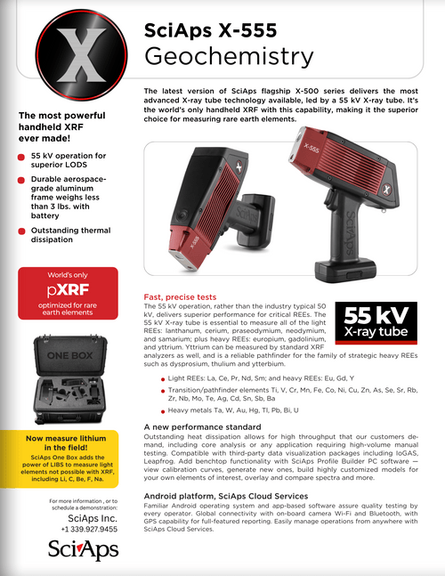
Layout Preview | English Text | Translated Text
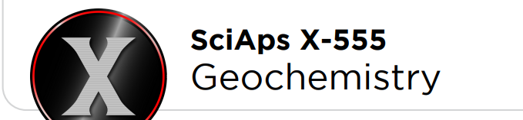 | SciAps X-555
 | Geochemistry
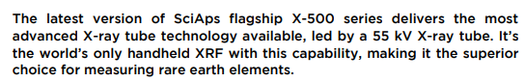 | The latest version of SciAps flagship X-500 series delivers the most advanced X-ray tube technology available, led by a 55 kV X-ray tube. It’s the world’s only handheld XRF with this capability, making it the superior choice for measuring rare earth elements.
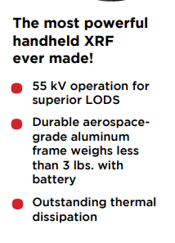 | The most powerful handheld XRF ever made!
 | 55 kV operation for superior LODS
Durable aerospace-grade aluminum
frame weighs less than 3 lbs. with battery
 | Outstanding thermal dissipation
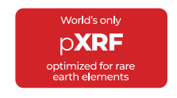 | World’s only pXRF optimized for rare earth elements
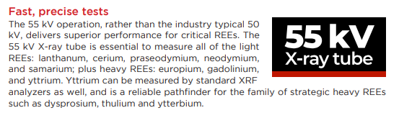 | Fast, precise tests
 | The 55 kV operation, rather than the industry typical 50 kV, delivers superior performance for critical REEs. The 55 kV X-ray tube is essential to measure all of the light REEs: lanthanum, cerium, praseodymium, neodymium, and samarium; plus heavy REEs: europium, gadolinium, and yttrium. Yttrium can be measured by standard XRF analyzers as well, and is a reliable pathfinder for the family of strategic heavy REEs such as dysprosium, thulium and ytterbium.
 | 55 kV X-ray tube
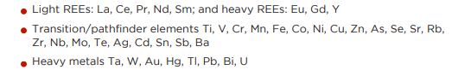 | Light REEs: La, Ce, Pr, Nd, Sm; and heavy REEs: Eu, Gd, Y
 | Transition/pathfinder elements Ti, V, Cr, Mn, Fe, Co, Ni, Cu, Zn, As, Se, Sr, Rb, Zr, Nb, Mo, Te, Ag, Cd, Sn, Sb, Ba
 | Heavy metals Ta, W, Au, Hg, Tl, Pb, Bi, U
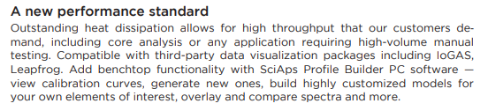 | A new performance standard
 | Outstanding heat dissipation allows for high throughput that our customers demand, including core analysis or any application requiring high-volume manual testing. Compatible with third-party data visualization packages including IoGAS, Leapfrog. Add benchtop functionality with SciAps Profile Builder PC software —view calibration curves, generate new ones, build highly customized models for your own elements of interest, overlay and compare spectra and more.
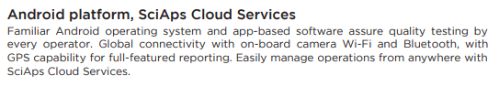 | Android platform, SciAps Cloud Services
 | Familiar Android operating system and app-based software assure quality testing by every operator. Global connectivity with on-board camera Wi-Fi and Bluetooth, with GPS capability for full-featured reporting. Easily manage operations from anywhere with SciAps Cloud Services.
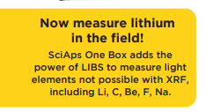 | Now measure lithium in the field!
 | SciAps One Box adds the power of LIBS to measure light elements not possible with XRF, including Li, C, Be, F, Na.
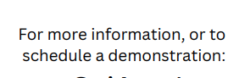 | For more information, or to schedule a demonstration:
(BACK)
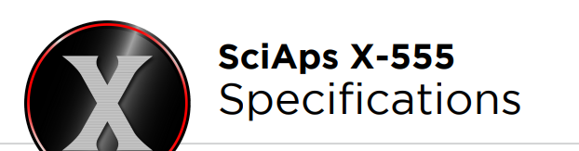 | SciAps X-555
 | Specifications
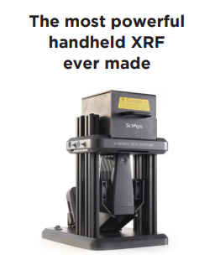 | The most powerful handheld XRF ever made
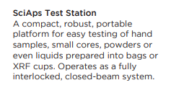 | SciAps Test Station
 | A compact, robust, portable platform for easy testing of hand samples, small cores, powders or even liquids prepared into bags or XRF cups. Operates as a fully interlocked, closed-beam system.
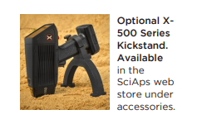 | Optional X-500 Series Kickstand.  Available in the SciAps web store under  accessories.
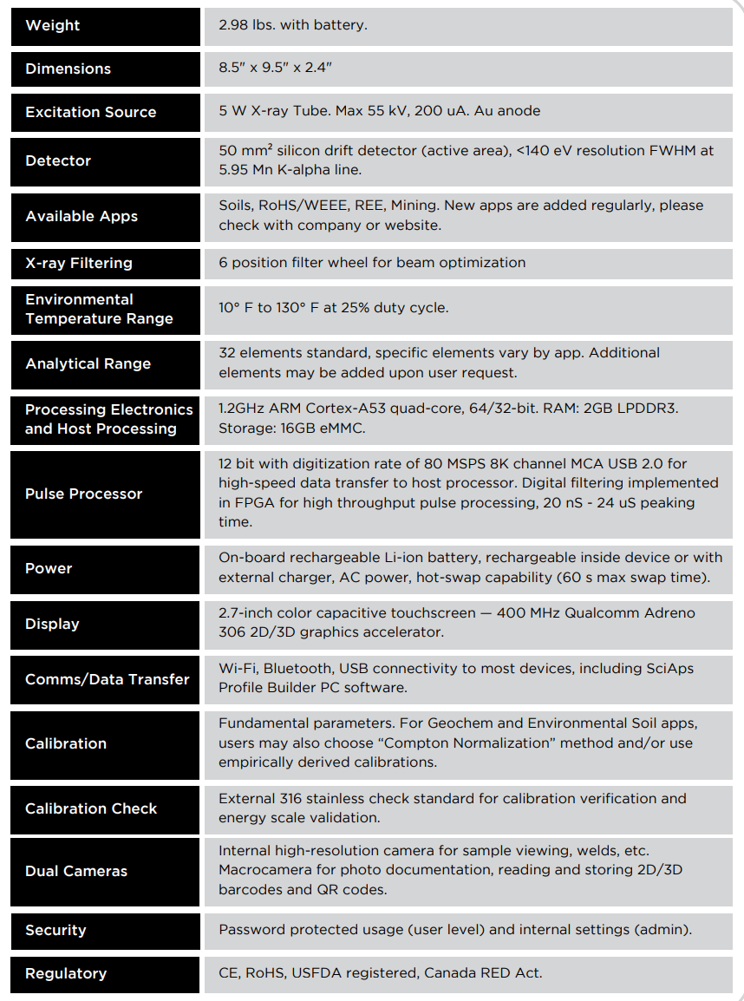
 | Weight
 | 2.98 lbs. with battery.
 | Dimensions
 | 8.5" x 9.5" x 2.4"
 | Excitation Source
 | 5 W X-ray Tube. Max 55 kV, 200 uA. Au anode
 | Detector
 | 50 mm² silicon drift detector (active area), <140 eV resolution FWHM at 5.95 Mn K-alpha line
 | Available Apps
 | Soils, RoHS/WEEE, REE, Mining. New apps are added regularly, please check with company or website.
 | X-ray Filtering
 | 6 position filter wheel for beam optimization
 | Environmental Temperature Range
 | 10° F to 130° F at 25% duty cycle.
 | Analytical Range
 | 32 elements standard, specific elements vary by app. Additional elements may be added upon user request.
 | Processing Electronics and Host Processing
 | 1.2GHz ARM Cortex-A53 quad-core, 64/32-bit. RAM: 2GB LPDDR3. Storage: 16GB eMMC.
 | Pulse Processor
 | 12 bit with digitization rate of 80 MSPS 8K channel MCA USB 2.0 for high-speed data transfer to host processor. Digital filtering implemented in FPGA for high throughput pulse processing, 20 nS - 24 uS peaking time.
 | Power
 | On-board rechargeable Li-ion battery, rechargeable inside device or with external charger, AC power, hot-swap capability (60 s max swap time).
 | Display
 | 2.7-inch color capacitive touchscreen — 400 MHz Qualcomm Adreno 306 2D/3D graphics accelerator.
 | Comms/Data Transfer
 | Wi-Fi, Bluetooth, USB connectivity to most devices, including SciAps Profile Builder PC software.
 | Calibration
 | Fundamental parameters. For Geochem and Environmental Soil apps, users may also choose “Compton Normalization” method and/or use empirically derived calibrations.
 | Calibration Check
 | External 316 stainless check standard for calibration verification and energy scale validation.
 | Dual Cameras
 | Internal high-resolution camera for sample viewing, welds, etc. Macrocamera for photo documentation, reading and storing 2D/3D barcodes and QR codes.
 | Security
 | Password protected usage (user level) and internal settings (admin)
 | Regulatory
 | CE, RoHS, USFDA registered, Canada RED Act.

