Document Title: SciAps X-5 Alloy Specifications
Rev Date: Apr 2025
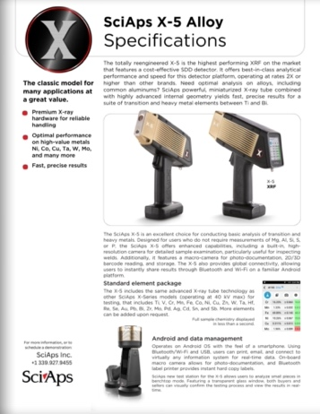
Layout Preview | English Text | Translated Text
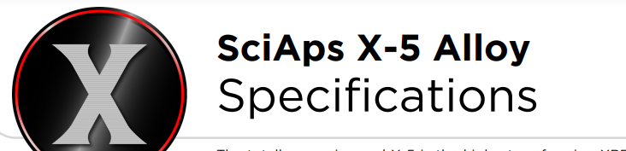 | SciAps X-5 Alloy
 | Specifications
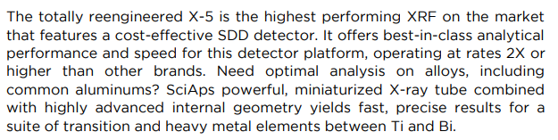 | The totally reengineered X-5 is the highest performing XRF on the market that features a cost-effective SDD detector. It offers best-in-class analytical performance and speed for this detector platform, operating at rates 2X or  higher than other brands. Need optimal analysis on alloys, including common aluminums? SciAps powerful, miniaturized X-ray tube combined with highly advanced internal geometry yields fast, precise results for a  suite of transition and heavy metal elements between Ti and Bi.
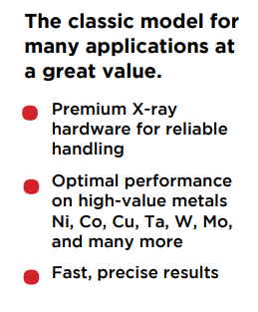 | The classic model for many applications at a great value.
 | Premium X-ray hardware for reliable handling
 | Optimal performance on high-value metals Ni, Co, Cu, Ta, W, Mo, and many more
 | Fast, precise results
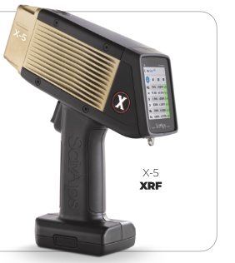 | X-5
 | XRF
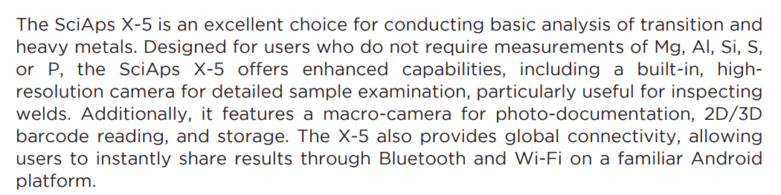 | The SciAps X-5 is an excellent choice for conducting basic analysis of transition and heavy metals. Designed for users who do not require measurements of Mg, Al, Si, S, or P, the SciAps X-5 offers enhanced capabilities, including a built-in, high resolution camera for detailed sample examination, particularly useful for inspecting welds. Additionally, it features a macro-camera for photo-documentation, 2D/3D barcode reading, and storage. The X-5 also provides global connectivity, allowing users to instantly share results through Bluetooth and Wi-Fi on a familiar Android platform.
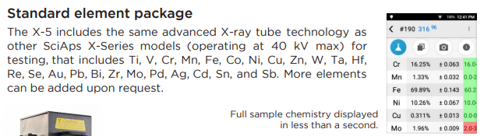 | Standard element package
 | The X-5 includes the same advanced X-ray tube technology as other SciAps X- Series models (operating at 40 kV max) for testing, that includes Ti, V, Cr, Mn, Fe, Co, Ni, Cu, Zn, W, Ta, Hf, Re, Se, Au, Pb, Bi, Zr, Mo, Pd, Ag, Cd, Sn, and Sb. More elements can be added upon request.
 | Full sample chemistry displayed in less than a second.
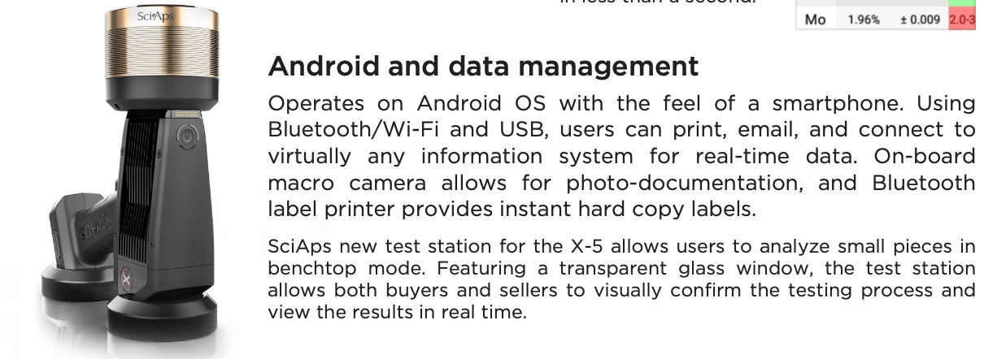 | Android and data management
 | Operates on Android OS with the feel of a smartphone. Using Bluetooth/Wi-Fi and USB, users can print, email, and connect to virtually any information system for real-time data. On-board macro camera allows for photo-documentation, and Bluetooth label printer provides instant hard copy labels.
 | SciAps new test station for the X-5 allows users to analyze small pieces in benchtop mode. Featuring a transparent glass window, the test station allows both buyers and sellers to visually confirm the testing process and view the results in real time.
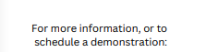 | For more information, or to schedule a demonstration:
(BACK)
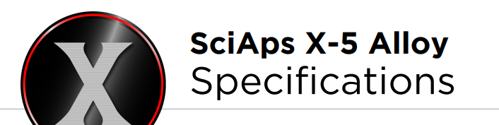 | SciAps X-5 Alloy
 | Specifications
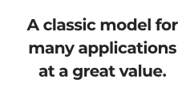 | A classic model for many applications at a great value.
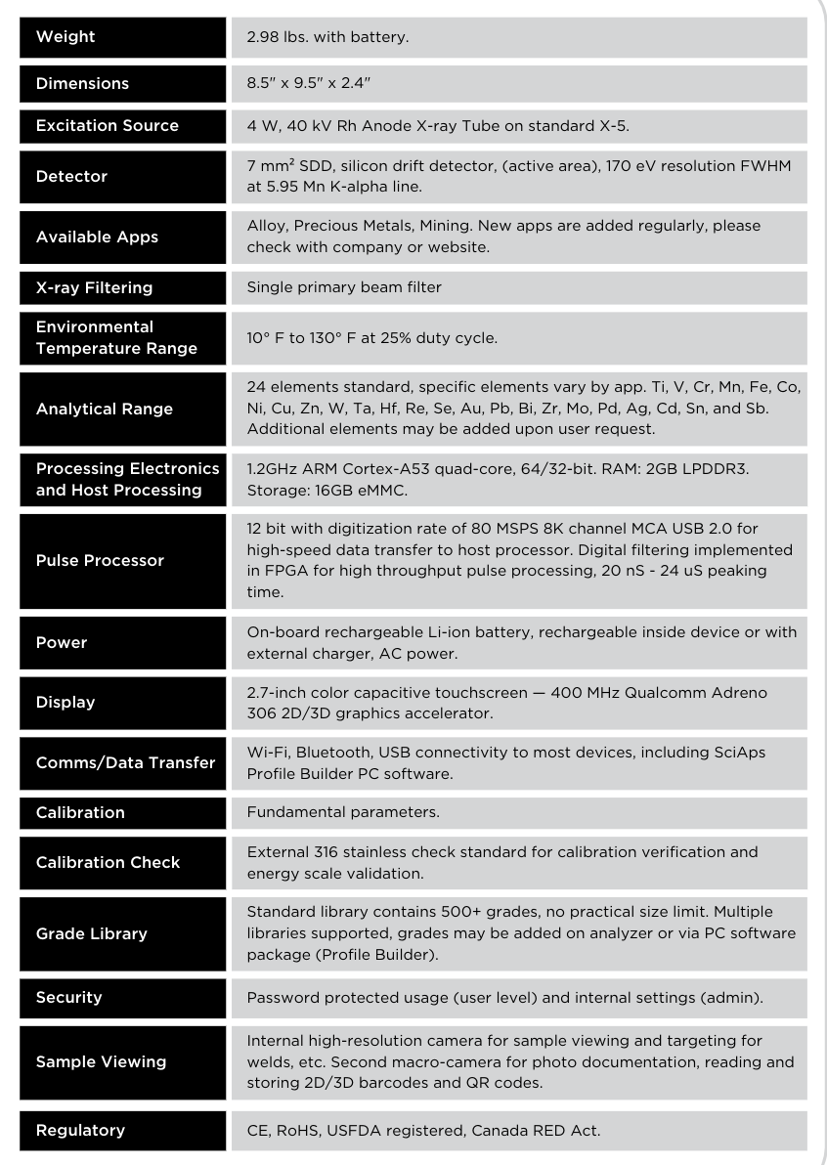 | Weight
 | 2.98 lbs. with battery.
 | Dimensions
 | 8.5" x 9.5" x 2.4"
 | Excitation Source
 | 4 W, 40 kV Rh Anode X-ray Tube on standard X-5.
 | Detector
 | 7 mm² SDD, silicon drift detector (active area), 170 eV resolution FWHM at 5.95 Mn K-alpha line.
 | Available Apps
 | Alloy, Precious Metals, Mining. New apps are added regularly, please check with company or website
 | X-ray Filtering
 | Single primary beam filter
 | Environmental Temperature Range
 | 10° F to 130° F at 25% duty cycle
 | Analytical Range
 | 24 elements standard, specific elements vary by app. Ti, V, Cr, Mn, Fe, Co, Ni, Cu, Zn, W, Ta, Hf, Re, Se, Au, Pb, Bi, Zr, Mo, Pd, Ag, Cd, Sn, and Sb. Additional elements may be added upon user request.
 | Processing Electronics and Host Processing
 | 1.2GHz ARM Cortex-A53 quad-core, 64/32-bit. RAM: 2GB LPDDR3. Storage: 16GB eMMC.
 | Pulse Processor
 | 12 bit with digitization rate of 80 MSPS 8K channel MCA USB 2.0 for high-speed data transfer to host processor. Digital filtering implemented in FPGA for high throughput pulse processing, 20 nS – 24 uS peaking time.
 | Power
 | On-board rechargeable Li-ion battery, rechargeable inside device or with external charger, AC power.
 | Display
 | 2.7-inch color capacitive touchscreen—400 MHz Qualcomm Adreno 306 2D/3D graphics accelerator.
 | Comms/Data Transfer
 | Wi-Fi, Bluetooth, USB connectivity to most devices, including SciAps Profile Builder PC software.
 | Calibration
 | Fundamental parameters.
 | Calibration Check
 | External 316 stainless check standard for calibration verification and energy scale validation.
 | Grade Library
 | Standard library contains 500+ grades, no practical size limit. Multiple libraries supported, grades may be added on analyzer or via PC software package (Profile Builder).
 | Security
 | Password protected usage (user level) and internal settings (admin).
 | Sample Viewing
 | Internal high-resolution camera for sample viewing and targeting for welds, etc. Second macro-camera for photo documentation, reading and storing 2D/3D barcodes and QR codes.
 | Regulatory
 | CE, RoHS, USFDA registered, Canada RED Act.

