Document Title: SciAps Pick Your Perfect XRF
Rev Date: May 2025
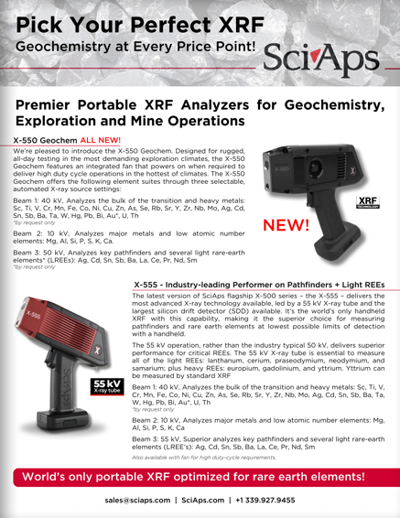
Layout Preview | English Text | Translated Text
 | Pick Your Perfect XRF
 | Geochemistry at Every Price Point!
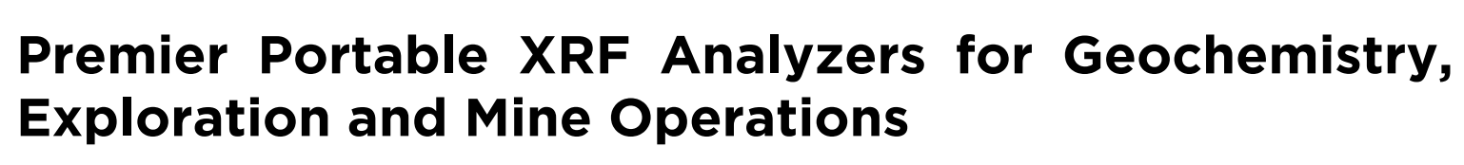 | Premier Portable XRF Analyzers for Geochemistry, Exploration and Mine Operations
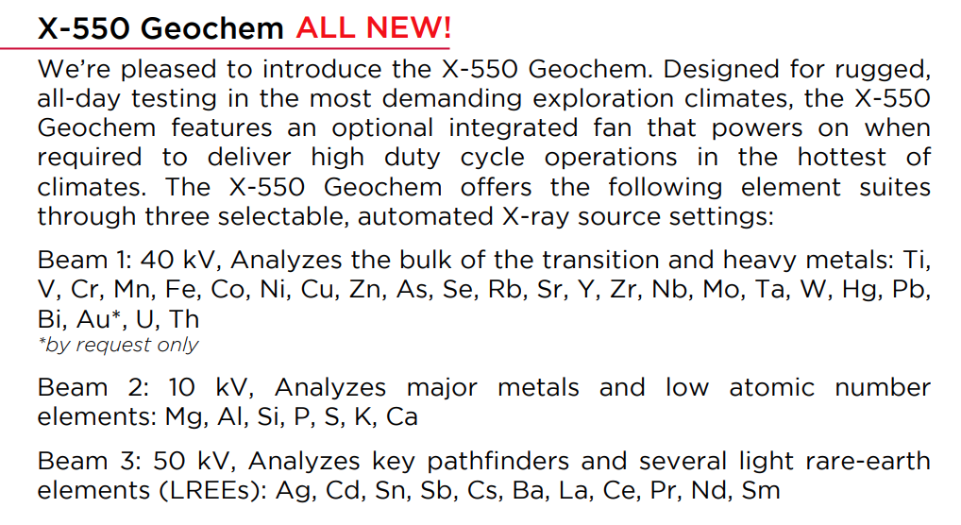 | X-550 Geochem All New!
 | We’re pleased to introduce the X-550 Geochem. Designed for rugged, all-day testing in the most demanding exploration climates, the X-550 Geochem features an optional integrated fan that powers on when required to deliver high duty cycle operations in the hottest of climates. The X-550 Geochem offers the following element suites through three selectable, automated X-ray source settings:
 | Beam 1: 40 kV, Analyzes the bulk of the transition and heavy metals: Ti, V, Cr, Mn, Fe, Co, Ni, Cu, Zn, As, Se, Rb, Sr, Y, Zr, Nb, Mo, Ta, W, Hg, Pb, Bi, Au*, U, Th
 | *by request only
 | Beam 2: 10 kV, Analyzes major metals and low atomic number elements: Mg, Al, Si, P, S, K, Ca
 | Beam 3: 50 kV, Analyzes key pathfinders and several light rare-earth elements (LREEs): Ag, Cd, Sn, Sb, Cs, Ba, La, Ce, Pr, Nd, Sm
 | New!
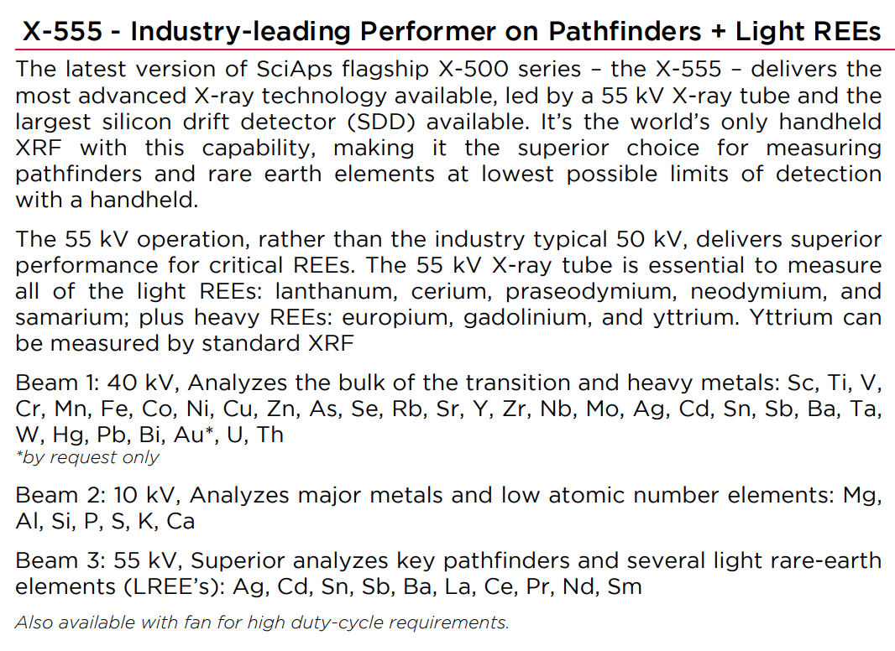 | X-555 - Industry-leading Performer on Pathfinders + Light REEs
 | The latest version of SciAps flagship X-500 series – the X-555 – delivers the most advanced X-ray technology available, led by a 55 kV X-ray tube and the largest silicon drift detector (SDD) available. It’s the world’s only handheld XRF with this capability, making it the superior choice for measuring pathfinders and rare earth elements at lowest possible limits of detection with a handheld.
 | The 55 kV operation, rather than the industry typical 50 kV, delivers superior performance for critical REEs. The 55 kV X-ray tube is essential to measure all of the light REEs: lanthanum, cerium, praseodymium, neodymium, and samarium; plus heavy REEs: europium, gadolinium, and yttrium. Yttrium can be measured by standard XRF.
 | Beam 1: 55 kV, Superior excitation condition analyzes key pathfinders and several light rare-earth elements (LREE’s): Ag, Cd, Sn, Sb, Cs, Ba, La, Ce, Pr, Nd, Sm
 | Beam 2: 40 kV, Analyzes the bulk of the transition and heavy metals: Ti, V, Cr, Mn, Fe, Co, Ni, Cu, Zn, As, Se, Rb, Sr, Y, Zr, Nb, Mo, Ta, W, Hg, Pb, Bi, Au*, U, Th
 | *by request only
 | Beam 3: 10 kV, Analyzes major metals and low atomic number elements: Al, Si, P, S, K, Ca
 | Also available with fan for high duty-cycle requirements.
 | World’s only portable XRF optimized for rare earth elements!
(BACK)
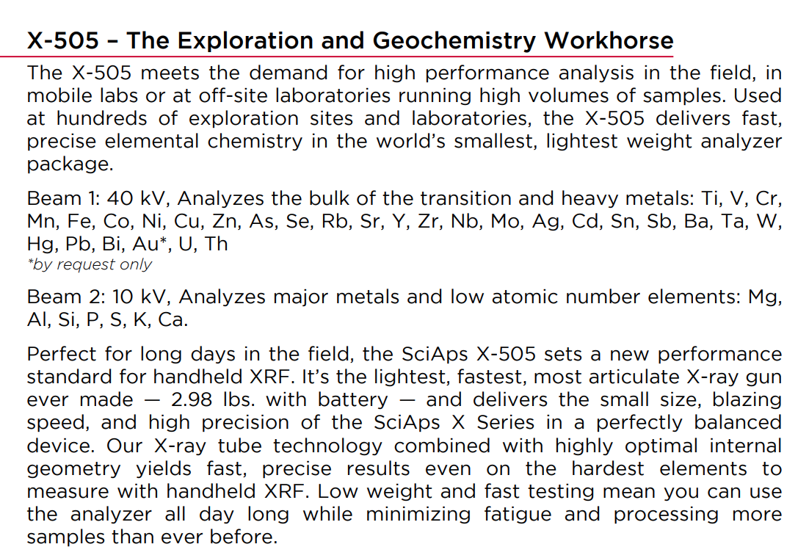 | X-505 – The Exploration and Geochemistry Workhorse
 | The X-505 meets the demand for high performance analysis in the field, in mobile labs or at off-site laboratories running high volumes of samples. Used at hundreds of exploration sites and laboratories, the X-505 delivers fast, precise elemental chemistry in the world’s smallest, lightest weight analyzer package.
 | Beam 1: 40 kV, Analyzes the bulk of the transition and heavy metals: Ti, V, Cr, Mn, Fe, Co, Ni, Cu, Zn, As, Se, Rb, Sr, Y, Zr, Nb, Mo, Ag, Cd, Sn, Sb, Ba, Ta, W, Hg, Pb, Bi, Au*, U, Th
 | *by request only
 | Beam 2: 10 kV, Analyzes major metals and low atomic number elements: Mg, Al, Si, P, S, K, Ca.
 | Perfect for long days in the field, the SciAps X-505 sets a new performance standard for handheld XRF. It’s the lightest, fastest, most articulate X-ray gun ever made — 2.98 lbs. with battery — and delivers the small size, blazing speed, and high precision of the SciAps X Series in a perfectly balanced device. Our X-ray tube technology combined with highly optimal internal geometry yields fast, precise results even on the hardest elements to measure with handheld XRF. Low weight and fast testing mean you can use the analyzer all day long while minimizing fatigue and processing more samples than ever before.
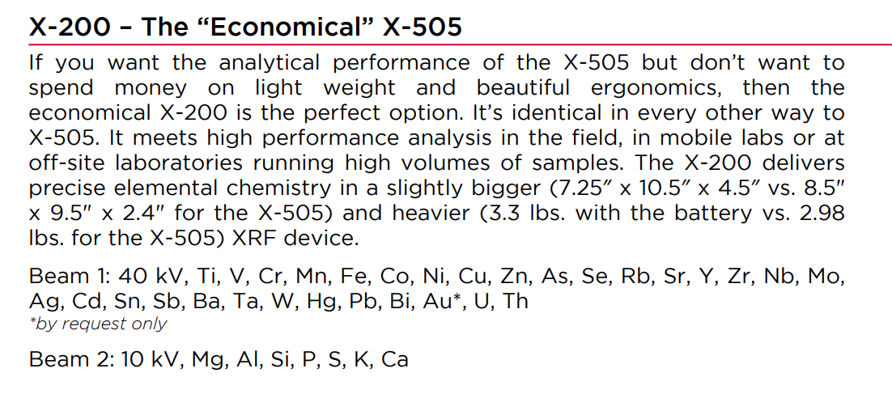 | X-200 – The “Economical” X-505
 | If you want the analytical performance of the X-505 but don’t want to spend money on light weight and beautiful ergonomics, then the economical X-200 is the perfect option. It’s identical in every other way to X-505. It meets high performance analysis in the field, in mobile labs or at off-site laboratories running high volumes of samples. The X-200 delivers precise elemental chemistry in a slightly bigger (7.25″ x 10.5″ x 4.5″ vs. 8.5" x 9.5" x 2.4" for the X-505) and heavier (3.3 lbs. with the battery vs. 2.98 lbs. for the X-505) XRF device.
 | Beam 1: 40 kV, Ti, V, Cr, Mn, Fe, Co, Ni, Cu, Zn, As, Se, Rb, Sr, Y, Zr, Nb, Mo, Ag, Cd, Sn, Sb, Ba, Ta, W, Hg, Pb, Bi, Au*, U, Th
 | *by request only
 | Beam 2: 10 kV, Mg, Al, Si, P, S, K, Ca
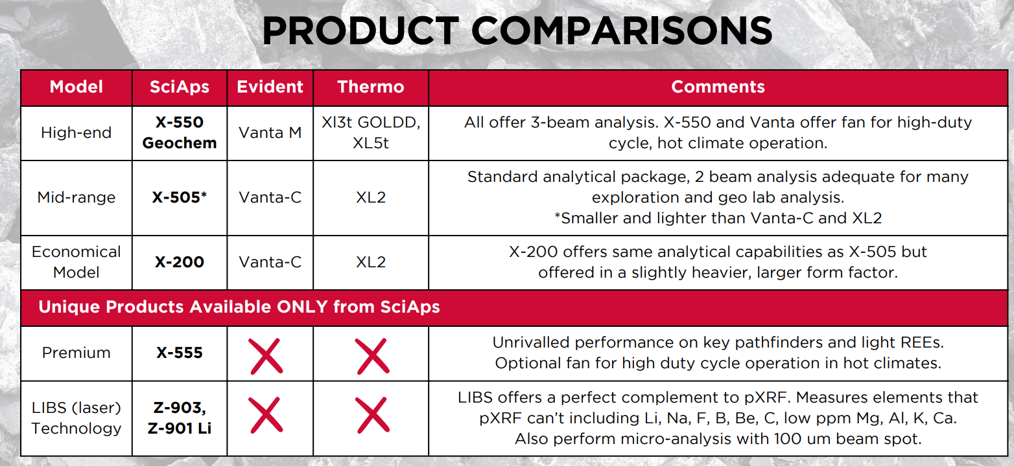 | PRODUCT COMPARISONS
 | Model
 | SciAps
 | Evident
 | Thermo
 | Comments
 | High-end
 | X-550 Geochem
 | Vanta M
 | Xl3t GOLDD, XL5t
 | All offer 3-beam analysis. X-550 and Vanta offer fan for high-duty cycle, hot climate operation.
 | Mid-range
 | X-505*
 | Vanta-C
 | XL2
 | Standard analytical package, 2 beam analysis adequate for many exploration and geo lab analysis.
 | *Smaller and lighter than Vanta-C and XL2
 | Economical Model
 | X-200
 | Vanta-C
 | XL2
 | X-200 offers same analytical capabilities as X-505 but offered in a slightly heavier, larger form factor.
 | Unique Products Available ONLY from SciAps
 | Premium
 | X-555
 | X
 | Unrivalled performance on key pathfinders and light REEs. Optional fan for high duty cycle operation in hot climates.
 | LIBS (laser) Technology
 | Z-903, Z-901 Li
 | X
 | LIBS offers a perfect complement to pXRF. Measures elements that pXRF can’t including Li, Na, F, B, Be, C, low ppm Mg, Al, K, Ca. Also perform micro-analysis with 100 um beam spot.

