Document Title: SciAps Z-70 Specifications
Rev Date: Feb 2024
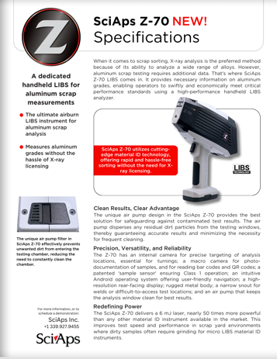

Layout Preview | English Text | Translated Text
 | SciAps Z-70 New!
 | Specifications
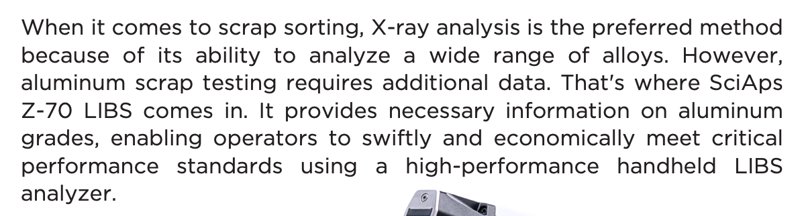 | When it comes to scrap sorting, X-ray analysis is the preferred method because of its ability to analyze a wide range of alloys. However, aluminum scrap testing requires additional data. That's where SciAps Z-70 LIBS comes in. It provides necessary information on aluminum grades, enabling operators to swiftly and economically meet critical performance standards using a high-performance handheld LIBS analyzer.
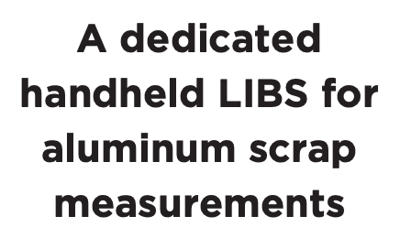 | A dedicated handheld LIBS for aluminum scrap measurements
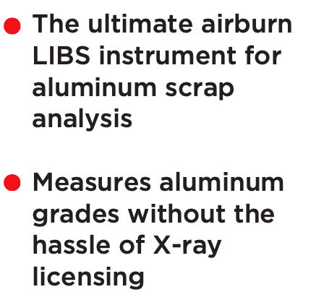 | The ultimate airburn LIBS instrument for aluminum scrap analysis
 | Measures aluminum grades without the hassle of X-ray licensing
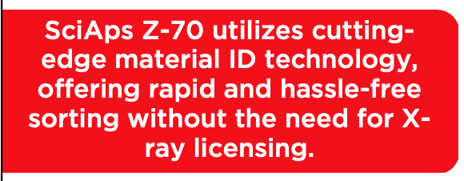 | SciAps Z-70 utilizes cutting-edge material ID technology, offering rapid and hassle-free sorting without the need for X-ray licensing.
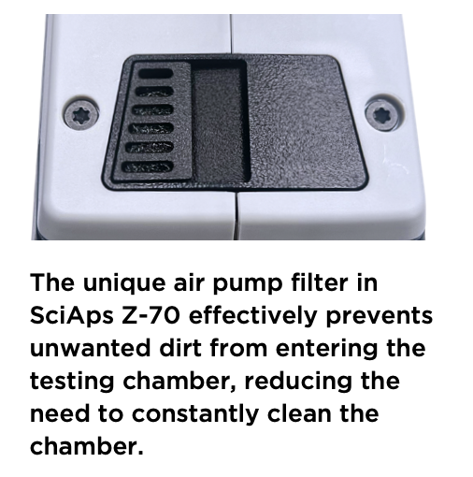 | The unique air pump filter in SciAps Z-70 effectively prevents unwanted dirt from entering the testing chamber, reducing the need to constantly clean the chamber.
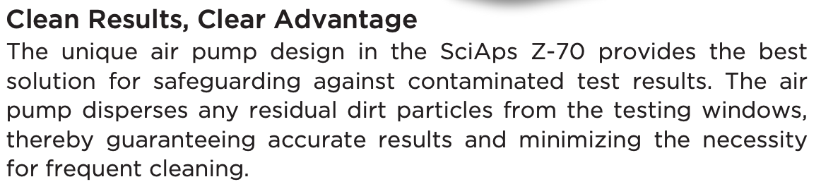 | Clean Results, Clear Advantage
 | The unique air pump design in the SciAps Z-70 provides the best solution for safeguarding against contaminated test results. The air pump disperses any residual dirt particles from the testing windows, thereby guaranteeing accurate results and minimizing the necessity for frequent cleaning.
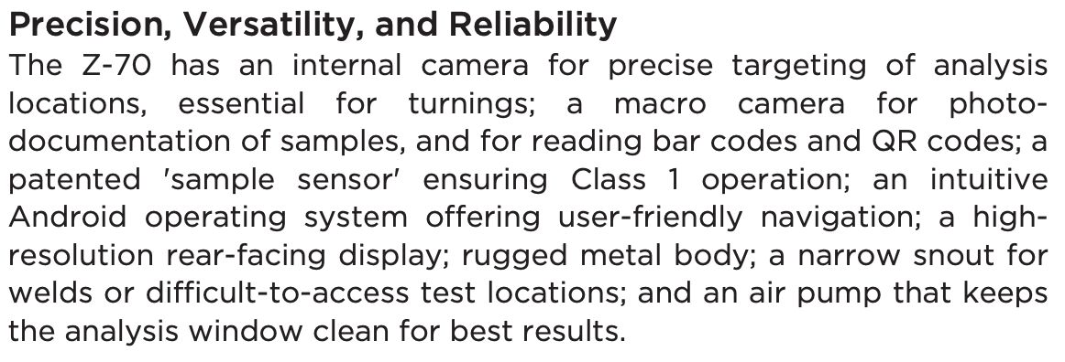 | Precision, Versatility, and Reliability
 | The Z-70 has an internal camera for precise targeting of analysis locations, essential for turnings; a macro camera for photo-documentation of samples, and for reading bar codes and QR codes; a patented 'sample sensor' ensuring Class 1 operation; an intuitive Android operating system offering user-friendly navigation; a high-resolution rear-facing display; rugged metal body; a narrow snout for welds or difficult-to-access test locations; and an air pump that keeps the analysis window clean for best results.
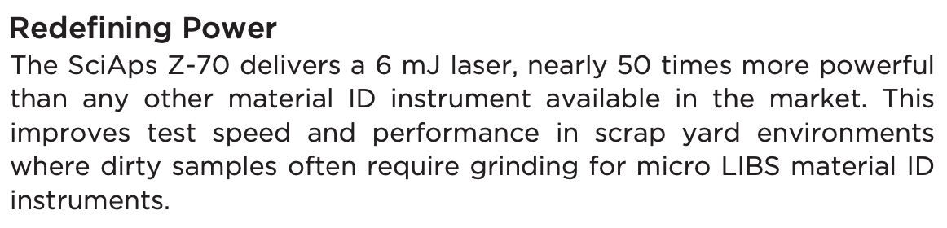 | Redefining Power
 | The SciAps Z-70 delivers a 6 mJ laser, nearly 50 times more powerful than any other material ID instrument available in the market. This improves test speed and performance in scrap yard environments where dirty samples often require grinding for micro LIBS material ID instruments.
 | For more information, or to schedule a demonstration:
(BACK)
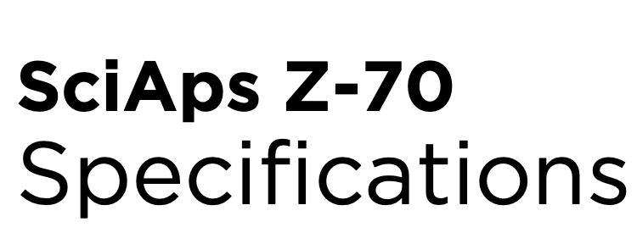 | SciAps Z-70
 | Specifications
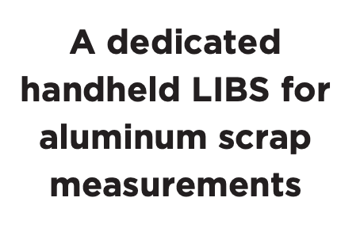 | A dedicated handheld LIBS for aluminum scrap measurements
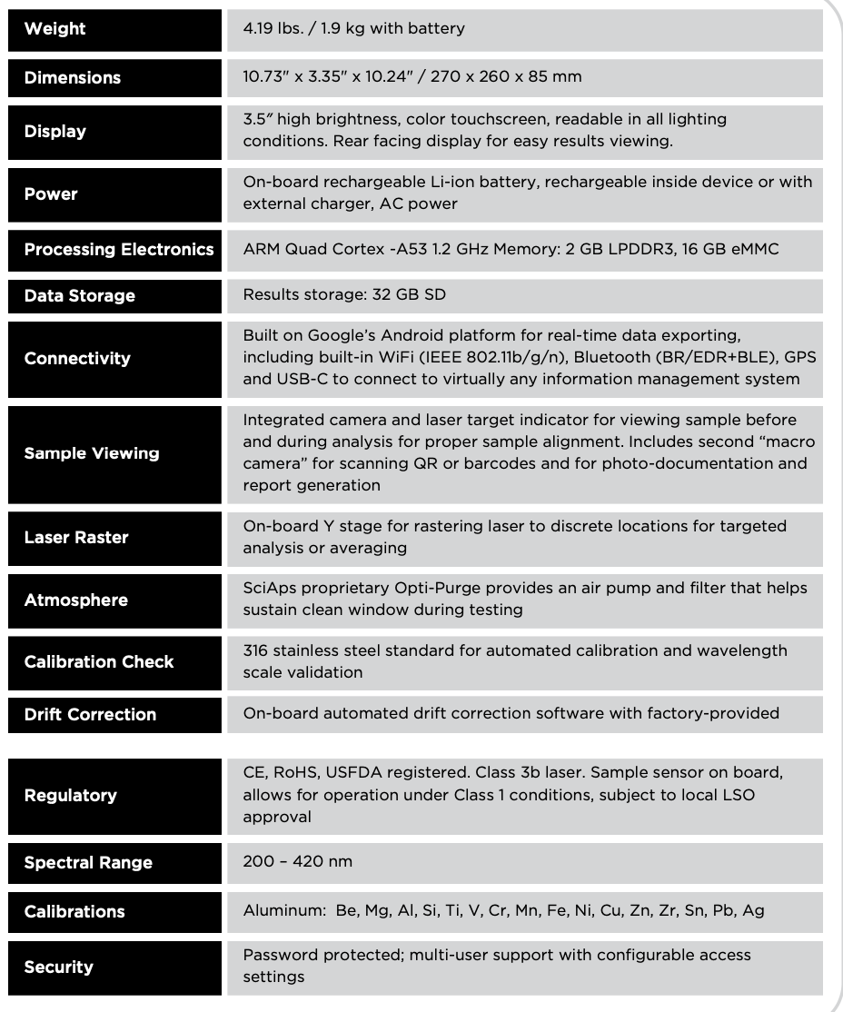 | Weight
4.19 lbs. / 1.9 kg with battery
Dimensions
 | 10.73" x 3.35" x 10.24" / 270 x 260 x 85 mm
 | Display
 | 3.5′′ high brightness, color touchscreen, readable in all lighting conditions. Rear facing display for easy results viewing.
 | Power
 | On-board rechargeable Li-ion battery, rechargeable inside device or with external charger, AC power
 | Processing Electronics
 | ARM Quad Cortex -A53 1.2 GHz Memory: 2 GB LPDDR3, 16 GB eMMC
 | Data Storage
 | Results storage: 32 GB SD
 | Connectivity
 | Built on Google’s Android platform for real-time data exporting, including built-in WiFi (IEEE 802.11b/g/n), Bluetooth (BR/EDR+BLE), GPS and USB-C to connect to virtually any information management system
 | Sample Viewing
 | Integrated camera and laser target indicator for viewing sample before and during analysis for proper sample alignment. Includes second “macro camera” for scanning QR or barcodes and for photo-documentation and report generation
 | Laser Raster
 | On-board Y stage for rastering laser to discrete locations for targeted analysis or averaging
 | Atmosphere
 | SciAps proprietary Opti-Purge provides an air pump and filter that helps sustain clean window during testing
 | Calibration Check
 | 316 stainless steel standard for automated calibration and wavelength scale validation
 | Drift Correction
 | On-board automated drift correction software with factory-provided calibrations
 | Regulatory
 | CE, RoHS, USFDA registered. Class 3b laser. Sample sensor on board, allows for operation under Class 1 conditions, subject to local LSO approval
 | Spectral Range
 | 200 – 420 nm
 | Calibrations
 | Aluminum: Be, Mg, Al, Si, Ti, V, Cr, Mn, Fe, Ni, Cu, Zn, Zr, Sn, Pb, Ag
 | Security
 | Password protected; multi-user support with configurable access settings

