Document Title: SciAps X-505 Geochemistry
Rev Date: Apr 2025
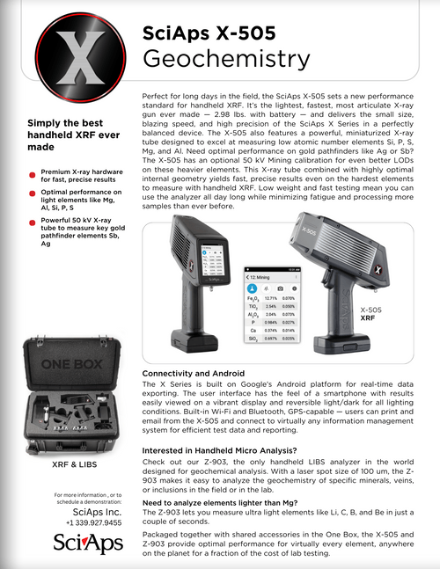
Layout Preview | English Text | Translated Text
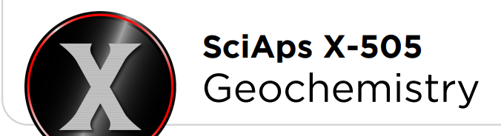 | SciAps X-505
 | Geochemistry
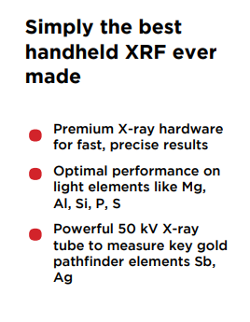 | Simply the best handheld XRF ever made
 | Premium X-ray hardware for fast, precise results
 | Optimal performance on light elements like Mg, Al, Si, P, S
 | Powerful 50 kV X-ray tube to measure key gold pathfinder elements Sb, Ag
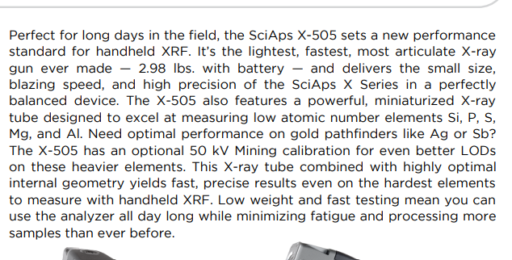 | Perfect for long days in the field, the SciAps X-505 sets a new performance  standard for handheld XRF. It’s the lightest, fastest, most articulate X-ray gun ever made — 2.98 lbs. with battery — and delivers the small size, blazing speed, and high precision of the SciAps X Series in a perfectly balanced device. The X-505 also features a powerful, miniaturized X-ray tube designed to excel at measuring low atomic number elements Si, P, S, Mg, and Al. Need optimal performance on gold pathfinders like Ag or Sb? The X-505 has an optional 50 kV Mining calibration for even better LODs on these heavier elements. This X-ray tube combined with highly optimal internal geometry yields fast, precise results even on the hardest elements to measure with handheld XRF. Low weight and fast testing mean you can use the analyzer all day long while minimizing fatigue and processing more samples than ever before.
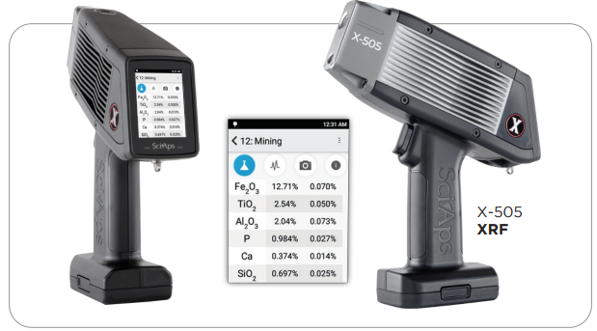 | X-505 XRF
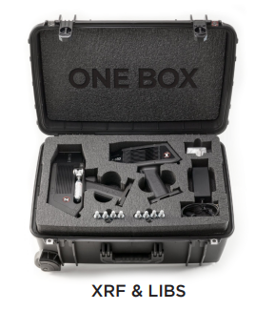 | XRF & LIBS
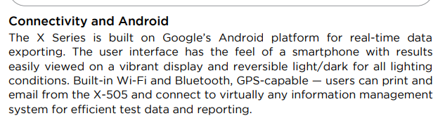 | Connectivity and Android
 | The X Series is built on Google’s Android platform for real-time data exporting. The user interface has the feel of a smartphone with results easily viewed on a vibrant display and reversible light/dark for all lighting conditions. Built-in Wi-Fi and Bluetooth, GPS-capable — users can print and email from the X-505 and connect to virtually any information management system for efficient test data and reporting.
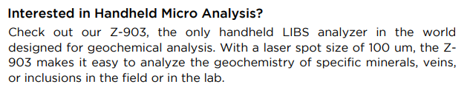 | Interested in Handheld Micro Analysis?
 | Check out our Z-903, the only handheld LIBS analyzer in the world designed for geochemical analysis. With a laser spot size of 100 um, the Z- 903 makes it easy to analyze the geochemistry of specific minerals, veins, or inclusions in the field or in the lab.
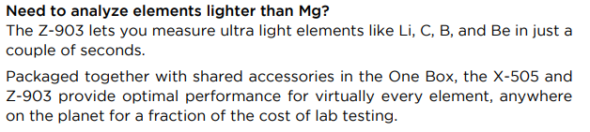 | Need to analyze elements lighter than Mg?
The Z-903 lets you measure ultra light elements like Li, C, B, and Be in just a
couple of seconds.
Packaged together with shared accessories in the One Box, the X-505 and Z-903 provide optimal performance for virtually every element, anywhere
on the planet for a fraction of the cost of lab testing.
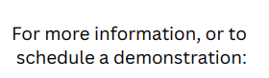 | For more information, or to schedule a demonstration:
(BACK)
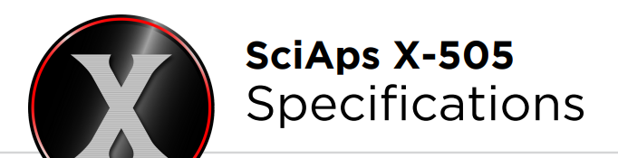 | SciAps X-505 Specifications
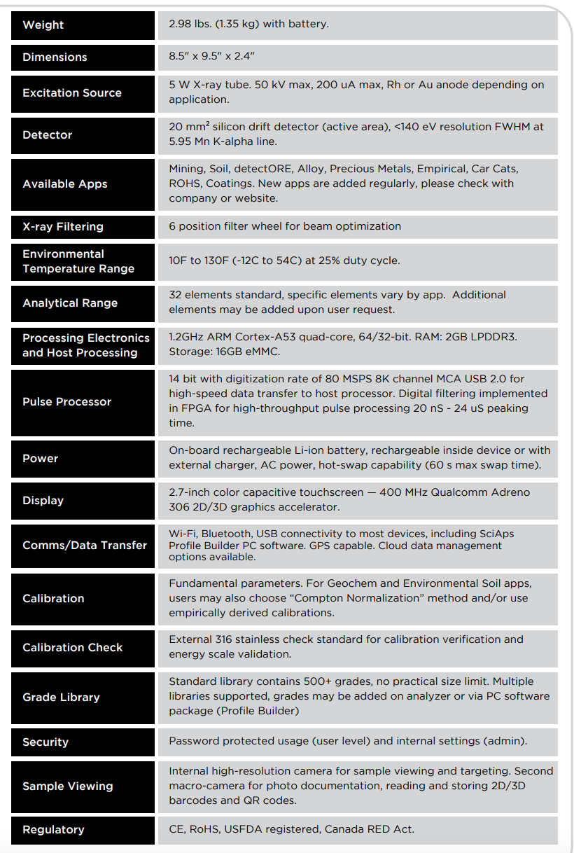 | Weight
 | 2.98 lbs. (1.35 kg) with battery
 | Dimensions
 | 8.5" x 9.5" x 2.4"
 | Excitation Source
 | 5 W X-ray tube. 50 kV max, 200 uA max, Rh or Au anode depending on application
 | Detector
 | 20 mm² silicon drift detector (active area), <140 eV resolution FWHM at 5.95 Mn K-alpha line.
 | Available Apps
 | Geochem, Mining, Soil, detectORE, Alloy, Precious Metals, Empirical, Car Cats, ROHS, Coatings. New apps are added regularly, please check with company or web.
 | X-ray Filtering
 | 6 position filter wheel for beam optimization
 | Environmental Temperature Range
 | 10F to 130F (-12C to 54C) at 25% duty cycle.
 | Analytical Range
 | 32 elements standard, specific elements vary by app. Additional elements may be added upon user request.
 | Processing Electronics and Host Processing
 | 1.2GHz ARM Cortex-A53 quad-core, 64/32-bit. RAM: 2GB LPDDR3. Storage: 16 GB eMMC
 | Pulse Processor
 | 14 bit with digitization rate of 80 MSPS 8K channel MCA USB 2.0 for high-speed data transfer to host processor. Digital filtering implemented in FPGA for high throughput pulse processing, 20 nS - 24 uS peaking time.
 | Power
 | On-board rechargeable Li-ion battery, rechargeable inside device or with external charger, AC power, hot-swap capability (60 s max swap time).
 | Display
 | 2.7-inch color capacitive touchscreen — 400 MHz Qualcomm Adreno 306 2D/3D graphics accelerator.
 | Comms/Data Transfer
 | Wi-Fi, Bluetooth, USB connectivity to most devices, including SciAps Profile Builder PC software. GPS capable. Cloud data management options available.
 | Calibration
 | Fundamental parameters. For Geochem and Environmental Soil apps, users may also choose “Compton Normalization” method and/or use empirically derived calibrations.
 | Calibration Check
 | External 316 stainless check standard for calibration verification and energy scale validation
 | Grade Library
 | Standard library contains 500+ grades, no practical size limit. Multiple libraries supported, grades may be added on analyzer or via PC software package (Profile Builder)
 | Security
 | Password protected usage (user level) and internal settings (admin).
 | Sample Viewing
 | Internal high-resolution camera for sample viewing and targeting. Second macro-camera for photo documentation, reading and storing 2D/3D barcodes and QR codes
 | Regulatory
 | CE, RoHS, USFDA registered, Canada RED Act.

