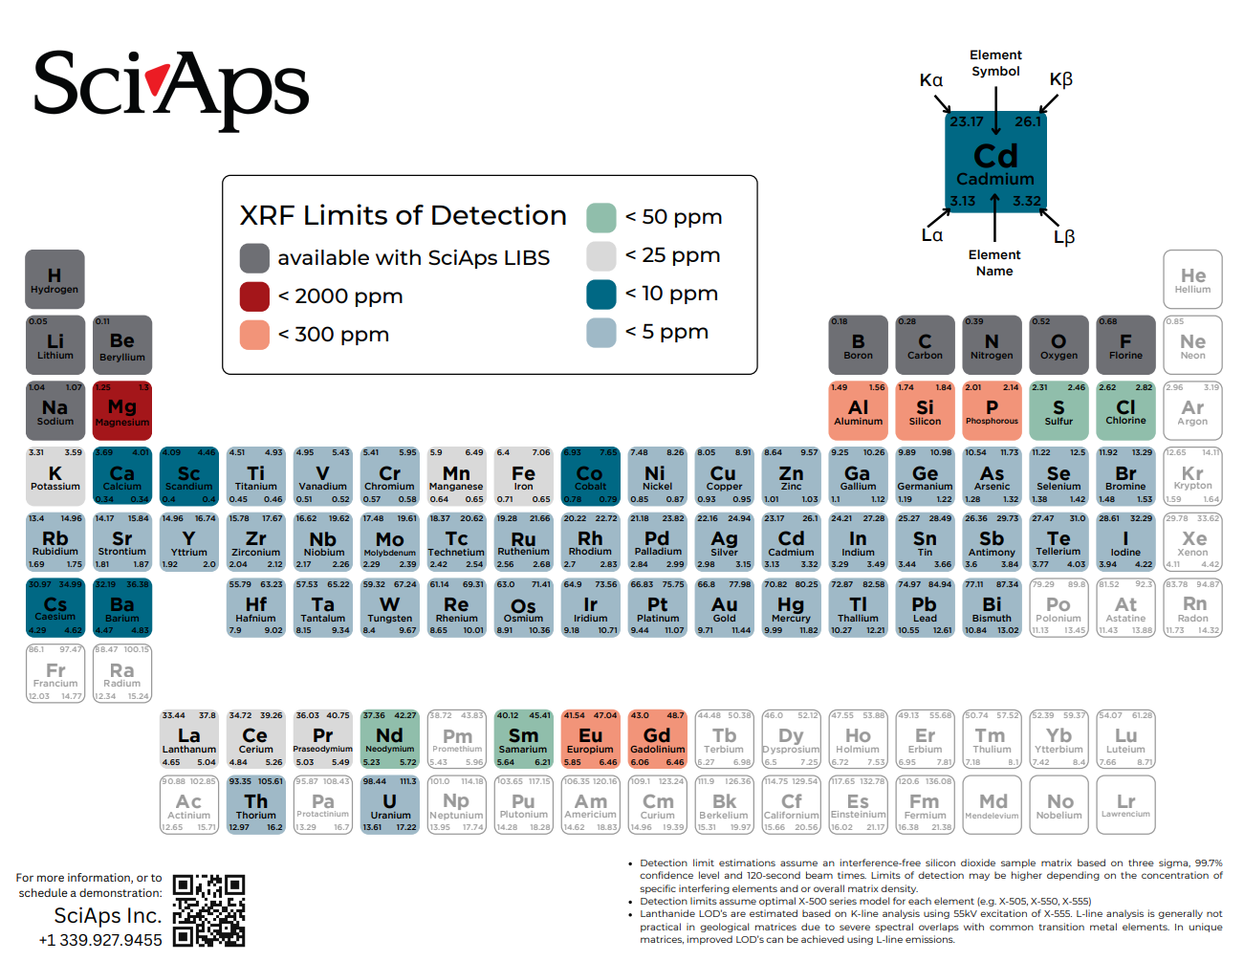
Document Title: SciAps Complete Periodic Table - Limits of Detection
Rev: Dec 2025
Layout Preview | English Text | Translated Text
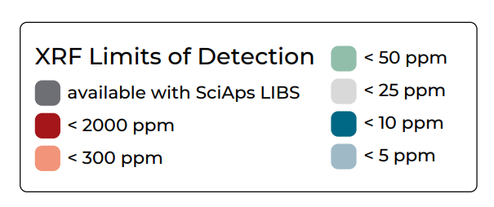 | XRF Limits of Detection
 | available with SciAps LIBS
 | < 2000 ppm
 | < 300 ppm
 | < 50 ppm
 | < 25 ppm
 | < 10 ppm
 | < 5 ppm
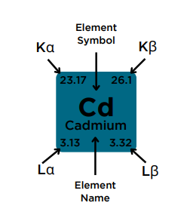 | Element Symbol
 | Cadmium
 | Element Name
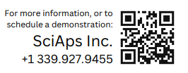 | For more information, or to schedule a demonstration:
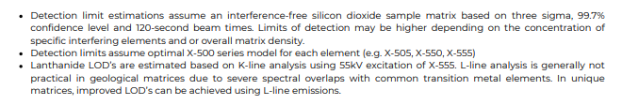 | Detection limit estimations assume an interference-free silicon dioxide sample matrix based on three sigma, 99.7% confidence level and 120-second beam times. Limits of detection may be higher depending on the concentration of specific interfering elements and or overall matrix density.
 | Detection limits assume optimal X-500 series model for each element (e.g. X-505, X-550, X-555).
 | Lanthanide LOD’s are estimated based on K-line analysis using 55kV excitation of X-555. L-line analysis is generally not practical in geological matrices due to severe spectral overlaps with common transition metal elements. In unique matrices, improved LOD’s can be achieved using L-line emissions.
Order of elements described goes from left to right, top column to bottom column.
 | Hydrogen
 | Helium
 | Lithium
 | Beryllium
 | Boron
 | Carbon
 | Nitrogen
 | Oxygen
 | Fluorine
 | Neon
 | Sodium
 | Magnesium
 | Aluminum
 | Silicon
 | Phosphorus
 | Sulfur
 | Chlorine
 | Argon
 | Potassium
 | Calcium
 | Scandium
 | Titanium
 | Vanadium
 | Chromium
 | Manganese
 | Iron
 | Cobalt
 | Nickel
 | Copper
 | Zinc
 | Gallium
 | Germanium
 | Arsenic
 | Selenium
 | Bromine
 | Krypton
 | Rubidium
 | Strontium
 | Yttrium
 | Zirconium
 | Niobium
 | Molybdenum
 | Technetium
 | Ruthenium
 | Rhodium
 | Palladium
 | Silver
 | Cadmium
 | Indium
 | Tin
 | Antimony
 | Tellurium
 | Iodine
 | Xenon
 | Cesium
 | Barium
 | Hafnium
 | Tantalum
 | Tungsten
 | Rhenium
 | Osmium
 | Iridium
 | Platinum
 | Gold
 | Mercury
 | Thallium
 | Lead
 | Bismuth
 | Polonium
 | Astatine
 | Radon
 | Francium
 | Radium
 | Lanthanum
 | Cerium
 | Praseodymium
 | Neodymium
 | Promethium
 | Samarium
 | Europium
 | Gadolinium
 | Terbium
 | Dysprosium
 | Holmium
 | Erbium
 | Thulium
 | Ytterbium
 | Lutetium
 | Actinium
 | Thorium
 | Protactinium
 | Uranium
 | Neptunium
 | Plutonium
 | Americium
 | Curium
 | Berkelium
 | Californium
 | Einsteinium
 | Fermium
 | Mendelevium
 | Nobelium
 | Lawrencium
[back]
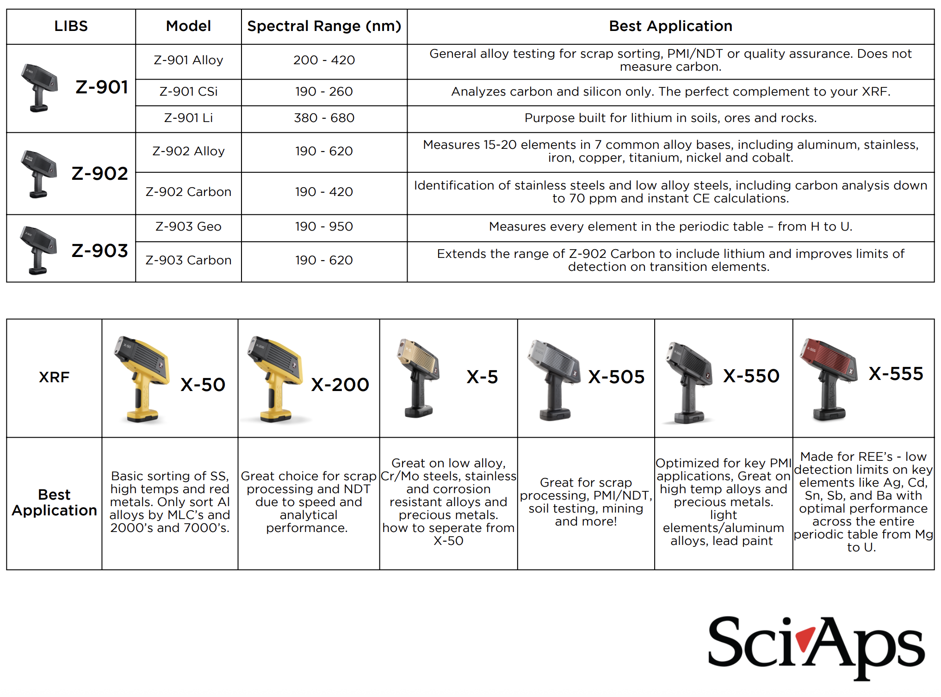 | Model
 | Z-901 Alloy
 | Z-901 CSi
 | Z-901 Li
 | Z-902 Alloy
 | Z-902 Carbon
 | Z-903 Geo
 | Z-903 Carbon
 | Spectral Range (nm)
 | 200 - 420
 | 190 - 260
 | 380 - 680
 | 190 - 620
 | 190 - 420
 | 190 - 950
 | 190 - 620
 | Best Application
 | General alloy testing for scrap sorting, PMI/NDT or quality assurance. Does not measure carbon.
 | Analyzes carbon and silicon only. The perfect complement to your XRF.
 | Purpose built for lithium in soils, ores and rocks.
 | Measures 15-20 elements in 7 common alloy bases, including aluminum, stainless, iron, copper, titanium, nickel and cobalt.
 | Identification of stainless steels and low alloy steels, including carbon analysis down to 70 ppm and instant CE calculations.
 | Measures every element in the periodic table – from H to U.
 | Extends the range of Z-902 Carbon to include lithium and improves limits of detection on transition elements.
 | Best Application
 | Basic sorting of SS, high temps and red metals. Only sort Al alloys by MLC’s and 2000’s and 7000’s.
 | Great choice for scrap processing and NDT due to speed and analytical performance.
 | Great on low alloy, Cr/Mo steels, stainless and corrosion resistant alloys and precious metals. how to separate from X-50
 | Great for scrap processing, PMI/NDT, soil testing, mining and more!
 | Optimized for key PMI applications, Great on high temp alloys and precious metals. light elements/aluminum alloys, lead paint
 | Made for REE’s - low detection limits on key elements like Ag, Cd, Sn, Sb, and Ba with optimal performance across the entire periodic table from Mg to U.

