Document Title: SciAps Z-901 Alloy Specifications
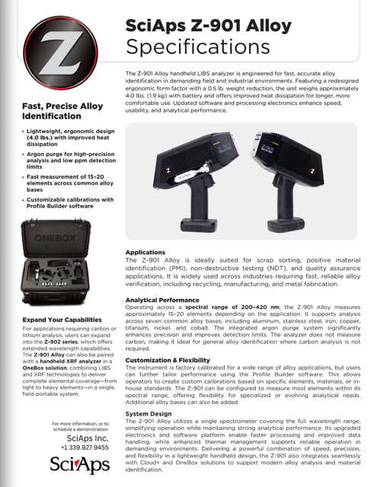
Rev Date: May 2026

Layout Preview | English Text | Translated Text
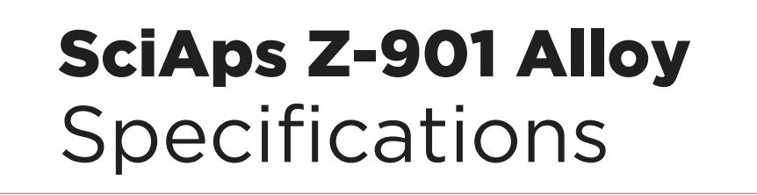 | SciAps Z-901 Alloy
 | Specifications
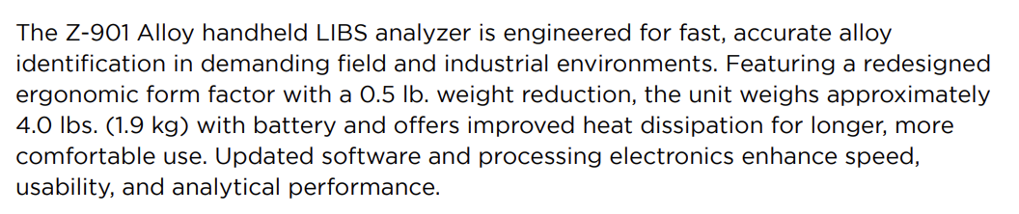 | The Z-901 Alloy handheld LIBS analyzer is engineered for fast, accurate alloy identification in demanding field and industrial environments. Featuring a redesigned ergonomic form factor with a 0.5 lb. weight reduction, the unit weighs approximately 4.0 lbs. (1.9 kg) with battery and offers improved heat dissipation for longer, more comfortable use. Updated software and processing electronics enhance speed, usability, and analytical performance.
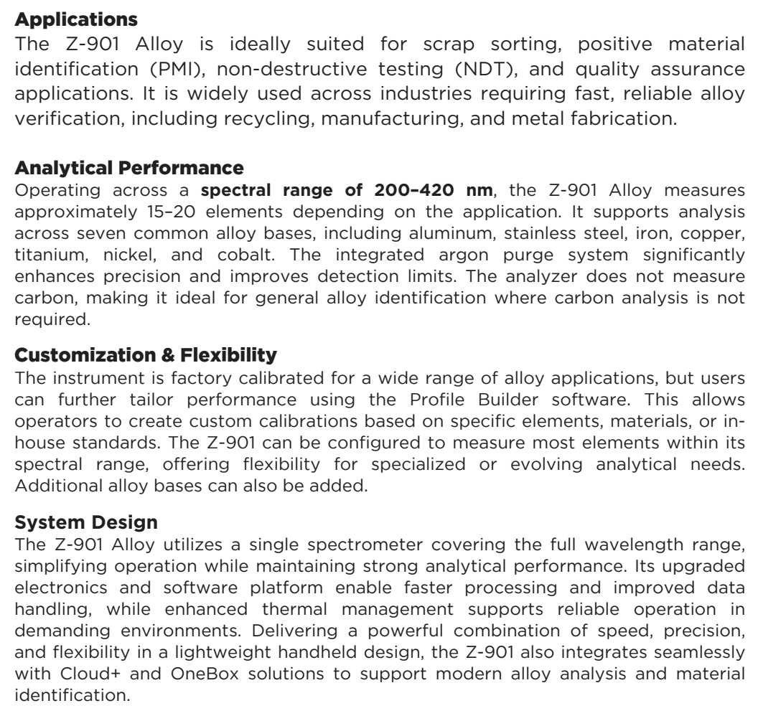 | Applications
 | The Z-901 Alloy is ideally suited for scrap sorting, positive material identification (PMI), non-destructive testing (NDT), and quality assurance applications. It is widely used across industries requiring fast, reliable alloy verification, including recycling, manufacturing, and metal fabrication.
 | Analytical Performance
 | Operating across a spectral range of 200–420 nm, the Z-901 Alloy measures approximately 15–20 elements depending on the application. It supports analysis across seven common alloy bases, including aluminum, stainless steel, iron, copper, titanium, nickel, and cobalt. The integrated argon purge system significantly enhances precision and improves detection limits. The analyzer does not measure carbon, making it ideal for general alloy identification where carbon analysis is not required.
 | Customization & Flexibility
 | The instrument is factory calibrated for a wide range of alloy applications, but users can further tailor performance using the Profile Builder software. This allows operators to create custom calibrations based on specific elements, materials, or inhouse standards. The Z-901 can be configured to measure most elements within its spectral range, offering flexibility for specialized or evolving analytical needs. Additional alloy bases can also be added.
 | System Design
 | The Z-901 Alloy utilizes a single spectrometer covering the full wavelength range, simplifying operation while maintaining strong analytical performance. Its upgraded electronics and software platform enable faster processing and improved data handling, while enhanced thermal management supports reliable operation in demanding environments. Delivering a powerful combination of speed, precision, and flexibility in a lightweight handheld design, the Z-901 also integrates seamlessly with Cloud+ and OneBox solutions to support modern alloy analysis and material identification.
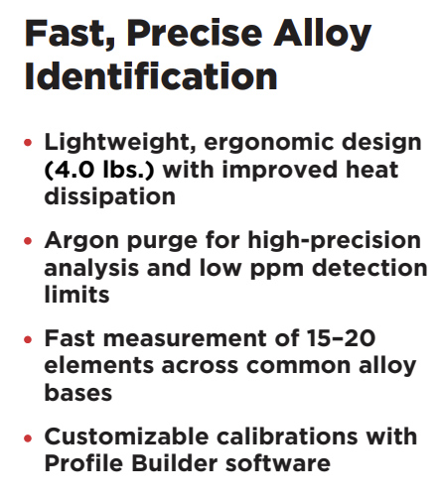 | Fast, Precise Alloy Identification
 | Lightweight, ergonomic design (4.0 lbs.) with improved heat dissipation
 | Argon purge for high-precision analysis and low ppm detection limits
 | Fast measurement of 15–20 elements across common alloy bases
 | Customizable calibrations with Profile Builder software
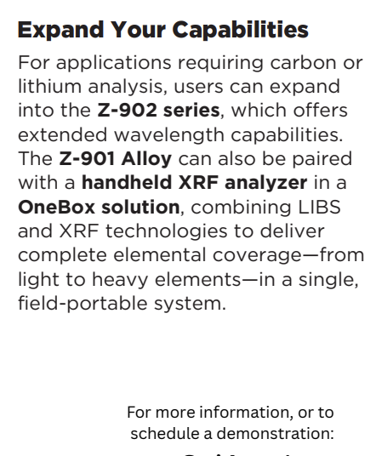 | Expand Your Capabilities
 | For applications requiring carbon or lithium analysis, users can expand into the Z-902 series, which offers extended wavelength capabilities. The Z-901 Alloy can also be paired with a handheld XRF analyzer in a OneBox solution, combining LIBS and XRF technologies to deliver complete elemental coverage—from light to heavy elements—in a single, field-portable system.
 | For more information, or to schedule a demonstration:
(BACK)
 | SciAps Z-901 Alloy
 | Specifications
 | Connected with SciAps Cloud+
 | With integrated SciAps Cloud+, users can streamline data management, monitor analyzer performance, and access results in real time from anywhere. Cloud+ enables automatic data storage, simplified reporting, and fleet management capabilities, helping organizations improve traceability, compliance, and operational efficiency.
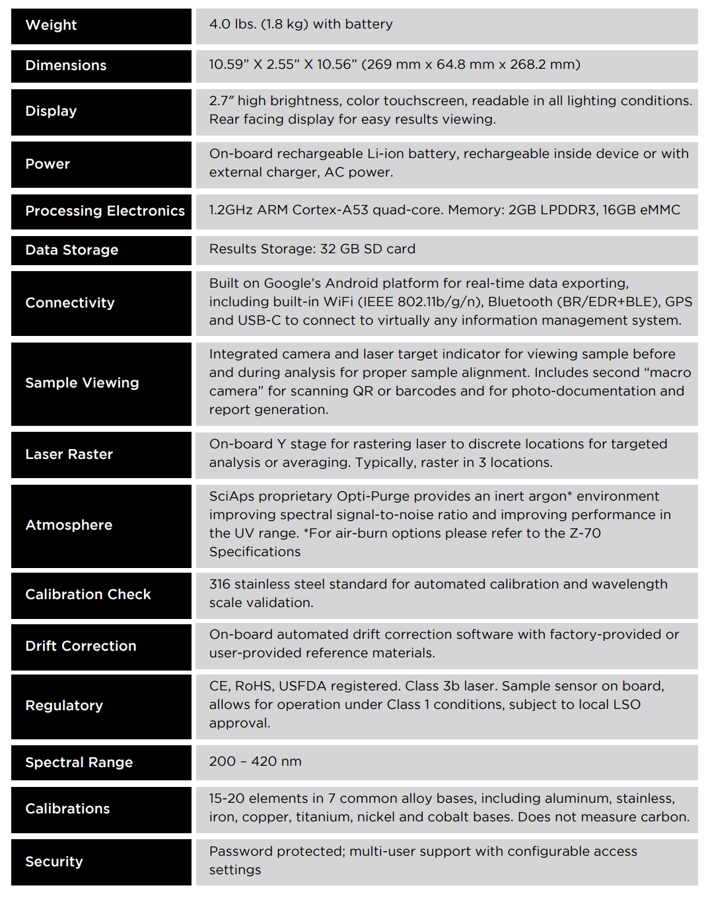 | Weight
 | 4.0 lbs. (1.8 kg) with battery
 | Dimensions
 | 10.59” X 2.55” X 10.56” (269 mm x 64.8 mm x 268.2 mm)
 | Display
 | 2.7″ high brightness, color touchscreen, readable in all lighting conditions. Rear facing display for easy results viewing.
 | Power
 | On-board rechargeable Li-ion battery, rechargeable inside device or with external charger, AC power.
 | Processing Electronics
 | 1.2GHz ARM Cortex-A53 quad-core. Memory: 2GB LPDDR3, 16GB eMMC
 | Data Storage
 | Results Storage: 32 GB SD card
 | Connectivity
 | Built on Google’s Android platform for real-time data exporting, including built-in WiFi (IEEE 802.11b/g/n), Bluetooth (BR/EDR+BLE), GPS and USB-C to connect to virtually any information management system.
 | Sample Viewing
 | Integrated camera and laser target indicator for viewing sample before and during analysis for proper sample alignment. Includes second “macro camera” for scanning QR or barcodes and for photo-documentation and report generation.
 | Laser Raster
 | On-board Y stage for rastering laser to discrete locations for targeted analysis or averaging. Typically, raster in 3 locations.
 | Atmosphere
 | SciAps proprietary Opti-Purge provides an inert argon* environment improving spectral signal-to-noise ratio and improving performance in the UV range. *For air-burn options please refer to the Z-70 Specifications.
 | Calibration Check
 | 316 stainless steel standard for automated calibration and wavelength scale validation.
 | Drift Correction
 | On-board automated drift correction software with factory-provided or user-provided reference materials.
 | Regulatory
 | CE, RoHS, USFDA registered. Class 3b laser. Sample sensor on board, allows for operation under Class 1 conditions, subject to local LSO approval.
 | Spectral Range
 | 200 – 420 nm
 | Calibrations
 | 15-20 elements in 7 common alloy bases, including aluminum, stainless, iron, copper, titanium, nickel and cobalt bases. Does not measure carbon.
 | Security
 | Password protected; multi-user support with configurable access settings.

